TE MSE-2
CASE STUDY REPORT
& EXAM REVISION PACK
Waste Management • E-Waste • Circular Economy
10 case studies | Executive summaries | Data tables | SWOT images | India comparisons | Recommendations | Revision sheets

Student Name | ____________________________
Roll No. | ____________________________
Class / Division | ____________________________
Subject | ____________________________
MSE | MSE-2

Source basis: the uploaded list contains the 10 case-study titles. The report expands each title using current/recent official sources and clearly notes estimates where city-level data vary.

Contents
- 1. Why Japan Recycles More Than Most Countries: Lessons for India
- 2. Switzerland's E-Waste Success Story
- 3. India's E-Waste Management Rules 2022
- 4. India's Extended Producer Responsibility (EPR): Success or Paper Compliance?
- 5. Bengaluru—India's E-Waste Capital?
- 6. Mumbai's E-Waste Ecosystem
- 7. Kerala's Clean Kerala Company
- 8. Pune's SWaCH Model
- 9. Dharavi Recycling Ecosystem
- 10. Dell's Circular Economy Strategy
- 11. Master Exam Revision Sheet — Cross-Case Comparison
- 12. References

Important data note: Figures come from sources with different years and definitions. In an exam, always state the year and what the percentage measures before comparing two figures.

Case 1: Why Japan Recycles More Than Most Countries: Lessons for India

Executive Summary
Japan's case is best understood as a mature waste-management system built around the 3Rs—Reduce, Reuse and Recycle—rather than recycling alone. Japan combines source separation, producer responsibility, municipal systems, waste reduction, high-capacity treatment and disciplined public participation. Its recent municipal data show a 99.2% waste-reduction rate in FY2024, while the recycling rate was 19.3%; therefore, the case's key lesson is not that Japan has the world's highest material-recycling percentage, but that it minimizes uncontrolled disposal and manages residual waste systematically.

Background
- Japan's Ministry of the Environment frames policy around a 'Sound Material-Cycle Society' and the 3R hierarchy: reduce first, then reuse and recycle.
- Municipalities play a major role in collection and treatment, while national policy provides laws, targets and a resource-circulation framework.
- Source separation and citizen participation are important because recyclables must reach the correct treatment stream.
- Japan also relies heavily on thermal treatment for residual municipal waste; in FY2024, 41.9% of municipal waste incineration plants had power-generation facilities.

Strategy / Initiative
- 3R hierarchy: prevent waste where possible, reuse products/components, and recycle materials that cannot be reused.
- Source separation and scheduled collection of recyclable categories.
- Producer and product-specific recycling laws for selected streams such as containers/packaging and electrical appliances.
- Modern treatment infrastructure, including incineration with energy recovery for residual waste.
- Public participation supported by clear municipal rules and long-term environmental policy.

Impact & Results
Indicator | Data / finding
FY2024 municipal waste generation | 38.11 million tonnes
Waste generation per person | 839 g/person/day
Waste reduction rate | 99.2%
Material recycling rate | 19.3%
Recycled waste | 7.38 million tonnes
Incineration plants with power generation | 41.9% of plants
Interpretation: The figures are indicators of system scale or reported performance. They should be quoted with their source year and definition; a collection/processing percentage is not automatically the same as a pure material-recycling rate.

SWOT Analysis
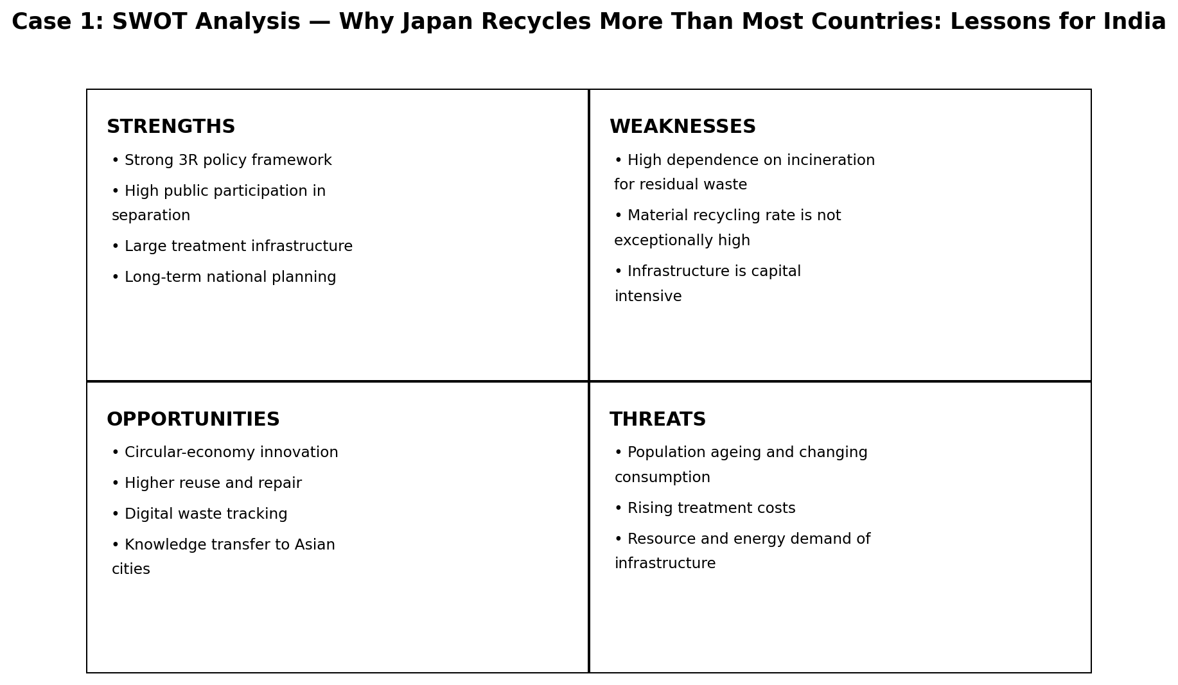

Comparison with India
- India has also moved toward source segregation, EPR and scientific processing, but implementation varies substantially across cities and waste streams.
- India's 2024-25 national e-waste data show 13,97,955.59 tonnes generated and 70.71% collected/dismantled/recycled/disposed under the reported metric; this is a different waste stream and should not be directly compared with Japan's municipal-solid-waste recycling rate.
- India can adapt Japan's emphasis on predictable municipal collection schedules, citizen compliance, product-specific take-back systems and transparent performance measurement.

Recommendations
- Make segregation rules simpler and consistent at ward/city level.
- Use digital dashboards for collection, processing, rejects and landfill diversion.
- Strengthen producer take-back for difficult waste streams.
- Use pay-as-you-throw or economic incentives only where local administrative capacity can support fair enforcement.
- Measure reduction, reuse, recycling and final disposal separately rather than using one recycling percentage.

Conclusion
Japan demonstrates that waste performance depends on an integrated system—policy, municipal operations, public behavior, producer responsibility and treatment infrastructure. India can borrow the system logic while adapting technology and enforcement to local conditions.
References / Sources
- Japan MOE — Municipal solid waste generation and disposal in FY2024 — https://www.env.go.jp/en/press/press_01569.html
- Japan MOE — Sound Material-Cycle Society — https://www.env.go.jp/en/recycle/smcs/
- Japan MOE — The 3R Initiative — https://www.env.go.jp/recycle/3r/en/outline.html

One-Page Exam Revision Sheet — Case 1
Why Japan Recycles More Than Most Countries: Lessons for India
Exam Point | Remember
Core idea | Integrated 3R + source separation + municipal treatment.
Important correction | Japan's FY2024 recycling rate was 19.3%; its strength is overall waste reduction and controlled treatment.
Key figure | 839 g municipal waste/person/day in FY2024.
Waste reduction | 99.2% in FY2024.
Energy recovery | 41.9% of incineration plants had power-generation facilities.
India lesson | Build a complete system, not just recycling targets.
5-line answer skeleton: Define the Japanese 3R model → explain source segregation and municipal responsibility → quote FY2024 data → compare with India → recommend adaptation, not direct copying.
Key terms: 3R, source segregation, Sound Material-Cycle Society, waste reduction, incineration, energy recovery

Case 2: Switzerland's E-Waste Success Story

Executive Summary
Switzerland's e-waste model combines mandatory take-back obligations with industry-operated, non-profit recycling systems financed through an advance recycling contribution. Consumers can return electrical and electronic equipment through retailers or collection points without paying a separate disposal charge at the time of return. The system makes the financing of collection, logistics and recycling visible and predictable.

Background
- Swiss rules require retailers, manufacturers and importers dealing in electrical and electronic equipment to accept used equipment free of charge.
- Consumers are expected to return equipment through the appropriate take-back system rather than placing it with household waste.
- Two major industry systems, SENS eRecycling and Swico Recycling, operate collection and recycling networks.
- Advance recycling contributions are built into product prices and earmarked for end-of-life management.

Strategy / Initiative
- Universal take-back through retailers and official collection points.
- Advance recycling contribution (ARC/ARF) finances collection, transport, processing and quality control.
- Industry and government roles are separated but coordinated through regulation and oversight.
- Specialist recyclers disassemble equipment and recover metals, plastics and glass.
- Collection data and system performance are tracked through organized take-back networks.

Impact & Results
Indicator | Data / finding
SENS system, 2025 volume | 104,751 tonnes
SENS per-capita collection/recycling volume | 11.48 kg/person
SENS collection points | 630
Swico system | ~40,000 tonnes/year
Swico collection points | ~600
Material recovery potential | SENS reports ~75% of an item can be reused/material recovered on average through recycling
Interpretation: The figures are indicators of system scale or reported performance. They should be quoted with their source year and definition; a collection/processing percentage is not automatically the same as a pure material-recycling rate.

SWOT Analysis
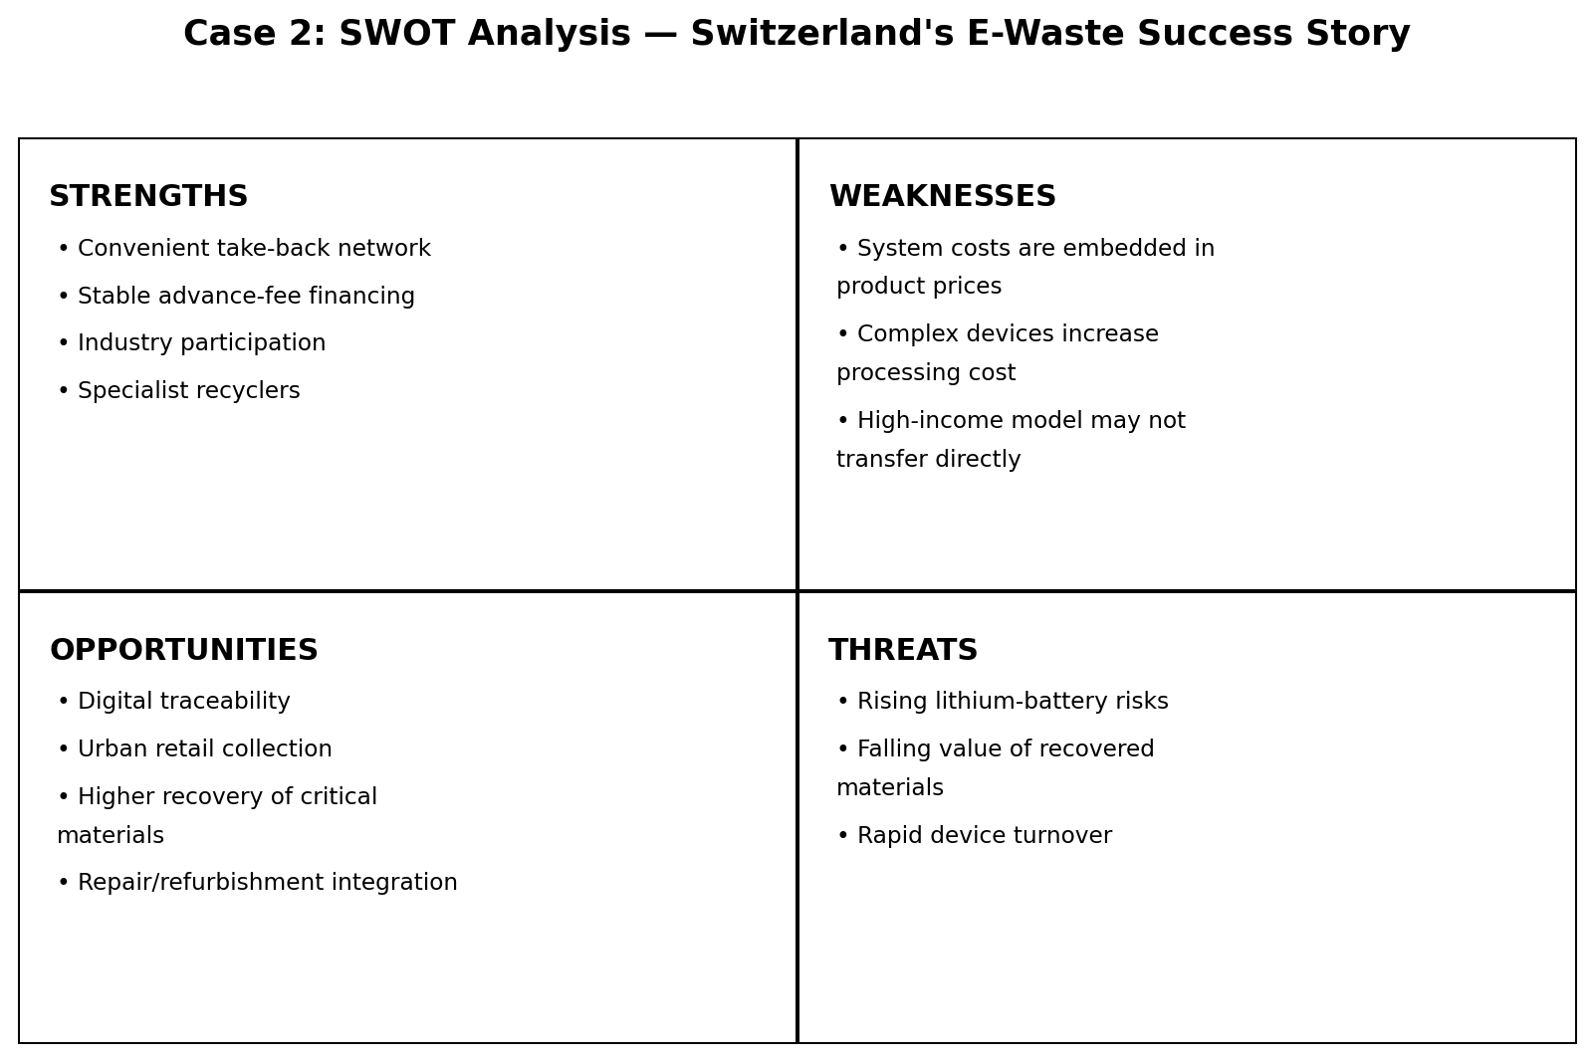

Comparison with India
- India's E-Waste Management Rules, 2022 use a producer EPR model with registration, recycling obligations and EPR certificates; the Swiss model provides a useful example of stable financing and convenient consumer take-back.
- India's EPR portal is digital and increasingly formalized, but consumer access to convenient collection remains uneven across cities.
- India could combine its existing EPR certificate mechanism with stronger retail take-back obligations and clearer consumer-facing collection networks.

Recommendations
- Expand visible e-waste return points at electronics retailers and service centres.
- Create standardized consumer communication: 'buy → use → return'.
- Ring-fence or transparently account for EPR/advance recycling funds.
- Track collection by product category and city, not only at national level.
- Improve data-security assurance for returned devices to increase consumer trust.

Conclusion
Switzerland's success rests on convenience, financing and accountability. The transferable lesson for India is to make the correct disposal route easy for consumers while ensuring that money follows the product to its end-of-life treatment.
References / Sources
- Swiss Federal Office for the Environment — Electrical and electronic equipment — https://www.bafu.admin.ch/en/electrical-and-electronic-equipment-en
- SENS eRecycling — Facts & Figures 2024/2025 — https://www.erecycling.ch/en/ueber-sens/medien-und-publikationen/geschaeftsbericht/2025/facts-figures.html
- Swico Recycling — Facts and figures — https://www.swico.ch/en/recycling/basics/facts-and-figures/
- Swiss Federal Audit Office — Supervision of recycling — https://www.efk.admin.ch/en/audit/supervision-of-recycling-of-waste-subject-to-taxes-and-advance-contributions/

One-Page Exam Revision Sheet — Case 2
Switzerland's E-Waste Success Story
Exam Point | Remember
Core mechanism | Advance Recycling Contribution + free take-back.
Consumer rule | Return used electrical/electronic equipment through authorized channels.
SENS 2025 | 104,751 tonnes; 11.48 kg/person.
Collection network | 630 SENS points; Swico ~600.
India lesson | Convenience + financing + accountability are essential.
Exam line | EPR works better when the consumer's return path is simple and visible.
5-line answer skeleton: Explain take-back → explain advance recycling fee → show SENS/Swico network → compare with India's EPR portal → suggest retail take-back and transparent financing.
Key terms: take-back, ARC/ARF, SENS, Swico, EPR, producer responsibility

Case 3: India's E-Waste Management Rules 2022

Executive Summary
The E-Waste (Management) Rules, 2022, effective from 1 April 2023, moved India toward a portal-based EPR system. Producers, manufacturers, recyclers and refurbishers are registered; producers receive recycling obligations; registered recyclers generate EPR certificates; and environmental compensation, returns and audits support enforcement. The rules therefore shift the system from mainly collection-oriented compliance toward measurable recycling outcomes.

Background
- The rules were notified on 2 November 2022 and superseded the 2016 rules from 1 April 2023.
- The framework covers 106 electrical/electronic equipment items under seven categories, according to CPCB's FAQ.
- Producer EPR obligations are linked to recycling and are fulfilled through registered recyclers using the online portal.
- The framework also supports refurbishment and provides for environmental compensation for violations.

Strategy / Initiative
- Mandatory registration of covered manufacturers, producers, recyclers and refurbishers.
- Online EPR portal for registration, obligations, certificates and returns.
- Recycling targets are phased: 60% for FY2023-24 and FY2024-25, 70% for FY2025-26 and FY2026-27, and 80% from FY2027-28 onward for the relevant producer obligation.
- Recycler-generated EPR certificates are transferred to producers to meet obligations.
- Environmental compensation and audit/verification provisions create an enforcement mechanism.

Impact & Results
Indicator | Data / finding
National e-waste generated, FY2023-24 | 12,54,286.55 MT
Reported collection/dismantling/recycling/disposal, FY2023-24 | 61.94%
National e-waste generated, FY2024-25 | 13,97,955.59 MT
Reported collection/dismantling/recycling/disposal, FY2024-25 | 70.71%
Producers on portal, FY2024-25 report | 6,685
Registered recyclers, FY2024-25 report | 276; annual processing capacity 19,06,570.414 TPA
Interpretation: The figures are indicators of system scale or reported performance. They should be quoted with their source year and definition; a collection/processing percentage is not automatically the same as a pure material-recycling rate.

SWOT Analysis
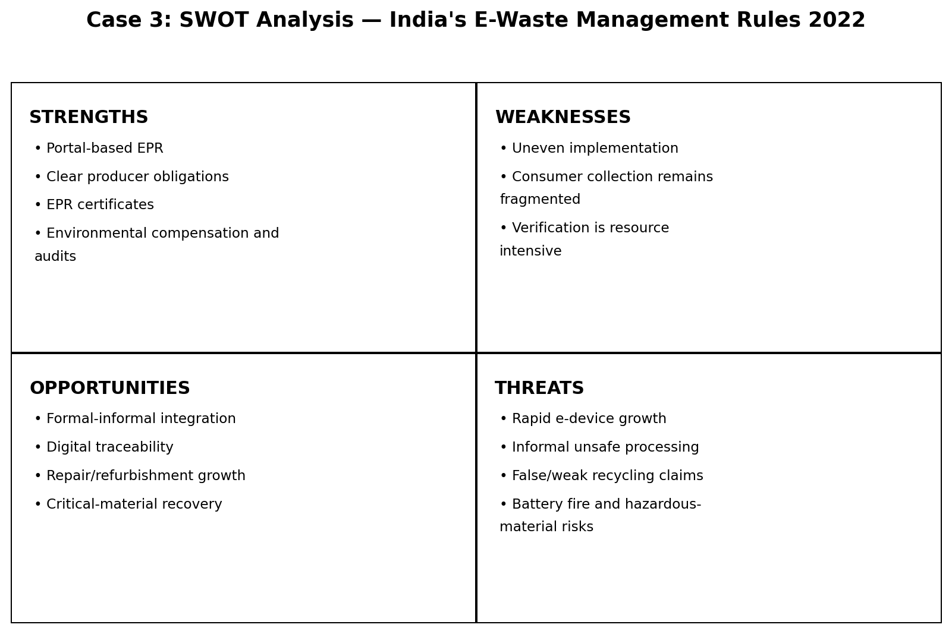

Comparison with India
- This is itself the India baseline against which the other international case studies can be compared.
- Compared with Switzerland, India has a strong digital EPR architecture but a much larger and more diverse informal sector and a more uneven collection network.
- Compared with Japan, India's rules are more specifically focused on e-waste and EPR, while Japan's wider lesson is integrated resource circulation and public participation.

Recommendations
- Publish city/state-level collection and recycling performance dashboards.
- Increase verification of recycler inputs, outputs and end-product sales.
- Build formal partnerships with informal collectors instead of relying only on enforcement.
- Strengthen consumer take-back points and awareness.
- Track reuse/refurbishment separately from material recycling to reward longer product life.

Conclusion
The 2022 rules provide a modern regulatory architecture for e-waste. Their effectiveness depends on reliable data, verification, recycler capacity, consumer participation and integration of informal collection networks.
References / Sources
- MoEFCC — Rules & Regulations: E-Waste Management Rules 2022 — https://moef.gov.in/rules-regulations-3
- CPCB — FAQ under E-Waste (Management) Rules, 2022 — https://cpcb.nic.in/uploads/Projects/E-Waste/FAQ_ewaste_23012024.pdf
- CPCB — E-Waste Management System / EPR Portal — https://eprewaste.cpcb.gov.in/
- PIB — E-waste processing management, 24 July 2025 — https://www.pib.gov.in/PressReleasePage.aspx?PRID=2147876&lang=2&reg=48

One-Page Exam Revision Sheet — Case 3
India's E-Waste Management Rules 2022
Exam Point | Remember
Effective date | 1 April 2023.
Coverage | 106 EEE items under seven categories (CPCB FAQ).
EPR target | 60% → 70% → 80% phased obligation for relevant producers.
FY2023-24 | 12.54 lakh MT generated; 61.94% reported handled by the stated metric.
FY2024-25 | 13.98 lakh MT generated; 70.71% reported handled.
Key mechanism | Registered recycler → EPR certificate → producer obligation.
5-line answer skeleton: State effective date → define EPR portal mechanism → explain targets/certificates → quote current national data → identify implementation gaps → recommend stronger verification and collection.
Key terms: E-Waste Management Rules 2022, EPR, EPR certificate, CPCB, registered recycler, environmental compensation

Case 4: India's Extended Producer Responsibility (EPR): Success or Paper Compliance?

Executive Summary
India's EPR framework is increasingly measurable because producers and recyclers operate through centralized portals and EPR certificates. The available official data show substantial registration and certificate trading. At the same time, compliance should not be judged only by certificates or portal transactions: the environmental outcome depends on whether material actually reaches verified recycling processes, whether recycled outputs are sold, and whether informal flows are safely integrated. Therefore, the case is best framed as a compliance-and-verification challenge rather than a simple success/failure label.

Background
- EPR makes producers responsible for specified end-of-life obligations instead of leaving all disposal responsibility with municipalities and consumers.
- Under the 2022 e-waste rules, producers meet obligations by purchasing EPR certificates from registered recyclers.
- CPCB requires evidence such as recycler sales data and GST-linked invoices for recycled end products in the e-waste system.
- Environmental compensation is available for non-compliance, creating a financial enforcement layer.

Strategy / Initiative
- Centralized registration of producers/recyclers/refurbishers.
- Quantified EPR obligations and certificate generation/transfer.
- Verification through portal records, audits and recycler documentation.
- Environmental compensation for violations.
- Formalization of recycling capacity and integration of circular-economy incentives.

Impact & Results
Indicator | Data / finding
E-waste producers registered, March 2026 | 7,226
E-waste recyclers registered, March 2026 | 386
E-waste recycled under EPR framework, March 2026 | 28.75 lakh MT
E-waste EPR certificates generated, March 2026 | 11.86 lakh MT
FY2023-24 EPR obligation | 2,76,771 MT
FY2023-24 certificates transferred | 2,54,607 MT
Interpretation: The figures are indicators of system scale or reported performance. They should be quoted with their source year and definition; a collection/processing percentage is not automatically the same as a pure material-recycling rate.

SWOT Analysis
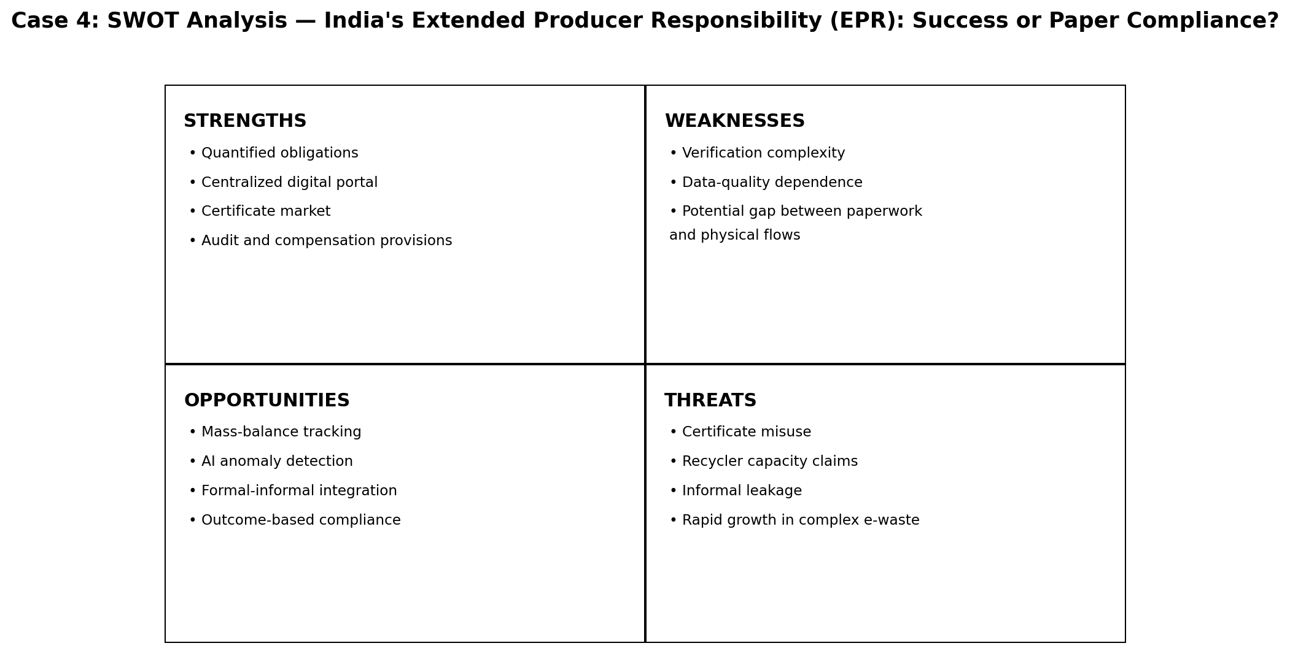

Comparison with India
- India's EPR system is stronger on formal digital compliance than older collection-only approaches.
- Switzerland demonstrates how financing and convenient take-back can reinforce producer responsibility; India still needs broader consumer-facing collection infrastructure.
- Japan demonstrates that producer responsibility is more effective when integrated with municipal source separation and public participation.

Recommendations
- Publish certificate-to-physical-output audit summaries without exposing commercially sensitive data.
- Use random third-party audits and mass-balance checks for high-risk recyclers.
- Measure reuse, refurbishment, recycling and final disposal separately.
- Create interoperable tracking from collection → dismantling → recycling → recovered material sale.
- Reward verified environmental outcomes rather than only administrative completion.

Conclusion
EPR in India has moved beyond a purely paper-based concept because it now has registration, targets, certificates and enforcement provisions. However, the quality of compliance depends on verification and real material flows. The appropriate policy focus is therefore 'verified EPR' rather than simply 'more EPR'.
References / Sources
- CPCB — E-Waste EPR Portal — https://eprewaste.cpcb.gov.in/
- CPCB — E-Waste FAQ — https://cpcb.nic.in/uploads/Projects/E-Waste/FAQ_ewaste_23012024.pdf
- MoEFCC Annual Report 2024-25 — E-waste management — https://moef.gov.in/uploads/pdf-uploads/English_Annual_Report_2024-25.pdf
- PIB — EPR implementation status, 5 March 2026 — https://www.pib.gov.in/PressReleasePage.aspx?PRID=2244104&lang=1&reg=1

One-Page Exam Revision Sheet — Case 4
India's Extended Producer Responsibility (EPR): Success or Paper Compliance?
Exam Point | Remember
Main question | Does EPR create real recycling or only administrative compliance?
Evidence of scale | 7,226 producers and 386 recyclers registered as of March 2026.
FY2023-24 | 2,76,771 MT obligation; 2,54,607 MT certificates transferred.
Key safeguard | GST-linked sales invoices are required as proof for recycled metal sales.
Core limitation | Certificates alone do not prove the entire physical chain is environmentally sound.
Best answer line | EPR is a strong governance tool, but verification determines environmental credibility.
5-line answer skeleton: Define EPR → show official registration/certificate data → explain verification safeguards → discuss compliance limits → recommend physical-flow verification.
Key terms: EPR, compliance, verification, EPR certificate, mass balance, environmental compensation

Case 5: Bengaluru—India's E-Waste Capital?

Executive Summary
Bengaluru is frequently described in media and studies as a major e-waste hub because of its concentration of IT, electronics consumption, repair, scrap and recycling activity. A widely cited older study estimated about 12,000 tonnes/year of computer-related e-waste, while a 2026 report again cites roughly 12,000 tonnes/year and says only about 15% is scientifically processed. Because these figures refer to different years and methodologies, they should be treated as estimates rather than a single definitive current city total.

Background
- Bengaluru's technology-intensive economy creates a large installed base of computers, peripherals, phones and other electronics.
- The ecosystem includes consumers, traders, repair shops, dismantlers, scrap dealers and formal recyclers.
- Informal channels can recover valuable materials efficiently but may use unsafe dismantling or processing practices.
- Karnataka has a significant concentration of registered e-waste recycling facilities.

Strategy / Initiative
- Formal recycling facilities for scientific dismantling and material recovery.
- Repair, reuse and resale channels that can extend product life.
- Informal scrap networks that aggregate devices and materials.
- State pollution-control oversight and national EPR rules for producers and recyclers.
- Potential integration of informal collectors into authorized supply chains.

Impact & Results
Indicator | Data / finding
Widely cited estimate, older Bangalore study | ~12,000 tonnes/year of computer/peripheral e-waste
2026 media estimate | ~12,000 tonnes/year
2026 reported scientific processing | ~15% of the cited city stream
Karnataka registered recyclers in FY2024-25 | 57
National lesson | Formal capacity does not automatically equal formal collection
Interpretation: The figures are indicators of system scale or reported performance. They should be quoted with their source year and definition; a collection/processing percentage is not automatically the same as a pure material-recycling rate.

SWOT Analysis
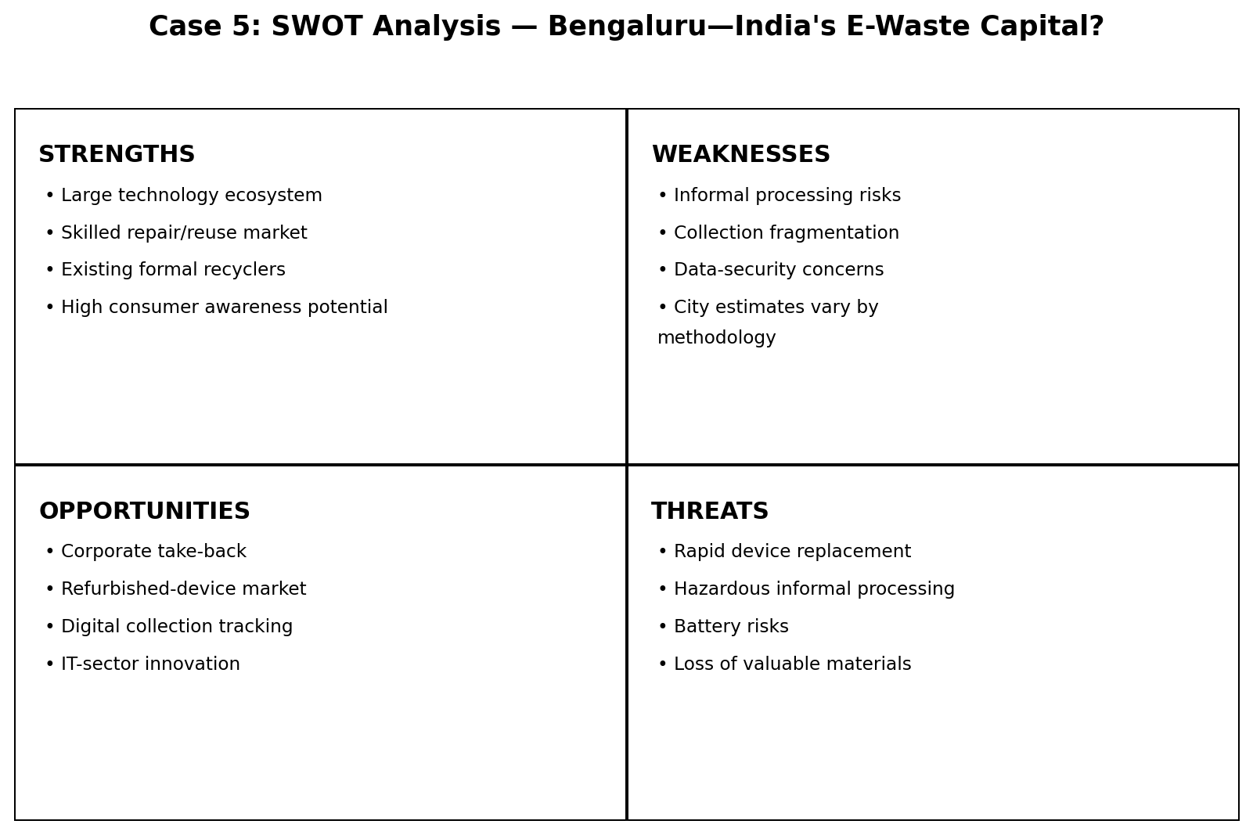

Comparison with India
- Bengaluru illustrates India's wider challenge: recycling capacity and EPR registration can grow faster than consumer collection and formal channelization.
- Compared with Switzerland, Bengaluru lacks the same universal take-back convenience and advance-fee financing structure.
- Compared with Pune's SWaCH model, Bengaluru's e-waste challenge is more product-specific and requires stronger electronics take-back, data security and specialized recycling.

Recommendations
- Create ward-level electronics collection days and permanent retail drop-off points.
- Formalize partnerships with repair shops and scrap dealers through training and buy-back contracts.
- Offer secure data-destruction certificates for computers and phones.
- Track material flows from collection through authorized recycler outputs.
- Use Bengaluru's IT sector as a testing ground for corporate take-back and refurbished-device markets.

Conclusion
Bengaluru's importance comes from the scale and density of its electronics economy, but its case also shows why collection, formalization and safe processing must grow together. The city's strongest opportunity is to connect its existing repair/scrap ecosystem with verified formal recycling.
References / Sources
- Pradhan & Sudhir — E-Waste Management: A Case Study of Bangalore — https://www.researchgate.net/publication/230766242_E-Waste_Management_A_Case_Study_of_Bangalore_India
- Bangalore Mirror — E-waste is piling up, 22 Feb 2026 — https://bangaloremirror.indiatimes.com/bangalore/cover-story/e-waste-is-piling-up/articleshow/128654505.cms
- PIB — E-waste processing management, 24 July 2025 — https://www.pib.gov.in/PressReleasePage.aspx?PRID=2147876&lang=2&reg=48

One-Page Exam Revision Sheet — Case 5
Bengaluru—India's E-Waste Capital?
Exam Point | Remember
Why important | Large electronics/IT consumption and recycling ecosystem.
Common estimate | ~12,000 tonnes/year appears in older research and 2026 reporting, but methodology/year differ.
2026 reported issue | Only ~15% of the cited stream scientifically processed.
Karnataka FY2024-25 | 57 registered e-waste recyclers reported by PIB.
Main challenge | Formal capacity ≠ formal collection.
Solution | Integrate repair/scrap networks with authorized recycling.
5-line answer skeleton: Explain Bengaluru's IT-driven e-waste growth → identify formal and informal actors → give estimate with caveat → discuss collection gap → propose formal-informal integration.
Key terms: Bengaluru, informal sector, formal recycler, IT waste, repair, take-back

Case 6: Mumbai's E-Waste Ecosystem

Executive Summary
Mumbai's e-waste ecosystem is a multi-actor network involving households, businesses, informal collectors, scrap dealers, dismantlers, recyclers, the BMC and the Maharashtra Pollution Control Board. Maharashtra has a large formal recycling base, while Mumbai's municipal climate plan calls for monthly e-waste collection drives. The case therefore demonstrates a hybrid formal–informal system where the major challenge is channelization and safe processing rather than the complete absence of infrastructure.

Background
- Mumbai is a high-consumption metropolitan region with large volumes of electronics in households, offices, institutions and commercial establishments.
- MPCB maintains e-waste rules, authorized-facility information and annual reporting.
- BMC's waste-management planning includes dry-waste sorting centres and e-waste collection initiatives.
- Informal collectors remain important because they provide convenient door-to-door recovery and material aggregation.

Strategy / Initiative
- Municipal awareness and collection drives.
- Dry-waste sorting centres and ward-level collection concepts.
- State-level authorization and monitoring of dismantlers/recyclers.
- EPR obligations for producers under national rules.
- Use of informal collection networks to aggregate materials, with formal processing as the desired end point.

Impact & Results
Indicator | Data / finding
Maharashtra FY2021-22 authorized facilities | 103 dismantlers; 11 recyclers
Maharashtra FY2021-22 material recovered from recycling/dismantling | 14,344.71 MT
Maharashtra FY2020-21 e-waste recycled (annual report) | 8,140 MT
BMC Climate Action Plan | Monthly e-waste collection drives listed as an action
National context, FY2024-25 | Maharashtra had 75 registered e-waste recyclers
Interpretation: The figures are indicators of system scale or reported performance. They should be quoted with their source year and definition; a collection/processing percentage is not automatically the same as a pure material-recycling rate.

SWOT Analysis
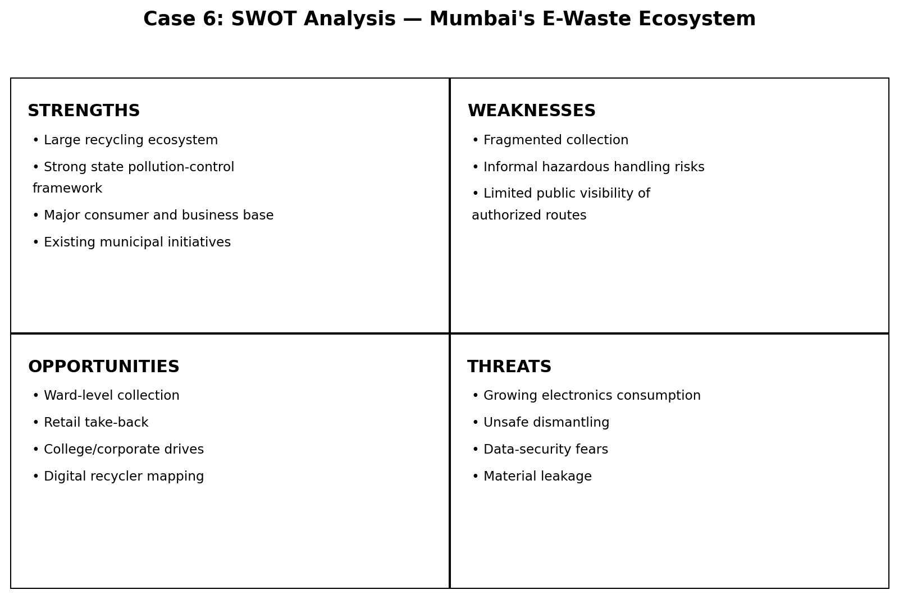

Comparison with India
- Mumbai's system is more decentralized and informal than Switzerland's retail take-back system.
- Compared with Bengaluru, Mumbai's ecosystem is strongly linked to informal collection and the wider metropolitan recycling economy.
- Compared with Pune's SWaCH, Mumbai's model has less of a single cooperative identity for e-waste; institutional coordination across wards and actors is more important.

Recommendations
- Create permanent e-waste drop-off points at ward offices, malls, colleges and electronics retailers.
- Publish an authorized recycler map with collection options and data-security guidance.
- Use BMC/MPCB campaigns to connect informal collectors with authorized recyclers.
- Measure Mumbai-specific e-waste collected, recycled and diverted from informal hazardous processing.
- Require transparent chain-of-custody records for bulk institutional e-waste.

Conclusion
Mumbai already has a significant formal recycling ecosystem and policy infrastructure. The key improvement is to make the authorized route as convenient and trusted as the informal route, while preserving livelihoods through responsible integration.
References / Sources
- MPCB — Electronic Waste / E-Waste Management — https://www.mpcb.gov.in/en/node/4297
- MPCB — E-Waste Annual Report 2021-22 — https://www.mpcb.gov.in/sites/default/files/E-Waste%20Annual%20Report_2021_22-Final.pdf
- BMC — Mumbai Climate Action Plan 2022 — https://portal.mcgm.gov.in/irj/go/km/docs/documents/Environment/Climate/Mumbai%20Climate%20Action%20Plan%202022.pdf
- PIB — E-waste processing management, 24 July 2025 — https://www.pib.gov.in/PressReleasePage.aspx?PRID=2147876&lang=2&reg=48

One-Page Exam Revision Sheet — Case 6
Mumbai's E-Waste Ecosystem
Exam Point | Remember
Key actors | BMC + MPCB + producers + collectors + dismantlers + recyclers.
FY2021-22 Maharashtra | 103 dismantlers, 11 recyclers; 14,344.71 MT material recovered.
FY2020-21 | 8,140 MT e-waste recycled in the MPCB report.
BMC plan | Monthly e-waste collection drives.
Main issue | Channelization from consumers/informal collectors to authorized recyclers.
Solution | Make formal collection more convenient and trusted.
5-line answer skeleton: Identify Mumbai actors → explain formal/informal flows → quote Maharashtra data → explain BMC/MPCB roles → recommend convenient ward-level channelization.
Key terms: Mumbai, MPCB, BMC, formal-informal ecosystem, collection, channelization

Case 7: Kerala's Clean Kerala Company

Executive Summary
Clean Kerala Company Limited (CKCL) is a state-supported organization working with local self-government institutions to create forward linkages for non-biodegradable waste. Its model connects local collection with authorized processing/disposal partners. The official Kerala Local Self Government Department reports large cumulative collection figures, including 2,265 MT of e-waste, illustrating how a state-level coordinating company can connect decentralized local bodies to formal waste processors.

Background
- CKCL operates under Kerala's Local Self Government Department and works with local governments, Haritha Karma Sena, Suchitwa Mission, KSWMP and private partners.
- The company focuses on non-biodegradable waste, including plastic and e-waste.
- Local governments remain central to collection, while CKCL provides downstream linkages.
- E-waste is handed to recycling companies approved by central and state pollution-control authorities.

Strategy / Initiative
- Decentralized collection through local self-government institutions.
- Forward linkage to authorized recyclers/processors.
- Integration with Haritha Karma Sena and other local waste workers.
- Separate handling of hazardous e-waste streams such as tube lights, CFLs and batteries.
- Partnerships with private processors and cement plants for appropriate reject streams.

Impact & Results
Indicator | Data / finding
Rural LSGs associated with CKCL | 667
Urban LSGs associated with CKCL | 47
Segregated plastic collected | 24,292 MT
E-waste collected | 2,265 MT
Hazardous e-waste collected | 161 MT
Glass waste collected | 3,792 MT
Interpretation: The figures are indicators of system scale or reported performance. They should be quoted with their source year and definition; a collection/processing percentage is not automatically the same as a pure material-recycling rate.

SWOT Analysis
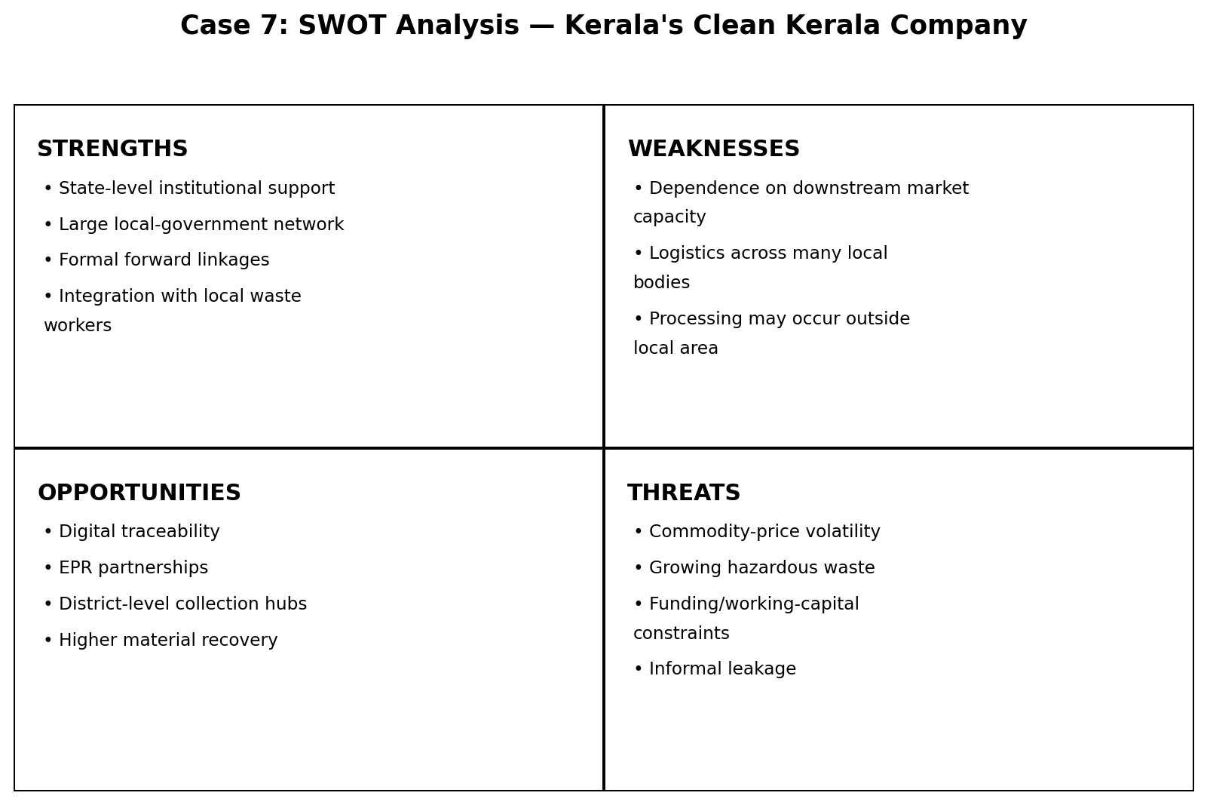

Comparison with India
- CKCL shows how India can build a state-level coordination layer between decentralized local bodies and formal processors.
- Compared with Mumbai, CKCL has a clearer statewide institutional linkage and a defined forward-linkage role.
- Compared with Switzerland, CKCL is more publicly coordinated and decentralized, but it does not use the same nationwide advance-fee financing model.

Recommendations
- Introduce digital material-flow tracking from Haritha Karma Sena to processor.
- Expand public collection points for e-waste and hazardous household items.
- Publish district-wise performance indicators.
- Link producer EPR obligations with local collection systems where legally feasible.
- Develop more local processing markets so transport distances and reject costs fall.

Conclusion
CKCL demonstrates the value of an institutional bridge between local collection and formal downstream processing. The model is particularly relevant to India because it works through existing local-government structures rather than requiring a single centralized collection agency.
References / Sources
- Kerala LSGD — Clean Kerala Company: Waste Management — https://lsgd.kerala.gov.in/en/waste-management/supporting-institutions/ckcl/
- Kerala LSGD — Clean Kerala Company overview — https://lsgd.kerala.gov.in/en/about-the-department/aligned-institutions/ckcl/

One-Page Exam Revision Sheet — Case 7
Kerala's Clean Kerala Company
Exam Point | Remember
Institution | Clean Kerala Company Limited (CKCL).
Network | 667 rural + 47 urban local self-government institutions.
E-waste | 2,265 MT collected cumulatively as reported by Kerala LSGD.
Hazardous e-waste | 161 MT collected.
Core model | Local collection → CKCL forward linkage → authorized processor.
Lesson | Institutional coordination can connect decentralized collection to formal recycling.
5-line answer skeleton: Define CKCL → explain local-government/Haritha Karma Sena linkage → quote collection data → compare with other Indian models → recommend digital tracking and EPR integration.
Key terms: CKCL, Kerala, LSGIs, Haritha Karma Sena, forward linkage, non-biodegradable waste

Case 8: Pune's SWaCH Model

Executive Summary
SWaCH is a cooperative of self-employed waste collectors that provides front-end waste-management services in Pune. Its importance lies in combining livelihood integration with household collection and recycling. Current SWaCH impact figures report coverage of about 10 lakh households, more than 4,000 waste pickers integrated, and about 82,891 tonnes of recycled waste annually. The model demonstrates that informal waste workers can become organized service providers rather than being excluded from formal systems.

Background
- SWaCH is described by the cooperative as India's first wholly-owned cooperative of self-employed waste collectors and other urban poor.
- It operates in partnership with citizens and the Pune municipal system.
- Waste pickers collect segregated materials at the front end and recover recyclable fractions.
- The cooperative model gives workers an organizational structure, service identity and access to city-level planning.

Strategy / Initiative
- Door-to-door collection from households and establishments.
- Source segregation and recovery of recyclable materials.
- Cooperative organization of waste pickers.
- Partnership with Pune Municipal Corporation.
- Additional programs such as V-Collect for old electronics and other reusable items.

Impact & Results
Indicator | Data / finding
Households covered daily, SWaCH 2025 | 1,000,000
Waste pickers integrated, SWaCH 2025 | 4,000+
Recycled waste annually, SWaCH 2025 | 82,891 tonnes
Coverage of Pune | Over 70%
PMC savings reported by SWaCH | ₹113 crore
Earlier detailed impact figure | ~80,000 tonnes diverted/recycled annually; ~100,000 MT CO₂ avoided
Interpretation: The figures are indicators of system scale or reported performance. They should be quoted with their source year and definition; a collection/processing percentage is not automatically the same as a pure material-recycling rate.

SWOT Analysis
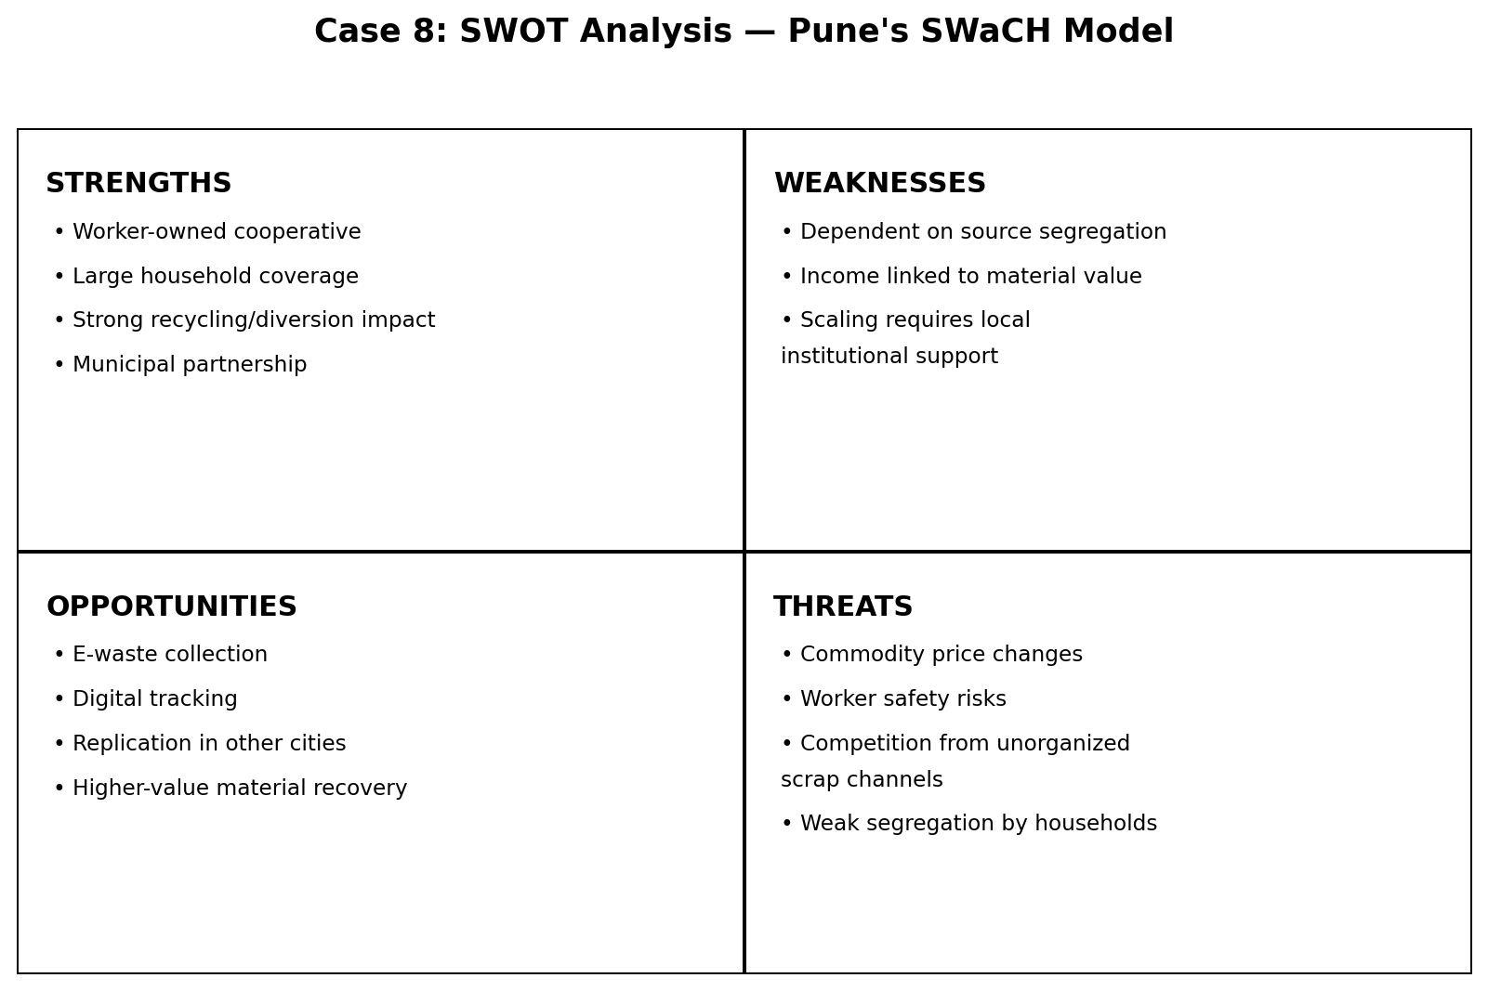

Comparison with India
- Compared with centralized collection, SWaCH creates a direct relationship between households and trained collectors.
- Compared with Mumbai/Dharavi, SWaCH gives informal workers a formal cooperative identity and structured municipal partnership.
- Compared with Switzerland, the model is less dependent on an advance recycling fee and more dependent on service organization, worker participation and local partnerships.

Recommendations
- Expand the cooperative approach to e-waste collection with authorized downstream recyclers.
- Provide occupational safety, insurance and skills training to waste workers.
- Use digital route and material tracking without undermining worker autonomy.
- Create performance-linked municipal contracts that reward diversion from landfill.
- Replicate the cooperative structure in other Indian cities after local feasibility assessment.

Conclusion
SWaCH's major contribution is institutional: it turns waste pickers into recognized service providers and makes source-separated recovery part of daily urban waste management. The model offers a practical route for inclusive circular economy design.
References / Sources
- SWaCH — Home / Impact 2025 — https://swachcoop.com/
- SWaCH — Impact — https://swachcoop.com/about/impact/
- SWaCH — UNESCAP Pune case study — https://swachcoop.com/pdf/UNESCAP-Closing-The-Loop-Pune-India-Case-Study.pdf

One-Page Exam Revision Sheet — Case 8
Pune's SWaCH Model
Exam Point | Remember
Organization | SWaCH — cooperative of self-employed waste collectors.
2025 coverage | 1 million households daily; 4,000+ waste pickers.
Annual recycling | 82,891 tonnes reported by SWaCH.
Coverage | Over 70% of Pune.
Main innovation | Formal cooperative + informal-worker inclusion + municipal partnership.
Exam lesson | Inclusive waste management can improve both livelihoods and material recovery.
5-line answer skeleton: Define SWaCH → explain cooperative structure → describe collection/recycling process → give impact numbers → compare with conventional systems → discuss replication.
Key terms: SWaCH, cooperative, waste pickers, Pune, source segregation, inclusive circular economy

Case 9: Dharavi Recycling Ecosystem

Executive Summary
Dharavi's recycling ecosystem is a dense informal circular economy built from waste pickers, kabadiwalas, traders, sorters, transporters and small processing/manufacturing units. Research on the 13 Compounds reports a highly significant flow of plastic through the area, while other studies describe the settlement as a major recycling center for Mumbai. The model is economically efficient in material recovery but has serious weaknesses around worker health, pollution, infrastructure and formal recognition.

Background
- Dharavi contains a dense network of micro-enterprises that sort, shred, remould and trade recyclable materials.
- The system relies heavily on informal labor and low-cost entry into collection and processing.
- Materials move through multiple actors before returning to manufacturing supply chains.
- Research stresses that the system is not an ecological ideal: pollution and worker-health risks coexist with high material recovery.

Strategy / Initiative
- Street-level collection by waste pickers and small dealers.
- Aggregation and sorting through neighborhood networks.
- Mechanical/manual processing of plastics, metals, paper and other materials.
- Sale of recovered materials to downstream manufacturers.
- Reuse of local knowledge, repair and manufacturing skills within the informal economy.

Impact & Results
Indicator | Data / finding
Dharavi 13 Compounds plastic handling estimate | ~500–800 tonnes/day
Annualized figure reported in research | ~187,000 tonnes/year
Peak estimate cited by research | ~80% of Mumbai's hard waste recycled through the 13 Compounds
Livelihoods cited in Compound 13 research | ~250,000 informal waste workers across the wider chain
Key caveat | Estimates vary by definition, year and geographic boundary
Interpretation: The figures are indicators of system scale or reported performance. They should be quoted with their source year and definition; a collection/processing percentage is not automatically the same as a pure material-recycling rate.

SWOT Analysis
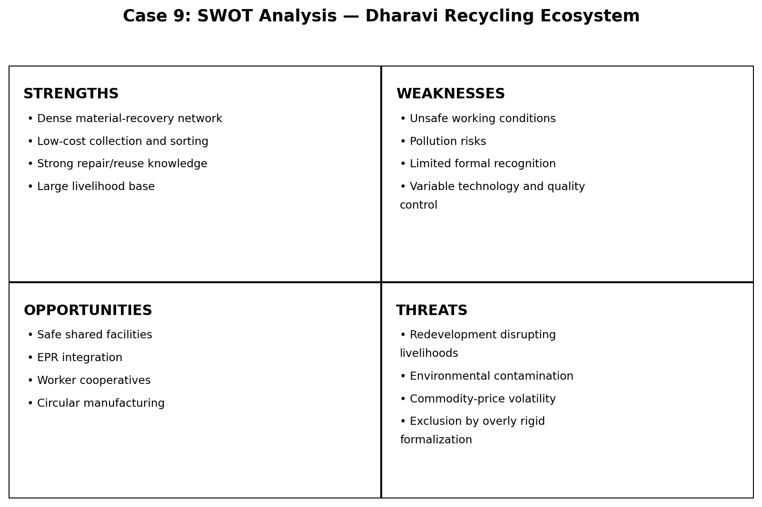

Comparison with India
- Compared with SWaCH, Dharavi is less formally organized but has a very dense market-driven material network.
- Compared with CKCL, Dharavi lacks the same formal state-supported downstream coordination.
- India should not simply eliminate such informal networks; a better approach is to reduce unsafe processing while preserving useful collection and material-recovery functions.

Recommendations
- Create shared safe-processing facilities with ventilation and pollution controls.
- Offer worker registration, protective equipment and occupational-health support.
- Connect informal collectors to authorized recyclers and EPR-funded collection.
- Provide affordable finance for safer machinery and pollution-control equipment.
- Use material-flow studies to identify where formal infrastructure can complement rather than replace existing networks.

Conclusion
Dharavi shows that informal economies can perform sophisticated circular-economy functions at scale. The policy challenge is to formalize safety, environmental controls and worker protections without destroying the collection and market networks that make material recovery possible.
References / Sources
- Compound 13 Lab / Springer — Learning Through Waste Ecologies — https://link.springer.com/chapter/10.1007/978-3-031-82338-1_3
- ARCC Journal — The Circular Economy of Dharavi — https://www.arcc-journal.org/index.php/arccjournal/article/view/1099
- British Academy — Waste, Water and Well-Being in Dharavi — https://www.thebritishacademy.ac.uk/projects/urban-well-being-waste-water-interface-dharavi-mumbai/

One-Page Exam Revision Sheet — Case 9
Dharavi Recycling Ecosystem
Exam Point | Remember
Core idea | Informal circular economy based on dense micro-enterprises.
13 Compounds | Research reports ~500–800 tonnes/day of plastic handling.
Annual estimate | ~187,000 tonnes/year in the cited study.
Main benefit | High recovery + livelihoods + low-cost material supply.
Main risk | Pollution and worker-health/safety problems.
Best policy | Safe formalization/integration, not simple displacement.
5-line answer skeleton: Describe the informal chain → explain material flows → quote 13 Compounds data with caveat → discuss economic/environmental trade-off → recommend safe formalization.
Key terms: Dharavi, informal sector, 13 Compounds, circular economy, kabadiwala, material recovery

Case 10: Dell's Circular Economy Strategy

Executive Summary
Dell Technologies applies circular-economy principles across product design, materials, repair, refurbishment, take-back and recycling. Its 2030 goals include reusing/recycling an equivalent amount for every metric ton of product purchased, making 100% of packaging from recycled or renewable material or reused packaging, and making more than half of product content from recycled, renewable or reduced-carbon-emissions materials. Dell also reports concrete progress in recycled/renewable materials and packaging.

Background
- The linear electronics model extracts materials, manufactures products, uses them and creates e-waste at end of life.
- Dell's circular strategy attempts to intervene throughout the product lifecycle rather than only at disposal.
- Product design includes durability, repairability, modularity and easier disassembly.
- Take-back and refurbishment create a route for reuse before material recycling.

Strategy / Initiative
- Design for durability, repair, upgrade and disassembly.
- Use recycled, renewable and lower-emissions materials.
- Take-back, trade-in and recovery services.
- Refurbish/redeploy products that still have useful life.
- Recycle components and materials that cannot be reused.
- Set measurable 2030 circularity goals across the value chain.

Impact & Results
Indicator | Data / finding
2030 take-back goal | For every metric ton of product bought, reuse or recycle one metric ton
2030 packaging goal | 100% recycled/renewable/reused packaging
2030 product-content goal | >50% recycled, renewable or reduced-carbon-emissions material
FY24 packaging reported by Dell | 96.4% reused, renewable or recycled
Recent materials figure reported by Dell | >95 million pounds of recycled and renewable materials used in products in the cited year
Dell recovery history | More than 2.6 billion pounds of used electronics diverted from landfills since 2007, per Dell reporting
Interpretation: The figures are indicators of system scale or reported performance. They should be quoted with their source year and definition; a collection/processing percentage is not automatically the same as a pure material-recycling rate.

SWOT Analysis
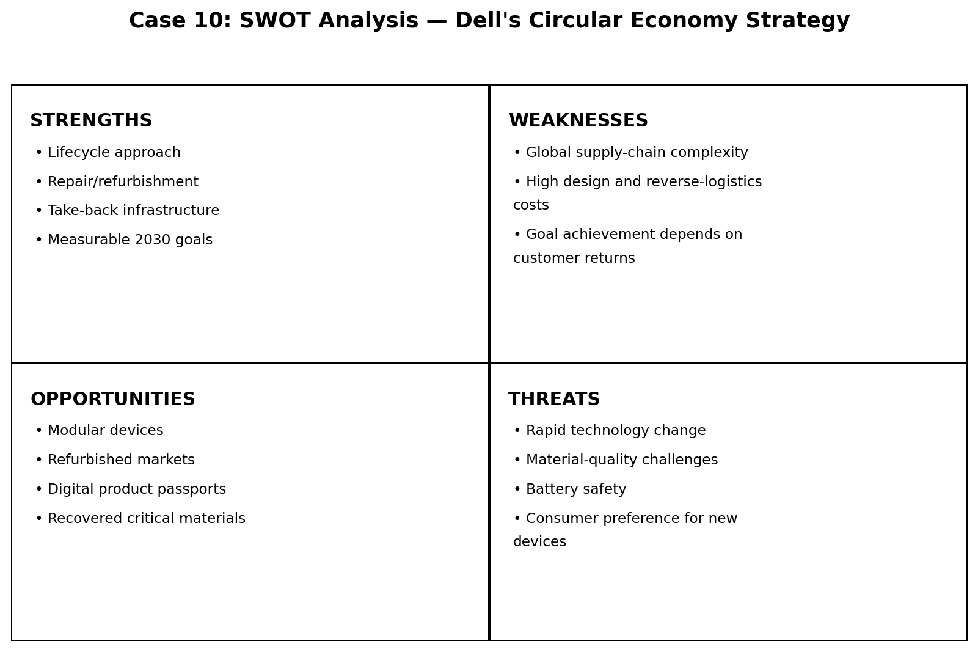

Comparison with India
- India's EPR system focuses on producer responsibility and verified recycling, while Dell adds design-for-circularity and product-life extension.
- India can use Dell's approach to complement EPR: repairability, modularity, refurbishment and take-back can reduce the amount of material that reaches recycling in the first place.
- Indian electronics companies can combine product-level circular design with national EPR certificates and authorized recycling.

Recommendations
- Encourage design-for-repair and availability of spare parts.
- Promote refurbishment markets and warranty-backed second-life devices.
- Link corporate take-back programs to India's EPR portal where applicable.
- Measure product life extension separately from material recycling.
- Use digital product passports or serialized tracking for enterprise IT assets.

Conclusion
Dell's strategy shows that circular economy begins before a product becomes waste. Designing for repair and reuse can preserve more product value than waiting for end-of-life recycling, while take-back and recycling close the remaining material loop.
References / Sources
- Dell India — Accelerating the Circular Economy — https://www.dell.com/en-in/dt/corporate/social-impact/advancing-sustainability/accelerating-the-circular-economy.htm
- Dell — Circular Economy in Action, 2024/2025 — https://www.dell.com/en-us/blog/circular-economy-in-action-leading-the-fight-against-e-waste/
- Dell — From Vision to Reality: Circular Design & AI PCs — https://www.dell.com/en-us/blog/from-vision-to-reality-circular-design-ai-pcs/

One-Page Exam Revision Sheet — Case 10
Dell's Circular Economy Strategy
Exam Point | Remember
Core idea | Circularity across design → use → repair → reuse → recycle.
2030 goal 1 | 1:1 reuse/recycle by product mass.
2030 goal 2 | 100% circular packaging materials.
2030 goal 3 | >50% circular/renewable/reduced-carbon product content.
FY24 packaging | 96.4% reported reused, renewable or recycled.
India lesson | EPR should be complemented by repair, refurbishment and design-for-circularity.
5-line answer skeleton: Define Dell circular economy → explain design/take-back/refurbishment → quote 2030 goals and progress → compare with Indian EPR → recommend design-for-repair and second-life markets.
Key terms: circular economy, Dell, repairability, refurbishment, take-back, sustainable materials

Master Exam Revision Sheet — Cross-Case Comparison
Indicator | Data / finding

Master Exam Revision Sheet — Cross-Case Comparison
Case | Core mechanism | Key data / exam figure
Japan | 3R + source segregation + municipal treatment | 99.2% waste reduction; 19.3% recycling rate (FY2024)
Switzerland | Take-back + advance recycling contribution | SENS 104,751 t in 2025; 630 collection points
E-Waste Rules 2022 | Portal-based EPR + certificates | 60% → 70% → 80% phased producer obligation
EPR debate | Compliance + verification | FY2023-24: 2,54,607 MT certificates transferred vs 2,76,771 MT obligation
Bengaluru | IT-driven e-waste + formal/informal ecosystem | ~12,000 t/year estimate; 2026 report cites ~15% scientific processing
Mumbai | BMC + MPCB + informal collectors + recyclers | Maharashtra FY2021-22: 14,344.71 MT material recovered
Kerala CKCL | Local-government collection + forward linkage | 2,265 MT e-waste collected; 667 rural + 47 urban LSGIs
Pune SWaCH | Worker-owned cooperative + door-to-door recovery | 1M households; 4,000+ waste pickers; 82,891 t recycled annually
Dharavi | Informal circular economy + dense material markets | 13 Compounds: ~500–800 t/day plastic estimate
Dell | Design + repair + refurbishment + take-back + recycling | 2030: 1:1 reuse/recycle; 100% circular packaging; >50% circular material

Fast Comparison Framework
- Policy-led model: India E-Waste Rules 2022.
- Financing-led take-back: Switzerland.
- Behavior + municipal system: Japan.
- Inclusive worker model: Pune SWaCH.
- State coordination: Kerala CKCL.
- Market-driven informal circularity: Dharavi.
- Corporate product-lifecycle model: Dell.
- Large metropolitan hybrid ecosystems: Mumbai and Bengaluru.
- Best exam approach: compare mechanism, stakeholders, measurable impact, limitations and transferability to India.

References
- Japan MOE — Municipal solid waste generation and disposal in FY2024 — https://www.env.go.jp/en/press/press_01569.html
- Japan MOE — Sound Material-Cycle Society — https://www.env.go.jp/en/recycle/smcs/
- Japan MOE — The 3R Initiative — https://www.env.go.jp/recycle/3r/en/outline.html
- Swiss Federal Office for the Environment — Electrical and electronic equipment — https://www.bafu.admin.ch/en/electrical-and-electronic-equipment-en
- SENS eRecycling — Facts & Figures 2024/2025 — https://www.erecycling.ch/en/ueber-sens/medien-und-publikationen/geschaeftsbericht/2025/facts-figures.html
- Swico Recycling — Facts and figures — https://www.swico.ch/en/recycling/basics/facts-and-figures/
- Swiss Federal Audit Office — Supervision of recycling — https://www.efk.admin.ch/en/audit/supervision-of-recycling-of-waste-subject-to-taxes-and-advance-contributions/
- MoEFCC — Rules & Regulations: E-Waste Management Rules 2022 — https://moef.gov.in/rules-regulations-3
- CPCB — FAQ under E-Waste (Management) Rules, 2022 — https://cpcb.nic.in/uploads/Projects/E-Waste/FAQ_ewaste_23012024.pdf
- CPCB — E-Waste Management System / EPR Portal — https://eprewaste.cpcb.gov.in/
- PIB — E-waste processing management, 24 July 2025 — https://www.pib.gov.in/PressReleasePage.aspx?PRID=2147876&lang=2&reg=48
- MoEFCC Annual Report 2024-25 — E-waste management — https://moef.gov.in/uploads/pdf-uploads/English_Annual_Report_2024-25.pdf
- PIB — EPR implementation status, 5 March 2026 — https://www.pib.gov.in/PressReleasePage.aspx?PRID=2244104&lang=1&reg=1
- Pradhan & Sudhir — E-Waste Management: A Case Study of Bangalore — https://www.researchgate.net/publication/230766242_E-Waste_Management_A_Case_Study_of_Bangalore_India
- Bangalore Mirror — E-waste is piling up, 22 Feb 2026 — https://bangaloremirror.indiatimes.com/bangalore/cover-story/e-waste-is-piling-up/articleshow/128654505.cms
- MPCB — Electronic Waste / E-Waste Management — https://www.mpcb.gov.in/en/node/4297
- MPCB — E-Waste Annual Report 2021-22 — https://www.mpcb.gov.in/sites/default/files/E-Waste%20Annual%20Report_2021_22-Final.pdf
- BMC — Mumbai Climate Action Plan 2022 — https://portal.mcgm.gov.in/irj/go/km/docs/documents/Environment/Climate/Mumbai%20Climate%20Action%20Plan%202022.pdf
- Kerala LSGD — Clean Kerala Company: Waste Management — https://lsgd.kerala.gov.in/en/waste-management/supporting-institutions/ckcl/
- Kerala LSGD — Clean Kerala Company overview — https://lsgd.kerala.gov.in/en/about-the-department/aligned-institutions/ckcl/
- SWaCH — Home / Impact 2025 — https://swachcoop.com/
- SWaCH — Impact — https://swachcoop.com/about/impact/
- SWaCH — UNESCAP Pune case study — https://swachcoop.com/pdf/UNESCAP-Closing-The-Loop-Pune-India-Case-Study.pdf
- Compound 13 Lab / Springer — Learning Through Waste Ecologies — https://link.springer.com/chapter/10.1007/978-3-031-82338-1_3
- ARCC Journal — The Circular Economy of Dharavi — https://www.arcc-journal.org/index.php/arccjournal/article/view/1099
- British Academy — Waste, Water and Well-Being in Dharavi — https://www.thebritishacademy.ac.uk/projects/urban-well-being-waste-water-interface-dharavi-mumbai/
- Dell India — Accelerating the Circular Economy — https://www.dell.com/en-in/dt/corporate/social-impact/advancing-sustainability/accelerating-the-circular-economy.htm
- Dell — Circular Economy in Action, 2024/2025 — https://www.dell.com/en-us/blog/circular-economy-in-action-leading-the-fight-against-e-waste/
- Dell — From Vision to Reality: Circular Design & AI PCs — https://www.dell.com/en-us/blog/from-vision-to-reality-circular-design-ai-pcs/
Source-file note: The uploaded TE Case studies document lists the ten case-study titles only. The explanatory material in this report is expanded from the cited external sources; estimates are labeled where definitions or years differ.

