CS203 Project Report
Homework #Bonus
Student’s Full name: Tanmay Joshi
BlazerId: tjoshi

Introduction
This project analyzes employee data from a CSV file using Object-Oriented Programming principles in Java. The goal is to practice OOP design, file handling, data structures (ArrayList), and efficient algorithmic analysis. The program performs various data processing tasks like finding lowest-paid employees by department, calculating average salary, and identifying leads and longest-tenured employees.

Code Explanation
Two main classes were created:
1. Employee: Represents each employee and includes fields like name, department, salary, years of service, and lead status.
2. Company: Manages a list of Employee objects and implements the five required data analysis methods using Java Streams.
Key OOP principles applied:
- Encapsulation of employee data
- Modular methods for each task
- Use of Java collections (ArrayList) and streams for efficiency

Results / Outputs
Below are sample printed outputs from the running Java program:

- Identify the lowest-paid employee in each department. Display their names and salaries.

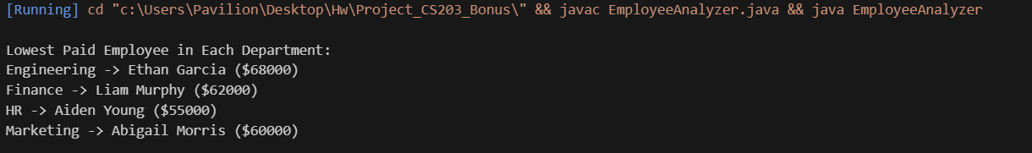

- List employees who have been with the company for less than 4 years. Display their full information
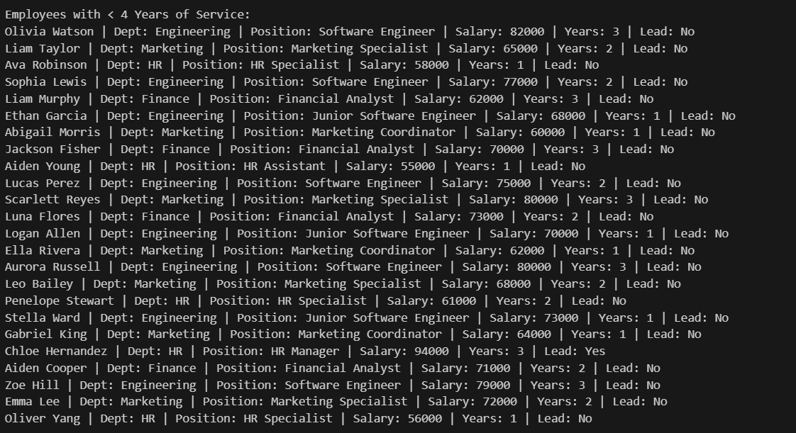

3. Calculate the average salary of employees in the Marketing department.

4. Determine the employee with the longest tenure in the company. Display their full information.

5. Display the list of departments along with the number of leads in each department.

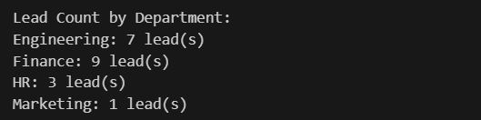

References
No external code or AI tools were used. The project was implemented solely using course concepts and Java official documentation.

