**CAR RENTAL SYSTEM DATABASE**

**Introduction:**

This document outlines the database design for a Car Rental Management System that aims to enhance rental car inventory management, customer record retention, operational efficiency, online bookings and payments, and scalability. The system allows better handling of bookings and pricing based on car availability and demand, stores essential customer data and booking history for improved service and faster check-ins/check-outs, automates processes like vehicle returns and maintenance scheduling to maximize fleet utilization, supports online bookings and payments for a seamless customer experience, and ensures scalability for managing vehicle and customer information as the agency grows.

**Business problems addressed:**

Rental car inventory management: The database will enable inventory management of the cars with agencies. This will allow us to better manage bookings and pricing based on car availability and demand.

Customer record retention: The database will enable us to retain the required customer data and their booking history to provide better service, quick check-ins and check-outs, which will further reduce turnaround time, enhancing customer satisfaction.

Operational efficiency: The database will automate certain redundant operational processes, vehicle returns, and cleaning/maintenance schedules, enabling us to maximize fleet utilization.

Booking and Payments: This database will enable online bookings and online payments.

Scalability: This database will enable the scalability and management of vehicle information and customer information for rental agencies.

**Entities Description:**

1. **Person**

Attributes: PersonID, Name, Address, ContactNumber

Relationships:

- Is a Customer

- Is a Employee

1. **Customer**

Attributes: CustomerID, DrivingLicense, PaymentInfo

Relationships:

Makes: Bookings

Provides: Feedbacks

1. **Employee**

Attributes: EmployeeID, Designation

Relationships:

Handles: Bookings

Manages: VehicleIsuue

Performs: Maintenance

Works at: Branch

1. **Vehicle**

Attributes: VehicleID, BrandName, ModelName, YearOfManufacturing, LicensePlate, FuelType, VehicleType

Relationships:

Is Booked in: Bookings

Undergoes: Maintenance

Has: Insurance

Is a: Sedan or SUV

1. **Sedan**

Attributes: TransmissionType

Relationships:

Is a: Vehicle

1. **SUV**

Attributes: FourWheelDrive, GroundClearance

Relationships:

Is a: Vehicle

1. **Booking**

Attributes: BookingID, StartDateTime, EndDateTime, TotalCost, PaymentStatus

Relationships:

Made by: Customer

Involves: Vehicle

Handled by: Employee

Has: Billing

Receives: Feedback

1. **Billing**

Attributes: BillingID, PaymentDate, Amount, PaymentMethod

Relationships:

Associated with: Booking

1. **Branch**

Attributes: BranchID, BranchName, Address, City, State

Relationships:

Employs: Employees

1. **Maintenance**

Attributes: MaintenanceID, MaintenanceDate, Cost, Description, MaintenanceType

Relationships:

Performed on: Vehicle

Performed by: Employee

Is a: Service, Cleaning, or Repair

1. **Service**

Attributes: ServiceType, Frequency, NextServiceDue

Relationships:

Is a: Maintenance

1. **Cleaning**

Attributes: CleaningType, CleaningStaffAssigned

Relationships:

Is a: Maintenance

1. **Repair**

Attributes: RepairType, IssueDescription

Relationships:

Is a: Maintenance

1. **Insurance**

Attributes: InsuranceID, Provider, PolicyNumber, StartDate, EndDate

Relationships:

Insures: Vehicle

1. **Feedback**

Attributes: FeedbackID, Ratings, Comments, FeedbackDate

Relationships:

Provided by: Customer

Associated with: Booking

1. **Vehicle Issue**

Attributes: IssueID, MaintenanceDate, Cost, Description

Relationships:

Related to: Vehicle

Handled by: Employee

Leads to: Maintenance

**Entity Relationships:**

* **Person**

Customer: Is-A (A customer is a person.)

Employee: Is-A (An employee is a person.)

* **Customer**

Bookings: One-to-Many (A customer can make multiple bookings.)

Feedbacks: One-to-Many (A customer can provide multiple feedback entries.)

* **Employee**

Bookings: One-to-Many (An employee can handle multiple bookings.)

Maintenance Records: One-to-Many (An employee can perform multiple maintenance tasks.)

Branch: Many-to-One (An employee works at one branch.)

* **Vehicle**

Bookings: One-to-Many (A vehicle can be booked multiple times.)

Maintenance Records: One-to-Many (A vehicle can have multiple maintenance records.)

Insurance: One-to-One (Each vehicle has one insurance policy.)

Vehicle Type: Is-A (A vehicle can be a Sedan or an SUV.)

* **Sedan**

Vehicle: Is-A (A sedan is a type of vehicle.)

Transmission Type: Attribute (Specifies the transmission type of the sedan.)

* **SUV**

Vehicle: Is-A (An SUV is a type of vehicle.)

Four Wheel Drive: Attribute (Indicates if the SUV has four-wheel drive.)

Ground Clearance: Attribute (Specifies the ground clearance of the SUV.)

* **Booking**

Customer: Many-to-One (Each booking is made by one customer.)

Vehicle: Many-to-One (Each booking involves one vehicle.)

Employee: Many-to-One (Each booking is handled by one employee.)

Billing: One-to-One (Each booking has one billing record.)

Feedbacks: One-to-Many (A booking can have multiple feedback entries.)

* **Billing**

Booking: One-to-One (Each billing corresponds to one booking.)

* **Branch**

Employees: One-to-Many (A branch employs multiple employees.)

* **Maintenance**

Vehicle: Many-to-One (Each maintenance record is for one vehicle.)

Employee: Many-to-One (Each maintenance task is performed by one employee.)

Maintenance Type: Is-A (Maintenance can be a Service, Cleaning, or Repair.)

* **Service**

Maintenance: Is-A (Service is a type of maintenance.)

Frequency: Attribute (Specifies how often the service occurs.)

Next Service Due: Attribute (Indicates when the next service is due.)

* **Cleaning**

Maintenance: Is-A (Cleaning is a type of maintenance.)

Cleaning Type: Attribute (Specifies the type of cleaning.)

Cleaning Staff Assigned: Attribute (Indicates the staff assigned to cleaning.)

* **Repair**

Maintenance: Is-A (Repair is a type of maintenance.)

Repair Type: Attribute (Specifies the type of repair.)

Issue Description: Attribute (Describes the issue being repaired.)

* **Insurance**

Vehicle: One-to-One (An insurance policy is associated with one vehicle.)

* **Feedback**

Customer: Many-to-One (Each feedback is provided by one customer.)

Booking: Many-to-One (Each feedback is associated with one booking.)

* **Vehicle Issue**

Vehicle: Many-to-One (Each vehicle issue is related to one vehicle.)

Employee: Many-to-One (An employee handles the vehicle issue.)

Maintenance: One-to-One (Each vehicle issue leads to a maintenance record.)

**ER Diagram:**

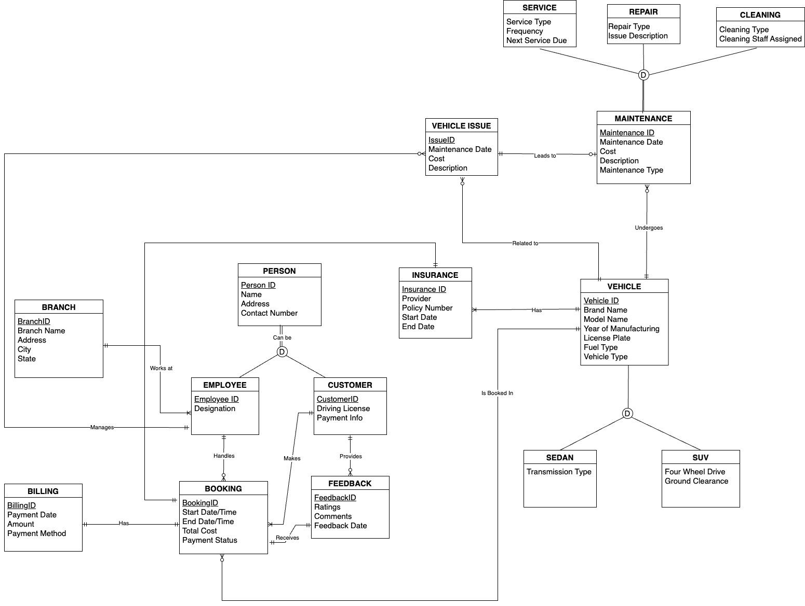

**Key design:**

* The database includes an Employee entity to track staff members who process bookings, handle vehicle issues, and perform maintenance tasks.
* The Booking entity includes an EmployeeID foreign key to link each booking to the employee responsible for processing it.
* Each Employee is linked to a Branch via the BranchID foreign key, supporting operations across multiple locations.
* The Branch entity allows the database to manage data across various rental locations, facilitating business scalability.
* Linking employees to bookings, vehicle issues, and maintenance tasks ensures accountability and enables performance monitoring.
* The database structure accommodates additional entities and attributes, allowing for expansion as business needs evolve.
* The Booking and Billing entities facilitate online transactions, improving customer convenience and streamlining processes.
* Storing customer data and booking history allows for personalized services and faster transaction processing, improving customer satisfaction.
* The Feedback entity enables the company to quickly address any negative feedback, enhancing customer satisfaction and preventing future issues.
* Insurance is linked to the Vehicle, associating each vehicle with a specific insurance policy that applies to all rentals of that vehicle.
* The InsuranceID foreign key is in the Vehicle entity, linking each vehicle to its insurance policy, rather than in the Booking entity.