1. Write a query for the HR department to produce the addresses of all the departments. Use

the LOCATIONS and COUNTRIES tables. Show the location ID, street address, city, state or province, and country in the output.

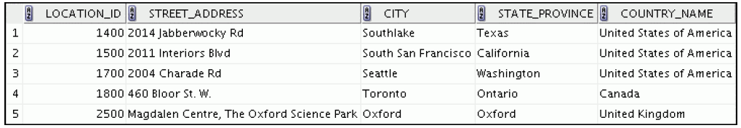

SELECT location_id, street_address,city,state_province,country_name

FROM locations

INNER JOIN countries ON locations.country_id=countries.country_id;

2. The HR department needs a report of all employees. Write a query to display the last name,

department number, and department name for all the employees.

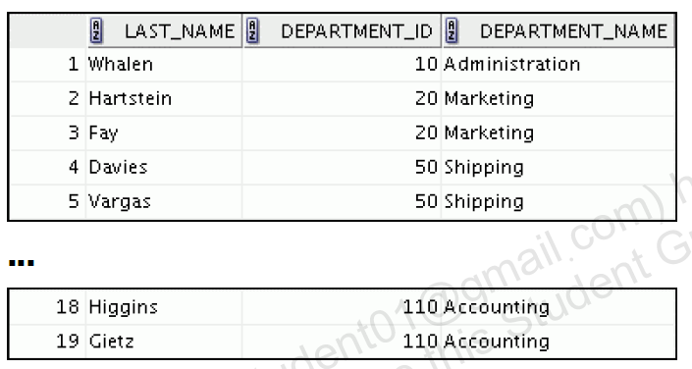

select employees.last_name,employees.job_id,departments.department_name

from employees

inner join departments on employees.department_id=departments.department_id join locations on

departments.location_id=locations.location_id;

3. Create a report to display employees’ last names and employee number along with their

managers’ last names and manager number. Label the columns Employee, Emp#,

Manager, and Mgr#, respectively. Save your SQL statement as lab_06_04.sql. Run

the query.

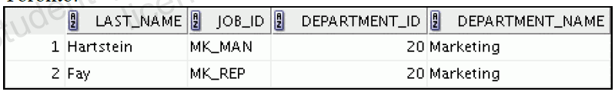

select a.last_name as "Employee",a.employee_id as"emp#" ,b.last_name as"Manager",b.employee_id as "MGR#"

from employees a , employees b

where a.manager_id=b.employee_id;

4. Create a report for the HR department that displays employee last names, department

numbers, and all the employees who work in the same department as a given employee. Give

each column an appropriate label.

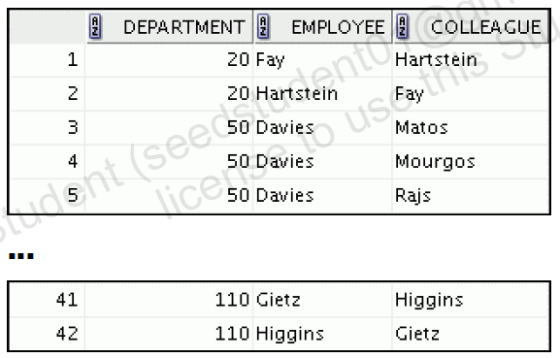

select *

from employees

join on departments

on employees.department_id=departments.department_id;

5. The query should display the last name and hire date of any employee who work in the same

department in which Zlotkey (last name of an employee) work (excluding that employee).

Select last_name,hire_data from employees

Where department_id=(select department_id from employees where last_name =”Zlotkey”)

And last_name!=”Zlotkey”;

6. Create a report that displays the employee number, last name, and salary of all employees

who earn more than the average salary. Sort the results in order of ascending salary.

Select employees_id,last_name,salary

from employees

where salary>(select avg(salary) from employees )

order by salary;

7. Write a query that displays the employee number and last name of all employees who work

in a department with any employee whose last name contains a “u.”

select employees_id , last_name

from employees

where where department_id in(select department_id from employees

where last_name like “%u%”)

8. The HR department needs a report that displays the last name, department number, and job ID

of all employees whose department location ID is 1700.

Select last_name,e.department_id,job_id from employees

e.join departments d

on e.departments_id = d.departments_id

where d.location_id=1700;

9. Create a report for HR that displays the department number, last name, and job ID for every

employee in the Executive department.

Select e.department_id , last_name,job_id

From employees e

Join department d

On e.departments_id=d.department_id

Where department_name=”Executive”;

10. display the employee number, last name, and salary of all employees who earn more than the

average salary and who work in a department with any employee whose last name contains a

“u.”