WEEK 1 Advanced SQL Hands On

Exercise 1: Ranking and Window Functions:

**Code:**

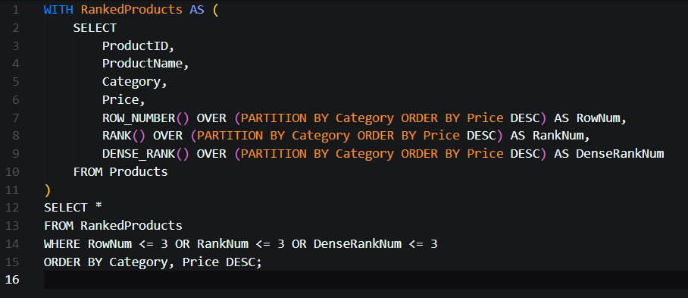

Exercise 1: Create a Stored Procedure:

**Code:**

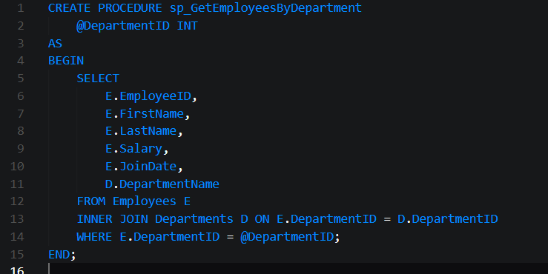

Exercise 5: Return Data from a Stored Procedure:

**Code:**

