**Computational Intelligence Lab**

**Assignment - 4**

Name – Tanmay Pramod Varade

IT - B5 36

----------------------------------------------------------------------------------------------------

**Write a program in MATLAB to plot various membership functions.**

1. Triangular Membership Function
2. Trapezoidal Membership Function
3. Bell-Shaped Membership Function
4. **Triangular Membership Function**

x = 0:0.1:10;

y = trim(x,[3 6 8]);

plot(x,y)

xlabel('trim, P = [3 6 8]')

ylim([-0.05 1.05]

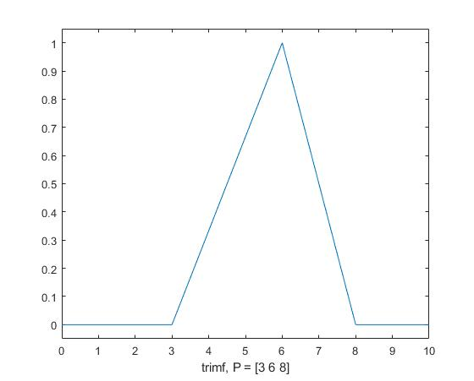

1. **Trapezoidal Membership Function**

x = 0:0.1:10;

y = trapmf(x,[1 5 7 8]);

plot(x,y)

xlabel('trapmf, P = [1 5 7 8]')

ylim([-0.05 1.05])

**Output-**

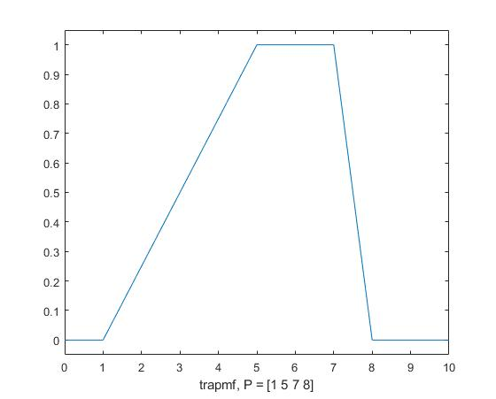

1. **Bell-Shaped Membership Function**

x = 0:0.1:10;

y = gbellmf(x,[2 4 6]);

plot(x,y)

xlabel('gbellmf, P=[2 4 6]')

**Output**

**.**