Create Operations
Create or insert operations add new documents to a collection. If the collection does not currently exist, insert operations will create the collection.
MongoDB provides the following methods to insert documents into a collection:
- db.collection.insertOne() New in version 3.2
- db.collection.insertMany() New in version 3.2
In MongoDB, insert operations target a single collection. All write operations in MongoDB are atomic on the level of a single document.

Read operations retrieves documents from a collection; i.e. queries a collection for documents. MongoDB provides the following methods to read documents from a collection:
- db.collection.find()
You can specify query filters or criteria that identify the documents to return.
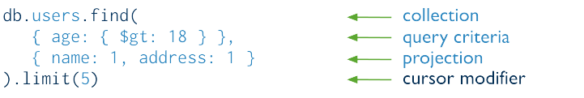

- Query Documents
- Query on Embedded/Nested Documents
- Query an Array
- Query an Array of Embedded Documents

Update Operations
Update operations modify existing documents in a collection. MongoDB provides the following methods to update documents of a collection:
- db.collection.updateOne() New in version 3.2
- db.collection.updateMany() New in version 3.2
- db.collection.replaceOne() New in version 3.2
In MongoDB, update operations target a single collection. All write operations in MongoDB are atomic on the level of a single document.
You can specify criteria, or filters, that identify the documents to update. These filters use the same syntax as read operations.
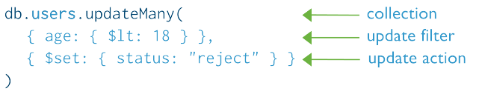

Delete Operations
Delete operations remove documents from a collection. MongoDB provides the following methods to delete documents of a collection:
- db.collection.deleteOne()
- db.collection.deleteMany()
In MongoDB, delete operations target a single collection. All write operations in MongoDB are atomic on the level of a single document.
You can specify criteria, or filters, that identify the documents to remove. These filters use the same syntax as read operations.

