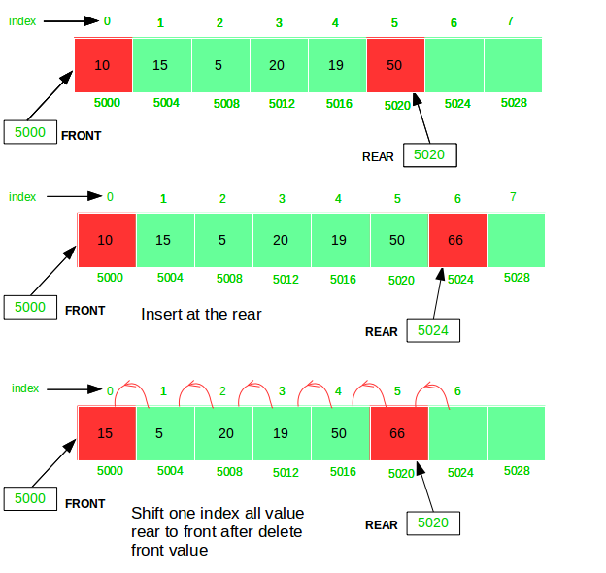

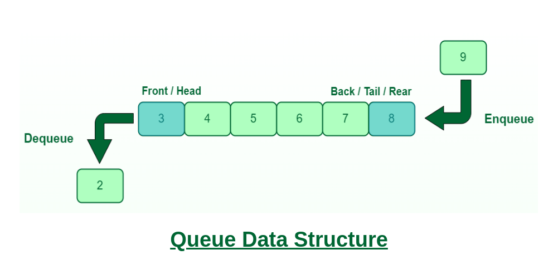

# Single Queue using List

class Queue:
def __init__(self):
self.queue=[]

def enqueue(self,item):
self.queue.append(item)

def dequeue(self):
if self.isEmpty():
print("Queue Under Flow!!")
self.queue.pop()

def isEmpty(self):
return len(self.queue) == 0

def size(self):
return len(self.queue)

def display_item(self):
if self.isEmpty():
print("Queue is Empty!!")
print(self.queue)

q=Queue()
q.enqueue(10)
q.enqueue(20)
q.enqueue(30)
q.enqueue(40)
q.enqueue(50)

q.dequeue()
q.dequeue()

q.display_item()
size=q.size()
print("Size of Queue: ",size)

# Single Queue using Linked List
class Node:
def __init__(self,data):
self.data=data
self.next=None

class Queue:
def __init__(self):
self.front=None
self.rear=None

def enqueue(self,data):
new_node=Node(data)
if self.isEmpty():
self.front=new_node
self.rear=new_node
else:
self.rear.next=new_node
self.rear=new_node

def dequeue(self):
if self.isEmpty():
return None
data = self.front.data
if self.front == self.rear:
self.front = None
self.rear = None
else:
self.front = self.front.next
return data

def displayItem(self):
if self.isEmpty():
print("Queue is Empty!!")
return
cur=self.front
while cur != None:
print(cur.data," ",end="")
cur=cur.next

def isEmpty(self):
return self.front is None

def peek(self):
if self.isEmpty():
return None
return self.front.data

q=Queue()
print(q.isEmpty())

q.enqueue(23)
q.enqueue(83)
q.displayItem()

q.dequeue()
q.displayItem()
print("\n","q.peek(): ",q.peek())

# Circuler Queue using List
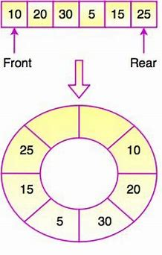

CIrculer Queue Using Linked List
class Node:
def __init__(self,data):
self.data=data
self.next=None

class Queue:
def __init__(self):
self.front=None
self.rear=None
def enqueue(self,data):
new_node=Node(data)
if self.isEmpty():
self.front=new_node
self.rear=new_node

else:
self.rear.next=new_node
self.rear=new_node

def dequeue(self):
if self.isEmpty():
return None
data = self.front.data

if self.front == self.rear: # If Only one node is there in the Queue.In this case, both self.front and self.rear pointing to single node
del(self.front)
self.front = None
self.rear = None
else:
self.front = self.front.next
return data

def displayItem(self):
if self.isEmpty():
print("Queue is Empty!!")
return
cur=self.front
while cur != None:
print(cur.data," ",end="")
cur=cur.next

def isEmpty(self):
return self.front is None

def peek(self):
if self.isEmpty():
return None
return self.front.data

q=Queue()
print(q.isEmpty())

q.enqueue(23)
q.enqueue(83)
q.displayItem()

q.dequeue()
q.displayItem()
print("\n","q.peek(): ",q.peek())

CIrculer Queue Using Linked List with fixed size
#Circuler Queue Using Linked List with fixed Capacity
class Node:
def __init__(self, data):
self.data = data
self.next = None

class CircularQueue:
def __init__(self, capacity):
self.capacity = capacity
self.front = None
self.rear = None
self.size = 0

def enqueue(self, data):
# Check if the queue is full
if self.size == self.capacity:
raise Exception("Queue is full")

# Create a new node
node = Node(data)

# If the queue is empty, set the front and rear to the new node
if self.size == 0:
self.front = node
self.rear = node
else:
# Otherwise, set the rear's next node to the new node
self.rear.next = node
# And set the rear to the new node
self.rear = node

# Increment the size of the queue
self.size += 1

def dequeue(self):
# Check if the queue is empty
if self.size == 0:
raise Exception("Queue is empty")

# Get the data from the front node
data = self.front.data

# If the queue only has one element, set the front and rear to None
if self.size == 1:
self.front = None
self.rear = None
else:
# Otherwise, set the front to the front node's next node
self.front = self.front.next

# Decrement the size of the queue
self.size -= 1

return data

def is_empty(self):
return self.size == 0

def is_full(self):
return self.size == self.capacity

def display(self):
if self.is_empty():
print("Queue is Empty!!")
return
cur=self.front
while cur != None:
print(cur.data," ",end="")
cur=cur.next

q=CircularQueue(5)
print(q.is_empty())

q.enqueue(23)
q.enqueue(83)
q.display()

Priority Circuler Queue Using Linked List
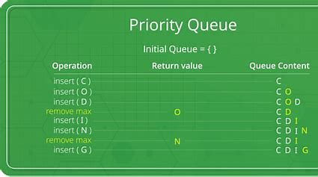

#Priority Queue
class Node:
def __init__(self, data, priority):
self.data = data
self.priority = priority
self.next = None

class PriorityQueue:
def __init__(self):
self.head = None

def enqueue(self, data, priority):
new_node = Node(data, priority)
if self.head is None:
self.head = new_node
else:
cur = self.head
while cur is not None and cur.priority < priority:
prev = cur
cur = cur.next

if cur is None:
prev.next = new_node
else:
new_node.next = cur
prev.next = new_node

def dequeue(self):
if self.head is None:
return None
else:
data = self.head.data
self.head = self.head.next
return data

def peek(self):
if self.head is None:
return None
else:
return self.head.data

def is_empty(self):
return self.head is None

def display(self):
if self.head is None:
print("Queue is empty")
else:
cur = self.head
while cur is not None:
print(cur.data, end=" ")
cur = cur.next

p=PriorityQueue()
p.enqueue(10,1)
p.enqueue(20,3)
p.enqueue(30,2)
p.enqueue(40,7)
p.enqueue(50,4)
p.display()

