Selection Sort:
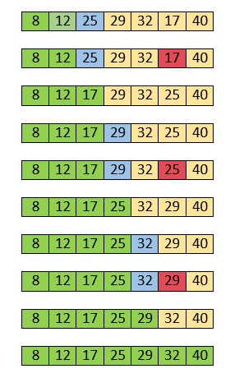
//Time Complexcity:
Time Complexity: The time complexity of Selection Sort is O(N2) as there are two nested loops:
- One loop to select an element of Array one by one = O(N)
- Another loop to compare that element with every other Array element = O(N)
- Therefore overall complexity = O(N) * O(N) = O(N*N) = O(N2)

Best Case: O(n²)
It occurs when there is no sorting required, i.e. the array is already sorted. The best-case time complexity of selection sort is O(n²). In best case swapping complexity is O(1).

- Best case: The array is already sorted. In this case, the selection sort algorithm will only need to make one swap, so the time complexity is O(n).

Average Case: O(n²)
It occurs when the array elements are in jumbled order that is not properly ascending and not properly descending. The average case time complexity of selection sort is O(n²).
In average case swapping complexity is O(n)
Worst Case: O(n²)
It occurs when the array elements are required to be sorted in reverse order. That means suppose you have to sort the array elements in ascending order, but its elements are in descending order. The worst-case time complexity of selection sort is O(n²).
In worst case swapping complexity is O(n) because at each pass we are doing swapping process.

//Space Complexcity: O(1)
It doesn't require any additional memory space.
The space complexity of insertion sort is O(1). It is because, in insertion sort, an extra variable is required for swapping.
Space complexity of insertion’s recursive approach is O(n) due to recursion stack.

//Selection sort Program:
def selection_sort(array):
for i in range(len(array)):
min_index=i
for j in range(i+1,len(array)):
if array[j]<array[min_index]:
min_index=j
array[i],array[min_index]=array[min_index],array[i]
return array

#Driven
array=[4,6,2,9,3]
s=selection_sort(array)
print(s)

OUTPUT:
[2, 3, 4, 6, 9]

