Insertion Sort:
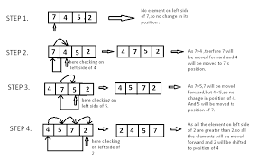
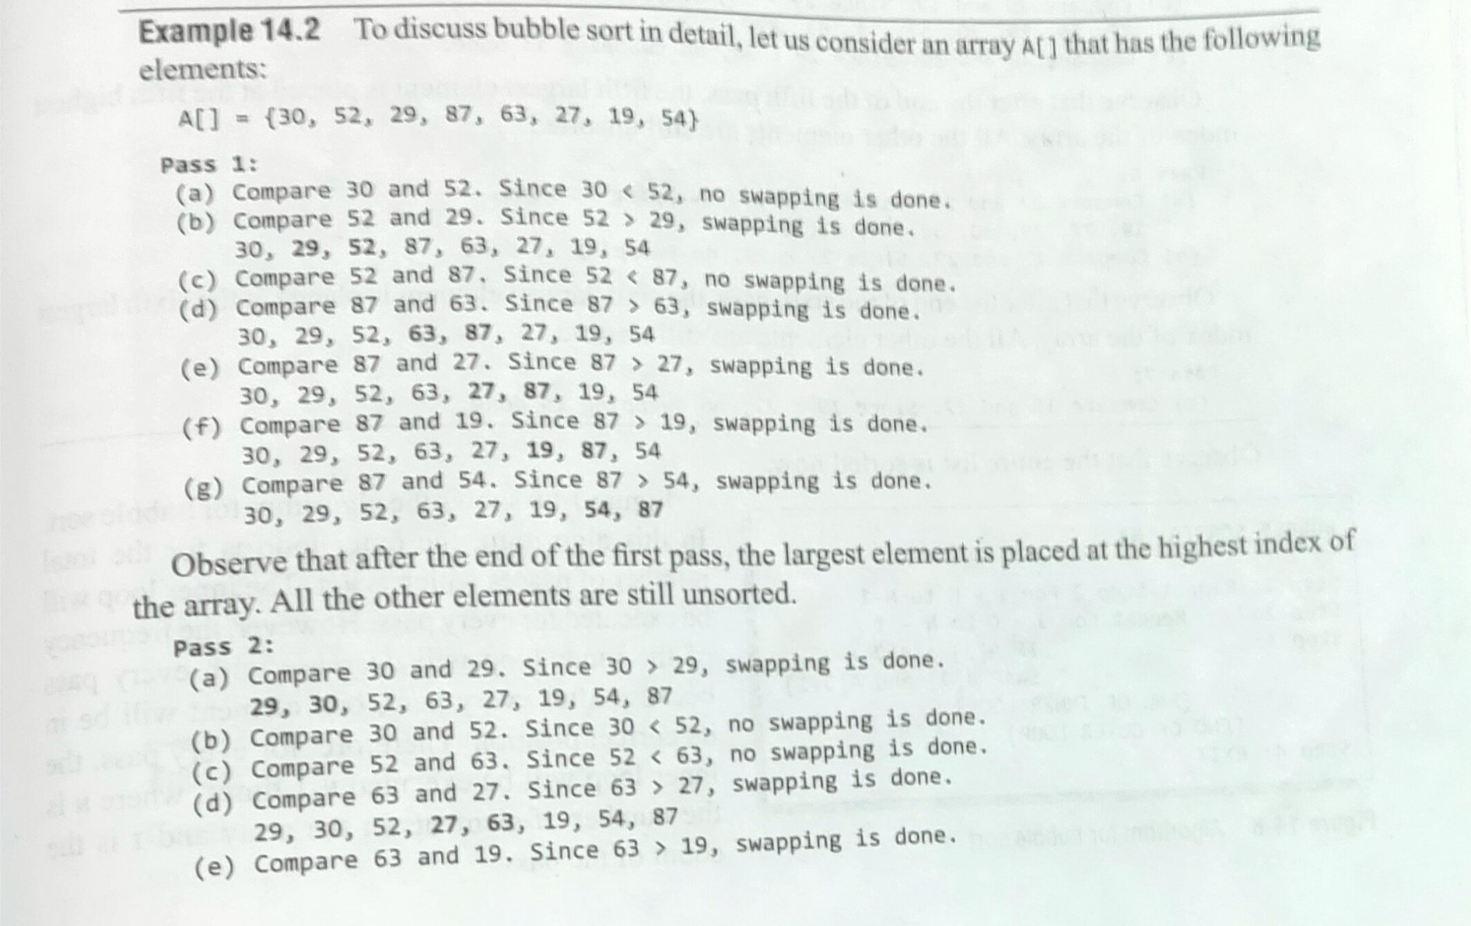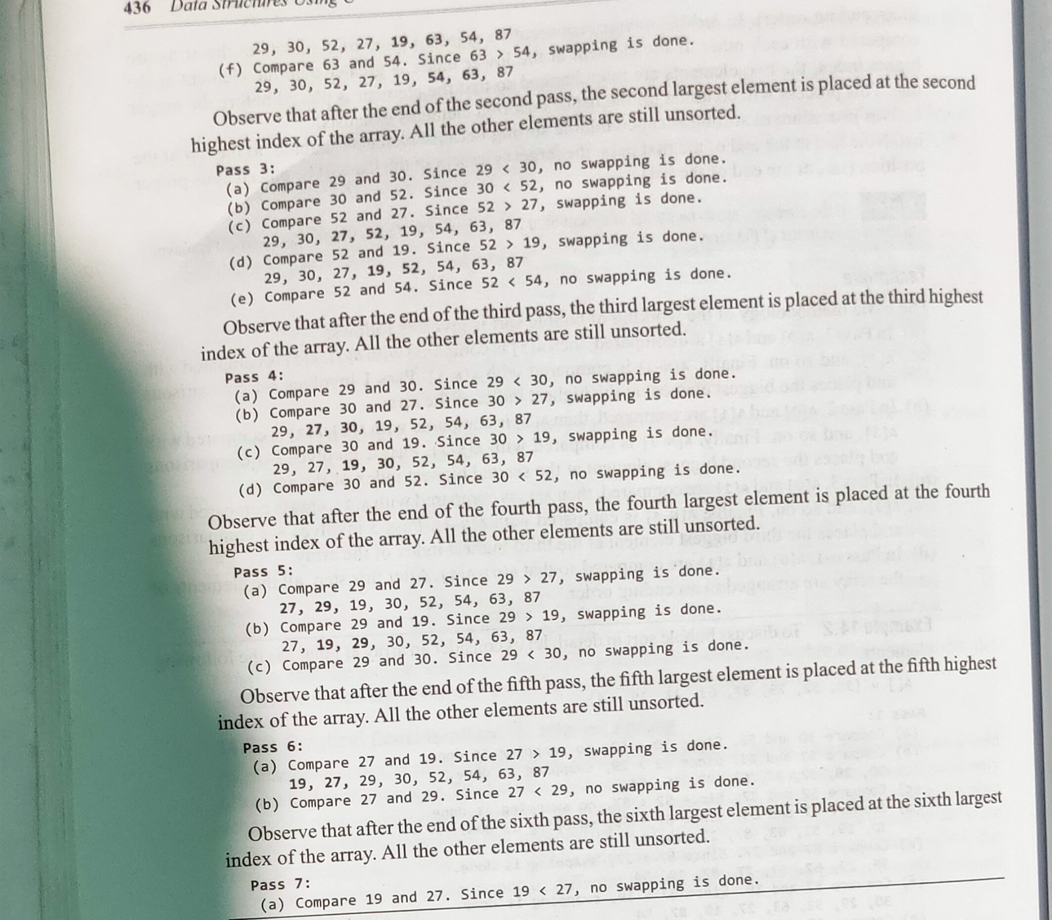
//Time Complexcity:
Best Case: O(n)
It occurs when there is no sorting required, i.e. the array is already sorted. The best-case time complexity of selection sort is O(n²).
- Best case: The array is already sorted. In this case, the bubble sort algorithm will only need to make one pass through the array, so the time complexity is O(n).
Average Case: O(n²)
It occurs when the array elements are in jumbled order that is not properly ascending and not properly descending. The average case time complexity of selection sort is O(n²).
The array is in a random order. In this case, the bubble sort algorithm will need to make on average n/2 swaps, so the time complexity is O(n^2).
Worst Case: O(n²)
It occurs when the array elements are required to be sorted in reverse order. That means suppose you have to sort the array elements in ascending order, but its elements are in descending order. The worst-case time complexity of selection sort is O(n²).
The array is in a random order. In this case, the bubble sort algorithm will need to make on average n/2 swaps, so the time complexity is O(n^2).

//Space Complexcity: O(1)
It doesn't require any additional memory space.
The space complexity of insertion sort is O(1). It is because, in insertion sort, an extra variable is required for swapping.This is because insertion sort only requires a constant amount of additional space to store a temporary variable.

//Insertion sort Program:
def insertionSort(arr):
for i in range(1, len(arr)):

key = arr[i]

# Move elements of arr[0..i-1], that are
# greater than key, to one position ahead
# of their current position
j = i-1
while j >= 0 and key < arr[j] :
arr[j + 1] = arr[j]
j -= 1
arr[j + 1] = key
return arr

# Driver code to test above
arr = [12, 11, 13, 5, 6]
s=insertionSort(arr)
print(s)

