Queck Sort:
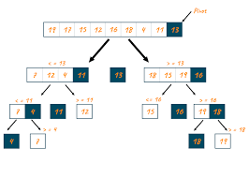

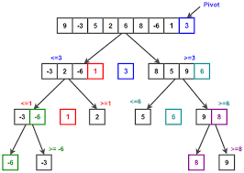
//Time Complexcity:
- Best case: The best case occurs when the pivot element is the median of the array. In this case, the quicksort algorithm can divide the array into two equal-sized subarrays in each recursive call. This results in a logarithmic number of recursive calls, and the overall time complexity is O(n log n).
- Average case: The average case occurs when the pivot element is chosen randomly. In this case, the quicksort algorithm can still divide the array into two equal-sized subarrays in each recursive call, on average. This results in a logarithmic number of recursive calls, and the overall time complexity is O(n log n).
- Worst case: The worst case occurs when the pivot element is either the smallest or the largest element in the array. In this case, the quicksort algorithm can only divide the array into two subarrays of size 1 and n-1, respectively. This results in a quadratic number of recursive calls, and the overall time complexity is O(n^2).

//Space Complexcity: O(1)
Auxiliary Space: O(1) as no extra space is used
//Quick sort Program:
def quick_sort(arr):
if len(arr) <= 1:
return arr
else:
pivot = arr[0]
less = [x for x in arr[1:] if x <= pivot]
greater = [x for x in arr[1:] if x > pivot]
return quick_sort(less) + [pivot] + quick_sort(greater)

# Example usage
array = [5, 2, 9, 1, 7, 6, 3]
sorted_array = quick_sort(array)
print(sorted_array)

//Alternative Quick sort Program:
def partition(array, low, high):

# Choose the rightmost element as pivot
pivot = array[high]

# Pointer for greater element
i = low - 1

# Traverse through all elements
# compare each element with pivot
for j in range(low, high):
if array[j] <= pivot:

# If element smaller than pivot is found
# swap it with the greater element pointed by i
i = i + 1

# Swapping element at i with element at j
(array[i], array[j]) = (array[j], array[i])

# Swap the pivot element with
# the greater element specified by i
(array[i + 1], array[high]) = (array[high], array[i + 1])

# Return the position from where partition is done
return i + 1

# Function to perform quicksort
def quicksort(array, low, high):
if low < high:

# Find pivot element such that
# element smaller than pivot are on the left
# element greater than pivot are on the right
pi = partition(array, low, high)

# Recursive call on the left of pivot
quicksort(array, low, pi - 1)

# Recursive call on the right of pivot
quicksort(array, pi + 1, high)

# Driver code
if __name__ == '__main__':
array = [10, 7, 8, 9, 1, 5]
N = len(array)

# Function call
quicksort(array, 0, N - 1)
print('Sorted array:')
for x in array:
print(x, end=" ")

