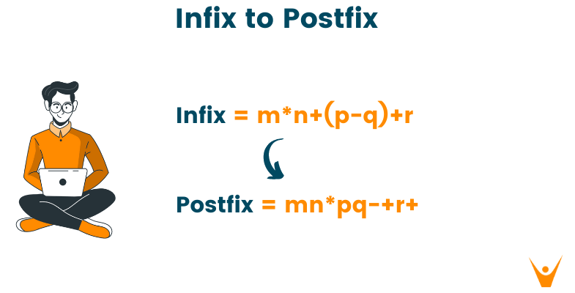

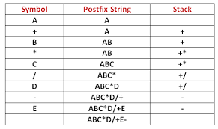

operators = set(['+', '-', '*', '/', '(', ')', '^']) # collection of operators
priority = {'+':1, '-':1, '*':2, '/':2, '^':3} # dictionary having priorities of operators

def infixToPostfix(expr):
stack = [] # initialization of empty stack
output = []

for char in expr:
if char not in operators: # if an operand append in postfix expr
output.append(char)
else:
if char=='(': # else operators push onto stack
stack.append('(')

elif char==')':
while stack and stack[-1]!= '(':
output.append(stack.pop())
stack.pop() # Remove the '(' from the stack

else:
while stack and stack[-1]!='(' and priority[char]<=priority[stack[-1]]:
output.append(stack.pop())
stack.append(char)

while stack:
output.append(stack.pop())

return "".join(output)

expr = input('Enter infix expr : ').replace(" ","")
print('infix notation: ',expr)
print('postfix notation: ',infixToPostfix(expr))

