**📘 Next.js**

[**What is Next.js?**](https://nextjs.org/docs#what-is-nextjs)

Next.js is a React framework for building full-stack web applications.

• A React framework developed by **Vercel**.

• Used for building **SEO-friendly** and **high-performance** web apps.

• Popular among top companies like Netflix, TikTok, etc.

**❌ Problems with React (Client-Side Rendering Only):**

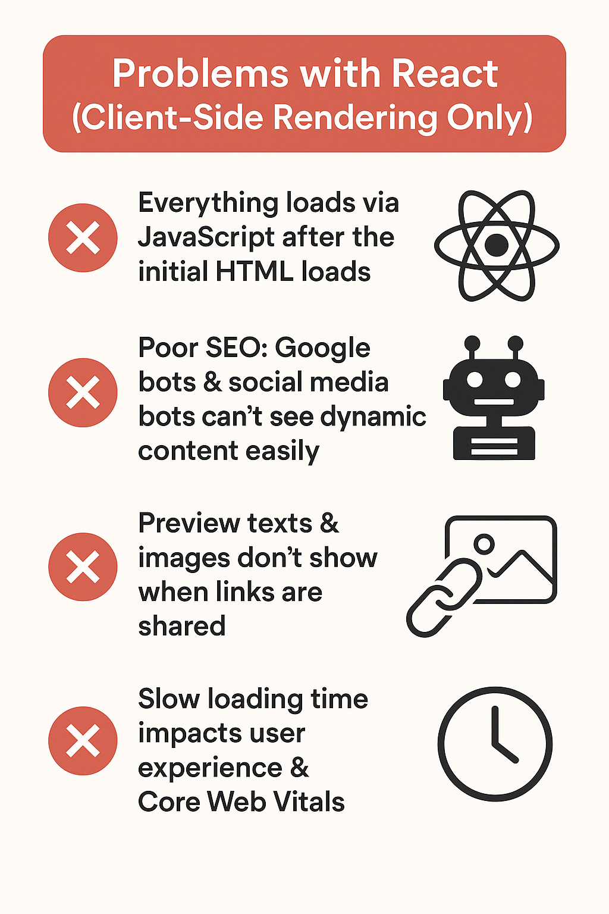

* Next.js as a Full Stack Framework:** Unlike React which is purely a UI library, Next.js provides a full-fledged framework integrating routing, rendering, and backend runtime under one umbrella. This simplifies development by allowing frontend and backend code to coexist seamlessly in a single project, improving maintainability and reducing complexity. The built-in Node.js runtime enables server-side rendering and API routes without maintaining separate backend services.
* Next.js 13 introduces server components by default, which are rendered on the server and sent as static HTML to the client. This reduces JavaScript bundle size and improves SEO since search engine bots receive fully rendered content. Client components, which handle user interactions and state, are used sparingly to optimize performance. This division allows developers to build faster, more efficient apps by minimizing client-side JavaScript and keeping sensitive logic on the server.



There are Two main way to execute the JavaScript code: -



There are two ways we can execute JavaScript code:

* On the **client side**, within a web browser
* On the **server side**, within a **Node.js runtime**

A Node.js runtime is simply a program that allows us to execute JavaScript code outside of a browser—on the server.

Next.js comes with a built-in Node.js runtime, which enables some powerful capabilities.  
We can perform **full-stack development** using a single Next.js project—writing both frontend and backend code together.

* The **backend code** runs in the Node.js runtime on the server.
* The **frontend code** is bundled and sent to the client, where it executes in the browser.

**Install and set up a new Next.js project:**

**🛠 Step 1: Create a Next.js App:** Use **npx** (npm package runner):

npx create-next-app@latest my-next-app

PS G:\4.WebDevelopment\3.Nextjs> npx create-next-app@latest nextjs

Need to install the following packages:

create-next-app@15.3.5

Ok to proceed? (y) y

√ Would you like to use TypeScript? ... No / Yes

√ Would you like to use ESLint? ... No / Yes

√ Would you like to use Tailwind CSS? ... No / Yes

√ Would you like your code inside a `src/` directory? ... No / Yes

√ Would you like to use App Router? (recommended) ... No / Yes

√ Would you like to use Turbopack for `next dev`? ... No / Yes

√ Would you like to customize the import alias (`@/*` by default)? ... No / Yes

Creating a new Next.js app in G:\4.WebDevelopment\3.Nextjs\nextjs.

PS G:\4.WebDevelopment\3.Nextjs>

PS G:\4.WebDevelopment\3.Nextjs>

PS G:\4.WebDevelopment\3.Nextjs>

PS G:\4.WebDevelopment\3.Nextjs>

PS G:\4.WebDevelopment\3.Nextjs>

PS G:\4.WebDevelopment\3.Nextjs>

PS G:\4.WebDevelopment\3.Nextjs>

PS G:\4.WebDevelopment\3.Nextjs> cd .\nextjs\

PS G:\4.WebDevelopment\3.Nextjs\nextjs> git init

Reinitialized existing Git repository in G:/4.WebDevelopment/3.Nextjs/nextjs/.git/

PS G:\4.WebDevelopment\3.Nextjs\nextjs> git add .

PS G:\4.WebDevelopment\3.Nextjs\nextjs> git commit -m "Inital commit1"

On branch master

nothing to commit, working tree clean

PS G:\4.WebDevelopment\3.Nextjs\nextjs>

* History restored

PS G:\4.WebDevelopment\3.Nextjs>

* History restored

PS G:\4.WebDevelopment\3.Nextjs> npx create-next-app@latest my-next-app1

√ Would you like to use TypeScript? ... No / Yes

√ Would you like to use ESLint? ... No / Yes

√ Would you like to use Tailwind CSS? ... No / Yes

√ Would you like your code inside a `src/` directory? ... No / Yes

√ Would you like to use App Router? (recommended) ... No / Yes

√ Would you like to use Turbopack for `next dev`? ... No / Yes

√ Would you like to customize the import alias (`@/*` by default)? ... No / Yes

Creating a new Next.js app in G:\4.WebDevelopment\3.Nextjs\my-next-app1.

Using npm.

Initializing project with template: app-tw

Installing dependencies:

- react

- react-dom

- next

Installing devDependencies:

- @tailwindcss/postcss

- tailwindcss

- eslint

- eslint-config-next

- @eslint/eslintrc

added 334 packages, and audited 335 packages in 2m

136 packages are looking for funding

run `npm fund` for details

found 0 vulnerabilities

Initialized a git repository.

Success! Created my-next-app1 at G:\4.WebDevelopment\3.Nextjs\my-next-app1

PS G:\4.WebDevelopment\3.Nextjs>

npm run dev