**Git & GitHub:**

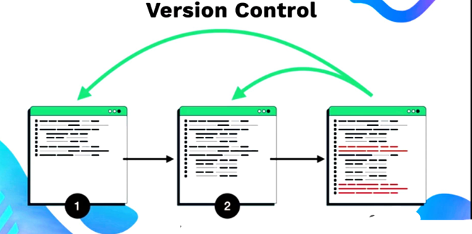 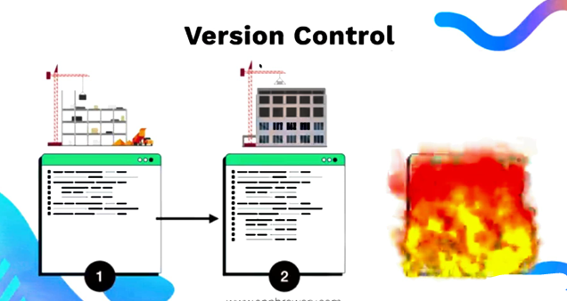

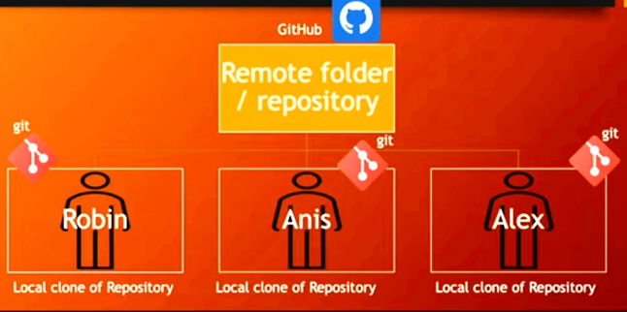

* **Git** tracks changes to files on your local machine. It records historical versions or snapshots of files as they exist at specific points in time.
* Git is a **version control system** that helps keep track of changes and supports collaboration in a project.
* **GitHub** is a **hosting platform** where you can upload your project directory, so that you can share with anyone from anywhere.
* When you and your colleagues work on the project from different local machines and make individual changes, GitHub acts as a **centralized platform** where everyone can **push their changes**. This allows all contributions to be merged and managed effectively in one place.

# Git is working locally and GitHub is working globally.

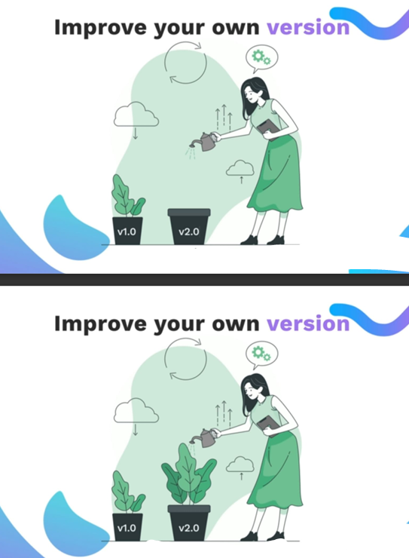 -



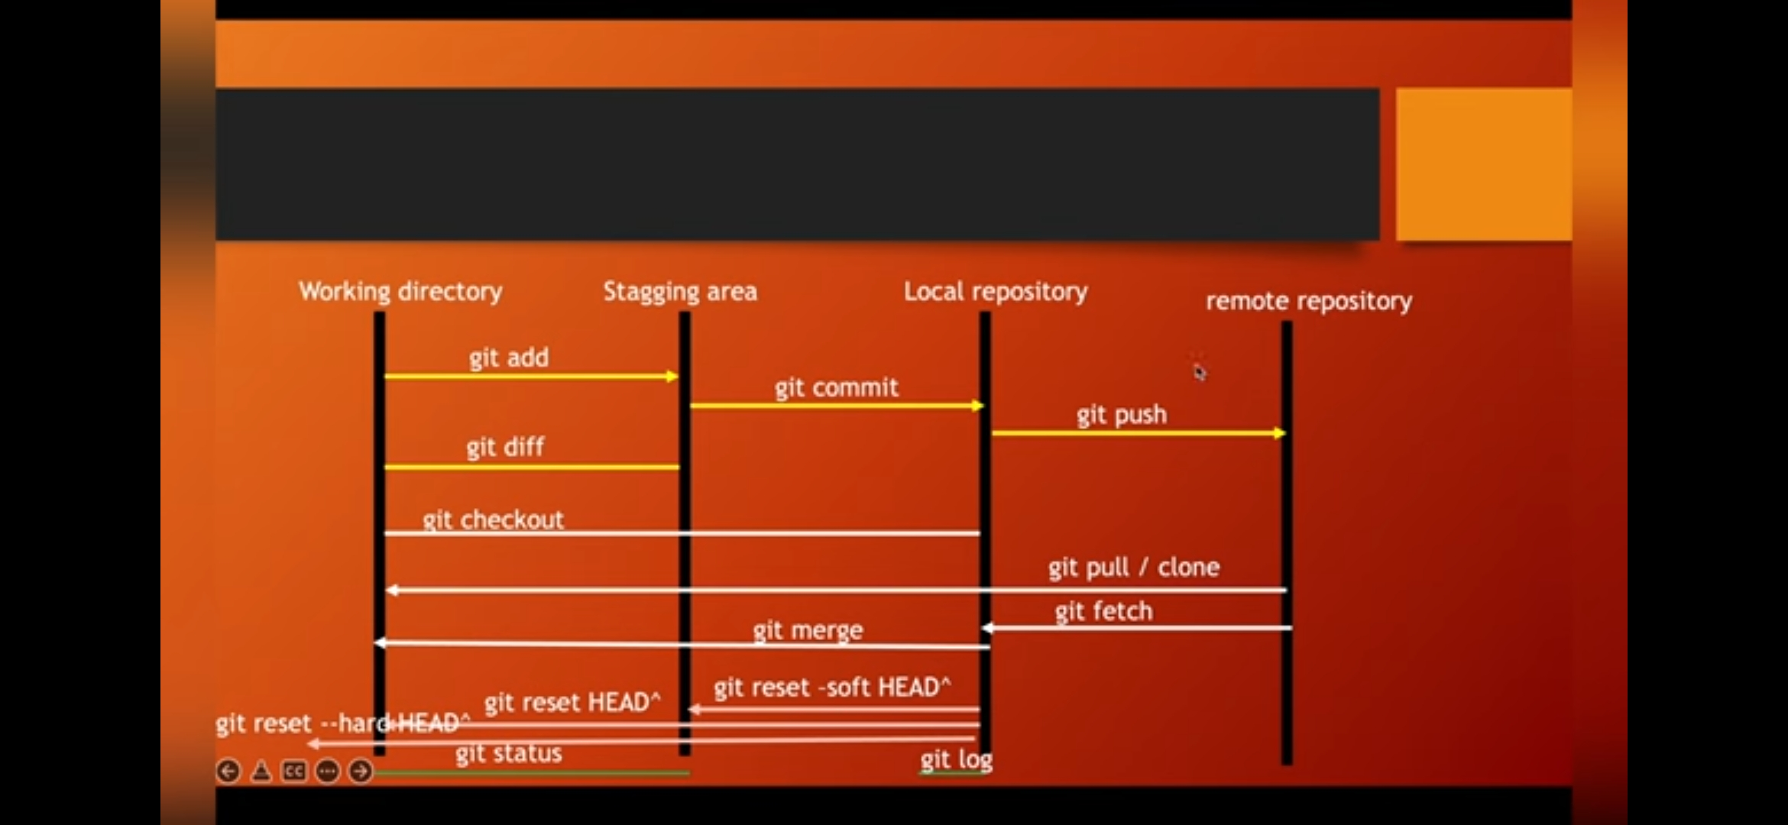

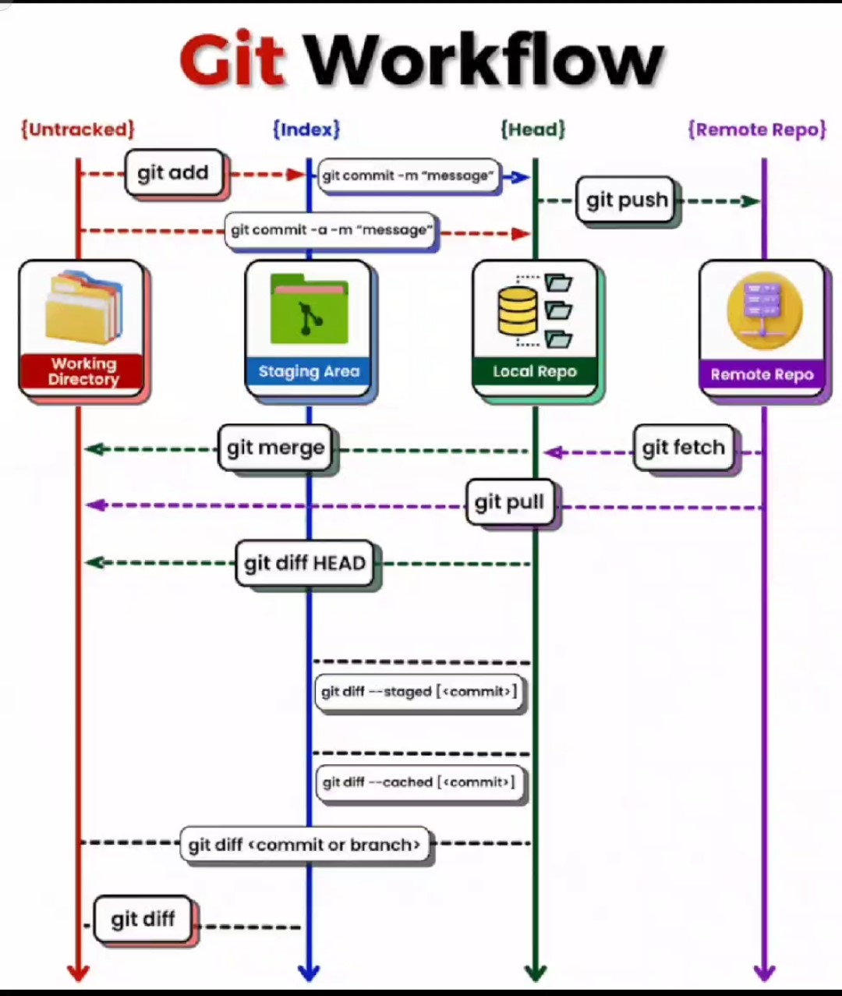

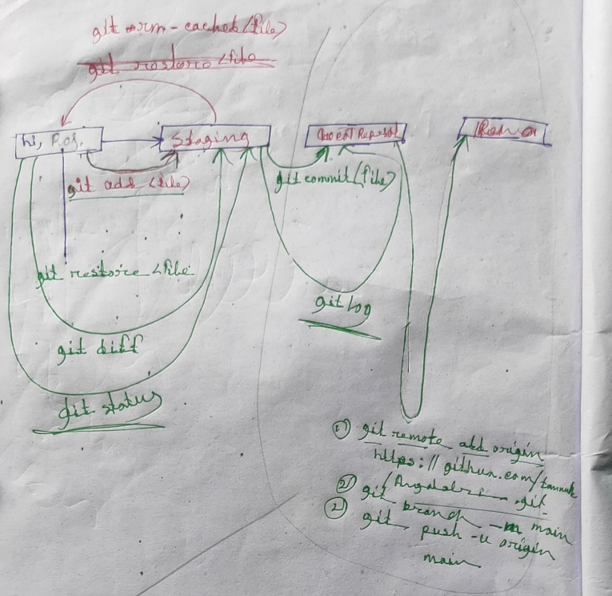

**Git:**

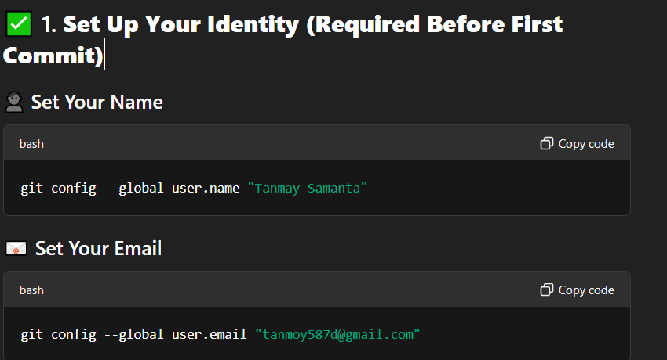

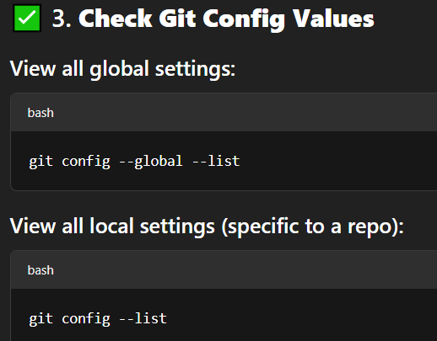

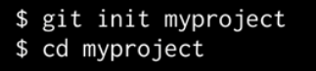

This creates a directory that can contain the project files as will as control files that store the historical elements, the history snapshots of yours documents, images, source code if you’re working with program.



This commend actually notice the files and puts them into a kind of holding zone, ready to committed.



Using this we permanently records a historical version or snapshot of the files as they exist at a given point in time.

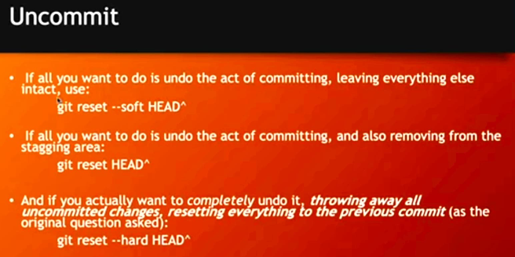

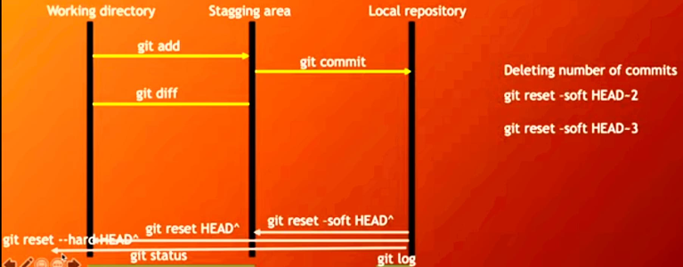

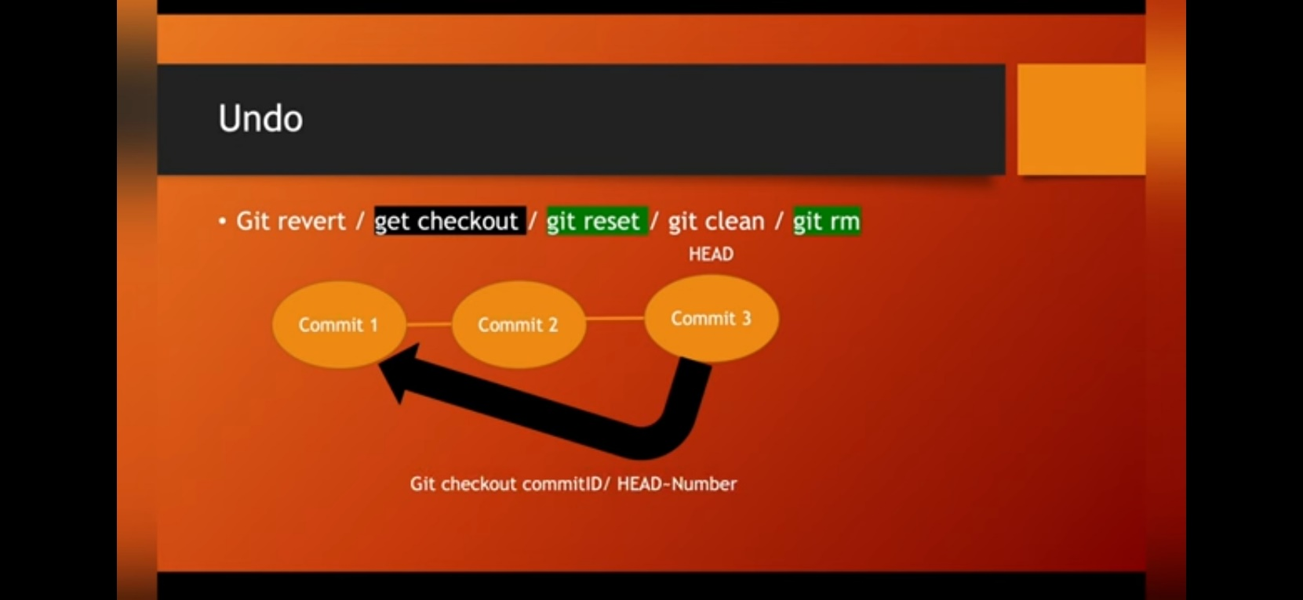

**Branch:**

**Merging:**

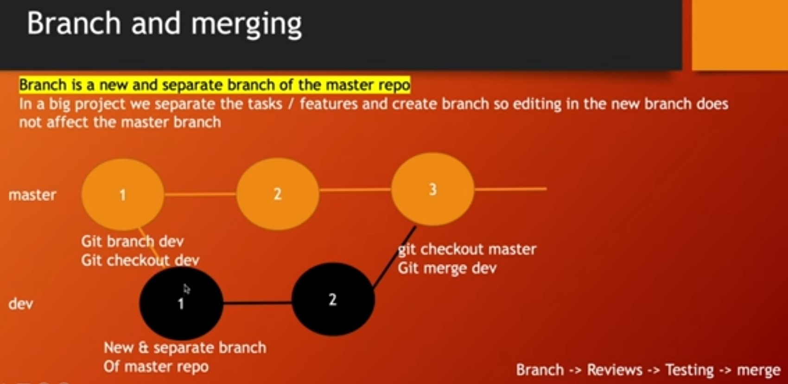

[Visualizing Git](https://git-school.github.io/visualizing-git/)

2-way Merging Forward Merging:

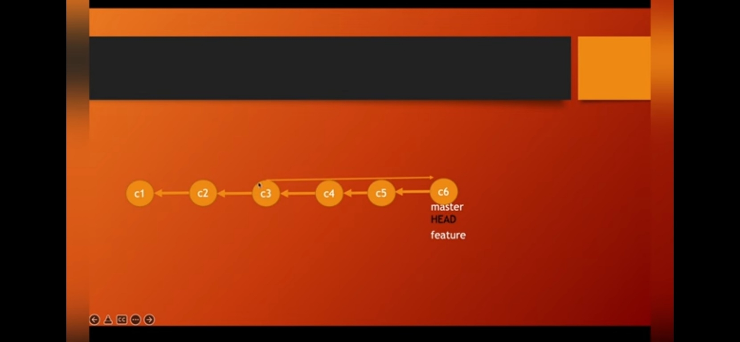

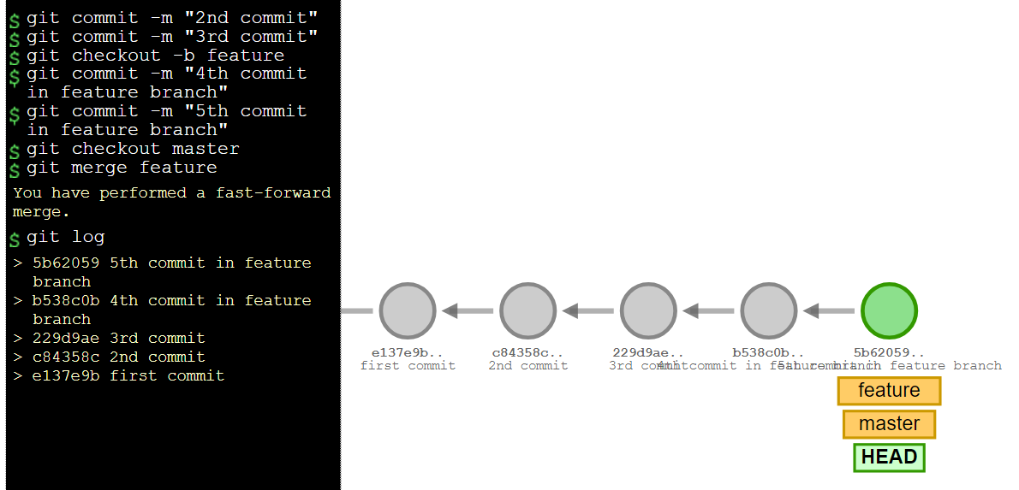

3-way Merging:

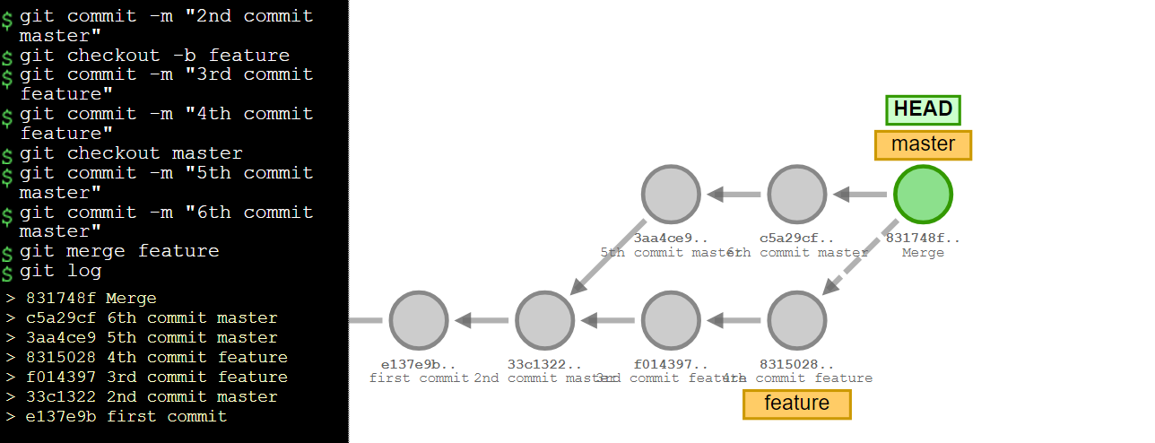

Pull & Push:

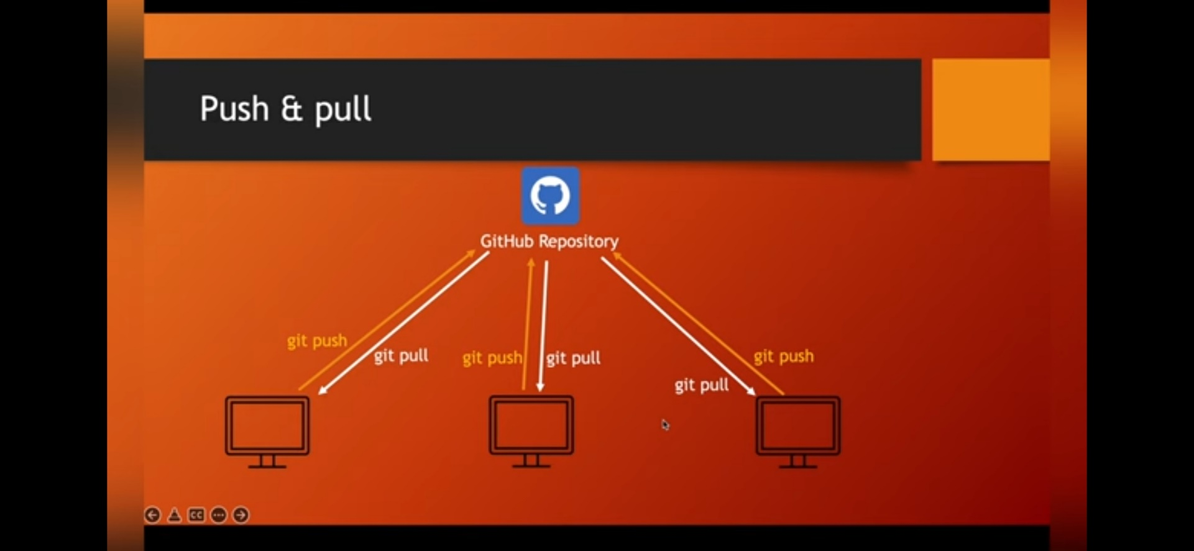

**GitHub:**

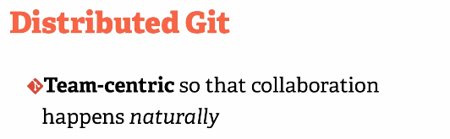

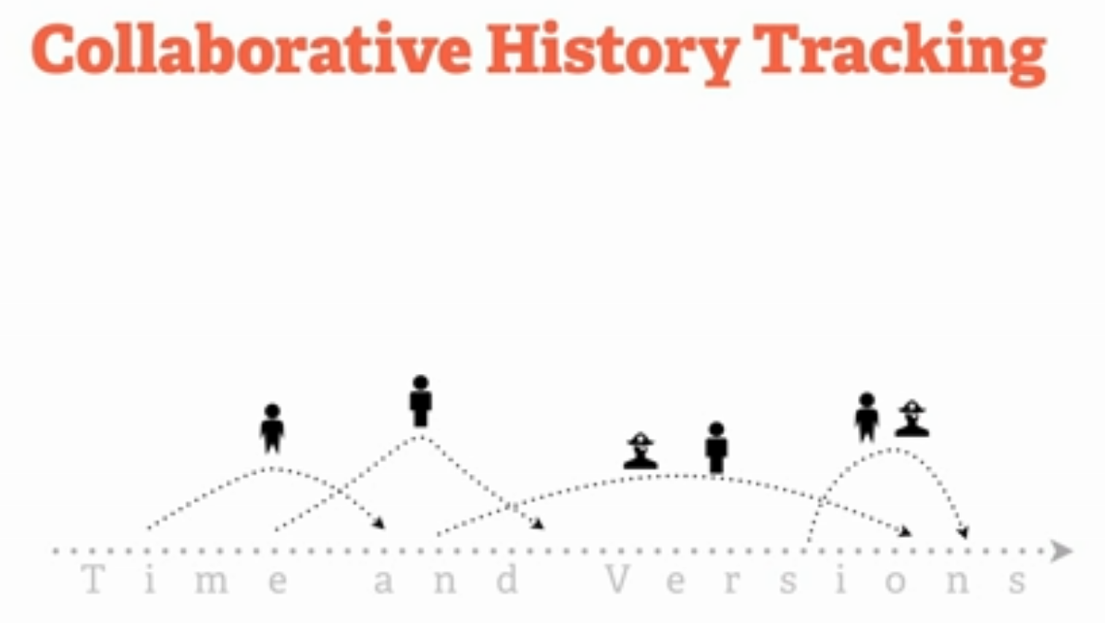

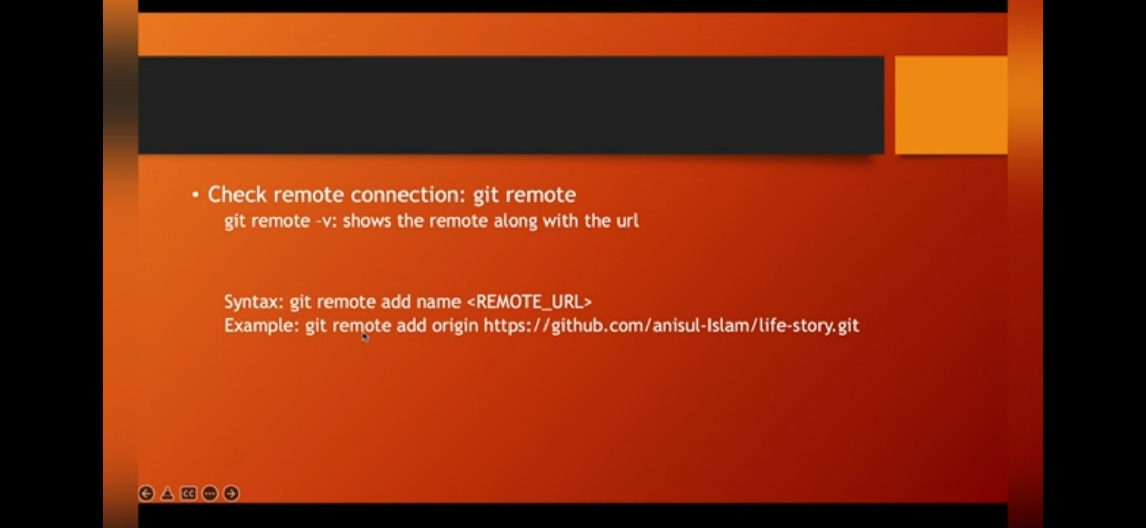

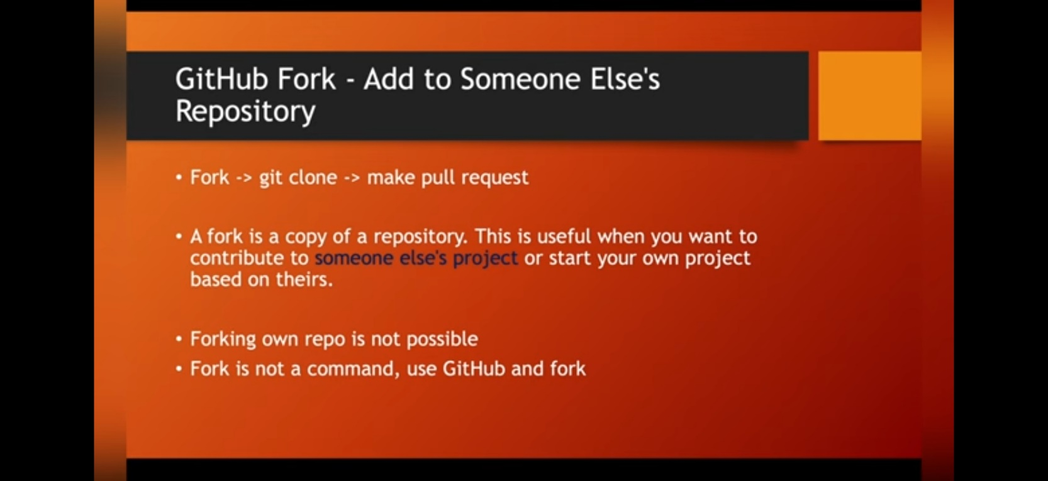

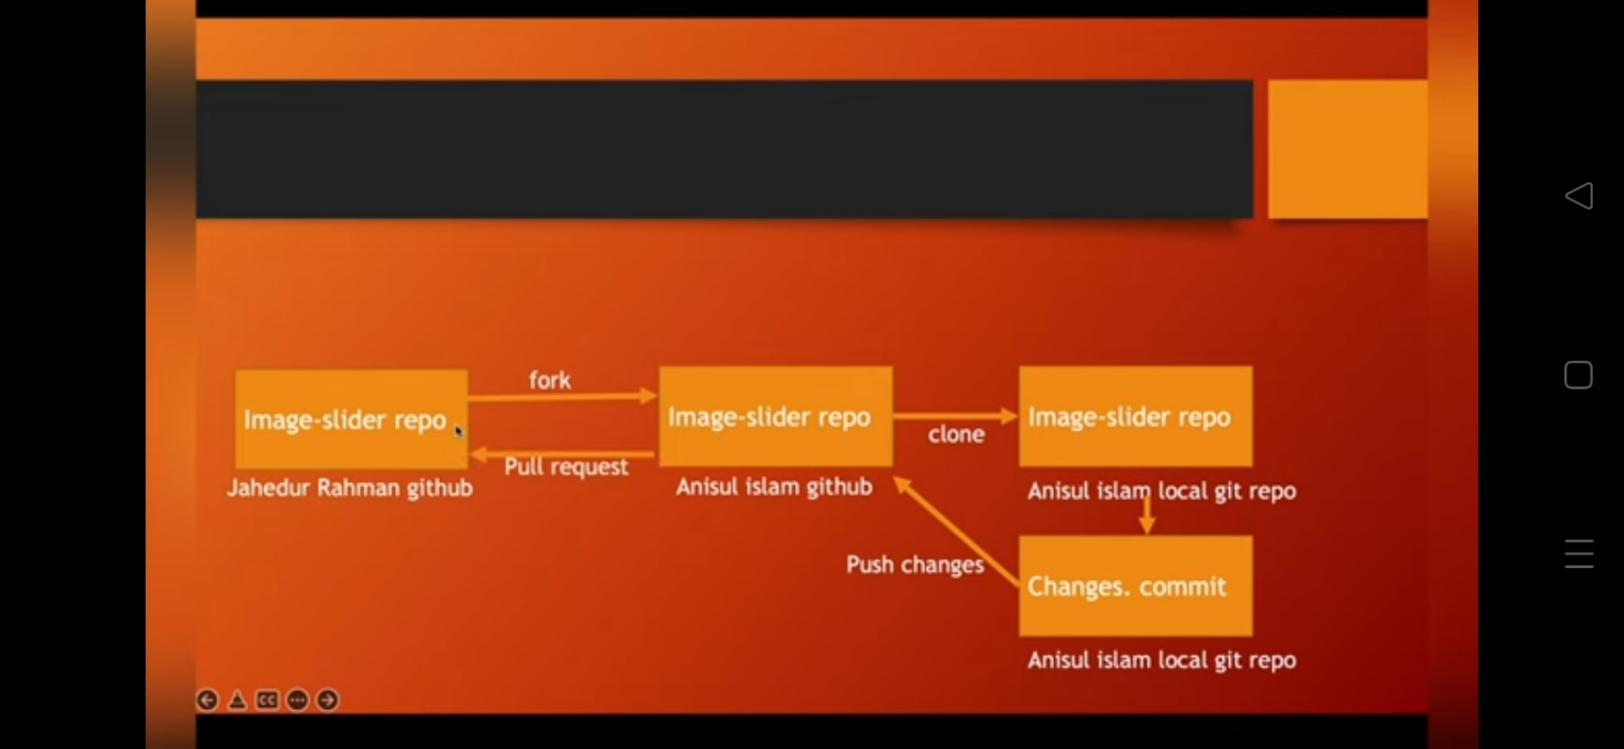

**Local repository & a Remote repository**

The important thing to note is that you can have a local repository completely in parallel with a remote repository check the differences between them, but you can also sync them or push things from your local repository to your remote local repository completely in parallel with a remote repository.

when we performed the command git push, then that effectively pushed all of those commits, all of those various versions and changes and code pieces to our remote repository on GitHub. So that's what "git push" does.