**NodeJS**

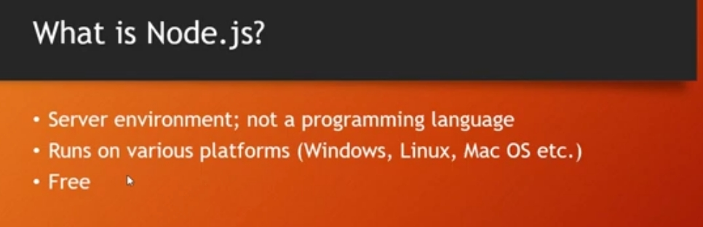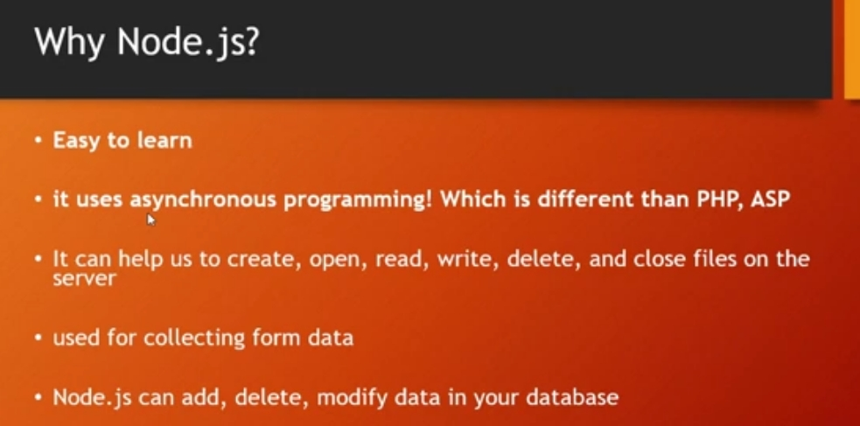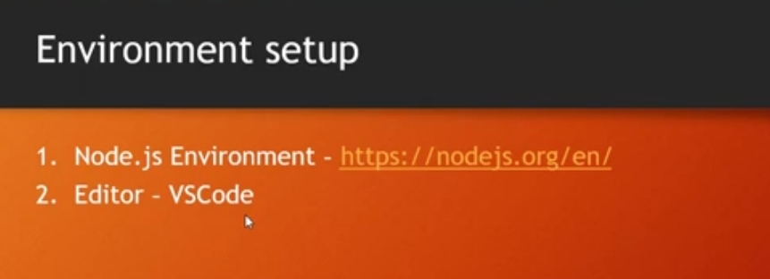

**NodeJS Modules:**

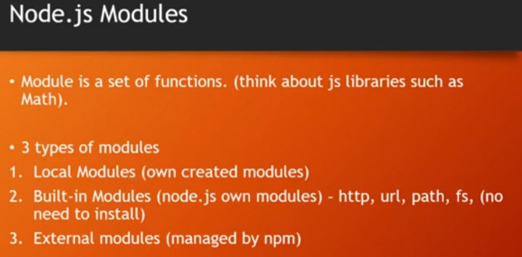

**NodeJS External Modules:**



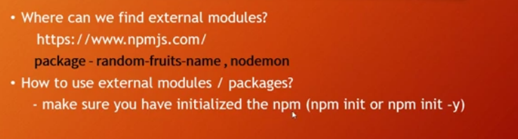

A stored procedure in SQL is a precompiled set of SQL statements that performs a specific task and is stored in the