Java Assignment

Tanmaya Harichandan

Q.WAP to find weather the no entered by user is even or odd.

**package** main;

**import** java.util.Scanner;

**public** **class** EvenorOdd {

**private** **static** Scanner *sc*;

**public** **static** **void** main(String[] args) {

*sc*=**new** Scanner(System.***in***);

System.***out***.println("Enter a number:");

**int** n=*sc*.nextInt();

**if**(n%2==0)

{

System.***out***.println("Even Number");

}

**else**

{

System.***out***.println("Odd Number");

}

}

}

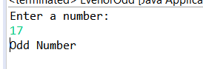

Q.WAP to swap the values of 2 nos.(Take input from user)

eg a=10 b=20

after swapping

a=20 b=10

**package** main;

**import** java.util.Scanner;

**public** **class** SwapNumbers {

**private** **static** Scanner *sc*;

**public** **static** **void** main(String[] args) {

*sc*=**new** Scanner(System.***in***);

System.***out***.println("Enter the first number:");

**int** n=*sc*.nextInt();

System.***out***.println("Enter the second number");

**int** m=*sc*.nextInt();

**int** temp=m;

m=n;

n=temp;

System.***out***.println("The first number after swapping:"+n);

System.***out***.println("The second number after swapping:"+m);

}

}

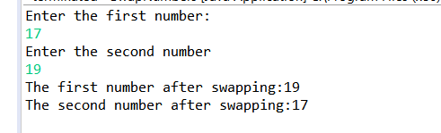

Q.WAP to find the greatest between the 3 nos and display the output. (Take input from user)

**package** main;

**import** java.util.Scanner;

**public** **class** GreatestNumber {

**private** **static** Scanner *sc*;

**public** **static** **void** main(String[] args) {

*sc*=**new** Scanner(System.***in***);

System.***out***.println("Enter the first number");

**int** a=*sc*.nextInt();

System.***out***.println("Enter the second number");

**int** b=*sc*.nextInt();

System.***out***.println("Enter the third number");

**int** c=*sc*.nextInt();

**if**(a>b && a>c)

{

System.***out***.println(a+" is greatest");

}

**else** **if**(b>c)

{

System.***out***.println(b+" is greatest");

}

**else**

{

System.***out***.println(c+" is greatest");

}

}

}

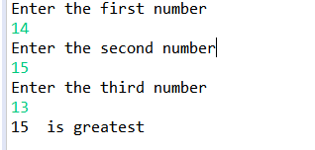

Q.WAP to find weather the character entered by user is a vowel or not.(solve by using if..else and switch case)

**package** main;

**import** java.util.Scanner;

**public** **class** VowelOrConsonant {

**private** **static** Scanner *sc*;

**public** **static** **void** main(String[] args) {

*sc*=**new** Scanner(System.***in***);

System.***out***.println("Enter a character:");

**char** c=*sc*.next().charAt(0);

**switch**(c){

**case** 'a':

**case** 'e':

**case** 'i':

**case** 'o':

**case** 'u': System.***out***.println("Vowel");

**break**;

**default**:System.***out***.println("Not Vowel");

}

}

}

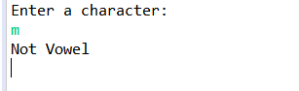

Q.WAP to print even nos from 1-50 using while loop.

**package** main;

**public** **class** EvenNumber {

**public** **static** **void** main(String[] args) {

**int** i=1;

**while**(i<=100)

{

**if**(i%2==0)

{

System.***out***.println(i);

}

i++;

}

}

}

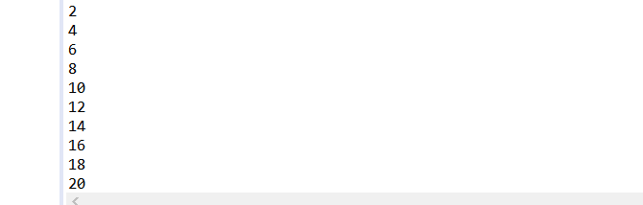

Q.WAP to print odd nos from 50-100 using do while loop.

**package** main;

**public** **class** OddNumber {

**public** **static** **void** main(String[] args) {

**int** i=50;

**do**

{

**if**(i%2!=0)

{

System.***out***.println(i);

}

i++;

}

**while**(i<=100);

}

}

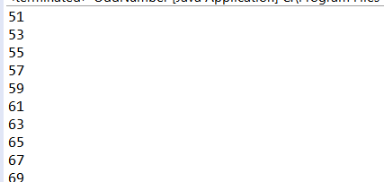

Q.Given a number N, print sum of all even numbers from 1 to N.

**package** main;

**import** java.util.Scanner;

**public** **class** EvenNumberToN {

**private** **static** Scanner *sc*;

**public** **static** **void** main(String[] args) {

*sc*=**new** Scanner(System.***in***);

System.***out***.println("Enter a number:");

**int** n=*sc*.nextInt();

**int** i=1;

**while**(i<=n)

{

**if**(i%2==0)

{

System.***out***.println(i);

}

i++;

}

}

}

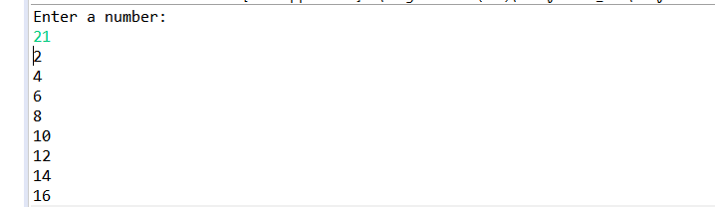

Q. WAP to print the following patterns

a.for n=4

1

22

333

4444

**package** main;

**import** java.util.Scanner;

**public** **class** Pattern1 {

**private** **static** Scanner *sc*;

**public** **static** **void** main(String[] args) {

*sc*=**new** Scanner(System.***in***);

System.***out***.println("Enter a number:");

**int** n=*sc*.nextInt();

**for**(**int** i=1;i<=n;i++)

{

**for**(**int** j=0;j<i;j++)

{

System.***out***.print(i);

}

System.***out***.println("");

}

}

}

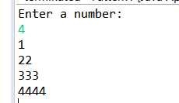

b.for n=4

4444

4444

4444

4444

**package** main;

**import** java.util.Scanner;

**public** **class** Pattern2 {

**private** **static** Scanner *sc*;

**public** **static** **void** main(String[] args) {

*sc*=**new** Scanner(System.***in***);

System.***out***.println("Enter a number:");

**int** n=*sc*.nextInt();

**for**(**int** i=0;i<n;i++)

{

**for**(**int** j=0;j<n;j++)

{

System.***out***.print(n);

}

System.***out***.println("");

}

}

}

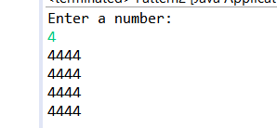

c.for n=5

*

**

***

****

*****

**package** main;

**import** java.util.Scanner;

**public** **class** Pattern3 {

**private** **static** Scanner *sc*;

**public** **static** **void** main(String[] args) {

*sc* = **new** Scanner(System.***in***);

System.***out***.println("Enter a number:");

**int** n = *sc*.nextInt();

**for** (**int** i = 1; i <= n; i++)

{

**for** (**int** j = n; j > i; j--)

{

System.***out***.print(" ");

}

**for** (**int** k = 1; k <= i; k++)

{

System.***out***.print(" *");

}

System.***out***.println();

}

}

}

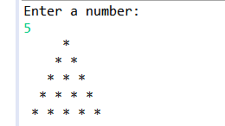

Q.Revers an Array.

**public** **class** ArrayReverse {

**private** **static** Scanner *sc*;

**public** **static** **void** main(String args[])

{

*sc*=**new** Scanner(System.***in***);

System.***out***.print("Enter the size of array:");

**int** n=*sc*.nextInt();

**int** [] array=**new** **int**[n];

System.***out***.print("Enter the array elements:");

**for**(**int** i=0;i<n;i++)

{

array[i]=*sc*.nextInt();

}

**int** [] newarray=**new** **int**[n];

**for**(**int** i=0;i<n;i++)

{

newarray[i]=array[n-i-1];

}

System.***out***.println("Reversed Array");

**for**(**int** i=0;i<n;i++)

{

System.***out***.print(newarray[i]+" ");

}

}

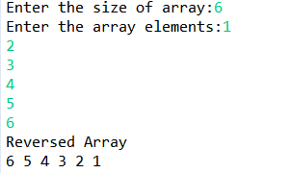

Q.Swap the nos in Array.

**package** main;

**import** java.util.Scanner;

**public** **class** ArraySwap {

**private** **static** Scanner *sc*;

**public** **static** **void** main(String args[])

{

*sc*=**new** Scanner(System.***in***);

System.***out***.print("Enter the size of array:");

**int** n=*sc*.nextInt();

**int** [] array=**new** **int**[n];

System.***out***.print("Enter the array elements:");

**for**(**int** i=0;i<n;i++)

{

array[i]=*sc*.nextInt();

}

**for**(**int** i=0;i<n-1;i+=2)

{

**int** j=i+1;

**int** temp=array[i];

array[i]=array[j];

array[j]=temp;

}

System.***out***.println("After Swap:");

**for**(**int** i=0;i<n;i++)

{

System.***out***.print(array[i]+" ");

}

}

}

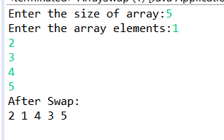

Q.WAP to calculate and display the factorial of a no entered by user.

**package** main;

**import** java.util.Scanner;

**public** **class** Factorial {

**public** **static** **long** factorialcalc(**int** n)

{

**if**(n==0||n==1)

**return** 1;

**else**

**return** n\**factorialcalc*(n-1);

}

**private** **static** Scanner *sc*;

**public** **static** **void** main(String args[]) {

*sc* = **new** Scanner(System.***in***);

System.***out***.print("Enter the number:");

**int** n = *sc*.nextInt();

**long** r=*factorialcalc*(n);

System.***out***.println("The Factorial is "+r);

}

}

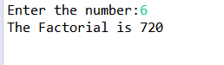

Q.WAP to check weather the no entered by user is prime or not.

**package** main;

**import** java.util.Scanner;

**public** **class** PrimeOrNot {

**public** **static** **boolean** isPrime(**int** n) {

**if** (n <= 1) {

**return** **false**;

}

**for** (**int** i = 2; i < Math.*sqrt*(n); i++) {

**if** (n % i == 0) {

**return** **false**;

}

}

**return** **true**;

}

**private** **static** Scanner *sc*;

**public** **static** **void** main(String args[]) {

*sc* = **new** Scanner(System.***in***);

System.***out***.print("Enter the number:");

**int** n = *sc*.nextInt();

**if** (!*isPrime*(n)) {

System.***out***.println(n + " is not a prime number.");

} **else** {

System.***out***.println(n + " is a prime number.");

}

}

}

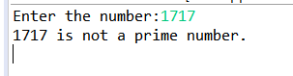

Q.Given an integer N, print all the prime numbers that lie in the range 2 to N (both inclusive).

**package** main;

**import** java.util.Scanner;

**public** **class** PrimeNumber {

**public** **static** **boolean** isPrime(**int** n) {

**if** (n <= 1) {

**return** **false**;

}

**for** (**int** i = 2; i < Math.*sqrt*(n); i++) {

**if** (n % i == 0) {

**return** **false**;

}

}

**return** **true**;

}

**private** **static** Scanner *sc*;

**public** **static** **void** main(String args[]) {

*sc* = **new** Scanner(System.***in***);

System.***out***.print("Enter a number:");

**int** n = *sc*.nextInt();

**for** (**int** i = 2; i <= n; i++) {

**if** (*isPrime*(i))

{

System.***out***.print(i + " ");

}

}

}

}

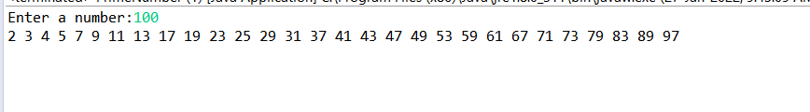

Q.WAP to generate the reverse of a given number N. Print the corresponding reverse number.

**package** main;

**import** java.util.Scanner;

**public** **class** ReverseOfNumber {

**private** **static** Scanner *sc*;

**public** **static** **void** main(String args[]) {

*sc* = **new** Scanner(System.***in***);

System.***out***.print("Enter a number:");

**int** n = *sc*.nextInt();

**int** t=0;

**while**(n>0)

{

**int** r=n%10;

t=t*10+r;

n=n/10;

}

System.***out***.println("Reverse of the number is "+t);

}

}

