best commerce colleges in rajasthan rank 91

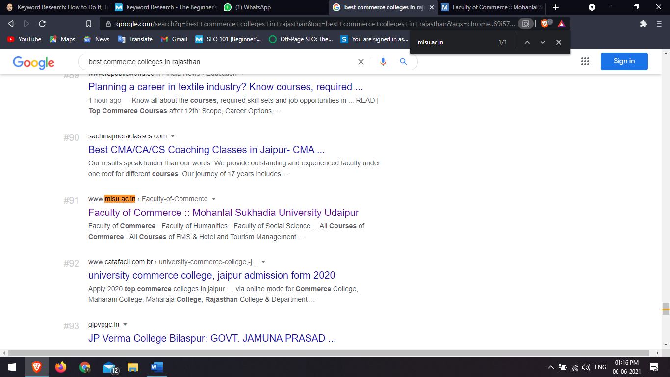<https://www.mlsu.ac.in/Faculty-of-Commerce>

hotel management colleges in Udaipur rank 30

[https://dthm.mlsu.ac.in](https://dthm.mlsu.ac.in/)

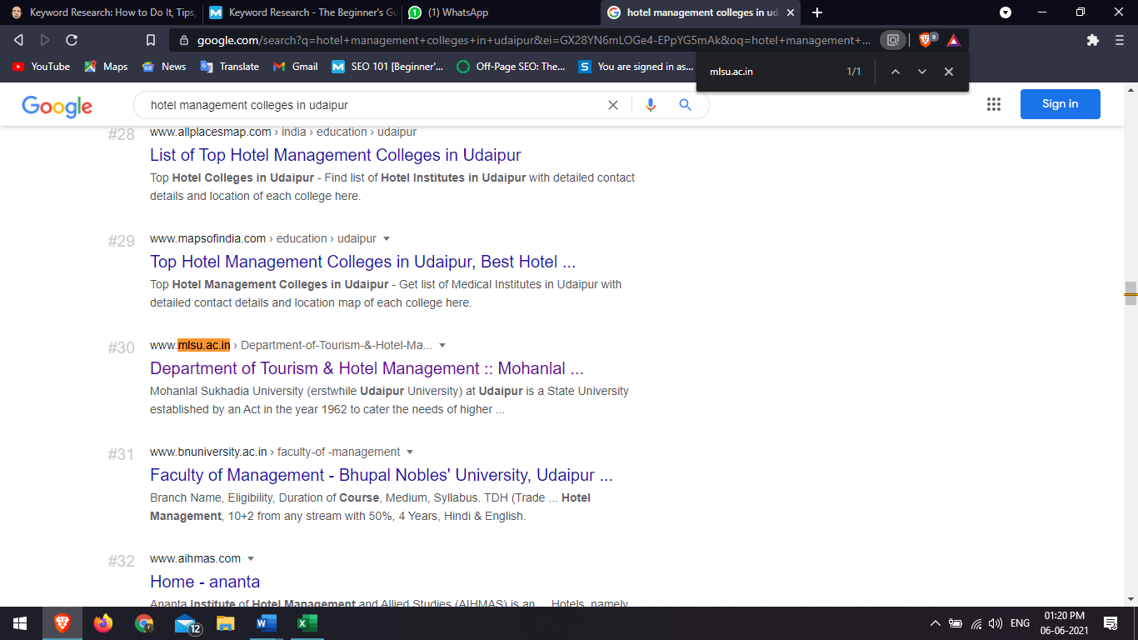

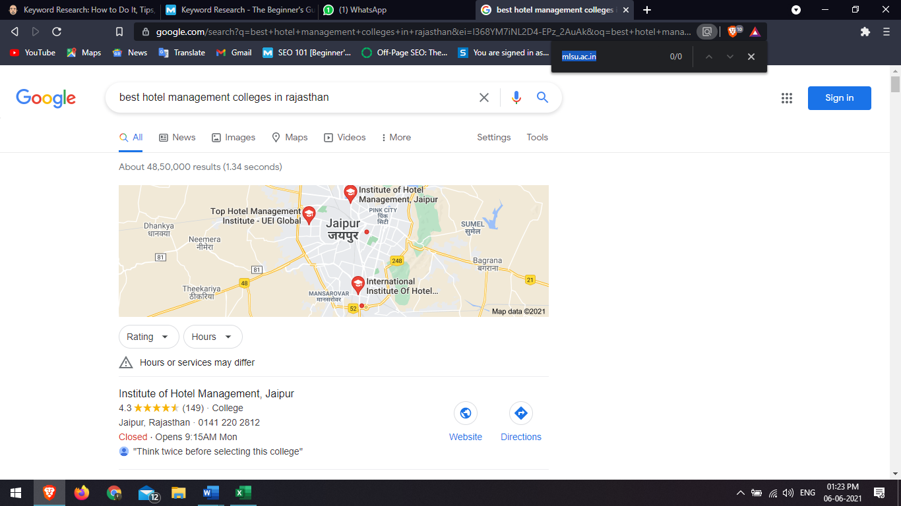best hotel management colleges in rajasthan rank na

management colleges in Udaipur rank 25

[https://fms.mlsu.ac.in](https://fms.mlsu.ac.in/)

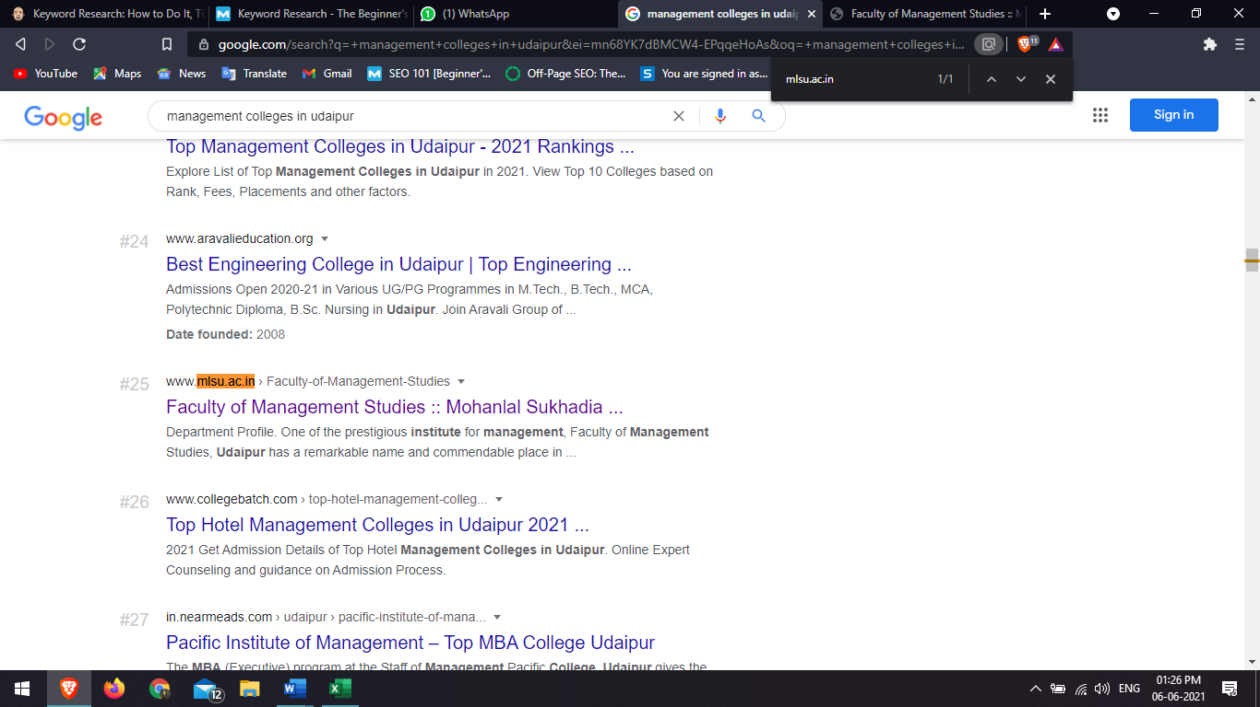

science colleges in rajasthan rank 38

s

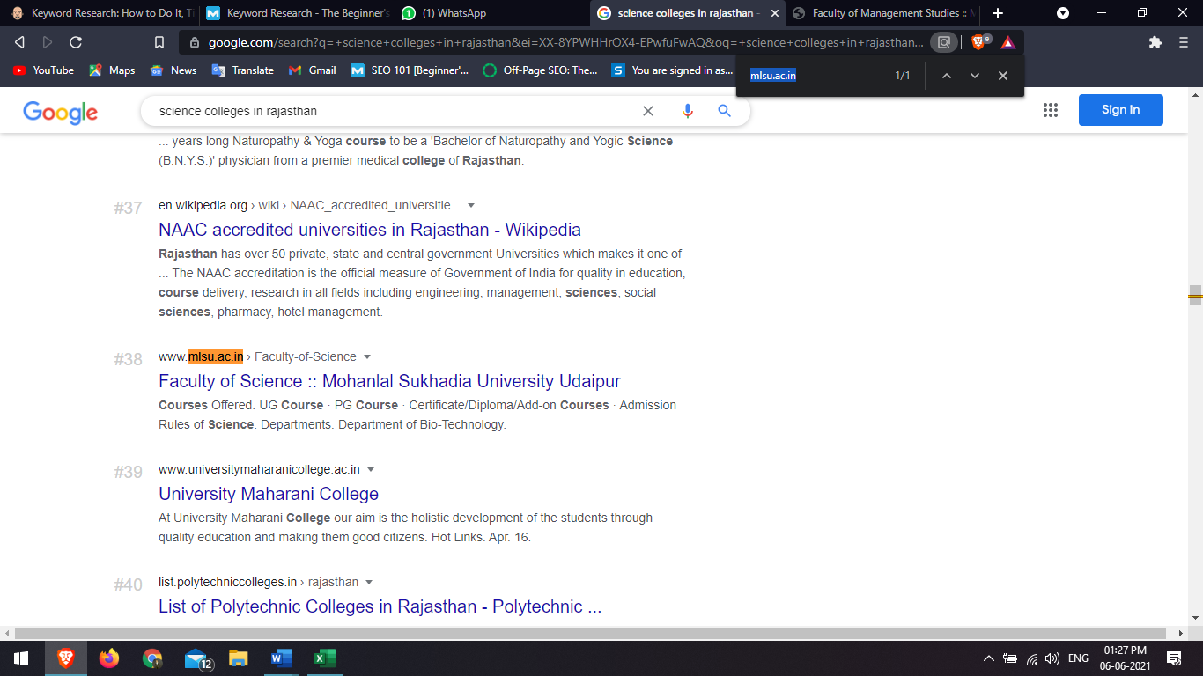

Phd college in Rajasthan Rank 42

<https://phd.mlsu.ac.in>

