SUMMER INTERNSHIP REPORT
ON
SMART CAMPUS ISSUE & FACILITY MANAGEMENT SYSTEM
VII Semester
Bachelor of Technology in Information Technology
Submitted by
Tanmay Kishor Dafe
Roll No. 24110002
Under the guidance of
Prof. Shankar Gadhve
Assistant Professor
Academic Year 2026 – 27

DEPARTMENT OF INFORMATION TECHNOLOGY
ST. VINCENT PALLOTTI
COLLEGE OF ENGINEERING AND TECHNOLOGY
Wardha Road, Gavsi Manapur, Nagpur-441108

ST. VINCENT PALLOTTI COLLEGE OF ENGINEERING AND TECHNOLOGY, NAGPUR
DEPARTMENT OF INFORMATION TECHNOLOGY
CERTIFICATE
This is to certify that Mr. Tanmay Kishor Dafe (UID No. 24110002), a student of VII Semester, Bachelor of Technology in Information Technology, has satisfactorily completed his individual contribution towards the project entitled “Smart Campus Issue & Facility Management System” under my supervision. He was responsible for the MySQL database design & full-stack integration of the system – relational database architecture, permanent storage of users, facilities, complaints, technician assignments and activity history, and secure retrieval of this data for the dashboard, student portal and reporting screens – and this report is a bonafide record of the work carried out by him as part of the project team during the academic year 2026-27.
Dr. Shabana Pathan  Assistant Professor  HEAD OF THE DEPARTMENT | Prof. Shankar Gadhve  Assistant Professor  GUIDE
PRINCIPAL
ST. VINCENT PALLOTTI COLLEGE OF ENGINEERING AND TECHNOLOGY

ACKNOWLEDGEMENT
Working on the Smart Campus Issue & Facility Management System has been an important milestone in my learning journey. I would like to express my sincere gratitude to my Project Guide, Prof. Shankar Gadhve, Assistant Professor, Department of Information Technology, for his valuable guidance, constant encouragement and continuous support throughout the project.
I am also grateful to our industry mentor, Mr. Prabhakar Dorge, Senior Technical Consultant, AD Infocom Systems, for his technical guidance and support during my summer internship and the development of the system.
My special thanks go to Dr. Shabana Pathan, Head, Department of Information Technology, and to all the faculty members who regularly evaluated our work and gave important feedback for its improvement.
I take this opportunity to express my deep sense of gratitude to the Management and the Principal, Dr. Prashant Maheshwary, St. Vincent Pallotti College of Engineering and Technology, for providing the computer lab, infrastructure and a supportive learning environment.
Finally, I thank my teammates and project peers for their active cooperation and constructive feedback, which made it possible to design, implement and test the complete system successfully.
Date: 23-10-2026  Place: Nagpur | Tanmay Kishor Dafe  UID No. 24110002

CONTENTS
Sr. No. | Contents | Page No.
1 | Introduction | 5
2 | Project Overview | 6
3 | Objectives of My Contribution | 6
4 | Technologies Used | 7
5 | Modules Developed / Tasks Performed  5.1 Database Design in MySQL  5.2 Database Tables and Schema Structure  5.3 Connecting Backend to MySQL via PDO  5.4 Authentication and Complaint Submission  5.5 System Outputs and User Interface Screens  • 5.5.1 Landing Portal & Student Authentication (Outputs 1 & 2)  • 5.5.2 Student Dashboard & New Complaint Filing (Outputs 3 & 4)  • 5.5.3 Admin Control Dashboard & Resolution Queue (Outputs 5 & 6)  5.6 Team Activities and Quality Assurance Testing | 7
6 | Outcomes Achieved  6.1 Technical Learning  6.2 Project Experience | 12
7 | Challenges Faced and Solutions | 12
8 | Conclusion | 13
9 | References | 13

1. Introduction
College and university campuses are large, active educational environments consisting of classroom complexes, computer laboratories, research centers, libraries, administrative offices, and student hostels. Keeping campus physical infrastructure in working order—including classroom projectors, lab computers, air conditioners, fans, lighting, network access points, and water sanitation fixtures—is vital for supporting smooth daily academic activities.
Traditionally, facility maintenance and complaint handling on campuses have relied on manual physical logbooks maintained in departmental offices, verbal messages passed to office attendants, or informal emails. This manual process has major flaws: complaints often lack essential specifics (such as the exact room number, bench location, or photo evidence of physical damage); manual registers give students zero visibility into whether their complaint was reviewed or assigned; and facility supervisors have no easy way to track recurring equipment faults, technician response delays, or departmental performance.
To overcome these challenges, the Smart Campus Issue & Facility Management System was developed as a modern, web and mobile-based platform. The system allows students, faculty members, and campus staff to quickly report physical defects and equipment breakdowns directly from their web browsers or Android smartphones. Every submitted ticket is assigned a unique tracking number, tagged with specific location coordinates, categorized by infrastructure domain, and supported by photo evidence.
During the summer internship, my individual contribution was the MySQL Database and Backend Integration of the system. I designed the normalized relational database schema and connected the PHP backend to MySQL using PDO so that user accounts, category definitions, room locations, complaint tickets, technician assignments, and status histories are stored permanently and retrieved reliably for the student portal, admin dashboard, and reporting views.
This report documents the project, the objectives of my contribution, the technologies used, the modules and tasks completed, the outcomes achieved, the challenges faced along with the solutions applied, and my overall conclusions. It reflects both the technical competencies I developed and my role in building a dependable, fully functional campus management system.

2. Project Overview
The Smart Campus Issue & Facility Management System is a full-stack web and mobile application designed to digitize the end-to-end handling of campus maintenance complaints. A student logs into the Student Portal, fills in issue details, attaches a photo, and submits the ticket. The backend validates and records the issue, while the Admin Dashboard allows facility administrators to assign tickets to technicians, monitor resolution progress, and review analytics. The main components are listed below; the database layer was my primary responsibility.
Component | Description
Student Web Portal (PHP) | Student registration, secure login, issue submission with photo upload, and personal complaint tracking.
Admin Dashboard (PHP) | KPI metric counters, ticket assignment to technicians, status updates, category setup, and CSV export.
Backend REST APIs (PHP) | RESTful endpoints for authentication, role verification, complaint submission, and data queries.
Database (MySQL) – My Contribution | Permanent storage of users, locations, categories, complaints, and ticket history with quick query retrieval.
Android App (Java / XML) | Native Android client communicating with the backend APIs for student and technician on-the-go access.
Whole Team | System testing, cross-module integration, API schema alignment, and project documentation.
3. Objectives of My Contribution
Because my role was the database and data integration layer, my objectives were to make the system's data persistent, reliable, and quick to retrieve:
- Database design – to design normalized MySQL tables for users, categories, locations, tickets, and history logs, maintaining relational integrity through foreign keys.
- Backend connection – to connect the PHP backend to MySQL using PDO with secure parameter bindings and centralized environment configuration.
- Data operations – to implement insert, search, update, and filter operations for student complaints, technician dispatches, and category lookups.
- History and dashboard data – to supply live query results for dashboard counters, status distribution charts, and audit timelines.
- Code management – to maintain database scripts and backend code in version control for team collaboration.

4. Technologies Used
My work used the database and backend stack together with the project's web and mobile interfaces. The main technologies were:
- MySQL 8.0 – the relational database management system used to store users, complaints, categories, and logs.
- PHP 8.1 & PDO – the server-side language and database abstraction interface in which backend APIs and queries were implemented.
- HTML5, CSS3 & JavaScript – the frontend technologies used to present forms, tables, and dashboards.
- Chart.js – client-side charting library for interactive issue statistics on the admin dashboard.
- Android (Java) – mobile client whose activities interact with the database via backend REST APIs.
- Git & GitHub – used for version control; the repository hosts the complete project codebase.
5. Modules Developed / Tasks Performed
My work followed the flow of data through the system – from the student's request on the frontend to the record stored in MySQL – as shown below:
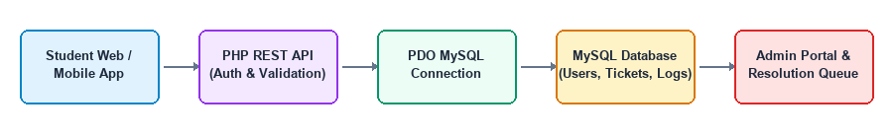
Fig. 5.1 My contribution – data flow from the frontend to MySQL Database
5.1 Database Design in MySQL
The database stores all operational information needed by the application. A users table holds accounts for students, technicians, and administrators. A categories table lists departments like Electrical and Hardware. A locations table maps campus blocks and room numbers. A tickets table holds every reported issue, its priority, photo attachment, and assigned technician. Relational tables ensure data consistency and prevent duplication.
5.2 Database Tables and Schema Structure
The primary tables and their relationships are structured so that any ticket's full lifecycle, reporting student, and assigned technician can be fetched with a single indexed join query.

Table 5.1 Relational Database Tables, Scope and Attributes
Table | Purpose | Key Fields
users | Accounts used for login and role verification | id, name, email, password, role, department
categories | Campus facility domains with SLA resolution hours | id, name, description, sla_hours
locations | Campus physical blocks, floors, and room numbers | id, block_name, floor, room_number
tickets | Every complaint submitted by a user | id, ticket_no, user_id, category_id, location_id, title, priority, status, image_url
ticket_history | Audit log of status changes and technician assignments | id, ticket_id, changed_by, old_status, new_status, timestamp
5.3 Connecting Backend to MySQL via PDO
The backend connects to MySQL once per request using PDO. Prepared statements ensure that database operations are fast and completely immune to SQL injection.
// backend/config/database.php - PDO Connection
class Database {
private $host = "localhost"; private $db_name = "smart_campus";
private $username = "root"; private $password = ""; public $conn;
public function getConnection() {
try {
$dsn = "mysql:host={$this->host};dbname={$this->db_name};charset=utf8mb4";
$this->conn = new PDO($dsn, $this->username, $this->password, [
PDO::ATTR_ERRMODE => PDO::ERRMODE_EXCEPTION,
PDO::ATTR_DEFAULT_FETCH_MODE => PDO::FETCH_ASSOC
]);
} catch(PDOException $e) { error_log("DB Error: " . $e->getMessage()); }
return $this->conn;
}
}
5.4 Authentication and Complaint Submission
At login, the backend verifies the user's password using password_verify() and starts a session. When a complaint is filed, the backend validates inputs, saves the image, and inserts the record.
// backend/api/create_ticket.php - Parameterized Ticket Insert
$query = "INSERT INTO tickets (ticket_no, user_id, category_id, location_id, title, description, priority, status, image_url)
VALUES (:ticket_no, :user_id, :cat_id, :loc_id, :title, :desc, :priority, 'Open', :img)";
$stmt = $db->prepare($query);
$stmt->execute([
':ticket_no' => 'TKT-' . date('Y') . '-' . strtoupper(bin2hex(random_bytes(3))),
':user_id' => $_SESSION['user_id'],
':cat_id' => $_POST['category_id'],
':loc_id' => $_POST['location_id'],
':title' => htmlspecialchars(strip_tags($_POST['title'])),
':desc' => htmlspecialchars(strip_tags($_POST['description'])),
':priority' => $_POST['priority'],
':img' => $uploaded_file_path
]);

5.5 System Outputs and User Interface Screens
The system interfaces were built to ensure clear navigation, role separation, and high usability. Below are the core operational screens developed for portal routing and student access.
5.5.1 Landing Portal & Student Authentication Screens (Outputs 1 & 2)
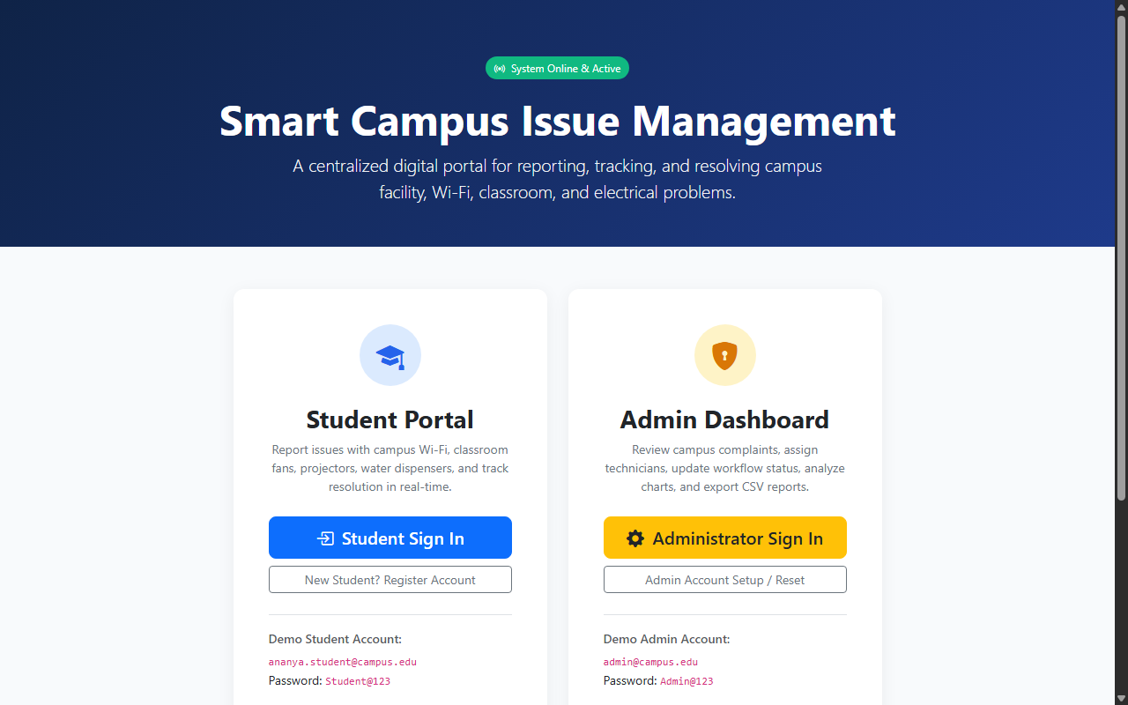
Fig. 5.2 Main Landing Portal Selector (Dual Routing for Students and Facility Administrators)
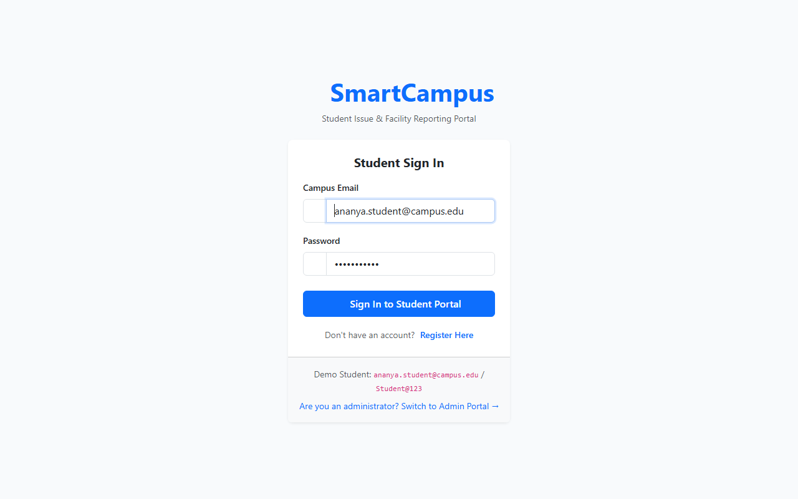
Fig. 5.3 Student Authentication & Login Interface with Session Security and Validation

5.5.2 Student Dashboard & New Complaint Filing (Outputs 3 & 4)
Once authenticated, students interact with their personalized complaint management environment to monitor existing tickets and file new grievances with attached photographic evidence.
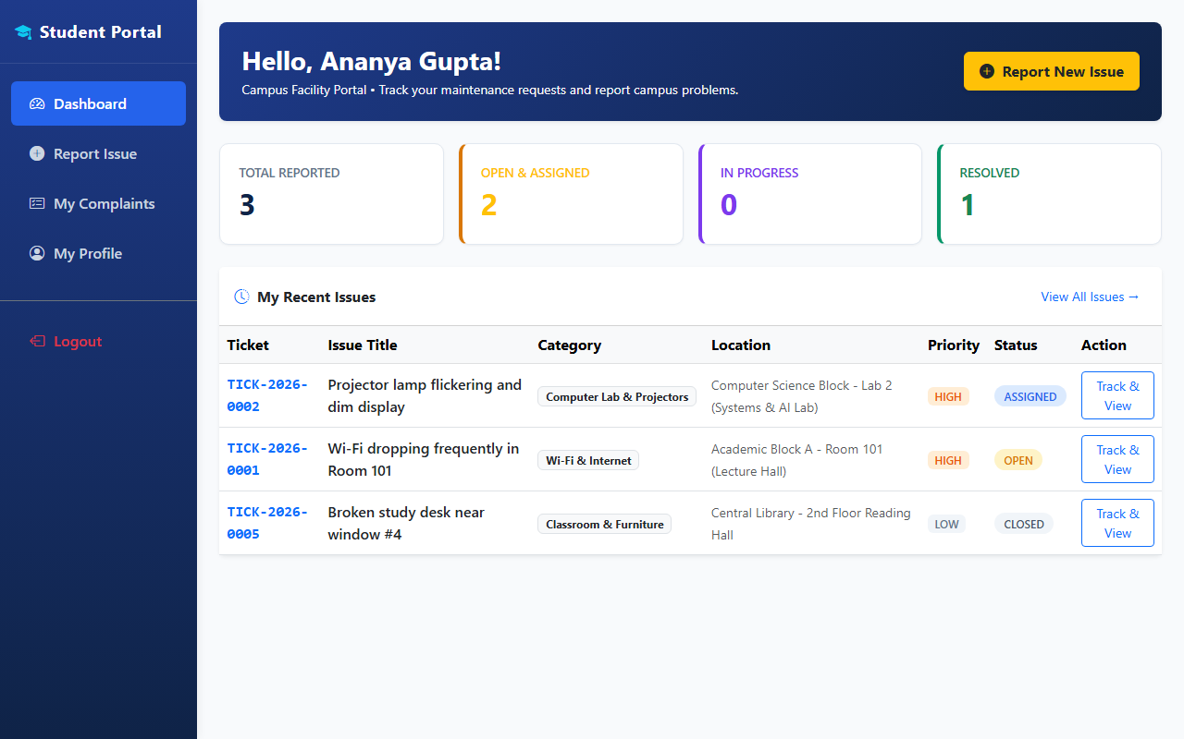
Fig. 5.4 Student Dashboard displaying KPI counters, live ticket status badges, and action buttons
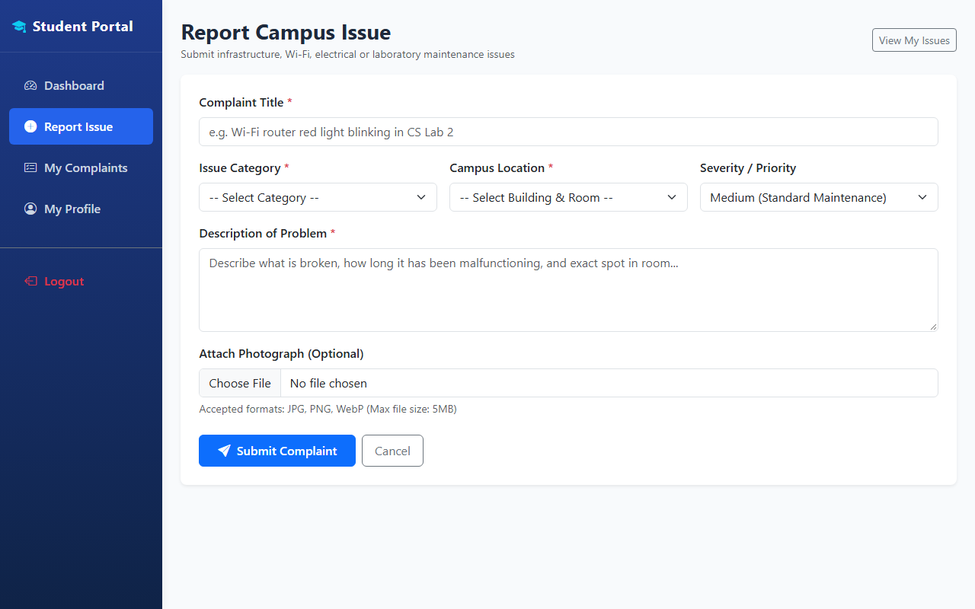
Fig. 5.5 New Complaint Filing Interface with Category selection, Room tagging, and Photo Evidence upload

5.5.3 Admin Control Dashboard & Resolution Queue (Outputs 5 & 6)
The administrative interface provides campus facility managers with complete oversight, real-time analytics, and technician allocation controls.
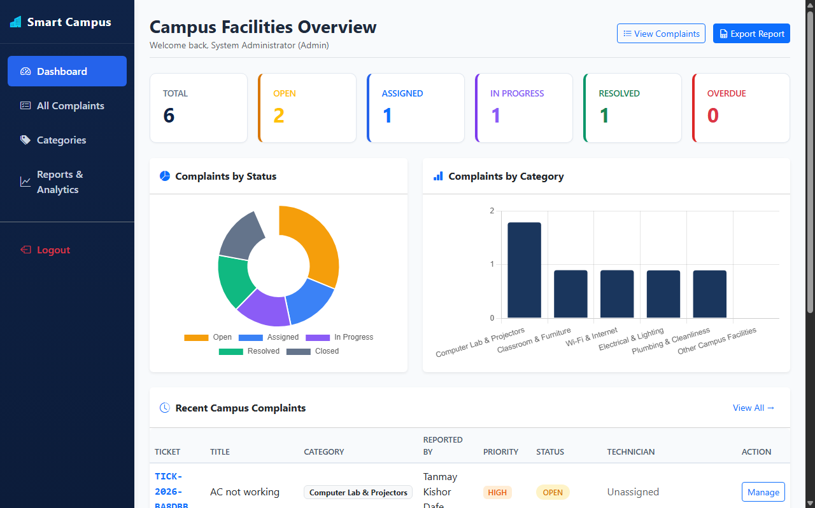
Fig. 5.6 Admin Central Control Dashboard featuring Real-Time KPI Cards and Chart.js Visualizations
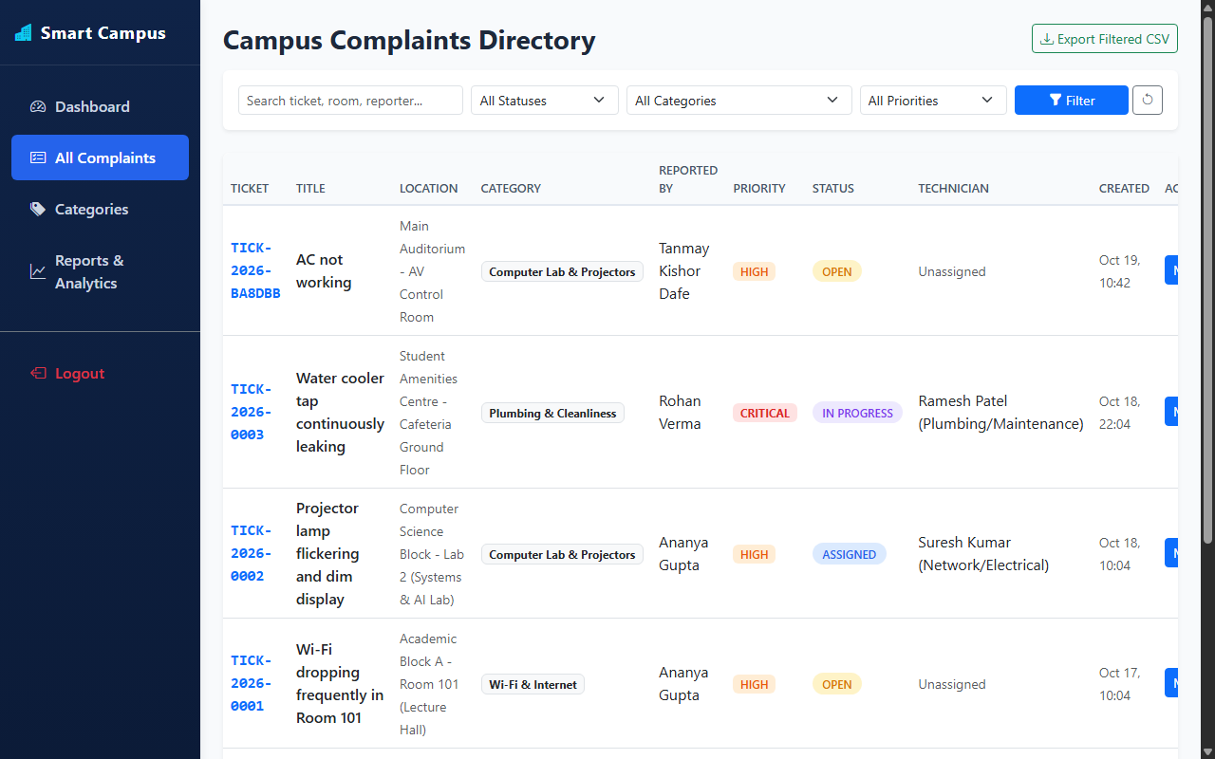
Fig. 5.7 Admin Complaints Management Table with Status filtering and Technician Assignment Controls
5.6 Team Activities – Integration & Quality Assurance Testing
Module Integration: Integrated REST APIs with the Android app and web portals, ensuring identical JSON contracts.
Testing: Verified SQL injection protection via PDO, confirmed file upload validation, and tested status update audit triggers across multi-role logins.

6. Outcomes Achieved
6.1 Technical Learning
- Learned principles of relational database design, foreign keys, normalization, and indexing in MySQL.
- Gained hands-on experience connecting PHP applications to MySQL using PDO and writing parameterized queries.
- Learned secure password handling using password_hash() and session management.
- Understood image file upload handling, MIME validation, and file path persistence in database tables.
- Practiced version control workflows using Git and GitHub for collaborative development.
6.2 Project Experience
- Collaborated with team members to match database schemas with web and mobile UI requirements.
- Saw the project grow from conceptual database design into a complete, usable campus management solution.
- Learned the importance of structured error handling and database transaction consistency.
7. Challenges Faced and Solutions
Managing data persistence and integration required addressing technical challenges between the frontend and MySQL:
Challenge | Solution Applied
Structuring relational campus data efficiently | Designed normalized tables for users, categories, locations, and complaints linked via foreign keys.
Preventing SQL injection vulnerabilities | Used PDO prepared statements with parameter binding for all database operations.
Handling file upload security for photos | Enforced MIME type checks on the server and generated unique file names before saving paths.
Maintaining an audit log of status updates | Created a dedicated ticket_history table to log every transition with timestamp and user ID.
Ensuring responsive dashboard metrics | Wrote optimized SQL aggregate queries (COUNT, GROUP BY) with indexed columns.

8. Conclusion
My contribution was the database and backend data integration layer of the Smart Campus Issue & Facility Management System. During the summer internship, I designed the MySQL schema, connected the PHP backend using PDO, and implemented structured storage for users, complaints, categories, and audit records so that the system maintains a complete, permanent operational record.
Working on the integration allowed me to ensure that what students report on the frontend, what the backend processes, and what administrators see on the dashboard remain synchronized. Issue reporting, technician assignment, and status timelines now pull directly from stored data, transforming manual register maintenance into an efficient digital process.
Overall, this internship gave me valuable practical experience in relational database design and demonstrated how a web platform becomes a robust product once data storage, security, and intuitive interfaces are integrated. In future, the database can be extended to support push notifications, mobile GPS coordinates, and preventive maintenance scheduling.
9. References
[1] Smart Campus Issue & Facility Management System – Internship Technical Documentation, Department of Information Technology, SVPCET Nagpur, 2026-27.
[2] Elmasri, R., & Navathe, S. B. (2021). Fundamentals of Database Systems, 7th Edition, Pearson Education.
[3] Nixon, R. (2021). Learning PHP, MySQL & JavaScript: With jQuery, CSS & HTML5, 6th Edition, O'Reilly Media.
[4] Fielding, R. T. (2000). Architectural Styles and the Design of Network-based Software Architectures, Doctoral dissertation, University of California, Irvine.
[5] MySQL 8.0 Reference Manual – https://dev.mysql.com/doc/refman/8.0/en/
[6] PHP Data Objects (PDO) Documentation – https://www.php.net/manual/en/book.pdo.php
[7] OWASP Foundation. (2023). OWASP Top Ten Web Application Security Risks – https://owasp.org/
[8] Chart.js Open-Source Charting Documentation – https://www.chartjs.org/docs/

