E-COMMERCE DATA ANALYTICS
Project Report — Python Data Analytics
Submitted by: Tanmay Debnath
Dataset: E Commerce Dataset.csv | Language: Python 3.11 | Libraries: pandas, matplotlib,
Date: June 2025
TABLE OF CONTENTS
1. Executive Summary
2. Project Overview & Objectives
3. Dataset Description
4. Step 1 — Data Collection & Loading
5. Step 2 — Data Cleaning & Quality Check
6. Step 3 — Sales Calculation
7. Step 4 — Grouping & Summarisation
8. Step 5 — Data Visualisation & Charts
9. Step 6 — Business Insights & Decisions
10. Project File Structure
11. Appendix — Python Source Code
1. Executive Summary
This report presents a complete end-to-end data analytics project on an E-Commerce transaction dataset. The project was developed using Python 3.11 with the pandas, matplotlib, and numpy libraries. The dataset contains 3,660 transaction records spanning January 2024 to November 2024 across 7 product categories and 5 payment methods.
The analysis follows six structured steps: (1) data loading, (2) data cleaning, (3) sales metric derivation, (4) grouped summarisation, (5) visual charting, and (6) business decision-making. Key findings include:
- Clothing is the top revenue-generating category with Rs. 1,15,314.84 in total sales.
- Credit Card is the most preferred payment method with 760 transactions.
- Q3 (July to September 2024) is the strongest quarter with Rs. 2,12,348.28 in revenue.
- Sunday records the highest order volume at 566 orders.
- Total revenue is Rs. 7,57,278.08 against a total discount of Rs. 1,75,292.39.
Nine charts were generated to visualise patterns, and nine actionable business recommendations were derived from the data analysis.
2. Project Overview & Objectives
The objective of this project is to apply data analytics techniques to a real-world e-commerce dataset in order to extract meaningful business insights. The project simulates a complete analytics pipeline as used in industry, covering the entire lifecycle from raw data to actionable decisions.
Project Objectives
Step | Objective
Step 1 — Load | Collect and load the CSV dataset into a pandas DataFrame for analysis.
Step 2 — Clean | Inspect and correct missing values, incorrect data types, invalid prices, and unparseable dates.
Step 3 — Sales | Derive the Sales metric: Sales = Quantity x Final_Price. Also compute Discount_Amount = Price - Final_Price.
Step 4 — Summarise | Group and aggregate data by Category, Payment Method, Month, Quarter, and Day-of-Week.
Step 5 — Visualise | Generate 9 charts (bar, pie, line, histogram) to visually communicate findings.
Step 6 — Decide | Produce 9 data-driven business recommendations from the analytical results.

3. Dataset Description
The dataset used is E Commerce Dataset.csv, a transactional sales file containing 3,660 records and 8 columns. Each row represents a single purchase transaction by a customer. The file covers the period 1 January 2024 to 21 November 2024.
Column Name | Data Type | Description
User_ID | String | Unique identifier for each customer
Product_ID | String | Unique identifier for each product
Category | String | Product category: Books, Beauty, Clothing, Electronics, Home & Kitchen, Sports, Toys
Price (Rs.) | Float | Original price of the product before discount
Discount (%) | Float | Percentage discount applied to the product
Final_Price(Rs.) | Float | Actual price paid by the customer after discount
Payment_Method | String | Payment channel: Credit Card, Debit Card, UPI, Net Banking, Cash on Delivery
Purchase_Date | Date (DD-MM-YYYY) | Date on which the transaction occurred
Note: The dataset does not include a Quantity column. Each row represents one transaction of one unit, therefore Quantity = 1 is assumed throughout this analysis.
4. Step 1 — Data Collection & Loading
The first step of the pipeline is to collect and load the raw CSV file into a pandas DataFrame. This is performed using pandas.read_csv(), which automatically infers column names from the header row.
Code Implementation:
import pandas as pd
df = pd.read_csv('E Commerce Dataset.csv')
Output Results:
Metric | Value
Total Rows Loaded | 3,660
Total Columns | 8
The file was found at the expected path and loaded successfully. The path is resolved dynamically using os.path so the script works from any machine.
5. Step 2 — Data Cleaning & Quality Check
Before analysis, the dataset must be validated and cleaned. The cleaning pipeline performs four operations in sequence:
- (1) Missing Value Detection — isnull().sum() was used to count missing values in each column. The dataset was found to have zero missing values across all 8 columns.
- (2) Empty Row Removal — Any rows where all 8 columns are empty are dropped. No such rows were found in this dataset.
- (3) Numeric Coercion & Validation — Price (Rs.), Discount (%), and Final_Price(Rs.) are cast to float. Rows with non-positive values in price columns (indicating data entry errors) are removed.
- (4) Date Parsing — Purchase_Date is parsed from DD-MM-YYYY format into a proper datetime object. Derived columns Month, Quarter, and DayOfWeek are then extracted for time-series analysis.
Data Quality Summary:
Check Performed | Result | Action Taken
Missing values | 0 missing values in all 8 columns | None required
Fully empty rows | 0 empty rows | None required
Invalid numeric prices | 0 invalid price rows | None required
Date parsing | All 3,660 dates parsed successfully | Derived Month, Quarter, DayOfWeek columns
Final clean dataset: 3,660 rows across date range 1 January 2024 to 21 November 2024.
6. Step 3 — Sales Calculation
Since each row in the dataset represents exactly one transaction with an implicit quantity of 1, the Sales and Discount Amount metrics are derived as follows:
Sales Formula: Sales = Quantity x Unit Price = 1 x Final_Price(Rs.) = Final_Price(Rs.)
Discount Amount: Discount_Amount = Price (Rs.) - Final_Price(Rs.)
Revenue Summary (All Transactions):
Metric | Value
Total Transactions | 3,660
Total Revenue (Rs.) | Rs. 7,57,278.08
Total Discount Given (Rs.) | Rs. 1,75,292.39
Average Sale Value (Rs.) | Rs. 206.91
The total discount of Rs. 1,75,292.39 represents approximately 18.8% of the gross (pre-discount) revenue, indicating a moderately aggressive discount strategy.
7. Step 4 — Grouping & Summarisation
The dataset is grouped across multiple dimensions to produce totals, counts, and averages. Five grouping analyses are performed.
7.1 Category Summary
Category | Total Sales (Rs.) | Transactions | Avg Sale (Rs.) | Avg Discount (%)
Clothing | 1,15,314.84 | 531 | 217.17 | 17.92
Books | 1,11,149.35 | 534 | 208.14 | 19.04
Home & Kitchen | 1,10,328.08 | 549 | 200.96 | 19.61
Sports | 1,08,518.79 | 520 | 208.69 | 19.33
Toys | 1,07,289.69 | 523 | 205.14 | 18.13
Beauty | 1,04,215.10 | 505 | 206.37 | 18.48
Electronics | 1,00,462.23 | 498 | 201.73 | 19.27
Key finding: Clothing leads in total revenue while Home & Kitchen has the highest transaction count. Electronics is the lowest-revenue category.
7.2 Payment Method Summary
Payment Method | Transactions | Avg Sale (Rs.)
Credit Card | 760 | 205.29
UPI | 757 | 204.34
Debit Card | 731 | 209.80
Net Banking | 716 | 205.03
Cash on Delivery | 696 | 210.36
Key finding: Credit Card and UPI are almost equally popular. Cash on Delivery users have the highest average sale value (Rs. 210.36).
7.3 Quarterly Revenue Summary
Quarter | Revenue (Rs.) | Orders | Avg Sale (Rs.)
Q1 (Jan–Mar) | 2,09,521.17 | 1,003 | 208.89
Q2 (Apr–Jun) | 2,07,459.04 | 1,018 | 203.79
Q3 (Jul–Sep) | 2,12,348.28 | 1,032 | 205.76
Q4 (Oct–Nov*) | 1,27,949.59 | 607 | 210.79
* Q4 data is partial — covers only October and November 2024.
7.4 Day-of-Week Order Pattern
Day | Orders | Revenue (Rs.)
Monday | 522 | 1,08,624.43
Tuesday | 542 | 1,12,299.98
Wednesday | 509 | 1,03,007.68
Thursday | 525 | 1,13,187.49
Friday | 519 | 1,06,048.81
Saturday | 477 | 98,827.45
Sunday | 566 | 1,15,282.24
Key finding: Sunday is the peak shopping day with 566 orders. Saturday records the fewest orders (477).
8. Step 5 — Data Visualisation & Charts
Nine charts were produced using matplotlib and saved as PNG images in the charts/ directory. All charts use a consistent clean theme with a light grey background, no top/right spines, and subtle grid lines.
# | Chart File | Description
1 | 01_sales_by_category.png | Horizontal bar chart of total revenue per category with value labels
2 | 02_transactions_by_category.png | Vertical bar chart of transaction count per category
3 | 03_revenue_share_pie.png | Donut chart showing percentage revenue share by category
4 | 04_monthly_revenue_trend.png | Line chart with filled area showing monthly revenue trend (Jan–Nov 2024)
5 | 05_payment_method_analysis.png | Dual-axis chart: bar (transactions) + line (avg sale) by payment method
6 | 06_avg_discount_by_category.png | Bar chart of average discount percentage per category
7 | 07_orders_by_day.png | Bar chart of order count by day of the week
8 | 08_quarterly_summary.png | Grouped bar chart comparing quarterly revenue and order count
9 | 09_sales_distribution.png | Histogram of sale value distribution with mean and median lines
Chart 1: Total Sales Revenue by Category
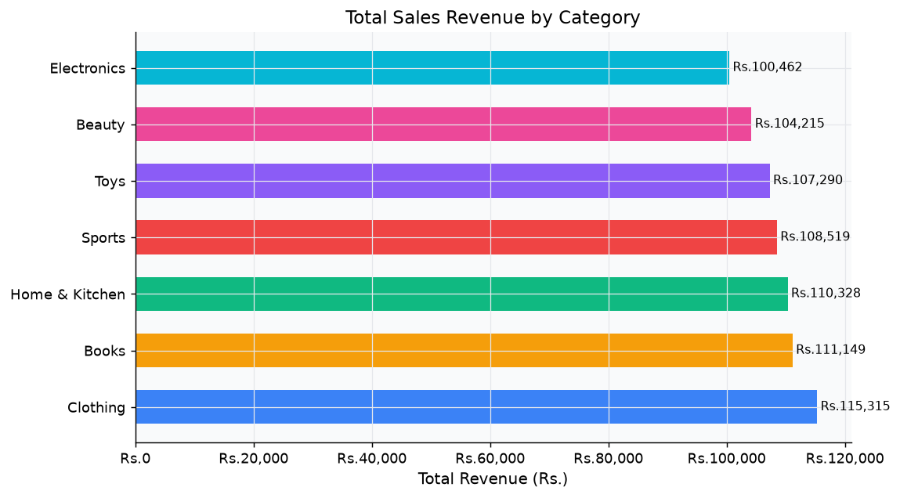
Figure 1: Clothing generates the highest revenue (Rs. 1,15,314) followed by Books. Electronics is the lowest at Rs. 1,00,462.
Chart 2: Transaction Count by Category
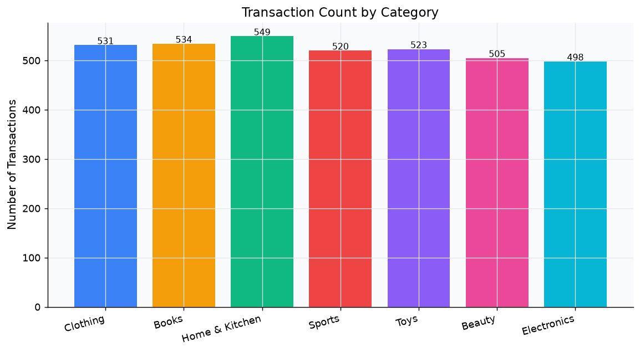
Figure 2: Home & Kitchen has the highest transaction count (549) while Electronics has the fewest (498).
Chart 3: Revenue Share by Category (Donut)
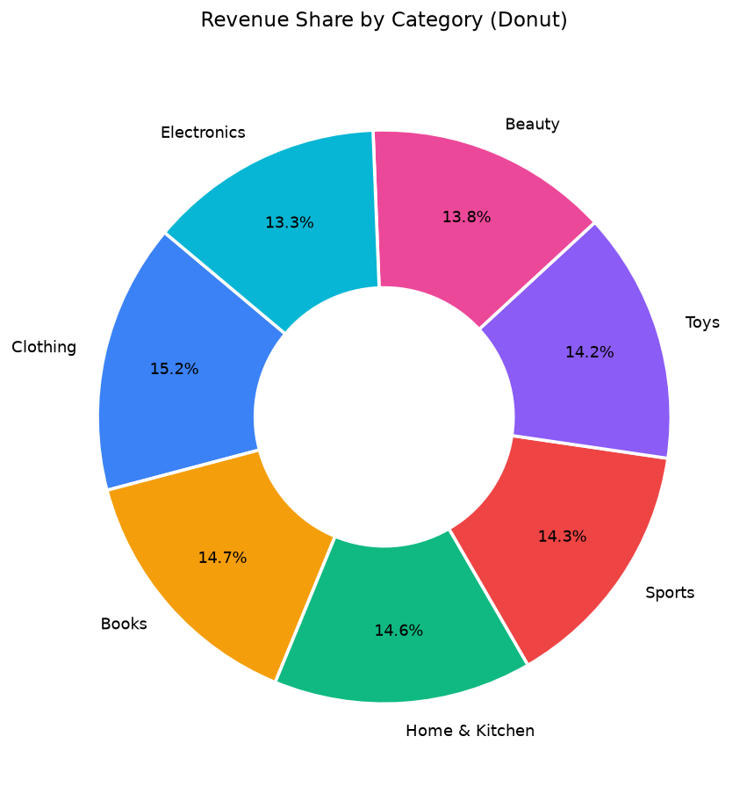
Figure 3: Revenue is evenly distributed across all 7 categories — each holds approximately 13–15% of total revenue.
Chart 4: Monthly Revenue Trend (Jan–Nov 2024)
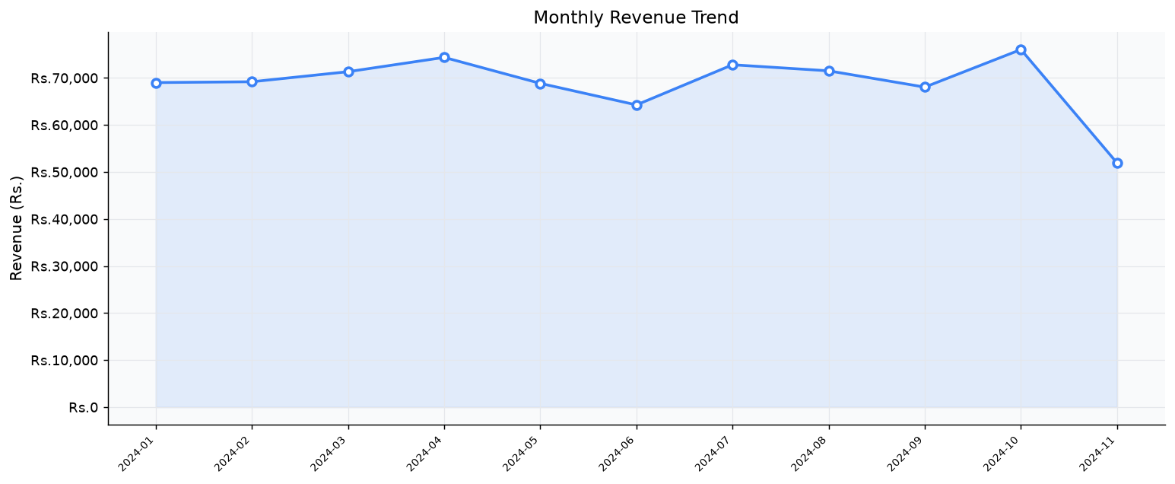
Figure 4: Revenue peaks in October 2024. November appears lower due to the dataset ending on 21 November 2024.
Chart 5: Payment Method Analysis
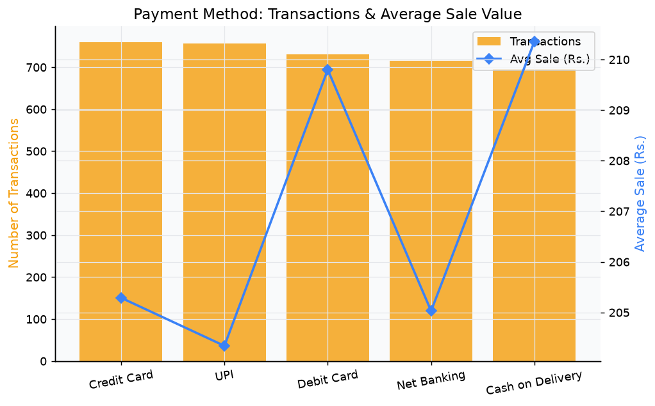
Figure 5: Credit Card leads in transaction count. Cash on Delivery customers have the highest average sale (Rs. 210.36).
Chart 6: Average Discount by Category
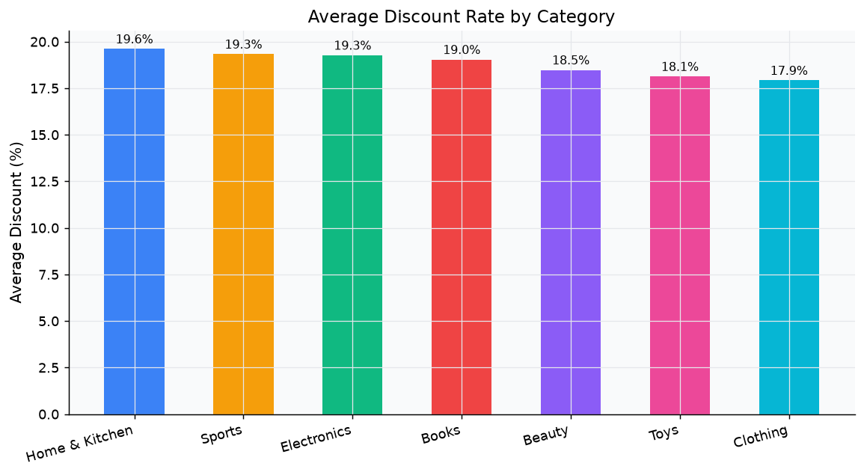
Figure 6: Home & Kitchen carries the highest average discount (19.6%). Clothing has the most restrained discount (17.9%).
Chart 7: Orders by Day of the Week
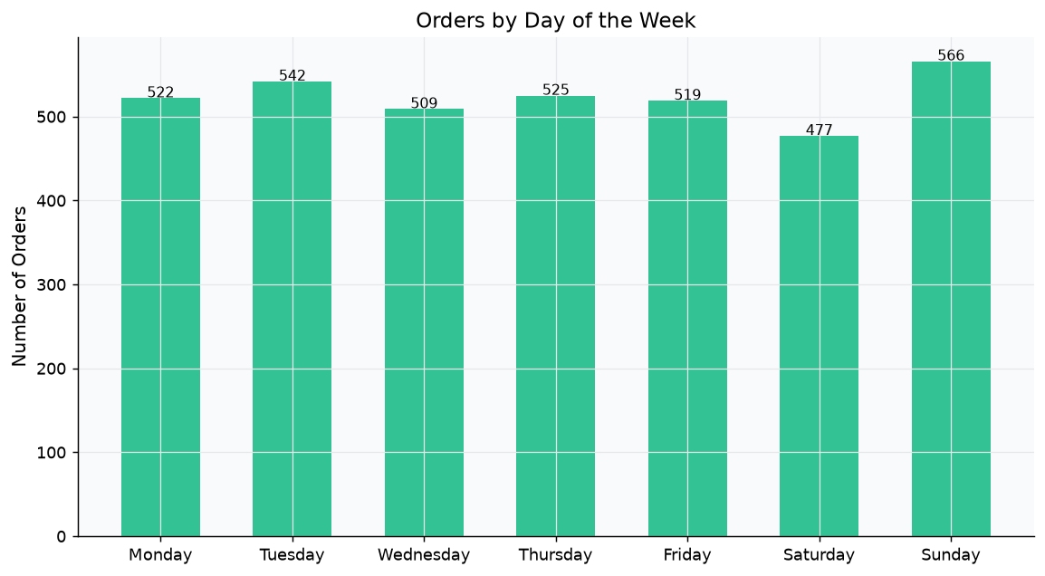
Figure 7: Sunday is the busiest day (566 orders). Saturday records the fewest purchases (477 orders).
Chart 8: Quarterly Revenue & Order Count
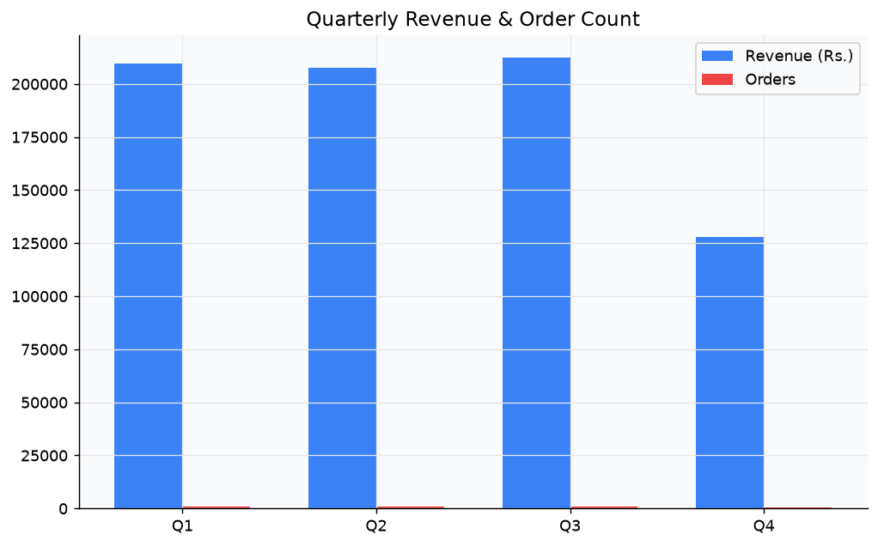
Figure 8: Q3 is the strongest full quarter. Q4 shows lower values as it covers October and November only.
Chart 9: Sale Value Distribution
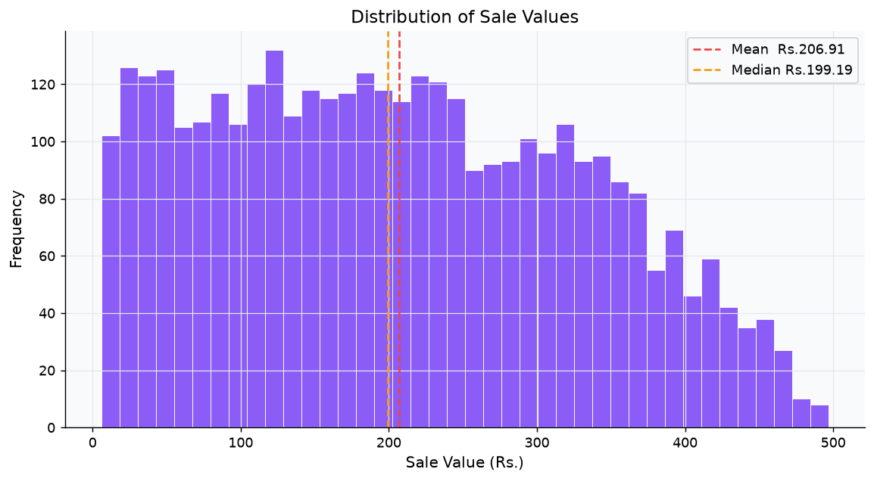
Figure 9: The distribution of sale values is spread across a wide range. The mean (Rs. 206.91) and median are close, indicating minimal extreme outliers.
9. Step 6 — Business Insights & Decisions
Nine data-driven business recommendations were derived from the analytical results. Each insight maps a finding from the data to a concrete action.
# | Insight Title | Finding & Recommendation
1 | Revenue Leader | Clothing generates the highest revenue at Rs. 1,15,314.84. Recommendation: Increase product variety and marketing spend in Clothing to capitalise on its strong performance.
2 | Underperformer | Electronics is the lowest-revenue category at Rs. 1,00,462.23. Recommendation: Review pricing, run targeted promotions, or bundle Electronics with Clothing or Sports to uplift its sales.
3 | Preferred Payment | Credit Card is the most-used payment method with 760 transactions. Recommendation: Negotiate lower processing fees with credit card providers and offer exclusive cashback or rewards.
4 | Peak Month | October 2024 records the highest monthly revenue. Recommendation: Build up inventory and plan flash-sale campaigns in advance of October every year.
5 | Slow Month | November 2024 records the lowest revenue in the captured window. Recommendation: Launch off-season discounts or loyalty incentives to boost sales in November.
6 | Discount Strategy | Home & Kitchen carries the highest average discount at 19.6%. Recommendation: Audit whether deep discounts are eroding margins; replace discounts with value-add bundles.
7 | Best Quarter | Q3 (July–September) is the strongest quarter with Rs. 2,12,348 revenue. Recommendation: Align supply chain and staffing with Q3 peak demand.
8 | Peak Shopping Day | Sunday records the most orders (566). Recommendation: Schedule email campaigns and push notifications on Thursdays and Fridays to smooth the order flow and reduce Sunday concentration.
9 | VIP Customer Tier | Top 10 customers account for Rs. 4,887.52 in spend. Recommendation: Introduce a VIP loyalty programme to retain high-value customers and grow their spend over time.

10. Project File Structure
The project is organised in the following directory structure within the IBM BOB Project workspace:
File / Folder | Purpose
E Commerce Dataset.csv | Raw input dataset (3,660 transactions, 8 columns)
TANMAY_DEBNATH_ecommerce_analysis.docx | This professional project report (current file)
ecommerce_analytics/ | Project root folder
ecommerce_analytics/TANMAY_DEBNATH_ecommerce_analysis.py | Main Python analytics script (all 6 steps)
ecommerce_analytics/requirements.txt | Python dependency list: pandas, matplotlib, numpy
ecommerce_analytics/README.md | Setup and usage guide for the project
ecommerce_analytics/category_summary.csv | Generated output: category-level aggregation table
ecommerce_analytics/charts/01_sales_by_category.png | Chart: Total revenue per category (horizontal bar)
ecommerce_analytics/charts/02_transactions_by_category.png | Chart: Transaction count per category (vertical bar)
ecommerce_analytics/charts/03_revenue_share_pie.png | Chart: Revenue share by category (donut)
ecommerce_analytics/charts/04_monthly_revenue_trend.png | Chart: Monthly revenue trend (line with fill)
ecommerce_analytics/charts/05–09_*.png | Charts: Payment method, discount, day-of-week, quarterly, histogram
Run command | python ecommerce_analytics/TANMAY_DEBNATH_ecommerce_analysis.py

11. Appendix — Python Source Code
The following is the complete source code of the analytics script TANMAY_DEBNATH_ecommerce_analysis.py. The script is structured into six clearly labelled steps, each matching a section of this report.
File: ecommerce_analytics/TANMAY_DEBNATH_ecommerce_analysis.py
# Imports & Configuration
import os, sys, warnings, io
import matplotlib; matplotlib.use('Agg')
import matplotlib.pyplot as plt
import matplotlib.ticker as mticker
import numpy as np
import pandas as pd
# Path Setup
SCRIPT_DIR = os.path.dirname(os.path.abspath(__file__))
PROJECT_ROOT = os.path.dirname(SCRIPT_DIR)
CSV_PATH = os.path.join(PROJECT_ROOT, 'E Commerce Dataset.csv')
CHARTS_DIR = os.path.join(SCRIPT_DIR, 'charts')
os.makedirs(CHARTS_DIR, exist_ok=True)
# STEP 1 — Load Dataset
df = pd.read_csv(CSV_PATH)
# STEP 2 — Data Cleaning
missing = df.isnull().sum()
df.dropna(how='all', inplace=True)
text_cols = df.select_dtypes(include='object').columns.tolist()
df[text_cols] = df[text_cols].fillna('Unknown')
for col in ['Price (Rs.)', 'Discount (%)', 'Final_Price(Rs.)']:
df[col] = pd.to_numeric(df[col], errors='coerce')
mask_valid = (df['Price (Rs.)'] > 0) & (df['Final_Price(Rs.)'] > 0)
df = df[mask_valid].copy()
df['Purchase_Date'] = pd.to_datetime(df['Purchase_Date'], format='%d-%m-%Y', errors='coerce')
df['Month'] = df['Purchase_Date'].dt.to_period('M').astype(str)
df['Quarter'] = df['Purchase_Date'].dt.quarter.map(lambda q: f'Q{q}')
df['DayOfWeek']= df['Purchase_Date'].dt.day_name()
# STEP 3 — Sales Calculation
df['Quantity'] = 1
df['Sales'] = df['Quantity'] * df['Final_Price(Rs.)'] # Sales = Qty x Unit Price
df['Discount_Amount'] = df['Price (Rs.)'] - df['Final_Price(Rs.)']
# STEP 4 — Grouping & Summarisation
cat_summary = df.groupby('Category').agg(
Total_Sales=('Sales','sum'), Transactions=('Sales','count'),
Avg_Sale=('Sales','mean'), Avg_Discount=('Discount (%)','mean'),
Total_Discount=('Discount_Amount','sum')).sort_values('Total_Sales',ascending=False).round(2)
pay_summary = df.groupby('Payment_Method').agg(
Total_Sales=('Sales','sum'), Transactions=('Sales','count'),
Avg_Sale=('Sales','mean')).sort_values('Transactions',ascending=False).round(2)
monthly = df.groupby('Month').agg(Revenue=('Sales','sum'),Orders=('Sales','count')).reset_index().sort_values('Month').round(2)
quarterly = df.groupby('Quarter').agg(Revenue=('Sales','sum'),Orders=('Sales','count'),Avg_Sale=('Sales','mean')).reset_index().round(2)
dow_order = ['Monday','Tuesday','Wednesday','Thursday','Friday','Saturday','Sunday']
dow_summary = df.groupby('DayOfWeek').agg(Revenue=('Sales','sum'),Orders=('Sales','count')).reindex(dow_order).dropna().round(2)
# STEP 5 — Chart Generation (9 charts — abbreviated)
# Chart 1: Total Sales by Category (horizontal bar)
fig, ax = plt.subplots(figsize=(9, 5))
ax.barh(cat_summary.index, cat_summary['Total_Sales'], color=PALETTE[:len(cat_summary)], height=0.6)
ax.set_title('Total Sales Revenue by Category')
plt.savefig(os.path.join(CHARTS_DIR, '01_sales_by_category.png'), dpi=130, bbox_inches='tight')
# ... Charts 2–9 follow the same pattern (see full script for complete code)
# STEP 6 — Business Insights (auto-generated from data)
top_cat = cat_summary['Total_Sales'].idxmax()
low_cat = cat_summary['Total_Sales'].idxmin()
top_pay = pay_summary['Transactions'].idxmax()
best_month= monthly.loc[monthly['Revenue'].idxmax(), 'Month']
# Insights are printed as numbered recommendations — see section 9 of this report.
--- End of Report ---

