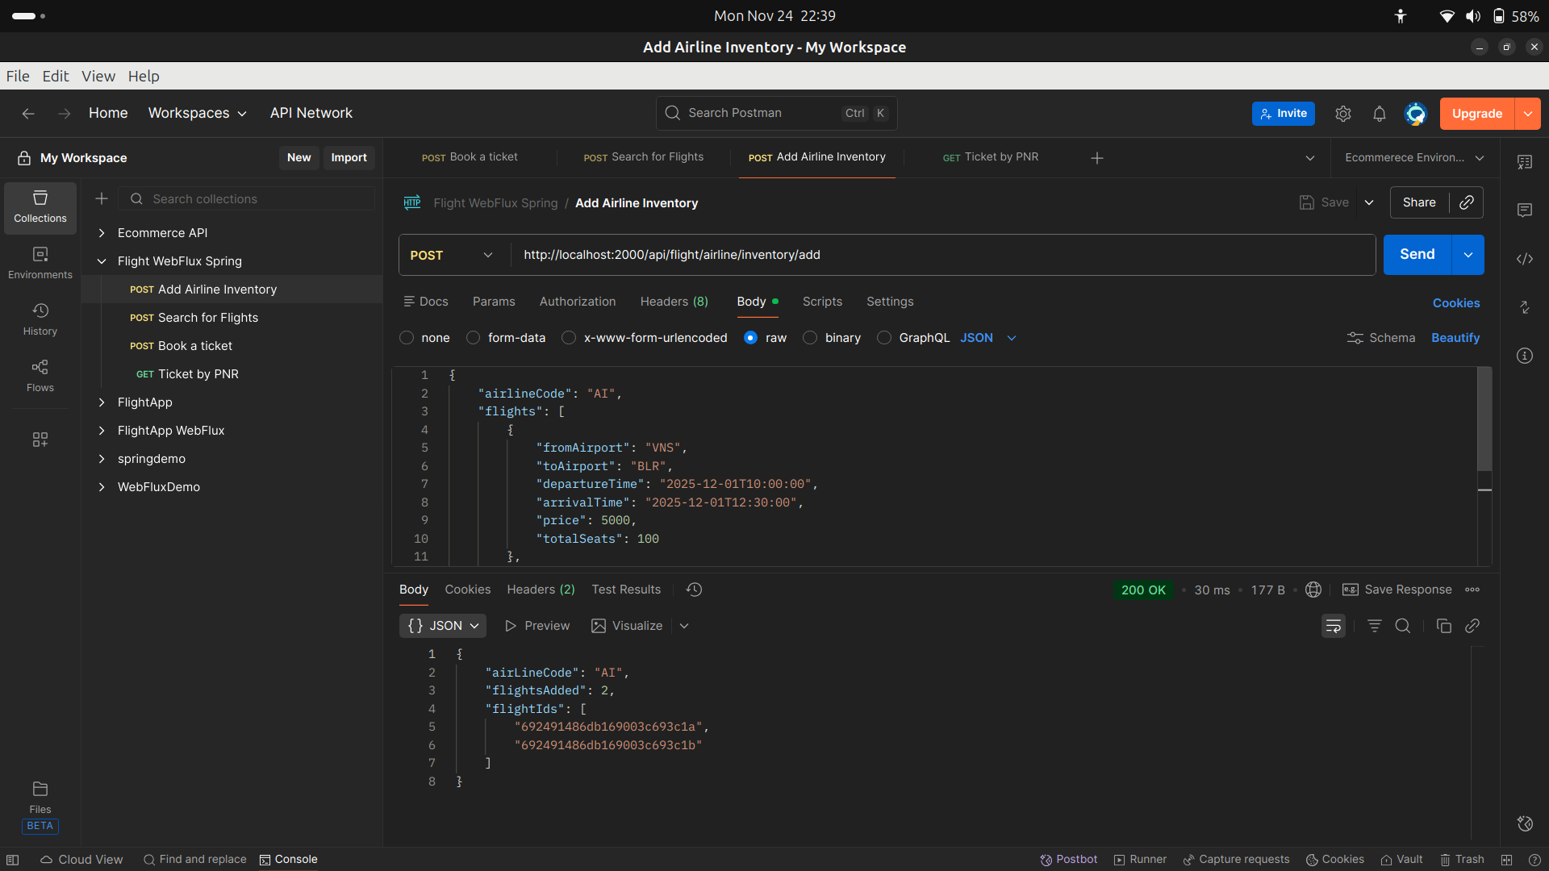
Postman testing
1) Add Airline Inventory

2) Search Flight

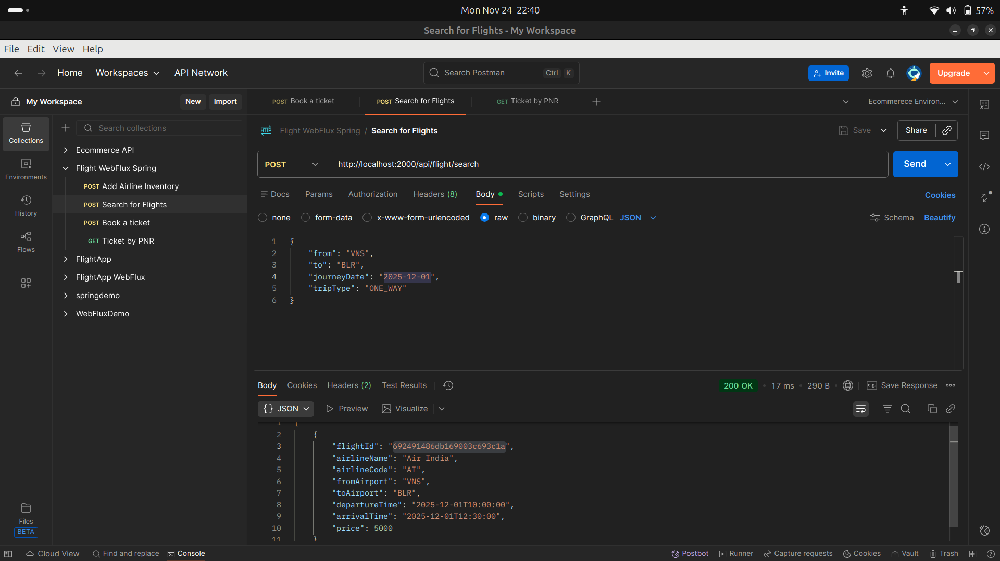

3) One-way Booking

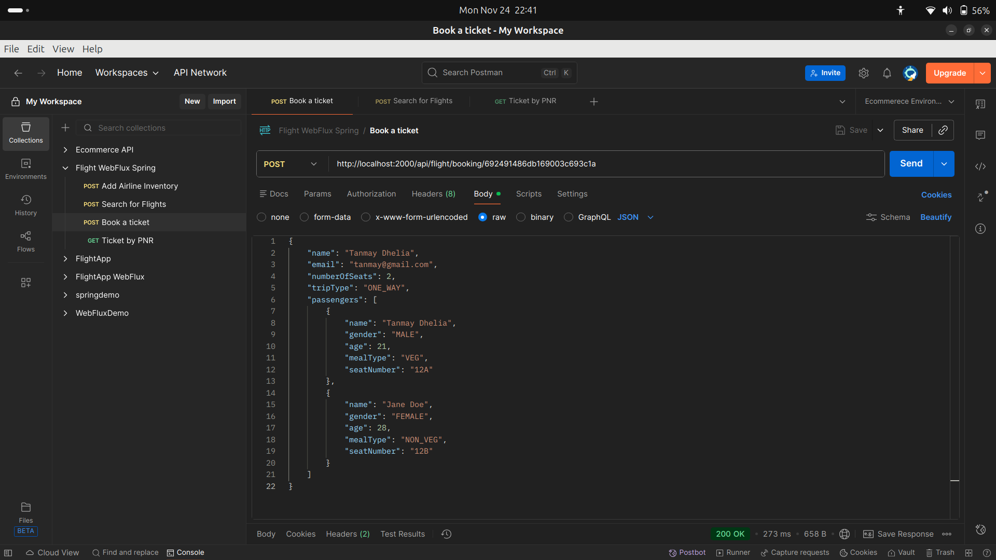
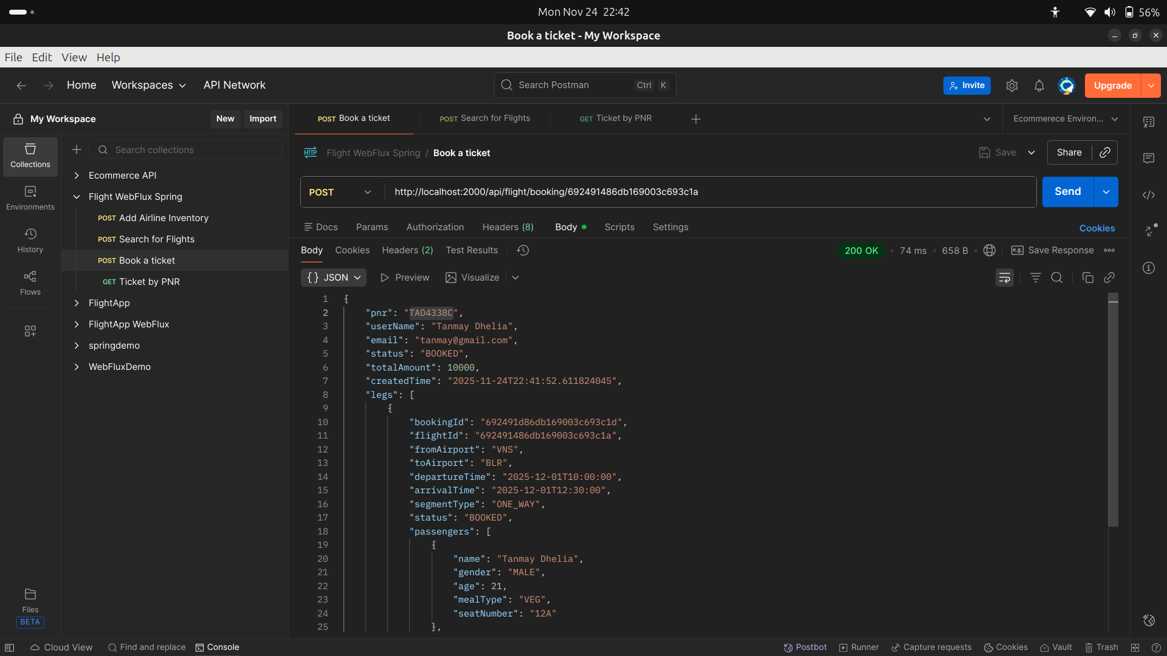

4)Round-Trip Booking

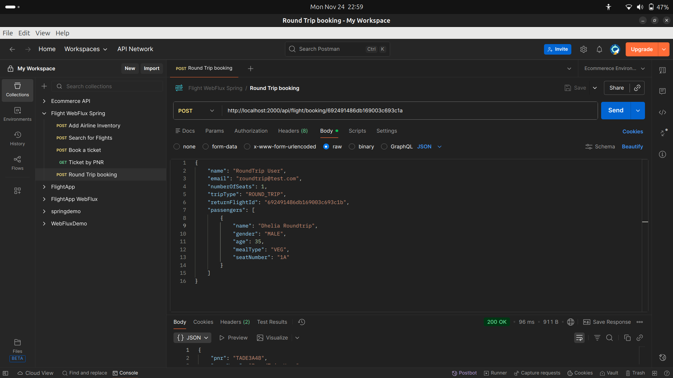
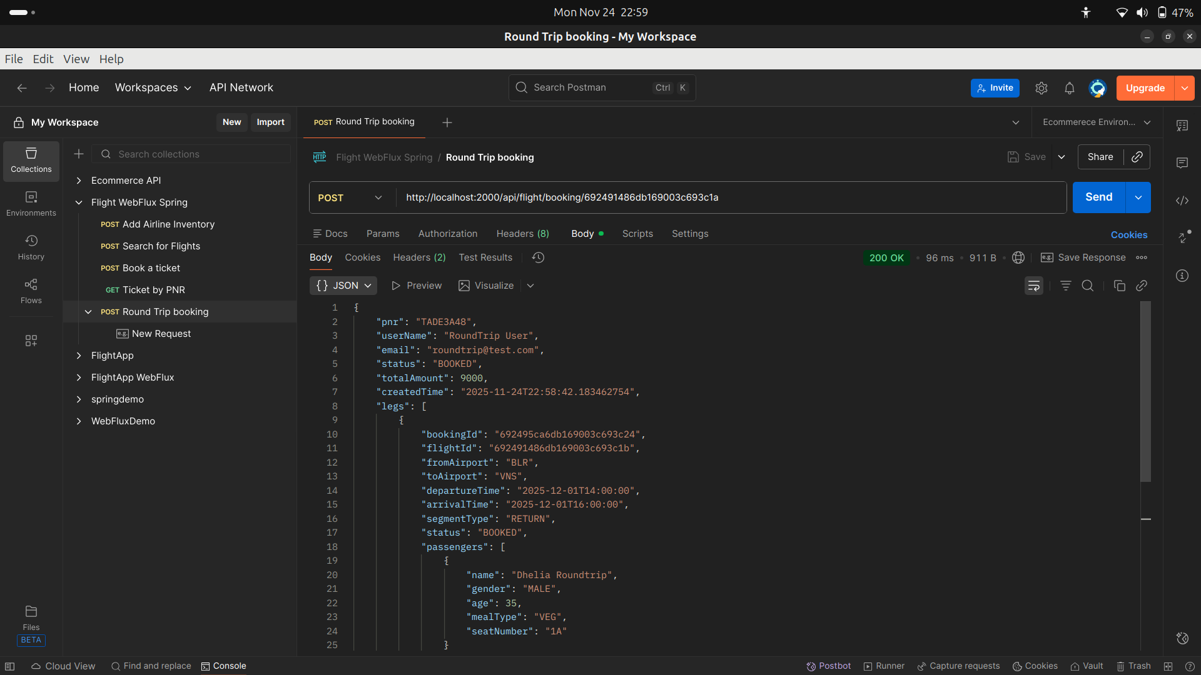

5) Fetch Bookings by Email
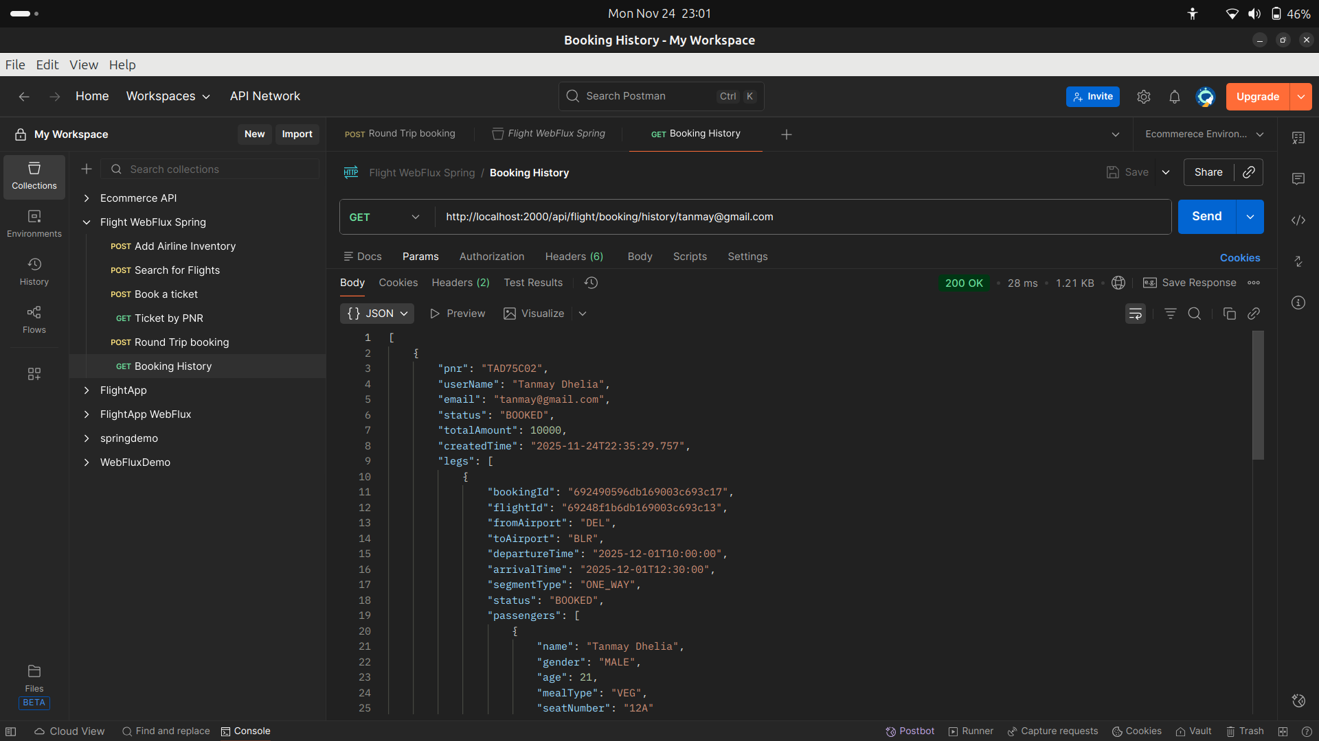

6) Cancel Ticket (Returns Nothing)

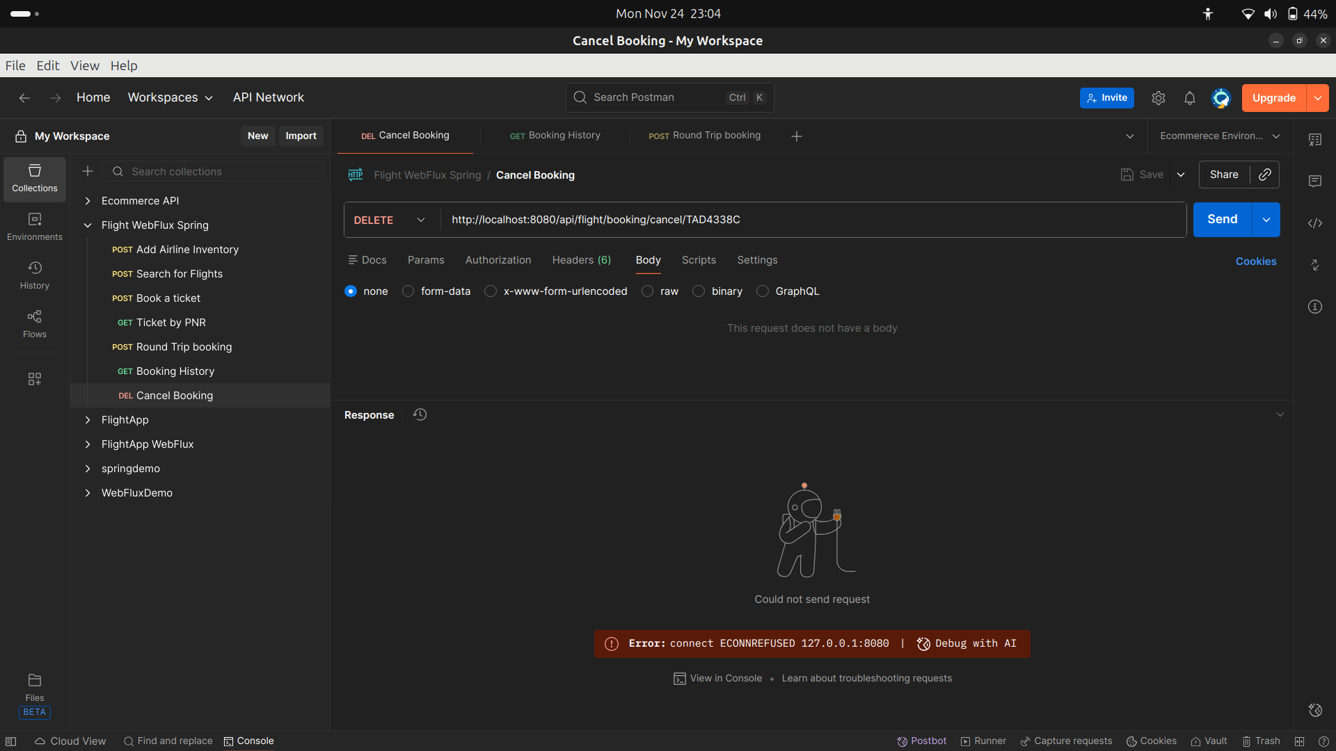

Apache Jmeter testing
Test Plan

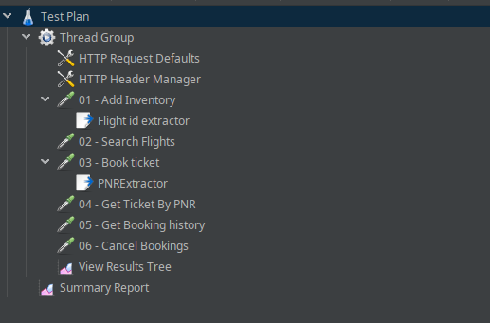

20 Users
Summary Report
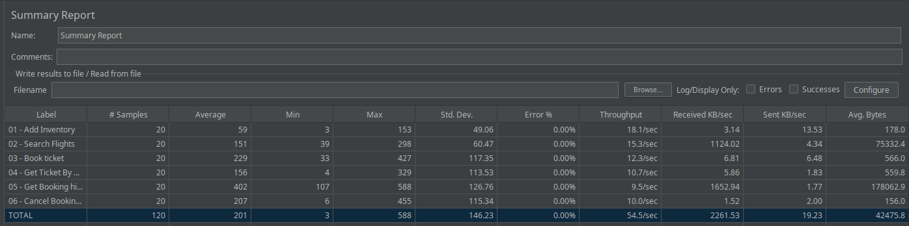
Result Tree
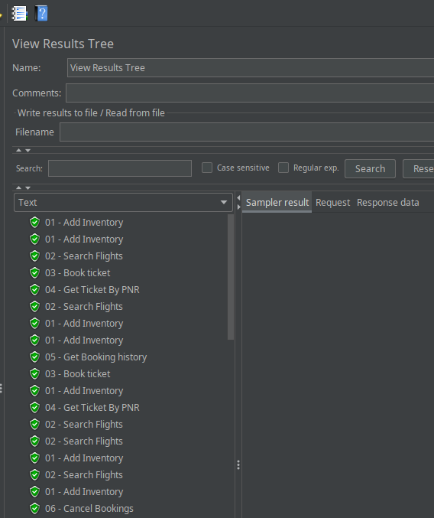

50 Users
Summary Report
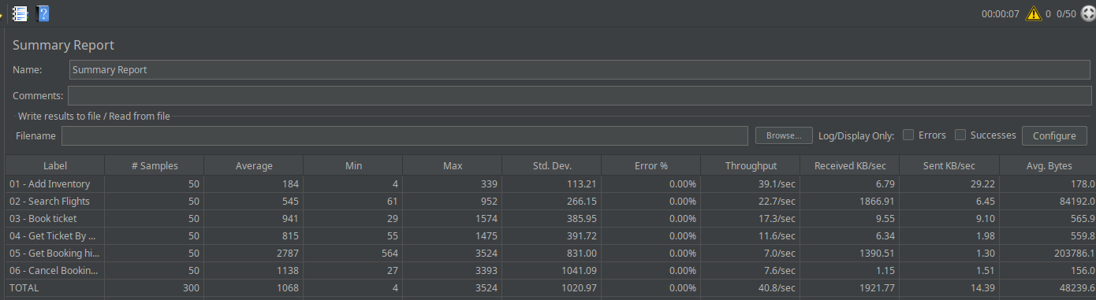

Result Tree
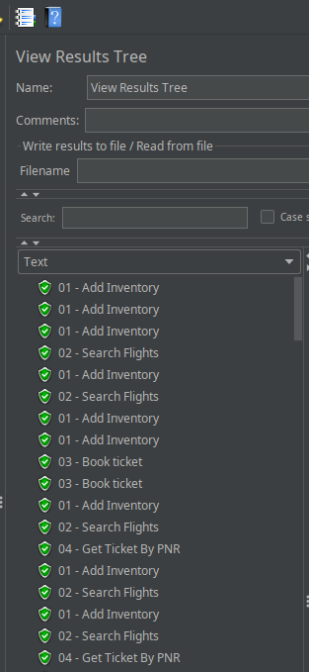
100 Users

Summary Report
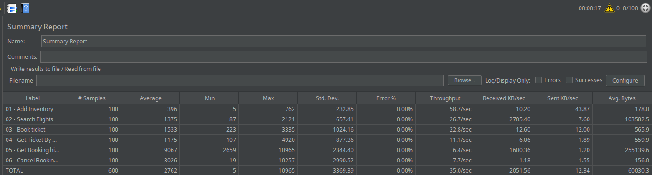

Result Tree
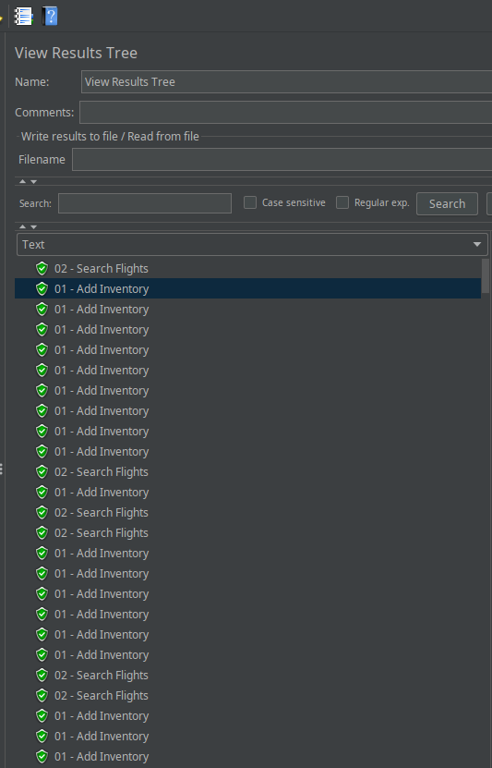

SonarQube Report

→ Previous Report
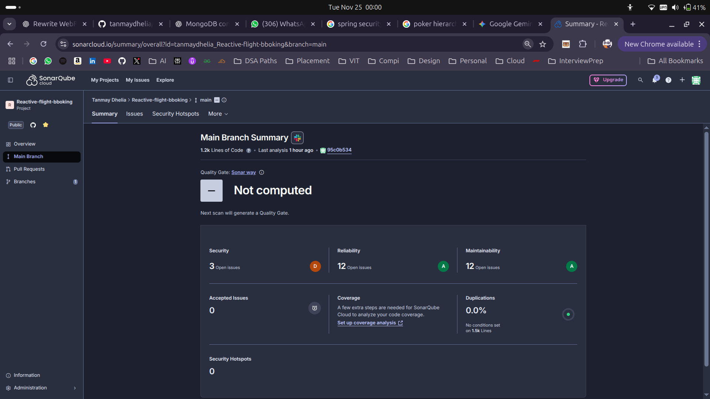
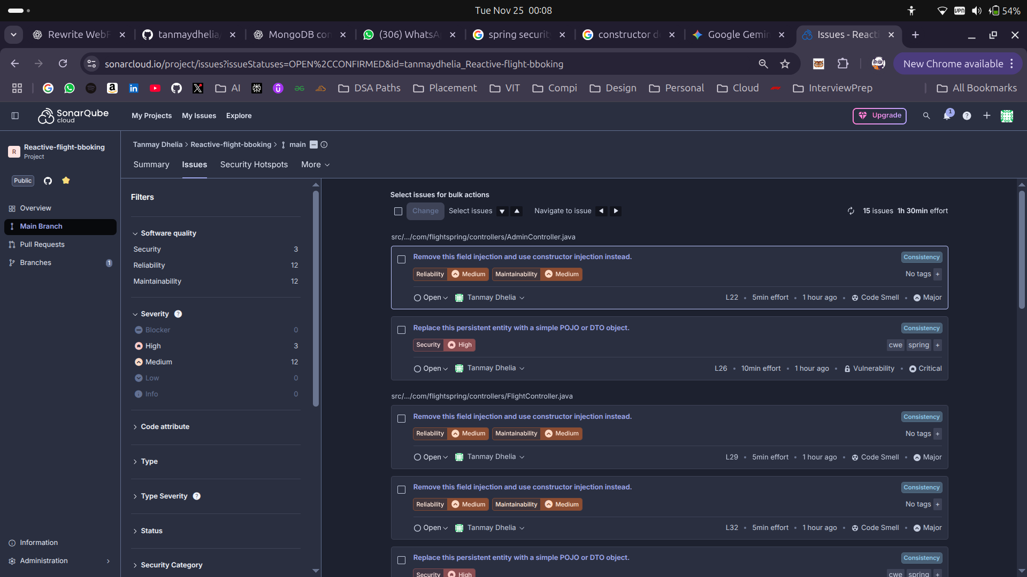

→ After Resolving Issues

- Removed Autowired and added dependency injection using constructors
- DTO were annonated as @Document but SonarQube wants DTO to be strictly DTO , hence resolved that

