Tanmay Fadnavis

SUID: 971141760

Computer Security

Lab-6

# TASK 1: DOCUMENT OBJECT MODEL

The practice for dom objects are below along with the screen shots. The code snippets are included in the screen shot itself.

Change HTML elements (getElementById, InnerHTML)

<http://www.w3schools.com/js/exercise.asp?filename=exercise_dom_change1>

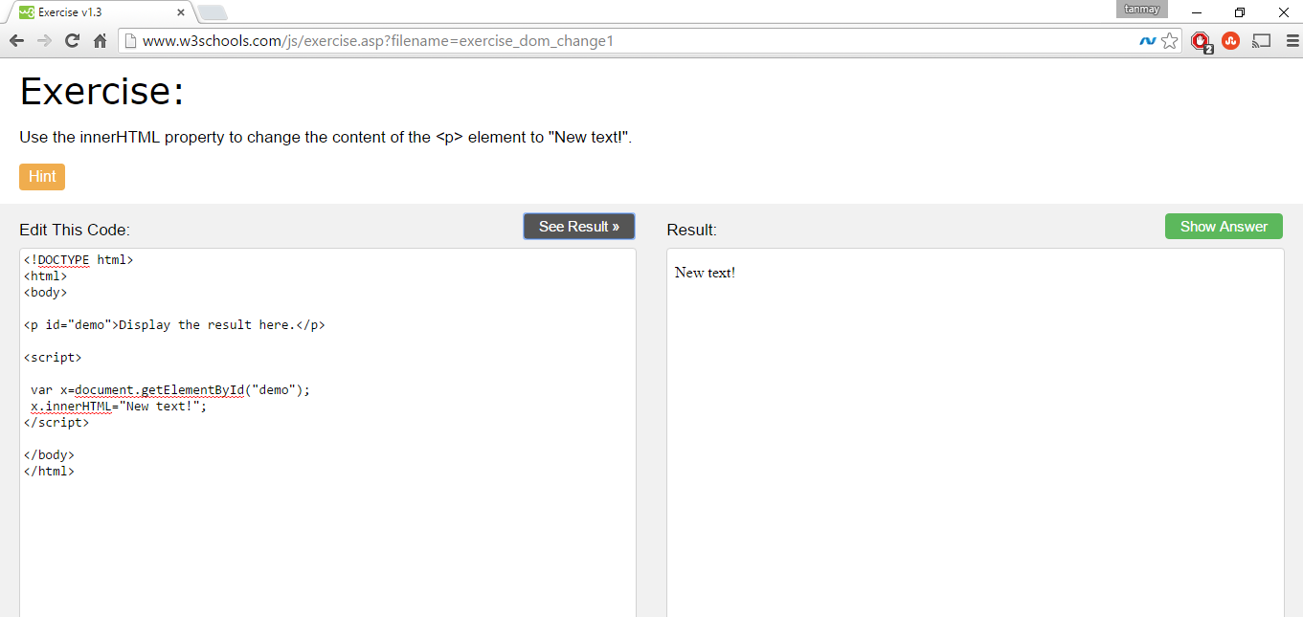

In the above screen shot in the result, we can see that I have added new text.

The code snippet is:

Var x =document.getElementById(“demo”);

x.innerHTML=”New Text”;

Thus, first, I am getting the dom element “p” with the id “demo” using the getelementById function and then using the innerHTML property writing the “New Text”. The innerHTML property will erase everything that was previously in that DOM element and over-write it with the new value that we provide. Hence we can see the “New Text” in the result in the screen shot.

<http://www.w3schools.com/js/exercise.asp?filename=exercise_dom_change4>

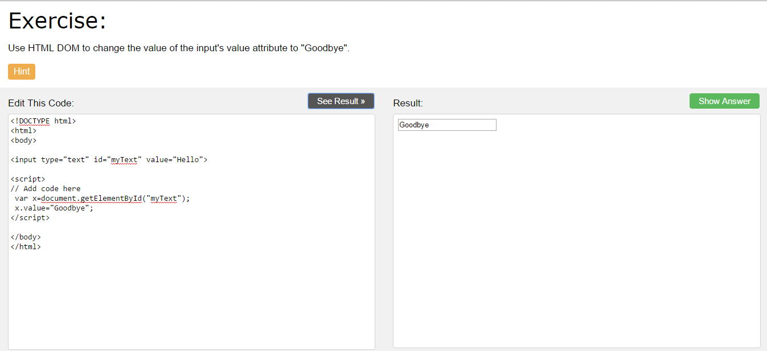

In the above screen shot, we can see that I have changed the input’s value attribute to “Goodbye”. The code snippet is,

Var x=document.getElementByid(“myText”);

x.value=”GoodBye”;

Thus, first I am getting the input identified by the id”myText” using getElementByid function. Then I am just setting the value to “GoodBye”. Hence in the result, we can see GoodBye as the default value of the input.

Add Event Handler to HTML elements

<http://www.w3schools.com/js/exercise.asp?filename=exercise_dom_events2>

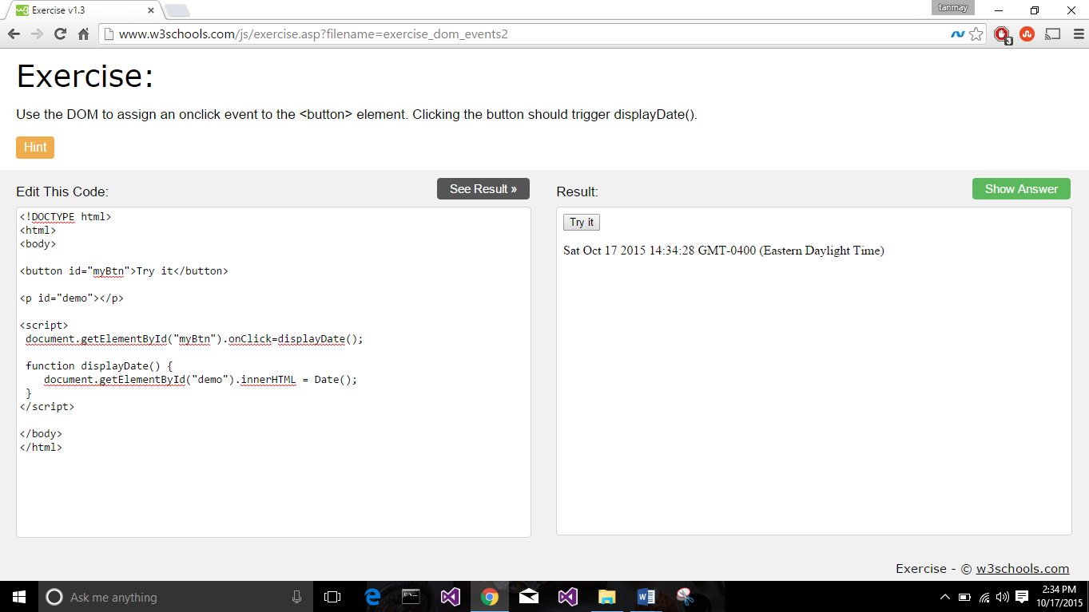

In this task, as we can see from the screen shot, I have add an event handler to the button. Thus in the javascript I am getting the DOM element button using the getElementById, a built-in javascript function and then just adding a onClick() function to it. That means when the button is clicked, the action described in the onClick() function will be called. In our case, displayDate() function is getting called. Thus whenever someone clicks the button, displayDate() function is called which basically displays the date in the paragraph (p) dom element. Code,

Document.getElementById(“demo”).onClick=displayDate();

<http://www.w3schools.com/js/exercise.asp?filename=exercise_dom_events1>

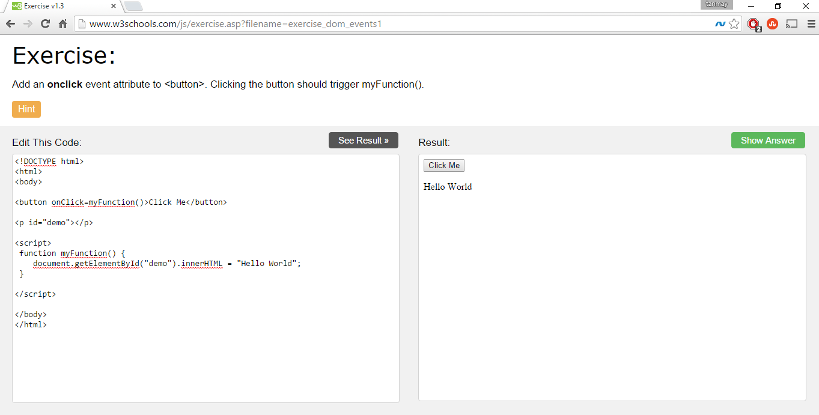

In the above screen shot, we can see that I am just adding the onclick event attribute in the html part itself. This is another way of adding the events to a DOM element. Thus, whenever the button is clicked, myFunction() will be called. In this case, it displays the “Hello World”.

<button onClick=myFunction()>Click Me</button>

HTML DOM Cookie Property (Code already Provided, just run it)

<http://www.w3schools.com/jsref/tryit.asp?filename=tryjsref_doc_cookie>

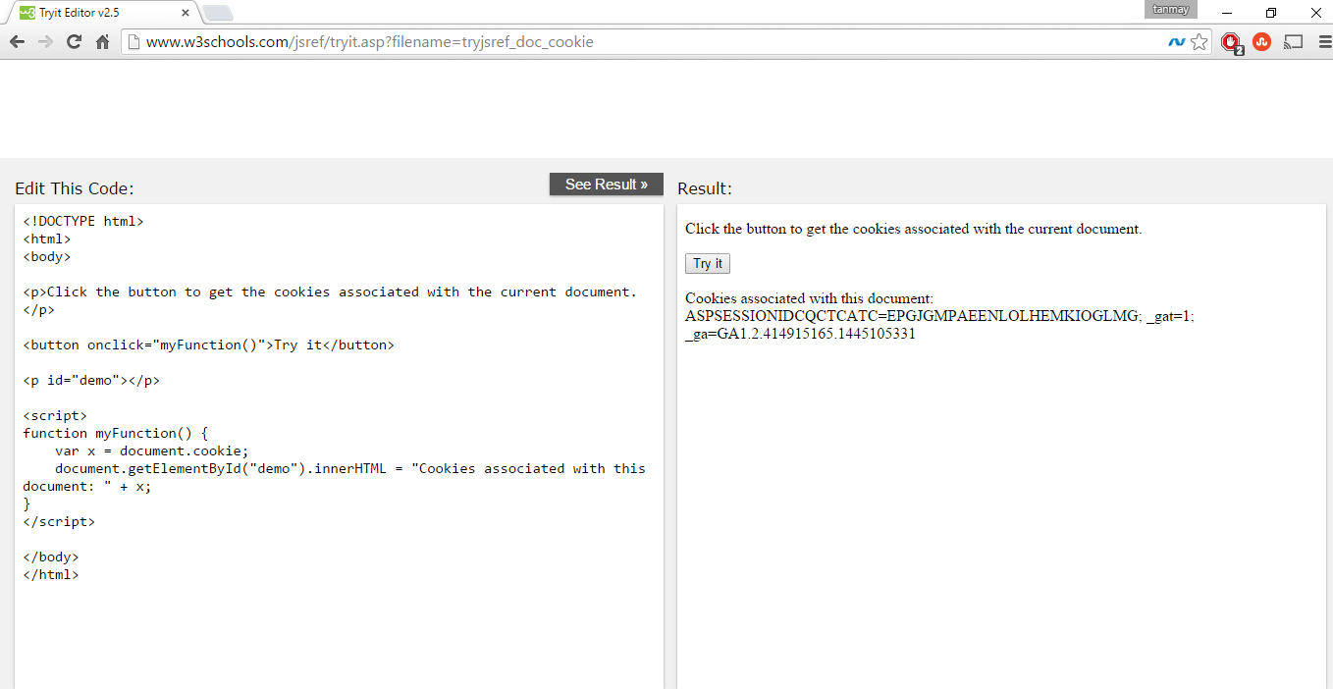

From the above screen shot, we can see that when I click the button, the cookie information is displayed. The reason is, we are getting the cookie information from the document.cookie property which is built in. Thus in the myFunction(), we are just displaying that information and we are calling the myFunction() when the button is clicked. Thus we are getting the cookie information and thus performing the above task.

# TASK 2:HTML5 TAGS

The screen shots for HTML5 tags are below.

Links:

<http://www.w3schools.com/html/exercise.asp?filename=exercise_links1>

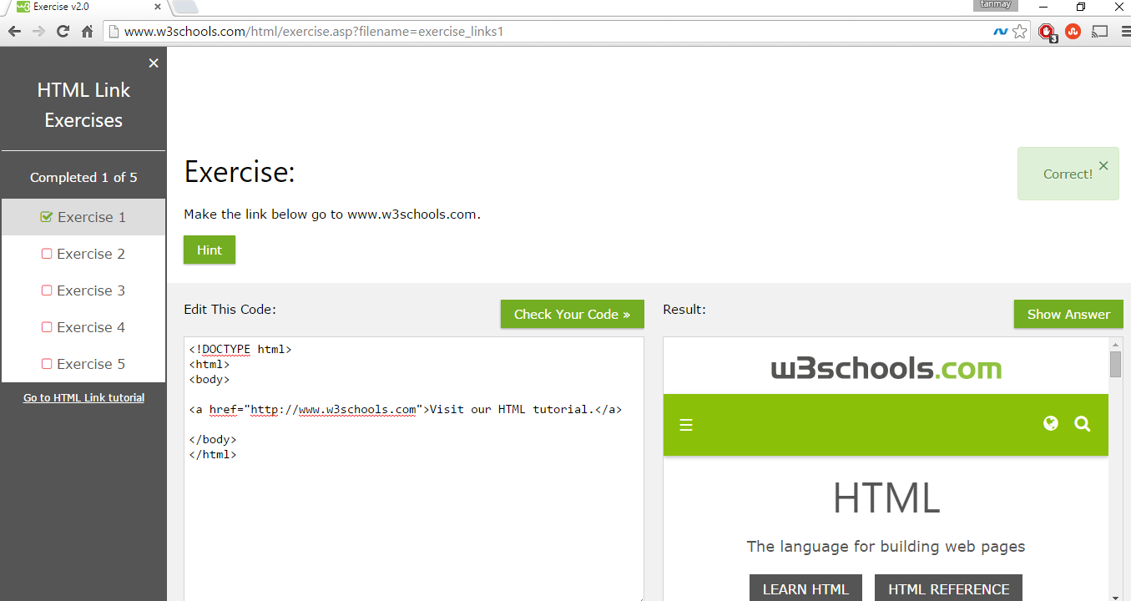

In the above screen shot, we can see that I have just added the link [www.w3schools.com](http://www.w3schools.com) to the href. This anchor tag, a will be a link to the [www.w3schools.com](http://www.w3schools.com) Thus, when we see the result, we see the home page of w3schools in the result box. Thus, when we click the text “Visit out HTML tutorial” text, the link which is in the href attribute, the user will be re-directed to that link. Whatever you write between the anchor tag, will act as a link.

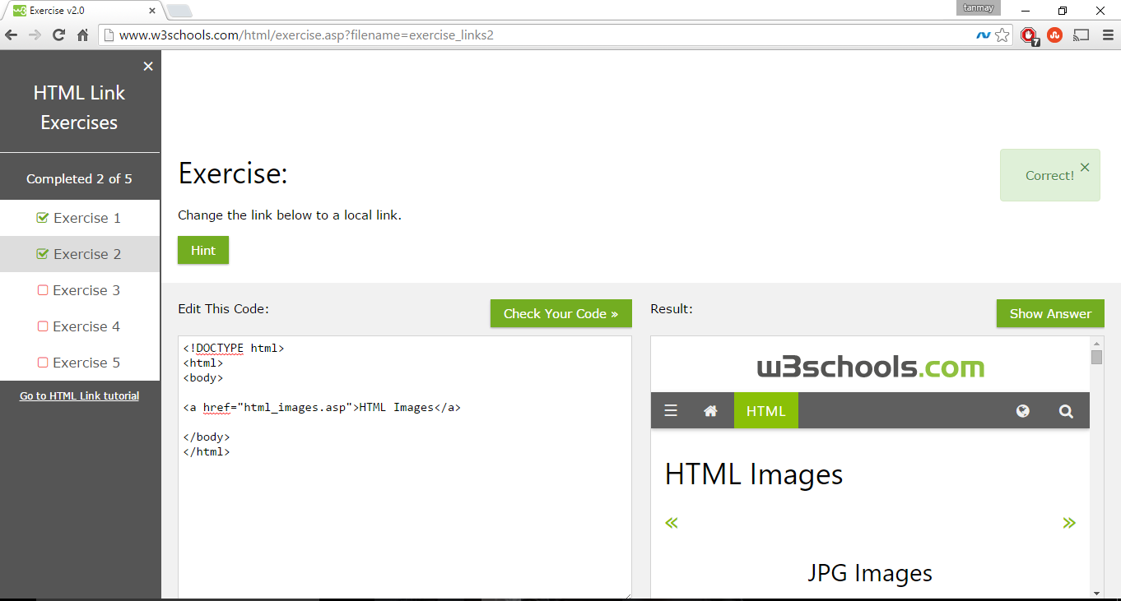

In the above task, instead of the absolute link, I write the local link, html_images.asp. Thus, we can also write the local link address in the href tag instead of the absolute link.

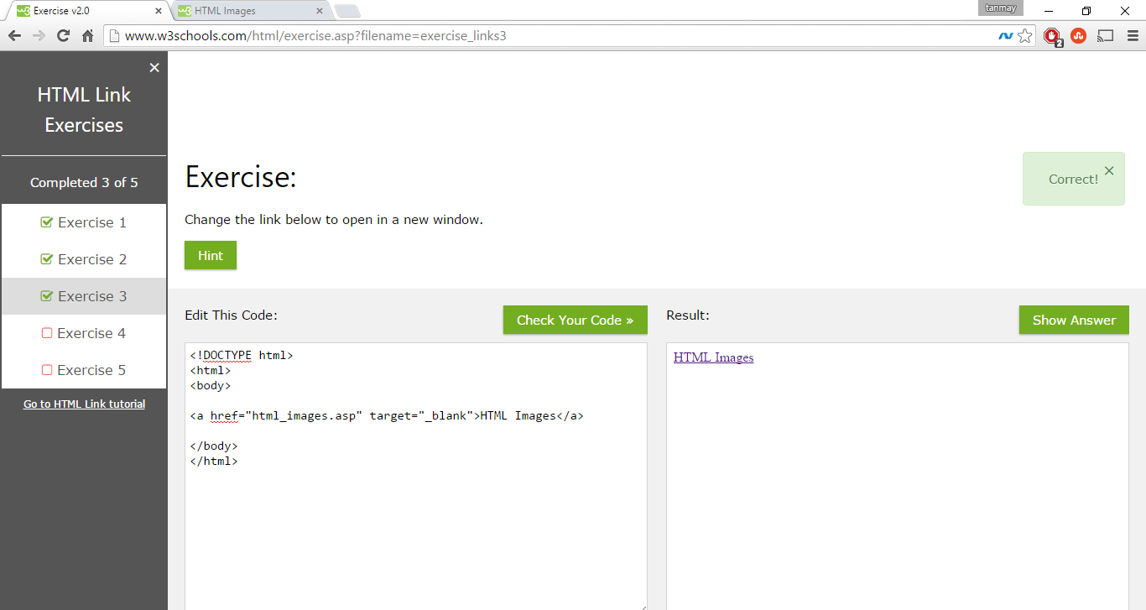

In this, when we click the MTL images, the link will be opened in a new tab. Reason is, we are adding the attribute target=_blank. What this will do is, instead of redirecting the same page, the link will be opened in a new tab.

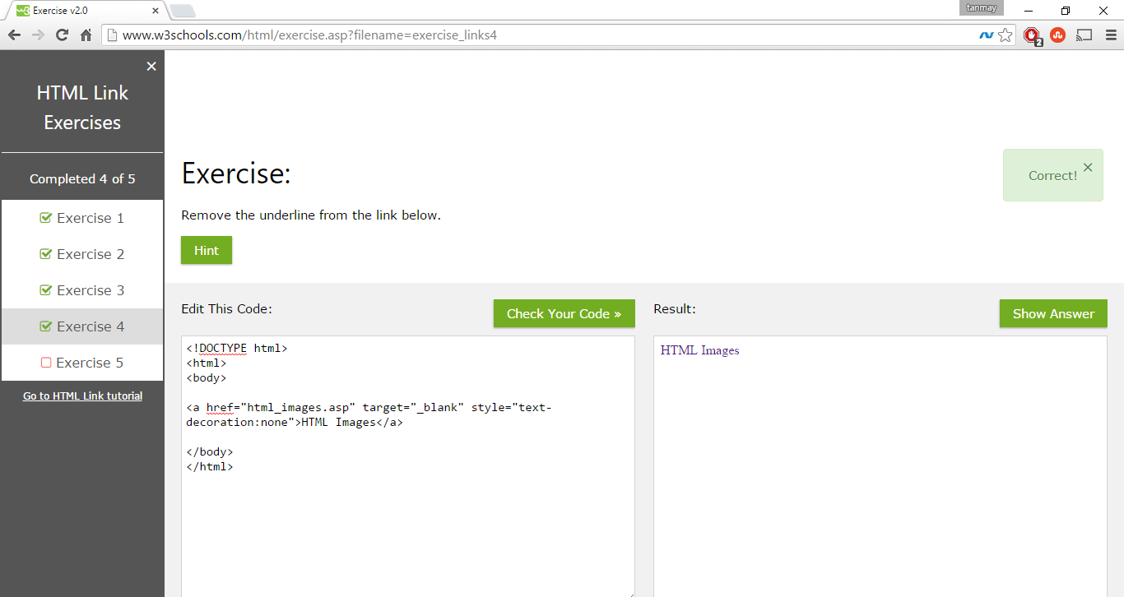

In this, by default, the text included in the anchor tag <a>, will have an underline, by default, as that is how the links are displayed. If we want to remove the underline, we use the style i.e. CSS to do the following. I am using the inline style property. If we do, text-decoration as none, i.e. if the text-decoration property is set to none, in the result we can see that there is no underline for the link.

Code:

<a href=”html_images.asp” target=”_blank” style=”text-decoration:none”>HTML Images</a>

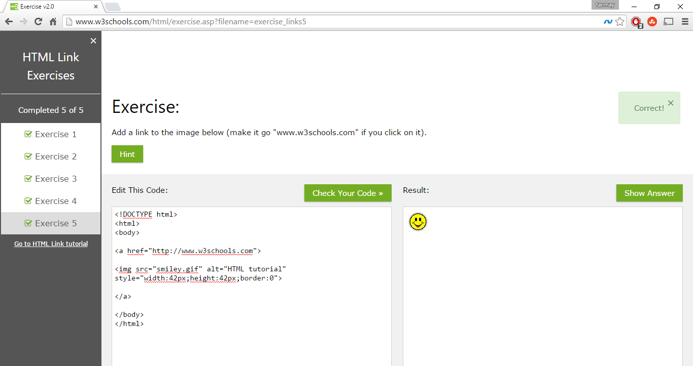

From the above screen shot, we can see that, we can add the link to the image also. How we achieve this is simple. If instead of a text, if we add an image between the anchor tag, that lmage will be associated to the link. Thus, in the code we see that between the <a> tags, we are just adding an image using the <img> tag. Thus in the result, we can see the image and if we click that image, it will act as a link and the user will be re-directed to the link coded in the href attribute of the anchor tag.

Script to change Image

<http://www.w3schools.com/html/exercise.asp?filename=exercise_scripts4>

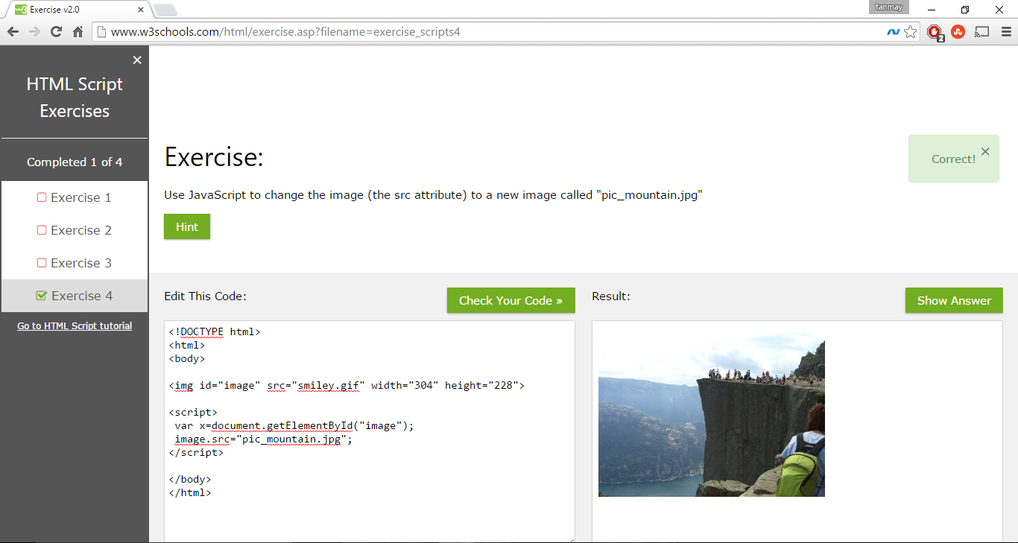

From the above screen shot, we can see that, we are basically changing the image source. How we achieve this is simple. I first take the image in a variable x, using document.getElementById java script function. After we get the DOM element of an image in x, I just change the source, to the new source and once the web page is loaded, the src of the image is changed to pic_mountain. We can see the output in the result tag. Thus, using “Src” attribute of the image, we can change the source of the image.

Code:

Var x =document.getElementById(“image”);

Image.src=pic_mountain.jpg;

Add iframe

<http://www.w3schools.com/html/exercise.asp?filename=exercise_iframe1>

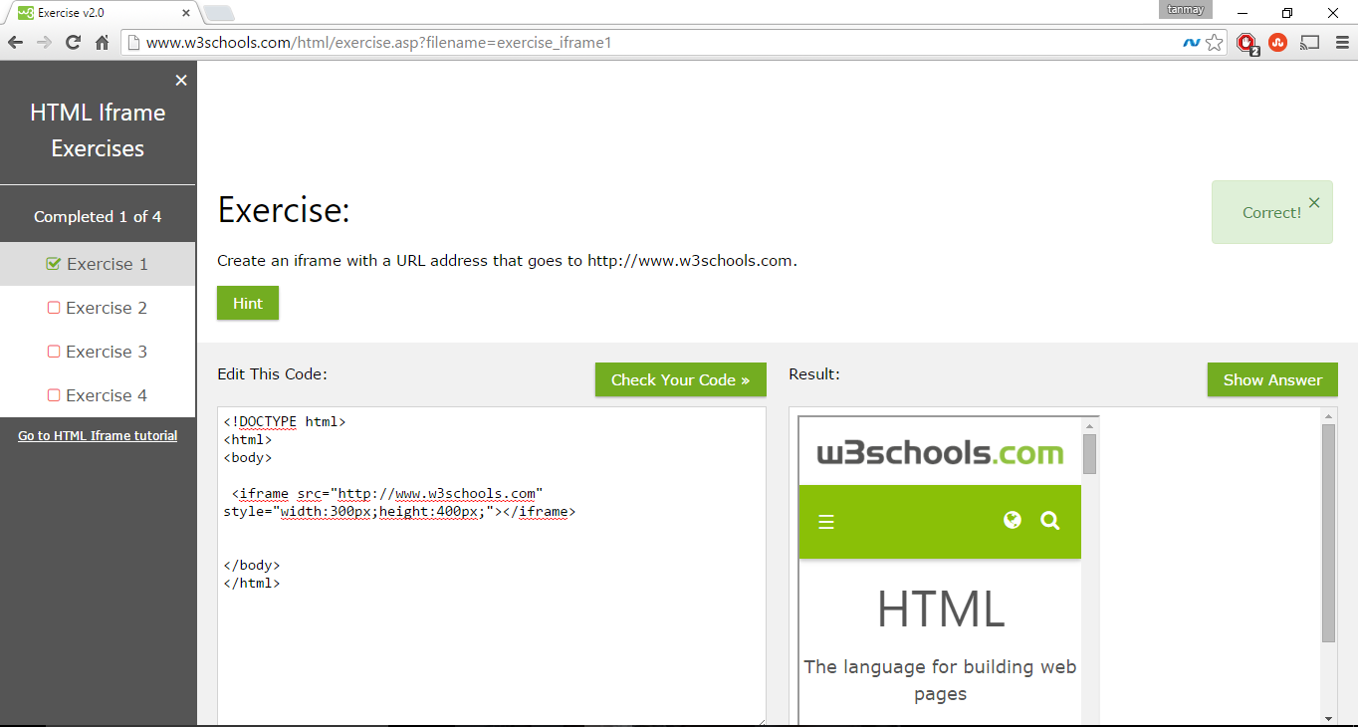

From the above screen shot, we can see that I am just creating an iframe. Iframe is used to display as web-page inside a web-page. Thus, I am giving the source of the iframe, i.e. which web-page to be displayed, i.e. the [www.w3schools.com](http://www.w3schools.com). Also, I am using the inline styling and setting the width and the height of the iframe. Thus we have completed the iframe task.

Code,

<iframe src=<http://www.w3schools.com> style=”width:300pxlheight:400px;”></iframe>

# TASK 3: BROWSER OBJECT MODEL

Alert Information (Code already provided, just run it)

<http://www.w3schools.com/jsref/tryit.asp?filename=tryjsref_alert>

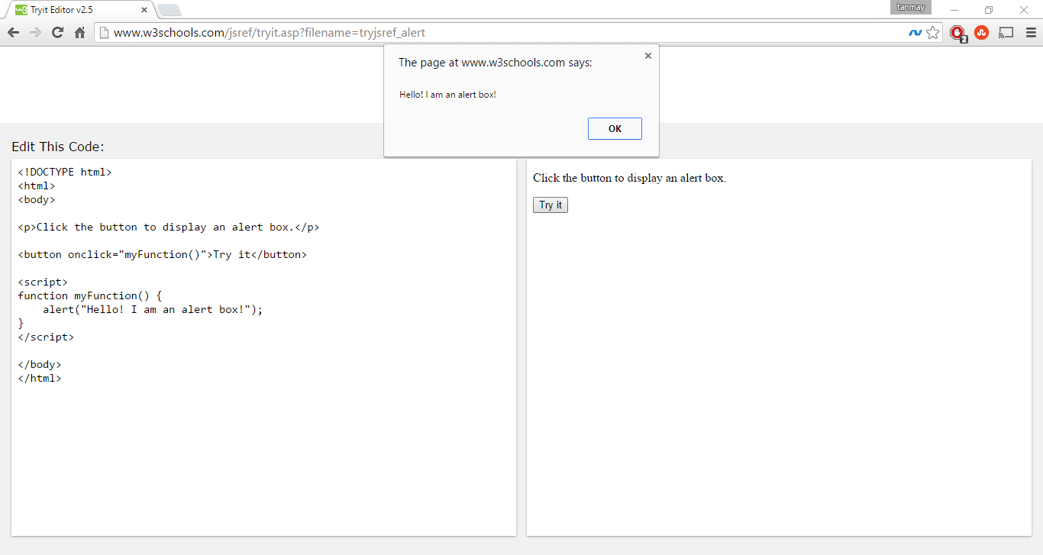

From the above screen shot, we can see that, when I click the “Try It” button, an alert box is displayed. Reason is, in the button onClick() event, i.e. whenever the use clicks the button, myFunction() is called. In the myFunction(), we have put the alert() code. What the alert code does is, it displays the alert, i.e. like a dialogue in the user browser. Hence when I click the button, the alert is being displayed. Please note that, whenever the alert is displayed, until the user takes some action, i.e. until the user clicks ok, no action takes palce.

# TASK 4: JS OBJECTS

This is a reading exercise. No practice. In this, the summary is, in java script everything are objects, i.e. Boolean, numbers, etc and we operate on objects everytime.

# TASK 5: JS FUNCTIONS

This is a reading exercise. No practice. The summary is, this just tells us how functions are defined in javascript and how to use them.

# TASK 6: JS STRINGS

Practice:

Alert the string (adgb 4$/_</script>) on the screen.

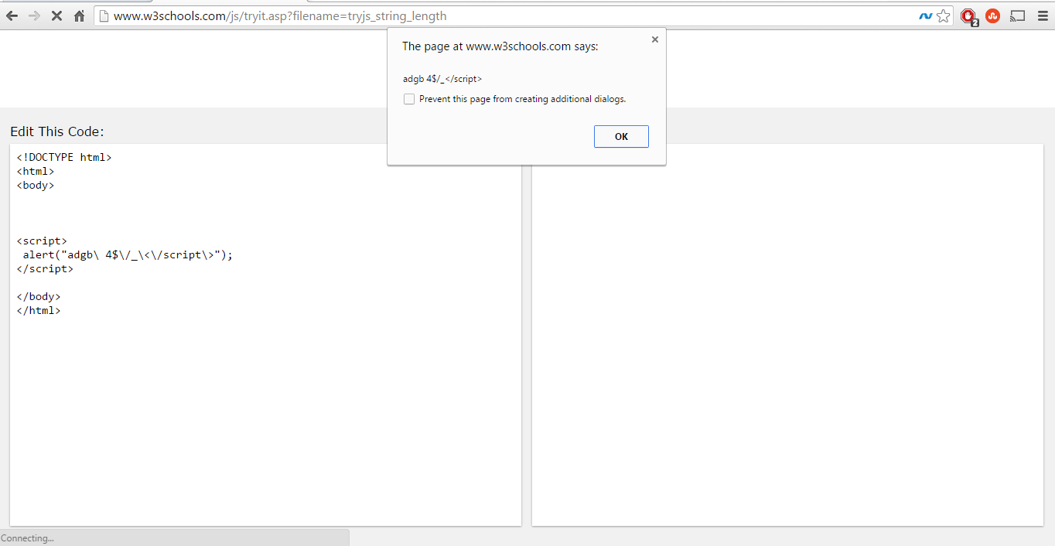

In the above screen shot, we can see the expected alert in the alert box. Coding is done as below.

Alert(“adgb\ 4$\/_\<\/script\>”);

The reason is, in javascript, if we want to alert special characters, we need to put backslash, “\” before the special characters, i.e. if we want to put < in the display we have to write, “\<” in the alert. This is logic I have written the alert in the above manner. Also, we need to put the <script> in the “\” way, because as its javascript, if the code sees <\script> it will take it as the end of the script instead of displaying. Thus we use backslash to display the above alert. And I am successfully able to alert the required alert given in the lab description.

# TASK 7: DEBUG METHOD

This is a reading exercise. The summary is just how to debug javascript code. As even if there is an error, it won’t display anything, Hence we use javascript debugger like, firebug or display messages using console.log or chrome inspect element, etc.

# TASK 8: AJAX

Practice:

Use the following link to send the request with the screenshot from **live http header** to prove your construction of the request is successful.

Work on the link:<http://www.w3schools.com/ajax/tryit.asp?filename=tryajax_post2>

The request should be:

1. POST
2. Send to <http://www.w3schools.com/ajax/JustANon-Existing-page>
3. Header include: Content-type = multipart/form-data
4. Content include: fname=Henry&lname=Ford&Price=49000

Solution: We have to construct a POST header using AJAX, which has the above parameters. The screen shot for the same are as below.

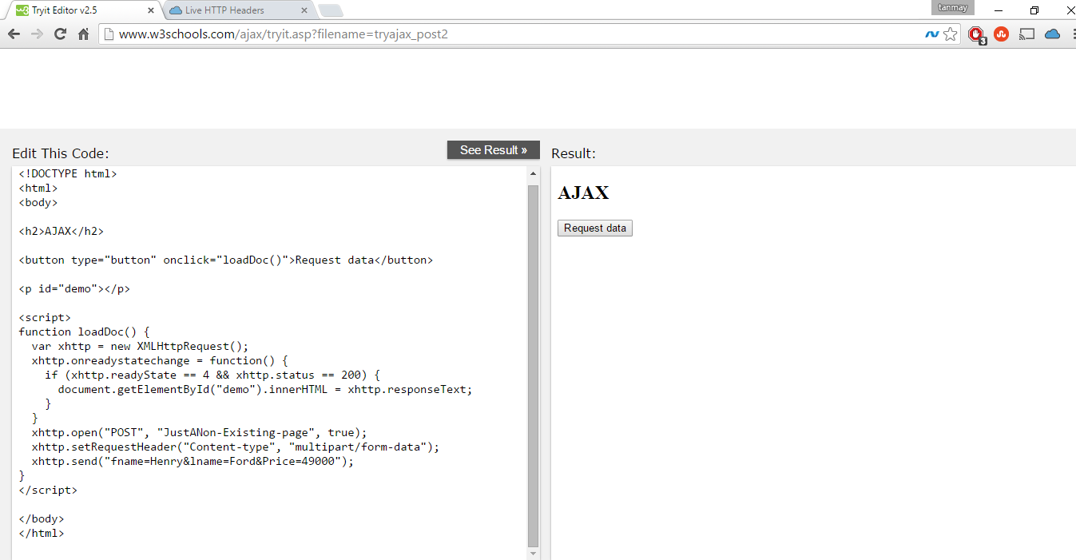

In the above screen shot, we can see the code. In the

Xhttp.open(“POST”,”JustANon-Existing-page”,true);

Here, I am requesting the <http://www.w3schools.com/ajax/JustANon-Existing-page> page, using the path, and it’s a POST request.

Xhttp.setRequestHeader(“Content-type”,multipart/form-data).

In the above line, we see that I am setting the content-type as multipart/form-data. As given in the requirements.

Also, I am sending the content as fname=Henry&lname=Ford&Price=49000 as given in the lab description. Thus, now let us confirm the construction of the request. As the page is non-existing, on click of the button, nothing is displayed. The response is 404, i.e. page not found.

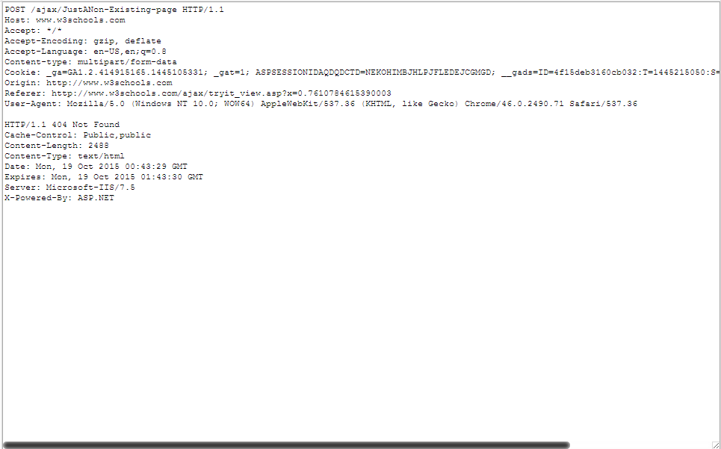

In the above screen shot, we can see the Live HTPP HEADER. In this, we can see the request method is POST, along with the page requested,status is 404 i.e. page not found. The content-type is multipart/form-data and we can see the rest of the information.

We can also view the same from the inspect element, network windows. The screen shot is below.

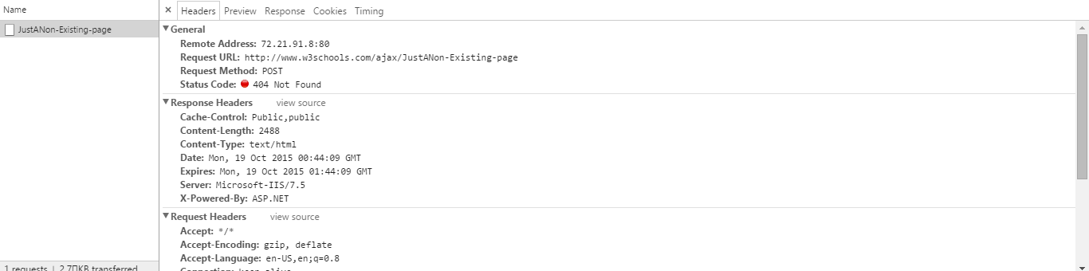

Here you can see the request URL, Along with the request method i.e. POST, and the status code, 404.

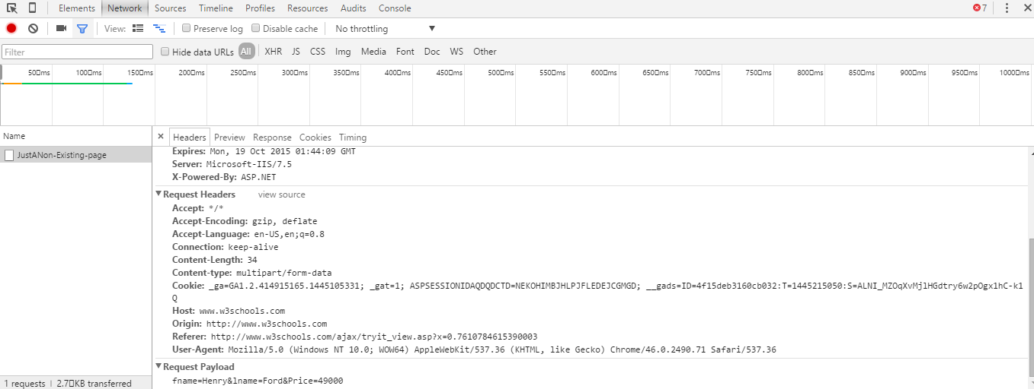

In the above screen shot, you can see the content-type multipart/form-data and the request payload with fname, lname and price. Thus, we can see that the construction of the request was successful.