WOLTERS KLUWER RESEARCH

TABLE OF CONTENTS
COMPANY OVERVIEW 3
BACKGROUND AND HISTORY 3
MANAGEMENT AND GOVERNANCE 5
SHAREHOLDER STRUCTURE 6
BUSINESS OPERATIONS 7
COMPANY-SPECIFIC RISKS 12

COMPANY OVERVIEW
Wolters Kluwer is a Dutch information, software and services group based in Alphen aan den Rijn and listed on Euronext Amsterdam as WKL. It sells expert content, software and AI tools to professionals in five markets: health care, tax and accounting, financial and corporate compliance, legal and regulatory work, and corporate performance and ESG (environmental, social and governance) reporting. It had €6.1bn of revenue and about 20,000 employees in 2025., Customers pay mainly subscriptions: recurring revenue was 83% of the 2025 total. The shares closed at €83.80 on 28 October 2026, a market value of about €18.6bn (calculated on 222.4m shares outstanding)., The key question for investors is whether generative AI will strengthen Wolters Kluwer's expert content and software or allow cheaper tools to replace them. The shares fell about 13% in one day on 3 February 2026 when this fear peaked, and still trade about 27% below their 52-week high of €114.10.,

BACKGROUND AND HISTORY

Dutch publishing houses (1836-1986)
The group traces its roots to four family-run Dutch publishing houses founded between 1836 and 1918; the oldest, J.B. Wolters, began as a schoolbook publisher in Groningen., In 1987 Kluwer merged with Wolters to form Wolters Kluwer, a defensive move to fend off a hostile takeover bid from Elsevier. It became the second-largest publishing house in the Netherlands.

Buying American professional publishers (1990-2007)
Wolters Kluwer then bought professional publishers in the United States, where it now earns most of its revenue. It acquired the medical publisher J.B. Lippincott in 1990 for more than $250m, and the tax and legal publisher CCH in 1995-96 for about $1.9bn; sources differ on the year., These purchases gave it the tax, legal and health content businesses that still make up most of its revenue. Nancy McKinstry became CEO in September 2003 and led the group for 22 years. In 2007 it sold its education division to concentrate on professional customers, and the clinical database UpToDate joined the Health division around the same time (sources give 2007 or 2008).,

From books to cloud software and AI (2008-2026)
Since then the group has swapped print for cloud software. It bought Enablon (environment, health and safety software) in May 2016 and Tagetik (financial planning software, now CCH Tagetik) in 2017., In 2024 it added Isabel Group's cloud financial-workflow software to Tax & Accounting. Print has shrunk to about 4% of revenue. The portfolio changed again over the last 18 months:
Finance, Risk and Regulatory Reporting sold. In July 2025 Wolters Kluwer agreed to sell this unit to Regnology at an enterprise value of about €450m; the unit had €123m of revenue in 2024, about 10% of the Financial & Corporate Compliance division. The sale produced a gain of €232m in 2025 (see Financial Profile).
AI capability bought and built. It acquired Libra Technology GmbH, a German legal AI start-up, and has launched the Libra workspace in the Netherlands, Belgium, Germany, Italy, Poland and other countries. In January 2026 it paid €32m for StandardFusion, a cloud governance, risk and compliance platform with about €4m of 2024 revenue, to extend Corporate Performance & ESG.
New CEO. Stacey Caywood replaced McKinstry as CEO in February 2026 and is steering the group towards what it calls Expert AI: AI features built into its own content and software, such as UpToDate Expert AI and CCH Axcess agentic tax tools.,,

MANAGEMENT AND GOVERNANCE

Leadership Team
Caywood has been CEO and Chair of the Executive Board since February 2026. She joined the Executive Board in 2025 and ran Wolters Kluwer Health from 2020., This means the strategy is led by an insider who knows the largest-profit division well, but she has only been group CEO for nine months. Kevin Entricken has been CFO and an Executive Board member since 1 May 2013, so financial policy (the buybacks, the debt level and the 2025-26 portfolio changes) has continuity. The Executive Board has two members. Tejas Shah joined in January 2026 as Chief Strategy & Innovation Officer.
Executive and supervisory leadership ,,
Name | Role | Name | Role
Stacey Caywood | CEO and Chair of the Executive Board (since Feb. 2026) | Greg Samios | CEO, Health
Kevin Entricken | Chief Financial Officer (since 2013) | Martin O'Malley | CEO, Legal & Regulatory
Tejas Shah | Chief Strategy & Innovation Officer | Lisa Nelson | CEO, Financial & Corporate Compliance
Ann Ziegler | Chair, Supervisory Board | Maria Montenegro | CEO, Corporate Performance & ESG

The management page we could open does not name a head of Tax & Accounting, the largest division by revenue, and it may lag recent appointments, so that role is not listed.

Supervisory Board
Wolters Kluwer has a Dutch two-tier board: the Executive Board runs the company and a separate Supervisory Board oversees it. The Chair is Ann Ziegler and the Vice Chair, who also chairs the Audit Committee, is Chris Vogelzang; both terms run to 2027. At the 21 May 2026 AGM shareholders adopted all resolutions, including the €2.52 dividend, re-appointed Heleen Kersten and appointed Maarten de Vries to the Supervisory Board (both to 2030). Jack de Kreij retired. Because a new CEO joined in February and the Board's two senior members are due for re-election in 2027, board continuity is worth watching during the AI transition. Insiders held only 0.24% of the shares according to one data provider, so management's own stake is not a source of alignment.

SHAREHOLDER STRUCTURE

Stockholders
Wolters Kluwer has about 224.7m shares in issue after it cancelled 7.8m treasury shares on 18 September 2026; it still holds 2.28m treasury shares (1.01%), leaving about 222.4m outstanding. There is no controlling shareholder. Institutions hold roughly 70%, according to Yahoo Finance data. Dutch law requires holders to report stakes at 3% and above. The largest we could confirm are below; they come from data providers that republish the Dutch regulator's filings, so the dates differ.,
Largest reported holders ,
Holder | Stake | Shares | Report date
BlackRock | 7.37% | 16.4m | 24 June 2026
Vanguard | 4.36% | 9.7m | 31 Aug. 2026
FMR (Fidelity) | 3.18% | 7.1m | 12 Aug. 2025

Shareholder returns
Wolters Kluwer returns cash through a dividend and a buyback. The 2025 dividend is €2.52 per share (+8%), of which a final €1.59 was paid in June 2026., In 2026 it plans to buy back up to €500m of shares; by mid-October it had bought about 3.9m shares for €264.2m at an average price of €67.96, 19% below the current price., The group returned €1.7bn to shareholders in 2025, more than its adjusted free cash flow of €1,348m, so net debt rose from €3.1bn to €4.0bn (2.0x EBITDA, against 1.6x a year earlier). Book equity fell from €1,545m to €798m in 2025 and stood at €940m at 30 June 2026., This policy lifts earnings per share but leaves a thin equity base, which matters for the balance sheet ratios in the JEME screen.

BUSINESS OPERATIONS

How Wolters Kluwer makes money
Wolters Kluwer sells to professional firms and institutions, such as hospitals, accounting firms, banks and law firms, not to consumers. It has more than 210,000 tax and accounting firm customers, and more than 450,000 law-firm and corporate customers, including over 90% of the 100 largest US law firms. Most revenue is recurring: €5,110m of the €6,125m total in 2025 (83%, up 7% organically). Recurring revenue comes from cloud software subscriptions, maintenance on software installed at the customer, and renewals of content subscriptions. Cloud software was 21% of revenue and grew 15% organically., In the first half of 2026 recurring revenue rose to 85% of the total.
Revenue model, FY2025 (€m) ,
Revenue type | €m | Share | What it is
Recurring | 5,110 | 83% | Cloud subscriptions, software maintenance, content renewals; +7% organic
Transactional | 447 | 7% | Fees per filing or search in Financial & Corporate Compliance (343) and Legal & Regulatory (104)
Print books | 115 | 2% | Non-recurring print sales; all print, including subscriptions, was about 4% of Q1 2026 revenue
Other non-recurring | 453 | 7% | Software licences, implementation and professional services
Total | 6,125 | 100% | Organic growth 6%

By geography, North America produced 63% of 2025 revenue (up 5% organically) and Europe 29% (up 6%); the remaining 8% is Asia Pacific and the rest of the world. This makes the euro-dollar rate the main currency exposure, discussed under Company-Specific Risks.

The five divisions
The divisions differ widely in profit. Tax & Accounting and Health earn about 62% of divisional adjusted operating profit on 53% of revenue, while Legal & Regulatory, where legal AI tools compete most directly, earns about 10%.
Divisions, FY2025 ,,
Division | What it sells | Revenue (€m) | Share | Organic growth | Adj. margin
Tax & Accounting | Tax and accounting software and research (CCH Axcess) for 210,000+ firms | 1,660 | 27% | +7% | 35.2%
Health | Clinical decision support (UpToDate) and clinical content for hospitals and clinicians | 1,596 | 26% | +5% | 32.1%
Financial & Corporate Compliance | Compliance solutions for financial institutions, corporations and law firms (CT Corporation, Lien Solutions) | 1,239 | 20% | +3% | 35.2%
Legal & Regulatory | Legal research, content and software for law firms and corporate legal teams; Libra AI workspace | 1,005 | 16% | +5% | 18.2%
Corporate Performance & ESG | Planning (CCH Tagetik), EHS and ESG (Enablon) and audit (TeamMate) software | 625 | 10% | +7% | 7.7%

Tax & Accounting is the largest and most profitable division. Cloud software in North America grew 19% in 2025, but North American organic growth slowed to 2% in the first quarter of 2026 from 5% a year earlier., Health grew 5%, led by Clinical Solutions (UpToDate) at 7% in 2025; that fell to 5% in the first half of 2026. Financial & Corporate Compliance grew 3% in 2025 and 7% excluding print, with Financial Services at only 1%. Its transactional revenue is tied to the volume of corporate filings and legal activity.
Legal & Regulatory grew 5% (its software, 24% of the division, also 5%) at an 18.2% margin, the lowest of the four mature divisions and down from 18.6%. In the first half of 2026 the margin eased again, which management attributed to higher product development spending and dilution from recent acquisitions., Corporate Performance & ESG grew 7% in 2025 on 18% growth in recurring cloud software, but adjusted operating profit fell 23% to €48m (margin 7.7%, from 10.2%) because of lower on-premise software licence revenue. In August 2026 management lowered the division's full-year outlook, citing weaker oil and gas activity and longer sales cycles.
Revenue and adjusted operating profit by division, FY2025
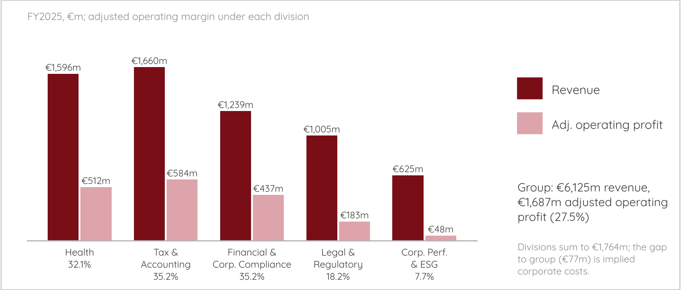

Financial profile
Revenue grew 3.5% in 2025 as reported and 6% organically; the gap is currency and disposals. The company-adjusted operating margin rose 40bp to 27.5%, and diluted adjusted EPS rose from €4.97 to €5.29, up 9% at constant currencies and 6% as reported. Adjusted figures exclude acquired-intangible amortisation, restructuring and disposal gains and are not IFRS measures. IFRS net profit was €1,308m in 2025, but this includes the €232m gain on the sale of the Finance, Risk and Regulatory Reporting unit, which was largely tax-exempt; without it profit was about €1,076m (if the gain is entirely tax-free), flat on 2024's €1,079m. Adjusted EPS grew faster than adjusted net profit (+3% to €1,225m) because the average diluted share count fell from 255.8m in 2022 to 231.8m in 2025.
Financial snapshot (€m unless stated) ,,
Metric | FY2025 | H1 2026 | 2026 guidance
Revenue | 6,125 | 3,033 | Good organic growth
Organic revenue growth | +6% | +5% | -
Adjusted operating profit | 1,687 | 893 | -
Adjusted operating margin | 27.5% | 29.4% | About 28%
Diluted adjusted EPS (€) | 5.29 | 2.83 (+14% constant currency) | High single-digit growth, constant currency
Adjusted free cash flow | 1,348 | 533 | 1,300-1,350
ROIC | 18.0% | 18.2% | 18-19%
Net debt | 4,024 | 4,024 | -
Net debt / EBITDA | 2.0x | 2.0x | -

Management guides 2026 to a margin of about 28% (H1: 29.4%), free cash flow of €1.30-1.35bn with cash conversion of 95-100% (2025: 103%), and product development spending of 12-13% of revenue to fund AI., The guidance already includes the €500m buyback and a euro-dollar rate of 1.15.
Diluted adjusted EPS, 2021-2025 (€) ,
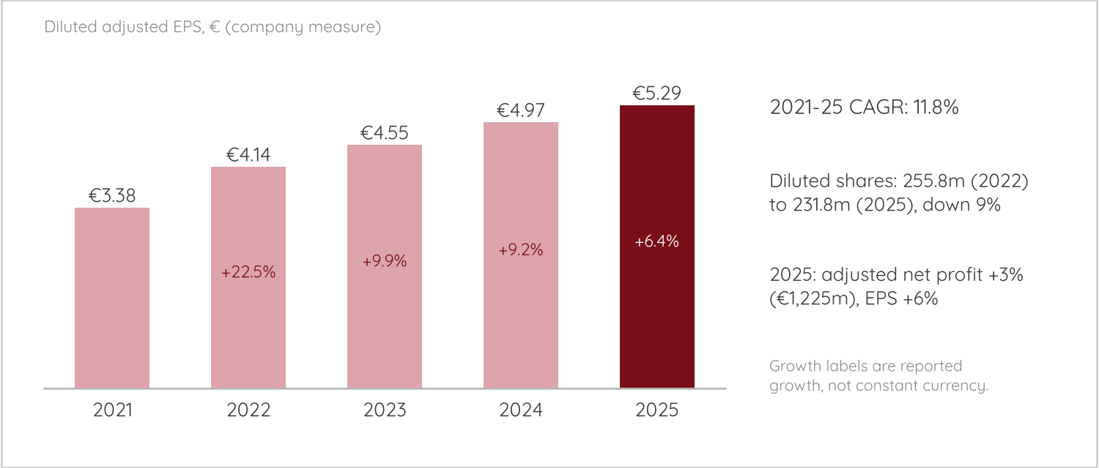

COMPANY-SPECIFIC RISKS
The five risks below are drawn from the risks and forward-looking statements in the 2025 annual report, the 2026 half-year report and results calls, and company announcements, ordered from most to least important for the next few years., We could not open the annual report's full risk chapter, so the cybersecurity and integration risks rely on the forward-looking-statement list and public reports. Where we use secondary summaries, the text says so.
Risk summary ,,
Risk | Severity | Why it matters | Next evidence
AI disruption of existing products | High | Health and Tax earn 62% of divisional profit; AI answers are cheap or free | Nine-month update, 4 Nov. 2026; renewals and organic growth
Execution: margin, investment and new CEO | Medium to high | Implied H2 2026 margin of 26-27%; Corporate Performance & ESG weak | FY2026 results and 2027 guidance, Feb. 2027
Cybersecurity and data protection | Medium | Tax-season outage or data loss would hit the largest-profit division | Any incident disclosure; annual report
Acquisition and divestment integration | Low to medium | Deals are small; margin dilution so far limited to Legal & Regulatory | Libra and StandardFusion contribution
Currency and balance sheet | Medium | 63% of revenue in North America; net debt/EBITDA 2.0x; equity €0.94bn | Net debt and euro-dollar rate at FY2026

1. AI disruption of existing products
This is the largest risk because the products most exposed to AI are also the most profitable. Health (26% of revenue, 32.1% margin) and Tax & Accounting (27% of revenue, 35.2% margin) together produce about 62% of divisional adjusted operating profit.
Share of group revenue and of divisional adjusted operating profit, FY2025
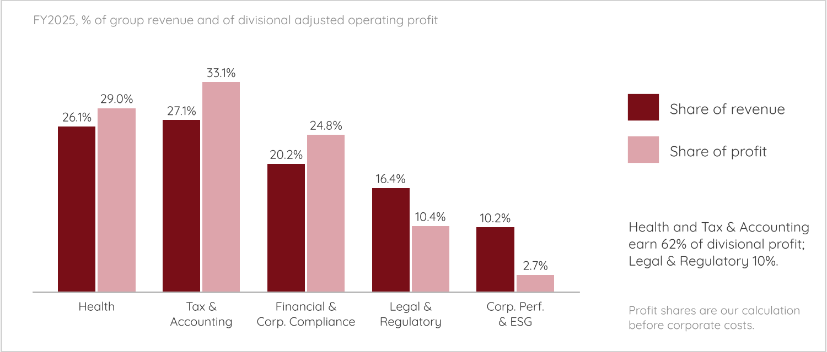
The threat differs by division. In Health, Caywood said on the August 2026 call that the individual-clinician UpToDate segment has always been more competitive and that general-purpose AI models now offer free medical chat tools. OpenEvidence, a free, advertising-funded clinical AI tool, is the closest rival; vendor-written comparisons claim it reaches around 65% of US physicians, a figure we could not verify., The core of UpToDate is sold to hospitals under enterprise contracts, where over 90% of US enterprise customers adopted Expert AI by July. In legal, Anthropic's February 2026 plug-in for contract review and similar tasks knocked about 13% off Wolters Kluwer's shares in a day. Commentators argued the plug-in does not replace legal research, the core of Legal & Regulatory (16% of revenue, about 10% of profit). In tax and accounting, Wolters Kluwer is itself launching agentic tools, such as agentic tax return preparation (October 2026), but only about 250 firms had subscribed to the agentic modules by July, against 210,000+ customer firms.,
Why the financial impact could be large. AI adoption is not paid revenue. Management said Expert AI is bundled into enterprise subscriptions and monetised "through supporting renewals and price increases", with add-ons priced at renewal over time. It has not disclosed any incremental AI revenue. If competitors give similar answers for free, that bundle must justify price increases at every renewal, while the group spends 12-13% of revenue on product development. Each percentage point of group organic growth is about €61m of revenue; if costs did not fall, that is up to €61m of operating profit (3.6% of the €1,687m total), and at the group's 27.5% margin about €17m (1.0%). Our estimate: a fall in organic growth from 6% to 3% could remove between €50m and €184m of annual operating profit before any further pricing pressure. This is a sensitivity, not a forecast.
What the data show so far: no damage yet. Recurring revenue grew 7% organically in H1 2026, and renewal rates for the largest subscription products stayed above 90% in 2025., But Clinical Solutions growth slowed from 7% to 5%, and Tax & Accounting North America to 2% in Q1, and the share price shows that investors are already discounting a worse outcome. The severity of this risk is high. The evidence that it is materialising would be organic growth below 5%, renewal rates below 90%, or price increases at renewal being reduced.

2. Execution: margin, investment and a new CEO
Management expects a 2026 adjusted margin of about 28%, but the first half was 29.4%. On our calculation, assuming 2026 revenue of €6.1-6.2bn, that implies a second-half margin of about 26-27%, because the extra product development spending is weighted to the second half., Cash conversion is also guided down, from 103% to 95-100%, and net financing costs are guided to about €105m from €86m. Several divisions are weak. Corporate Performance & ESG profit fell 23% in 2025 and its 2026 outlook was lowered. EHS and ESG revenue fell 1% in Q1 2026, and non-recurring revenue declined 3% in H1., Growth also leans on AI products that are new: the legal AI workspace Libra has only recently been rolled out across Europe.
The leadership transition adds execution risk. Caywood has been CEO since February 2026 after McKinstry's 22 years, Greg Samios reportedly became Health CEO in 2025, and a Chief Strategy & Innovation Officer joined in January 2026., A new team can reset targets, so the 2027 guidance in February 2027 is a key date. The severity of this risk is medium to high: it would show up as a margin below 27% in 2027 or a cut to the 28% target.

3. Cybersecurity and data protection
Wolters Kluwer's software holds tax returns, clinical content, corporate filings and legal data, and its tax products run on deadlines. We found no disclosed breach in 2025-26. In an earlier incident, a malware attack took CCH tax products offline; the company said it saw no evidence of customer data being taken (the report we found is several years old). The risk is that an outage in tax season, or a loss of customer data, would hit Tax & Accounting, which earns about 33% of divisional profit, through lost renewals and claims. AI adds new exposures: model security, data privacy and customer concerns over where their data go, and the company publishes responsible-AI principles that name privacy and security. We could not find the annual report's own assessment of this risk. The severity of this risk is medium: the probability is low, but a tax-season failure would be costly.

4. Acquisition and divestment integration
The deals so far are small. StandardFusion cost €32m for about €4m of revenue (0.07% of group revenue), and the company expects a return above its 8% cost of capital within three to five years. The price of Libra was not disclosed in the sources we found, but management says it is ahead of plan. The Finance, Risk and Regulatory Reporting sale brought in about €450m for a unit with 10% of the Financial & Corporate Compliance division's revenue. The 2025 report warns that further acquisitions or disposals may be dilutive to margins, earnings and return on invested capital in the near term. So far dilution has been limited to Legal & Regulatory, where the margin fell from 18.6% to 18.2%., The severity of this risk is low to medium: size limits the damage, but a large AI purchase to defend a division would change that.

5. Currency and balance sheet
Currency. With 63% of revenue in North America, the group says each one-cent move in the average euro-dollar rate changes diluted adjusted EPS by about 4.5 euro cents (0.85% of 2025 EPS), in the opposite direction., The assumed rate was already moved from 1.175 in May to 1.15 in August.,
Balance sheet. Net debt is €4,024m, or 2.0x EBITDA, and gross debt €5,548m against equity of €940m at 30 June 2026. Debt is serviceable: interest cover is about 20x on adjusted operating profit over adjusted net financing costs (our calculation), and an undrawn €600m credit facility is available. A €500m bond issued on 22 June replaced one repaid on 2 July, so gross debt will fall back.,, But free cash flow was fully used in the first half for dividends, buybacks and StandardFusion, and in 2025 shareholder returns exceeded free cash flow. If earnings disappoint, the company would have to choose between cutting buybacks and borrowing more. The severity of this risk is medium: cheap buybacks at €68 helped EPS, but they reduce room to manoeuvre.
In conclusion, AI disruption and execution are the two highest risks, and both will be tested within the next four months. The nine-month trading update on 4 November 2026 should show whether recurring growth stays near 7%, and the full-year results with 2027 guidance in February 2027 will show whether the 28% margin and AI spending plan hold. The company is profitable and cash-generative, renewal rates are above 90%, and the balance sheet is serviceable, so none of these risks is an immediate threat to earnings. What could change that is the combination of slowing growth in Health and Tax & Accounting with higher spending and a thin equity base. Our view is that the investment case depends less on Wolters Kluwer's own execution than on whether customers keep paying for expert content when AI answers are free, which is the main risk to the investment case.

Wikipedia - Wolters Kluwer
Wolters Kluwer - About us
Wolters Kluwer - 2025 Full-Year Report
Twelve Data - Wolters Kluwer (Euronext) Historical Prices
Wolters Kluwer - Completes capital reduction
Morningstar - Thomson Reuters, RELX and Wolters stocks crushed after Anthropic debuts Claude legal plug-in
Ad-hoc-news - Wolters Kluwer stock sits 23.59 percent below its 52-week high
Walter Scott - Wolters Kluwer
Funding Universe - History of Wolters Kluwer NV
Wikipedia - J. B. Lippincott & Co.
Wikipedia - Wolters Kluwer
Wolters Kluwer - CEO Nancy McKinstry announces retirement in early 2026
Northern Illinois University Libraries - Wolters Kluwer Timeline
Zippia - Wolters Kluwer History: Founding, Timeline, and Milestones
Umbrex - Wolters Kluwer Strategy and Business Model
CFO Shortlist - CCH Tagetik Guide 2026
Wolters Kluwer - 2025 Half-Year Report
Wolters Kluwer - First-Quarter 2026 Trading Update
Euronext - Wolters Kluwer to divest its Finance, Risk and Regulatory Reporting unit
Wolters Kluwer - 2025 Full-Year Report
Wolters Kluwer - Advances legal AI strategy with multi-country launch of Libra
Wolters Kluwer - Acquires StandardFusion
Wolters Kluwer - CEO Nancy McKinstry announces retirement in early 2026
Wolters Kluwer - Management Team
Yahoo Finance - Wolters Kluwer H1 2026 Earnings Call Highlights
Wolters Kluwer - Management Team
Wolters Kluwer - CEO Nancy McKinstry announces retirement in early 2026
Wolters Kluwer - Kevin Entricken
Nasdaq - Wolters Kluwer appoints Tejas Shah as Chief Strategy & Innovation Officer
Wolters Kluwer - Management Team
Wolters Kluwer - Supervisory Board
Nasdaq - Wolters Kluwer appoints Tejas Shah as Chief Strategy & Innovation Officer
Wolters Kluwer - Supervisory Board
Wolters Kluwer - Shareholders approve all resolutions at the 2026 AGM
Yahoo Finance - Wolters Kluwer Major Holders
Wolters Kluwer - Completes capital reduction
Yahoo Finance - Wolters Kluwer Major Holders
Investing.com - Who Owns Wolters Kluwer?
Fiscal.ai - Wolters Kluwer Total Ownership and Largest Shareholders
Investing.com - Who Owns Wolters Kluwer?
Fiscal.ai - Wolters Kluwer Total Ownership and Largest Shareholders
Wolters Kluwer - 2025 Full-Year Report
Wolters Kluwer - Shareholders approve all resolutions at the 2026 AGM
TipRanks - Wolters Kluwer Advances EUR 500 Million 2026 Share Buyback Program
Wolters Kluwer - Share Buyback Transaction Details, 17-23 September 2026
Wolters Kluwer - 2025 Full-Year Results Presentation
Wolters Kluwer - 2025 Full-Year Results (divisional tables)
Wolters Kluwer - 2026 Half-Year Report (MFN)
Wolters Kluwer - Our organization
Wolters Kluwer - 2025 Full-Year Report
Wolters Kluwer - 2025 Full-Year Results (divisional tables)
Wolters Kluwer - 2026 Half-Year Report
Wolters Kluwer - 2025 Full-Year Results (divisional tables)
Wolters Kluwer - 2025 Full-Year Report
Wolters Kluwer - 2025 Full-Year Results (divisional tables)
Wolters Kluwer - 2025 Full-Year Results (divisional tables)
Wolters Kluwer - 2025 Full-Year Results (divisional tables)
Wolters Kluwer - 2025 Full-Year Report
Wolters Kluwer - Our organization
Wolters Kluwer - 2025 Full-Year Report
Wolters Kluwer - First-Quarter 2026 Trading Update
Yahoo Finance - Wolters Kluwer H1 2026 Earnings Call Highlights
Wolters Kluwer - 2025 Full-Year Results (divisional tables)
Yahoo Finance - Wolters Kluwer H1 2026 Earnings Call Highlights
Wolters Kluwer - 2026 Half-Year Report
Wolters Kluwer - 2025 Full-Year Results (divisional tables)
Wolters Kluwer - 2025 Full-Year Report
Wolters Kluwer - 5-Year Key Figures
Wolters Kluwer - 2025 Full-Year Report
Wolters Kluwer - 2026 Half-Year Report
Wolters Kluwer - First-Quarter 2026 Trading Update
Wolters Kluwer - 2026 Half-Year Report
Wolters Kluwer - First-Quarter 2026 Trading Update
Wolters Kluwer - 5-Year Key Figures
Wolters Kluwer - 2025 Full-Year Report
Wolters Kluwer - 2025 Annual Report
Wolters Kluwer - 2026 Half-Year Report
Wolters Kluwer - 2025 Annual Report
Wolters Kluwer - 2026 Half-Year Report
Wolters Kluwer - First-Quarter 2026 Trading Update
Wolters Kluwer - 2025 Full-Year Results (divisional tables)
Wolters Kluwer - 2025 Full-Year Results (divisional tables)
Yahoo Finance - Wolters Kluwer H1 2026 Earnings Call Highlights
EvidenceMD - OpenEvidence vs UpToDate (2026)
Physician's Copilot - UpToDate vs OpenEvidence
Morningstar - Thomson Reuters, RELX and Wolters stocks crushed after Anthropic debuts Claude legal plug-in
ComplexDiscovery - Market Reaction or Overreaction? Anthropic's Legal Plugin
Yahoo Finance - Wolters Kluwer partners with Inscope to launch agentic financial statement preparation in CCH Axcess
Ad-hoc-news - Wolters Kluwer launches agentic tax tools
Investing.com - Wolters Kluwer H1 2026 Earnings Call Transcript
Wolters Kluwer - 2026 Half-Year Report
Wolters Kluwer - 2025 Annual Report
Wolters Kluwer - 2026 Half-Year Report
Yahoo Finance - Wolters Kluwer H1 2026 Earnings Call Highlights
Wolters Kluwer - 2025 Full-Year Report
Wolters Kluwer - 2025 Full-Year Results (divisional tables)
Wolters Kluwer - First-Quarter 2026 Trading Update
Wolters Kluwer - Advances legal AI strategy with multi-country launch of Libra
Wolters Kluwer - Management Team
Nasdaq - Wolters Kluwer appoints Tejas Shah as Chief Strategy & Innovation Officer
Accounting Today - CCH is back up following malware attack
Wolters Kluwer - 2025 Annual Report
Wolters Kluwer - Acquires StandardFusion
Investing.com - Wolters Kluwer H1 2026 Earnings Call Transcript
Euronext - Wolters Kluwer to divest its Finance, Risk and Regulatory Reporting unit
Wolters Kluwer - 2025 Annual Report
Wolters Kluwer - 2025 Full-Year Results (divisional tables)
Yahoo Finance - Wolters Kluwer H1 2026 Earnings Call Highlights
Wolters Kluwer - 2025 Annual Report
Wolters Kluwer - 2025 Full-Year Results (divisional tables)
Wolters Kluwer - First-Quarter 2026 Trading Update
Wolters Kluwer - 2026 Half-Year Report
Wolters Kluwer - 2026 Half-Year Report (MFN)
Wolters Kluwer - 2026 Half-Year Report
Wolters Kluwer - 2025 Full-Year Report
Wolters Kluwer - 2025 Full-Year Results Presentation
Wolters Kluwer - Investor Calendar

