# Operating Systems 2

## Tanmay Garg CS20BTECH11063

Theory Assignment 1

**Q1. Consider the atomic ‘increment’ function discussed in the book (page 270 of the pdf) using**

**hardware instruction ‘compare_and_swap’. As of now, there is no guarantee that a thread**

**invokind this function will terminate. So, can you develop an ‘atomic’ increment function that will**

**eventually terminate?**

Sol.

* Text

  Description automatically generated
* We can use such an implementation above, where only one process thread will be allowed to increment at a time
* We can use *atomic_fetch_add()* function to help overcome the issue of infinite loops and non-terminating threads
* We may also use *++* operator to increment the atomic variable
* The above methods can be used only if the hardware provides the instructions to implement such operations on atomic variables
* Atomic variables and functions cannot be further broken down and are very similar to machine instructions
* Some architectures may or may not also provide such features
* Some atomic read, modify, and write functions may internally use CAS method
* These instructions modify variables in a single step to help avoid race conditions
* If multiple threads are continuously modifying the variable, then the thread may or may not terminate
* Another way to tackle this starvation, is by providing a method to analyze multiple threads in a fair manner
* CAS functions are lock free algorithms. If an iteration of CAS fails, then it means that a thread has modified the contents of the variable. But this may cause the thread to be “blocked” as it will continuously spin in the loop till it clears
* *Atomic_fetch_add()* functions are wait free algorithms. So, no thread will be prevented to complete itself due to failure of other threads
* Even if such functions do not work, then simple mutex locks can be used in an efficient manner to avoid failure of termination of threads

**Q2. In the class we discussed the solution to the reader-writers problem using semaphores. We**

**saw that this solution can cause the writer threads to starve. Please develop an alternative**

**solution in which neither the reader nor the writers will starve. For this you can assume that the**

**underlying semaphore queue is fair.**

Sol.

* In this method the writer part will not starve
* The writer part now has the chance of being executed while reader parts are continuously being requested and then modifying variables and then terminating the process or thread
* We have a counter which keeps track of the second semaphore *sem2* and calls *wait()* and *signal()* as when required in the given conditions
* When a reader locks sem1 before the writer, then writer will be added to a waiting queue along with the other readers who are waiting for the semaphore
* When the writer acquires sem1 then it will wait for sem2. The readers in sem1 semaphore waiting queue will wait for writer to allow them to proceed ahead
* The other readers will finish all the tasks and wait in sem1 semaphore waiting queue
* In the end writer will lock both sem1 and sem2 and finish its critical section
* Then the reader will start executing its process and writers will wait in sem1 semaphore waiting queue
* The reader uses multiple mutex locks to prevent race conditions and for program safety
* This provides a faster and much reliable program flow to keep shared variables safe from being unknowingly modified by different threads

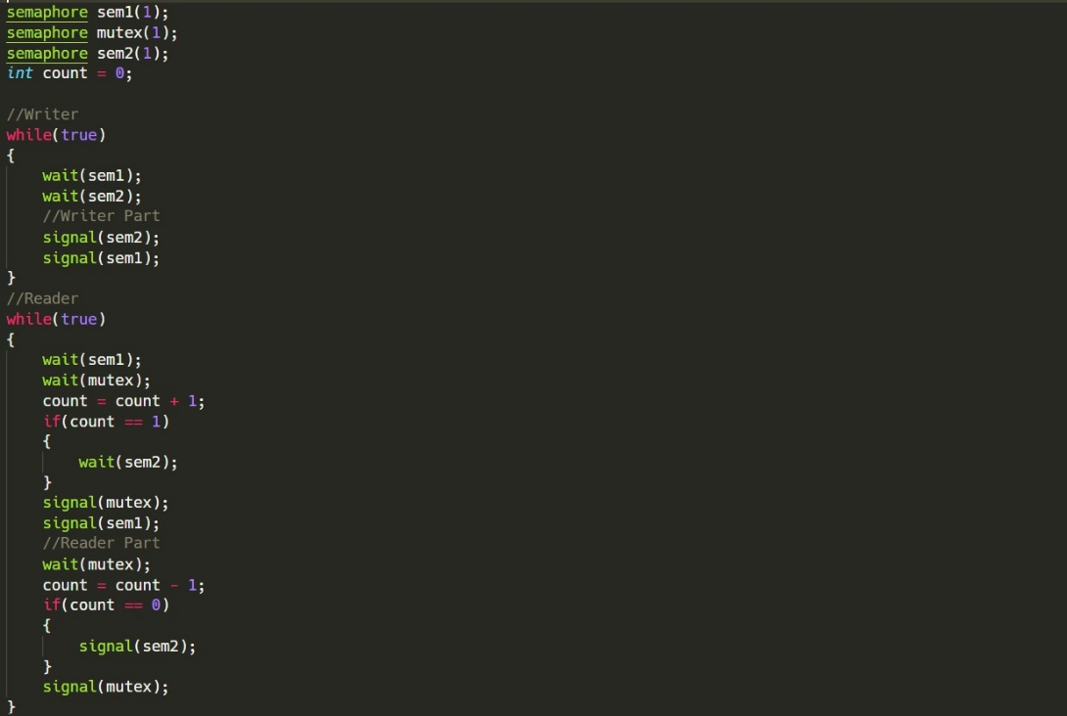

**Q3. Exercise 6.11 from the book.**

Sol.

* Yes, the “compare-and-swap” idiom works appropriately for implementing spinlocks
* Compare_and_swap takes three parameters: location, “expected_value” of that location, new value of that location
* It checks if the value of the location, matches the expected_value
* If it is same then it updates it with the new value, else it doesn’t make any change
* When the lock is 1, the while loop will continue to run till its value changes to 0 and it will break out of the loop
* When the lock is 0, there can be two situations when this occurs
* If the lock is interrupted before the statement
$if(*lock==0)$

* Then at this moment the value will be changed to 1 and then it will continue to run in the while loop
* If the lock is interrupted after the statement
$if\left(*lock==0\right)$

* Then at this moment the value will be changed to 1 and the inner if statement
$if(!(compare_and_swap(lock, 0, 1)))$

* The *compare_and_swap* will return a value of 1, so the break statement will not be executed
* Therefore, there can be only one thread in the critical section at a time while others wait in the spinlock
* All threads cannot exit while loop together due to the above structure
* The additional statement $if(*lock==0)$ reduces the need for executing another atomic operation on *lock*

**Q4. Exercise 6.12 from the book.**

Sol.

* When using *getValue()* as described in the scenario doesn’t prove to be useful
* When the function returns a particular value that it got, the value could have been changed by some other process
* If the semaphore was free and *getValue()* is called, in that case the process which had called was not waiting using *wait()*
* If we call *getValue()* and then semaphore becomes busy, in that case the process which had called will have to wait for completion as if *wait()* was called
* The function *getValue()* is not an atomic function, so it is not meant to
* Let us say that for some process and the value of the semaphore is 0 and process X
* Let another process Y is currently using the same semaphore. After Y releases and updates the value of semaphore to 1. Other process can get that semaphore by seeing that value and making it to 0
* If at this time, if X comes back and sees the value of semaphore as 0 then it will result in starvation for X
* X never gets the semaphore and will result in timing errors