DEPARTMENT OF COMPUTER SCIENCE & ENGINEERING (DATA SCIENCE)
ABES ENGINEERING COLLEGE, GHAZIABAD
SOFTWARE REQUIREMENTS
SPECIFICATION (SRS)
Project Title: Retail Inventory Management System
————————————————————————————
SUBMITTED BY | UNDER THE GUIDANCE OF | DATE OF SUBMISSION
1. Tanmay Garg  Roll No: 2400321540200  Degree: Bachelor of Technology (B.Tech)  Branch: CSE – Data Science  Academic Year: 2026 - 2027 | Avinay Raj  Project Guide | 01 Oct 2026  Submission of Software Requirements Specification (SRS)  College: ABES Engineering College, Ghaziabad

1. Introduction
1.1 Purpose
The purpose of this Software Requirements Specification (SRS) document is to provide a complete, clear, and unambiguous definition of the functionality, external interfaces, performance targets, and constraints of the proposed system: 'Retail Inventory Management System'. This specification serves as a binding reference agreement between the student developer, project evaluators, the academic supervisor, and prospective end users during the 3rd-year engineering curriculum.
1.2 Scope of the System
Retail businesses that operate from several warehouses must always know what stock they hold, where it is stored, what has already been promised to customers and what must be reordered. When this information is kept in spreadsheets, registers or disconnected tools, it becomes outdated quickly and different people see different numbers. The proposed application solves this problem by delivering an end-to-end web platform, called the Retail Command Center, backed by a single relational database. Key boundary guidelines include:
- In-Scope Capabilities: Centralized product, warehouse, inventory, order, supplier and purchase-order data; user registration and JWT-based authentication; role-based workflows for admin, supplier and customer; automatic stock reservation and low-stock alerts; notifications; dashboard visualization and CSV reports.
- Out-of-Scope Boundaries: Dedicated mobile applications, AI-based demand forecasting, external ERP / accounting integrations, and live commercial payment or shipping-carrier integration.
- Expected Benefits: A single trusted source of stock information, fewer manual data-entry errors, faster access to stock and order status, timely reorder alerts, and immediate accessibility from any modern browser.
1.3 Definitions, Acronyms, and Abbreviations
Category | Term / Acronym | Definition / Standard Context
Standard | SRS | Software Requirements Specification (IEEE Std 830-1998 format).
Architecture | API | Application Programming Interface for data interchange via JSON/HTTP.
Security | JWT / RBAC | JSON Web Token for stateless authorization; Role-Based Access Control.
Security | BCrypt | Salted one-way hashing algorithm used to store passwords.
Database | CRUD | Create, Read, Update, Delete basic data manipulation operations.
Database | JPA / ORM | Java Persistence API; maps Java entity classes to PostgreSQL tables.
Network | REST | Representational State Transfer stateless software architectural style.
Project Specific | SKU | Stock Keeping Unit – unique code identifying a product.
Project Specific | PO | Purchase Order – an order placed with a supplier to replenish stock.
Project Specific | Reserved stock | Quantity set aside for a placed order but not yet shipped.
Project Specific | Reorder level | Minimum available quantity of a product below which a low-stock alert is raised.
1.4 Document Overview
The remainder of this SRS is partitioned into structural sections: Section 2 outlines the product perspective, user classes, operating environment, constraints and the Agile development approach. Section 3 itemizes detailed functional requirements organized into the eleven software modules, with an explanation of how each module works. Section 4 specifies external interfaces (UI, Hardware, Software, Communication). Section 5 defines non-functional attributes. Section 6 provides the academic modeling diagrams. Section 7 documents the test cases, including a detailed authentication test plan, and Section 8 holds the review sign-off.
2. Overall Description
2.1 Product Perspective
The project is structured as a self-contained multi-tier system comprising a presentation layer (React + TypeScript), an application/API logic tier (Spring Boot REST services secured with Spring Security and JWT) and a persistent PostgreSQL database accessed through Spring Data JPA. It interfaces with an external SMTP mail server, used only for password-reset e-mails, through the Spring mail client.
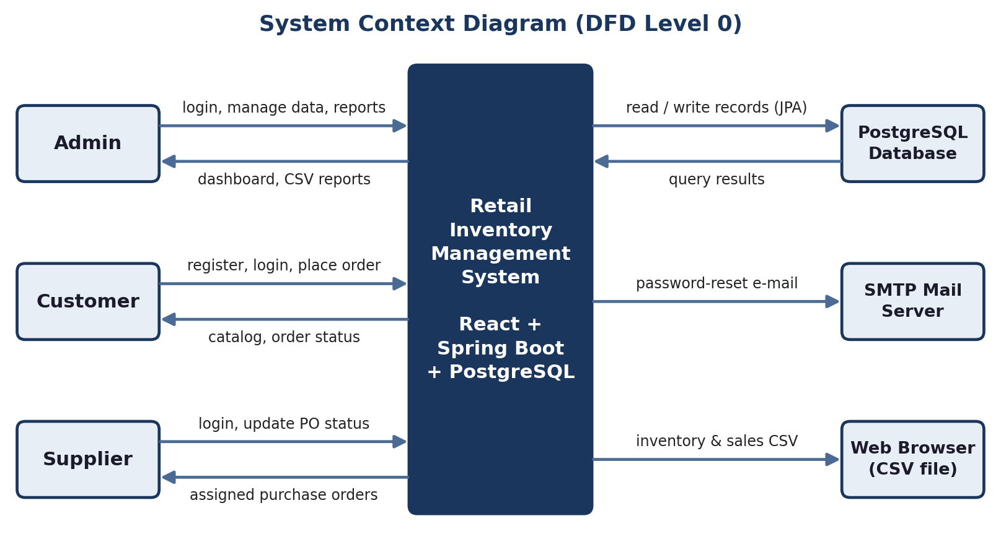
Figure 2.1: System context diagram (DFD Level 0)
2.2 User Classes and Characteristics
The software accommodates distinct user personas with varying access hierarchies:
User Role / Persona | Technical Proficiency | Core Responsibilities & Rights
System Administrator (ROLE_ADMIN) | High (operations / data management) | Complete access: dashboard, products, inventory, orders, fulfillment, suppliers, purchase orders, reports and user management, including suspending or activating accounts.
Supplier (ROLE_SUPPLIER) | Basic–Intermediate | Logs in to the supplier portal, views purchase orders assigned to the supplier, updates their status and edits item details.
Customer (ROLE_CUSTOMER) | Basic (general web user) | Registers and logs in, browses the product catalog by category, adds items to the cart, places orders and tracks own order history.
Registered User (ROLE_USER) | Basic | Base role of every account; authenticated profile management and catalog access.
Guest / Visitor | Basic | Can only reach the login and registration page; every other page and API requires authentication.
2.3 Operating Environment
The application operates within the following software and hardware environments:
- Client Requirements: Modern web browser (Google Chrome, Microsoft Edge, Mozilla Firefox, Safari); minimum display resolution 1366x768 for desktop.
- Server Runtime Environment: Java 17 (LTS) with Spring Boot 3.2 on Windows, Linux or macOS; Node.js LTS is required only to build and run the Vite frontend. The backend runs on port 8080 and the frontend development server on port 5173.
- Database Storage Tier: PostgreSQL (database rism_db) accessed through the PostgreSQL JDBC driver; optionally run with Docker Compose.
2.4 Design and Implementation Constraints
- Academic Budget Constraint: Only free / open-source tools are used; the system runs locally or in Docker containers without paid cloud services.
- Security Compliance: Passwords are stored only as BCrypt hashes; the API is stateless and every request except /api/auth/** requires a valid JWT; tokens expire after 24 hours.
- Modularity Standards: Layered architecture (Controller → Service → Repository → Entity) on the backend and page/component/service separation on the frontend ensures clean separation of concerns.
2.5 Assumptions and Dependencies
- Assumptions: Users have a working Internet / network connection and a modern browser; PostgreSQL is running and reachable before the backend starts.
- Dependencies: A configured SMTP account (for password-reset e-mails) and the open-source libraries declared in pom.xml and package.json.
2.6 Development Methodology
The project follows an Agile approach delivered in 15 incremental sprints. Each sprint produced a working, testable increment, allowing requirements to be refined as the system grew.
Sprint(s) | Focus / Deliverable
1 | Requirements, architecture, ER design, Git repository and project initialization.
2 | Authentication and authorization: login, JWT, roles.
3–5 | Product catalog, warehouses and basic inventory.
6–7 | Inventory transactions, stock adjustments and warehouse transfers.
8–9 | Order creation with stock validation and fulfillment workflow.
10–11 | Suppliers, purchase orders and supplier portal.
12–13 | Reports, dashboard enhancements, notifications and audit logs.
14–15 | Dockerization, testing, bug fixing and deployment preparation.
3. System Features and Functional Requirements
Requirements are categorized by functional subsystem modules with unique requirement identifiers (FR-x.x). Each module is first explained in brief and then itemized.
3.1 Module 1: Authentication and Access Governance
Controls who may enter the system and what each user may do. The login page posts credentials to /api/auth/login; Spring Security compares the password with its BCrypt hash and, if valid, a JWT is returned. The frontend stores the token, loads the user’s roles from /api/users/me and redirects to the correct portal.
Req ID | Feature Description | Input / Validation Rule | Priority
FR-1.1 | User Account Registration | Username (unique), e-mail, password, account type (customer / supplier); duplicate username rejected | High
FR-1.2 | Secure Credential Login | Username + password; verifies BCrypt hash; on failure returns “Incorrect username or password” | High
FR-1.3 | Session Token Management | Signed JWT valid for 24 hours, sent as Authorization: Bearer header | High
FR-1.4 | Role-Based Access and Redirection | Admin → /dashboard, Supplier → /supplier/dashboard, Customer → /customers/portal; unauthorized pages redirected | High
FR-1.5 | Forgot Password | Registered e-mail receives reset link; unknown e-mail gets a neutral message | Medium
FR-1.6 | Suspended Account Block | Accounts with non-active status refused with HTTP 403 message | Medium

3.2 Module 2: Dashboard
Gives administrators a quick summary of business activity on login. It reads inventory, order and purchase data from the REST APIs and shows them as summary cards and Recharts charts with links to detailed modules.
Req ID | Feature Description | Input / Validation Rule | Priority
FR-2.1 | Summary Metric Cards | Aggregated counts of products, stock, orders and purchase orders | Medium
FR-2.2 | Charts and Recent Activity | Order/status trends and recent orders rendered with Recharts | Low

3.3 Module 3: Product Catalog
Maintains the master list of items the business sells. Each product has a unique SKU, name, category, description, cost price, selling price, reorder level, status and image.
Req ID | Feature Description | Input / Validation Rule | Priority
FR-3.1 | Add / Edit / Deactivate Product | SKU unique and mandatory; cost and selling price numeric; reorder level integer | High
FR-3.2 | Category Management | Category name unique; products linked through category_id | Medium
FR-3.3 | Search and Filter | Free text on product name / SKU; filter by category | High

3.4 Module 4: Inventory and Warehouses
Shows how much of each product is held in each warehouse. The inventory record links a product to a warehouse and tracks total, reserved and available quantity; warehouse records store name, location, capacity and status. Saving an inventory record re-checks the product’s total available stock and raises a low-stock alert to inventory managers when it is below the reorder level.
Req ID | Feature Description | Input / Validation Rule | Priority
FR-4.1 | Warehouse-wise Stock View | Total, reserved and available quantity per product and warehouse (unique pair) | High
FR-4.2 | Stock Update / Adjustment | Quantity integer; available quantity cannot be negative (database CHECK) | High
FR-4.3 | Warehouse Management | Name, address / city, capacity, status | Medium
FR-4.4 | Stock Transfer and Transaction Records | API stores transfer (source, destination, quantity > 0) and stock transaction history records | Medium

3.5 Module 5: Orders
Captures customer orders and commits stock correctly. When an order is created, the order service goes through every item, reduces the available quantity and increases the reserved quantity across the warehouses holding that product. If the remaining available stock drops below the reorder level, a low-stock alert is sent to inventory managers.
Req ID | Feature Description | Input / Validation Rule | Priority
FR-5.1 | Create Order | Customer, warehouse, items (product, quantity > 0, unit price), total amount | High
FR-5.2 | Automatic Stock Reservation | Available quantity decreases and reserved quantity increases by the ordered amount | High
FR-5.3 | Low-Stock Alert | Triggered when total available quantity < product reorder level | High
FR-5.4 | Order Notifications | “Order Placed” to creator and “New Order” to order managers | Medium

3.6 Module 6: Fulfillment
Moves an order from placement to delivery. The fulfillment board groups orders by status (Pending, Packed, Shipped) and the admin updates them through PUT /api/orders/{id}/status. When an order becomes Shipped or Delivered, its reserved quantity is released and the total quantity is permanently reduced.
Req ID | Feature Description | Input / Validation Rule | Priority
FR-6.1 | Order Status Update | Status such as PENDING, CONFIRMED, PROCESSING, PACKED, SHIPPED, DELIVERED, CANCELLED | High
FR-6.2 | Inventory Finalization | On SHIPPED / DELIVERED: reserved and total quantity reduced | High
FR-6.3 | Status-Change Notification | Order creator notified with the new status | Medium

3.7 Module 7: Suppliers and Purchase Orders
Keeps a register of vendors (company, contact person, e-mail, phone, address, status) and manages replenishment. A purchase order is created for a supplier with product lines (quantity, unit cost, total cost) and moves through statuses such as Pending, Accepted, Shipped and Received. Supplier users receive a “New Purchase Order” notification, and procurement managers are notified when the supplier accepts it.
Req ID | Feature Description | Input / Validation Rule | Priority
FR-7.1 | Supplier Management | Add, edit, view and delete supplier records | High
FR-7.2 | Create Purchase Order | Supplier, items with quantity > 0 and unit cost; total amount | High
FR-7.3 | Purchase Order Status Tracking | Status updates; PO Accepted notifies procurement managers | Medium

3.8 Module 8: Supplier Portal
Lets suppliers handle their own purchase orders without admin rights. After login, a ROLE_SUPPLIER user sees only the supplier dashboard and purchase orders assigned to them, served by the /api/supplier endpoints.
Req ID | Feature Description | Input / Validation Rule | Priority
FR-8.1 | View Assigned Purchase Orders | Orders filtered by the logged-in supplier | High
FR-8.2 | Update Order Status | Status change request on a purchase order | High
FR-8.3 | Edit Item Details | Update item information of an assigned order | Medium

3.9 Module 9: Customer Portal
Provides an online shop front. Customers browse products by category or collection, add items to a cart, place orders and view their own order history with expandable order details. They cannot open admin pages.
Req ID | Feature Description | Input / Validation Rule | Priority
FR-9.1 | Browse and Filter Catalog | Category / collection filters | Medium
FR-9.2 | Cart and Place Order | Product and quantity added to cart, then submitted as an order | High
FR-9.3 | Order History | Only the logged-in customer’s orders and status shown | Medium

3.10 Module 10: Users and Profile
Administers accounts and lets users maintain their own details. Password hashes are never returned by the API.
Req ID | Feature Description | Input / Validation Rule | Priority
FR-10.1 | List Users (Admin) | All users displayed without password hashes | Medium
FR-10.2 | Activate / Suspend Account | Status field toggled by admin; suspended user cannot log in | Medium
FR-10.3 | Update Own Profile | Full name, e-mail, phone, address | Low

3.11 Module 11: Reports and Notifications
Supports monitoring and decision making. Two report endpoints produce downloadable CSV files, and notifications (low stock, new order, status change, purchase-order events) are stored per user and can be marked as read.
Req ID | Feature Description | Input / Validation Rule | Priority
FR-11.1 | Inventory CSV Report | GET /api/reports/inventory/csv – ID, SKU, name, category, selling and cost price | Medium
FR-11.2 | Sales CSV Report | GET /api/reports/sales/csv – order ID, date, status, total amount | Medium
FR-11.3 | User Notifications | List per user; mark as read | Medium

4. External Interface Requirements
4.1 User Interfaces (UI)
The interface follows standard UX usability practice: a clean sidebar navigation, role-specific menus, modal dialogs for data entry and tables with status badges. All forms provide immediate visual feedback (success banners or inline error alerts such as “Incorrect username or password”).
4.2 Hardware Interfaces
- Standard Deployment: Standard input/output peripherals (keyboard, mouse, display of at least 720p). No special hardware is required.
- Embedded / IoT Variants: Not applicable to this project.
4.3 Software Interfaces
- Relational Database Connector: Spring Data JPA / Hibernate with the PostgreSQL JDBC driver (database rism_db, port 5432).
- Mail Service: Spring Boot Mail using SMTP (STARTTLS on port 587) for password-reset e-mails.
- Frontend Libraries: Axios for REST calls, React Router for navigation, Recharts for charts.
4.4 Communication Interfaces
- Web Traffic Protocol: HTTP between the browser and the REST API (backend port 8080) during development; production deployment must use HTTPS with TLS.
- Data Serialization: All payload bodies are exchanged as UTF-8 application/json, using a common envelope with success, message and data fields; reports are returned as text/csv.
5. Non-Functional Requirements (NFRs)
Attribute | Target Metric / Standard | Verification & Testing Method
5.1 Performance | Normal pages load within about 3 seconds and API calls respond within about 1 second under typical classroom load. | Browser developer tools network tab; Postman response times.
5.2 Security | Zero plain-text passwords (BCrypt); stateless JWT with 24-hour expiry; all endpoints except /api/auth/** need a valid token; role-restricted routes; password hashes never returned by the API. | Authentication test cases TC10–TC13 and TC19; manual role-based access checks.
5.3 Reliability | Consistent storage through relational keys and CHECK constraints; automatic stock reservation inside a database transaction. | Order test cases TC30–TC34; Docker restart policy.
5.4 Portability | Works in Chrome, Edge, Firefox and Safari; runs on any OS with Java 17 and PostgreSQL. | Manual cross-browser inspection.
5.5 Usability | Role-specific navigation, clear error messages and status badges understandable by non-technical staff. | Walkthrough with sample users.
5.6 Maintainability | Modular layers (controller, service, repository, entity) and typed React components. | Code review; module-wise testing.
6. System Design and Analysis Models
University evaluation rubrics require standard graphical analysis models illustrating the dynamic and static behavior of the application. The models prepared for this project are summarized below and shown in the figures that follow.
Diagram Type | Objective & Scope | Deliverable Format
Use Case Diagram | Maps actors (Admin, Customer, Supplier) to their functional interactions. | UML use case diagram (Figure 6.1).
Data Flow Diagram (DFD) | Information flow: Level 0 (Figure 2.1) and Level 1 modular decomposition (Figure 6.2). | DFD with processes and data store.
Entity-Relationship (ERD) | Entities, primary / foreign keys and relationships of the PostgreSQL schema. | ERD with 1:N relationships (Figure 6.3).
Sequence Diagram | Message flow between UI, controller, security and database for the login feature. | UML sequence diagram (Figure 6.4).

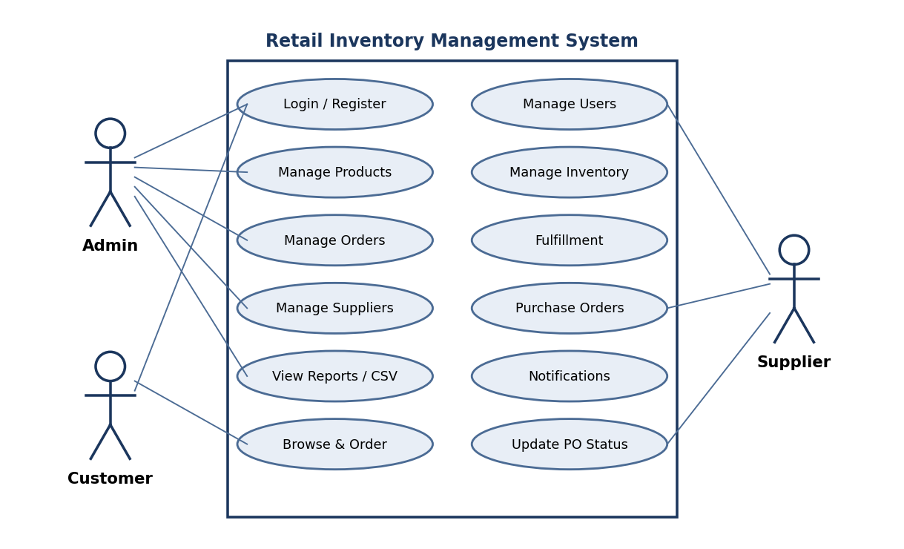
Figure 6.1: Use case diagram
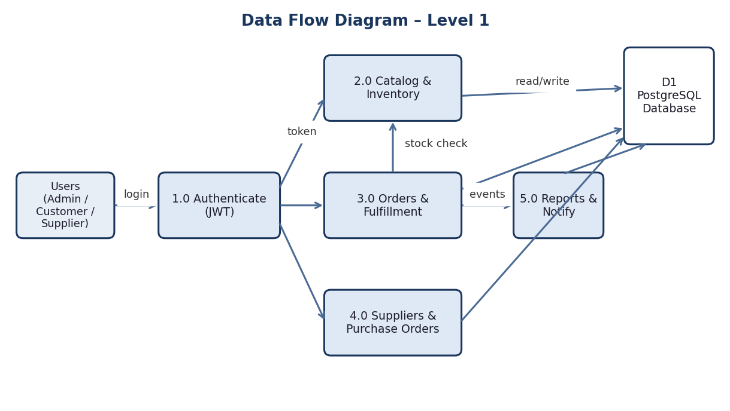
Figure 6.2: Data flow diagram – Level 1
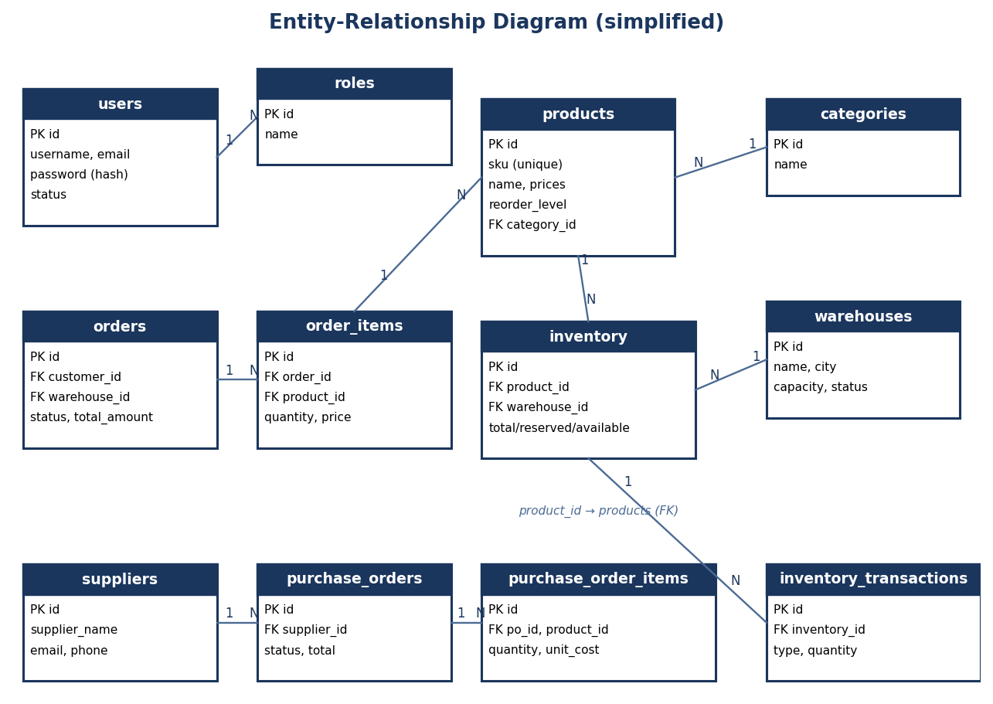
Figure 6.3: Entity-relationship diagram (simplified)
Normalization note: the schema is in third normal form – customer, product, category, warehouse and supplier data are stored once and referenced by foreign keys; order and purchase-order line items are held in separate child tables (order_items, purchase_order_items); users and roles are linked through the user_roles join table.
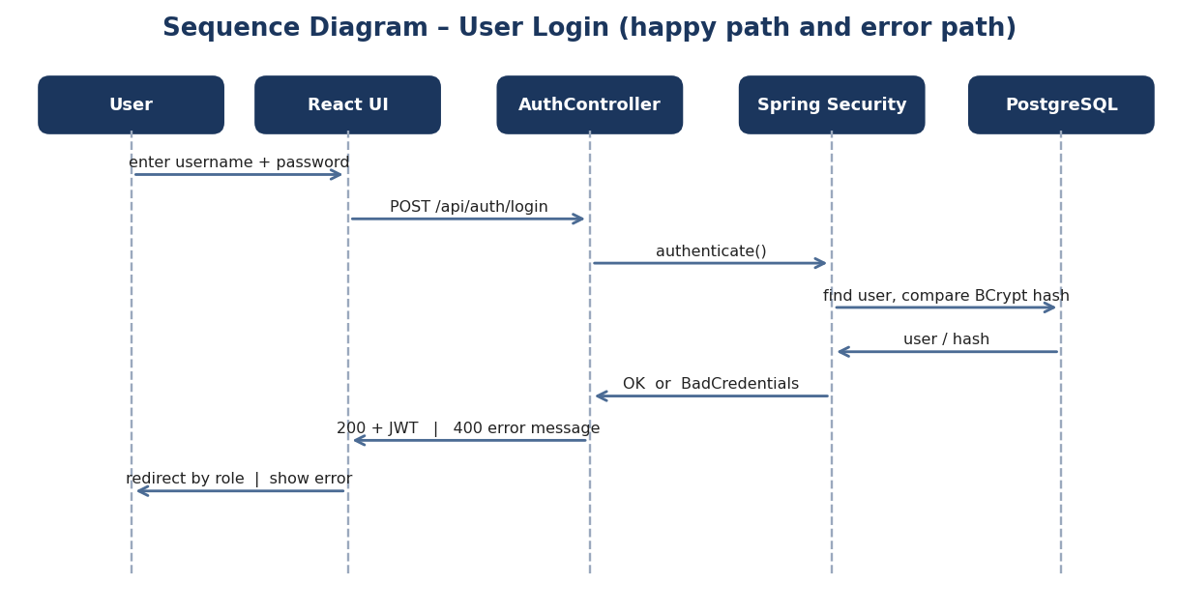
Figure 6.4: Sequence diagram – user login
6.1 Database Tables
Table | Important Fields | Purpose
users / roles / user_roles | id, username, password (hash), email, status; role name | Access and authorization
categories / products | sku, name, category_id, cost_price, selling_price, reorder_level, status | Catalog data
warehouses | name, address, city, capacity, status | Warehouse data
inventory | product_id, warehouse_id, total / reserved / available quantity | Warehouse-wise stock
inventory_transactions / stock_transfers | inventory_id, type, quantity; source / destination warehouse | Stock history and transfers
suppliers / purchase_orders / items | supplier_name, contact; supplier_id, status, total; product_id, quantity, unit_cost | Procurement data
customers / orders / order_items | customer_id, warehouse_id, status, total_amount; product_id, quantity, unit_price | Retail order data
shipments / notifications / audit_logs | carrier, tracking_number; type, message, is_read; action, details | Fulfillment, alerts, traceability
7. Testing and Validation
Testing is planned at functional level for every module through the user interface and the REST endpoints. Each test case lists the input and the expected result. Authentication is covered in the greatest detail because every other module depends on it. The Status column is to be updated after executing each case.
7.1 Authentication Test Cases
Endpoints under test: POST /api/auth/login, POST /api/auth/register, POST /api/auth/forgot-password and the /login page.
ID | Test | Input | Expected Result | Status
TC01 | Valid user login | Registered, active username and correct password | Login successful; JWT token issued; user redirected by role (Admin → Dashboard, Supplier → Supplier Dashboard, Customer → Customer Portal). | Pending
TC02 | Invalid password | Valid username with wrong password | Access rejected (HTTP 400); “Incorrect username or password” shown; no token issued. | Pending
TC03 | Invalid username | Unregistered username with any password | Access rejected; “Incorrect username or password” shown; no token issued. | Pending
TC04 | Invalid username and password | Both username and password incorrect | Access rejected; “Incorrect username or password” shown; no token issued. | Pending
TC05 | Empty fields | Submit login form with blank username / password | Browser validation stops submission; no request is sent. | Pending
TC06 | Suspended account | Correct credentials of an account suspended by admin | Access rejected (HTTP 403); “Restricted by admin. Your account has been suspended.” shown. | Pending
TC07 | Admin role redirect | Login with an admin account | Redirected to /dashboard; all admin menu items visible. | Pending
TC08 | Supplier role redirect | Login with a supplier account | Redirected to /supplier/dashboard. | Pending
TC09 | Customer role redirect | Login with a customer account | Redirected to /customers/portal. | Pending
TC10 | Protected page without login | Open /dashboard without logging in | User is redirected to the login page. | Pending
TC11 | Role restriction | Customer or supplier opens an admin-only URL such as /users | User is redirected to their own portal; admin page not shown. | Pending
TC12 | API call without token | Call a protected endpoint (e.g. GET /api/products) without Authorization header | Request rejected; no data returned. | Pending
TC13 | Invalid or tampered token | Send a modified / expired JWT in the Authorization header | Request rejected; user must log in again. | Pending
TC14 | Logout | Click logout, then open a protected URL | Session cleared; user is redirected to the login page. | Pending
TC15 | Register new account | Unique username, valid e-mail, password and account type | Account created; success message shown; user can then sign in. | Pending
TC16 | Duplicate username | Register with an existing username | Rejected with “Username already exists”. | Pending
TC17 | Forgot password – registered e-mail | Enter a registered e-mail | Success message; reset link e-mail sent (requires SMTP setup). | Pending
TC18 | Forgot password – unknown e-mail | Enter an unregistered e-mail | Neutral message “If that email exists, a reset link was sent.” – account existence not revealed. | Pending
TC19 | Password storage | Inspect the users table after registration | Password is stored as a BCrypt hash, not plain text. | Pending

7.2 Product and Inventory Test Cases
ID | Test | Expected Result | Status
TC20 | Product search | Matching product / SKU records displayed. | Pending
TC21 | Category filter | Only products of the selected category are shown. | Pending
TC22 | Add product | Product stored and shown in catalog. | Pending
TC23 | Duplicate SKU | Rejected by the unique constraint; error returned. | Pending
TC24 | Edit product | Updated price / details are saved and displayed. | Pending
TC25 | Inventory view | Warehouse-wise total, reserved and available quantities load. | Pending
TC26 | Update inventory below reorder level | Inventory saved; low-stock notification created for inventory managers. | Pending
TC27 | Add warehouse | New warehouse saved and listed. | Pending
TC28 | Stock transfer record | POST /api/stocktransfers stores the transfer with source, destination and quantity. | Pending

7.3 Order and Fulfillment Test Cases
ID | Test | Expected Result | Status
TC29 | Create order | Order saved; “Order Placed” notification generated for the creator. | Pending
TC30 | Stock reservation | Available quantity decreases and reserved quantity increases by the ordered amount. | Pending
TC31 | Low-stock alert on order | When remaining stock falls below reorder level, a low-stock notification is created. | Pending
TC32 | Update order status | New status saved and the order creator notified of the change. | Pending
TC33 | Ship / deliver order | Reserved quantity released and total quantity reduced. | Pending
TC34 | Customer order history | Customer sees only their own orders with details. | Pending
TC35 | Add to cart | Selected product and quantity appear in the cart. | Pending

7.4 Procurement and Supplier Test Cases
ID | Test | Expected Result | Status
TC36 | Add supplier | Supplier record saved and listed. | Pending
TC37 | Edit / delete supplier | Changes are reflected in the supplier list. | Pending
TC38 | Create purchase order | PO saved with items, total cost and pending status; supplier users notified. | Pending
TC39 | Supplier views POs | Supplier sees only purchase orders assigned to them. | Pending
TC40 | Supplier accepts PO | Status updated to ACCEPTED; procurement managers notified. | Pending
TC41 | Mark PO received | PO status changes to RECEIVED and is displayed in the procurement list. | Pending

7.5 Reports, Users and Other Test Cases
ID | Test | Expected Result | Status
TC42 | Dashboard | Summary cards and charts load with current data. | Pending
TC43 | Inventory CSV report | GET /api/reports/inventory/csv downloads inventory_report.csv. | Pending
TC44 | Sales CSV report | GET /api/reports/sales/csv downloads sales_report.csv. | Pending
TC45 | View users (admin) | User list displayed without password hashes. | Pending
TC46 | Suspend user | Account status changes; that user can no longer log in (see TC06). | Pending
TC47 | Update profile | Name, e-mail, phone and address are saved. | Pending
TC48 | Notifications | Notifications appear for the user and can be marked as read. | Pending

8. Academic Review & Sign-Off
This Software Requirements Specification document has been submitted and reviewed by the academic supervisory panel:
Project Coordinator / Guide (Avinay Raj) | Internal Examiner | Head of Department (HOD)
Signature:  __________________  Date:  __________________ | Signature:  __________________  Date:  __________________ | Signature:  __________________  Date:  __________________

