ASSIGNMENT – 15

REPORT ON BLOCKCHAIN

**1. Introduction**

Blockchain is a distributed ledger technology that enables secure and transparent transactions across a decentralized network. It operates through consensus mechanisms and cryptographic principles, making it resistant to tampering and fraud. Based on the level of access and governance, blockchains are classified into different types, each with its own set of features and use cases. This report explores the various types of blockchain—public, private, consortium, and hybrid—along with their real-time use cases across different industries.

**2. Types of Blockchain**

**2.1. Public Blockchain**

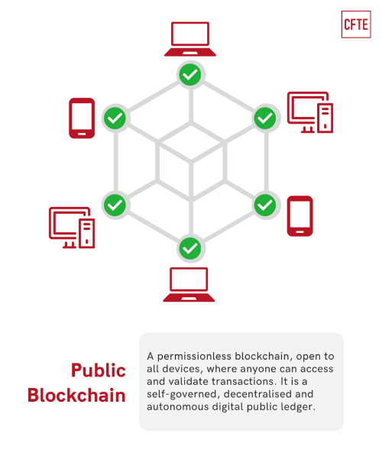

A public blockchain is a fully decentralized network where anyone can join, read, and write data. These blockchains operate on a consensus mechanism such as Proof of Work (PoW) or Proof of Stake (PoS), ensuring security and transparency. Public blockchains are open-source, providing full transparency to users.

**Examples:**

* **Bitcoin**
* **Ethereum**

**Use Cases:**

* **Cryptocurrencies**: Public blockchains are widely known for powering cryptocurrencies like Bitcoin and Ethereum. They enable secure, peer-to-peer financial transactions without the need for intermediaries.
* **Decentralized Finance (DeFi)**: Ethereum's public blockchain supports DeFi platforms that provide decentralized lending, borrowing, and trading services.
* **Non-Fungible Tokens (NFTs)**: Public blockchains like Ethereum are the backbone for NFT creation and trade, allowing digital ownership of art, music, and collectibles.

**2.2. Private Blockchain**

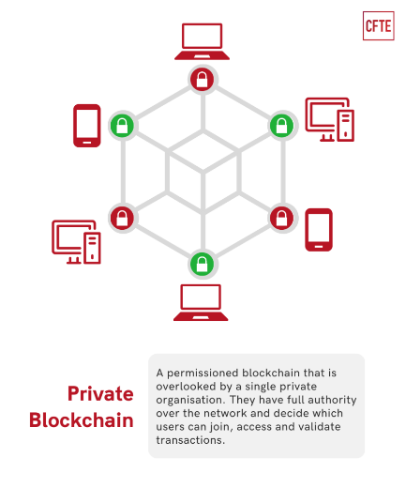

Private blockchains are permissioned networks where access is restricted to a specific group of participants. These networks are typically controlled by a single organization, ensuring faster transactions, privacy, and control. Private blockchains are mainly used within businesses or organizations where data privacy is a key concern.

**Examples:**

* **Hyperledger Fabric**
* **Corda**

**Use Cases:**

* **Supply Chain Management**: Companies like Walmart use private blockchains to track product movement through the supply chain, ensuring transparency and minimizing fraud.
* **Healthcare**: Private blockchains are used to manage sensitive patient records securely while ensuring privacy and compliance with regulations like HIPAA.
* **Banking and Finance**: Private blockchains allow banks to process international payments securely and efficiently. R3's Corda blockchain is an example used for this purpose.

**2.3. Consortium Blockchain**

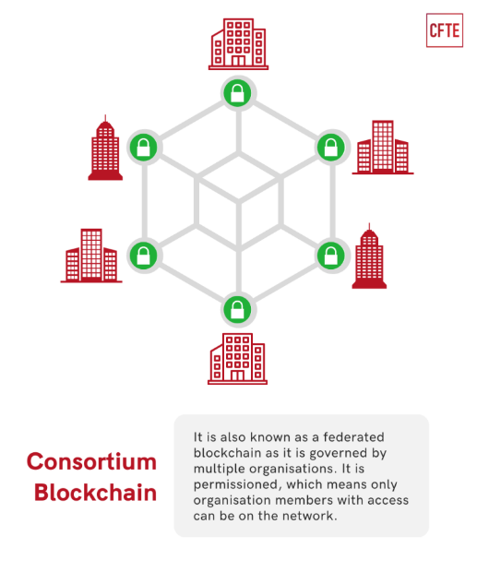

A consortium blockchain is a semi-decentralized type where multiple organizations share control of the network. Consortium blockchains are often used in industries where multiple entities need to work together but also require some level of privacy.

**Examples:**

* **Quorum**
* **Energy Web Foundation**

**Use Cases:**

* **Trade Finance**: Consortium blockchains are widely used in trade finance to streamline processes among multiple parties, such as banks, exporters, and importers. For example, the Marco Polo network uses blockchain to simplify trade finance operations.
* **Energy Sector**: The Energy Web Foundation uses consortium blockchains to manage decentralized energy grids, enabling energy trading among participants in a transparent and secure manner.
* **Insurance**: Multiple insurance companies collaborate using consortium blockchains for claims processing and fraud detection, improving efficiency and trust among different stakeholders.

**2.4. Hybrid Blockchain**

Hybrid blockchains combine elements of both public and private blockchains, offering a flexible approach that allows control over what data is kept private and what is shared publicly. This type of blockchain provides organizations with the ability to maintain confidentiality while leveraging the transparency of a public blockchain.

**Examples:**

* **Dragonchain**
* **XDC Network**

**Use Cases:**

* **Real Estate**: Hybrid blockchains are used in real estate for tokenizing property assets. Transactions involving property ownership are kept private, while sale records are made public to ensure transparency.
* **Retail**: Retailers use hybrid blockchains for customer loyalty programs, ensuring that customer data remains private while enabling public transparency for rewards distribution.
* **Government**: Governments use hybrid blockchains for voting systems where voter identities are kept private while voting results are public for verification and transparency.

**3. Real-Time Use Cases in Various Industries**

**3.1. Financial Services**

Blockchain is transforming the financial industry by enabling faster and more secure transactions. Public blockchains like Bitcoin and Ethereum are used for cross-border payments and decentralized finance (DeFi), while private and consortium blockchains support back-office operations like clearing and settlement in traditional banks.

**3.2. Healthcare**

In healthcare, private blockchains ensure the secure management of patient data and medical records. By using blockchain, hospitals and clinics can streamline the exchange of medical information, improve the accuracy of patient history, and protect patient privacy.

**3.3. Supply Chain Management**

Blockchain provides end-to-end visibility in supply chains, enabling companies to trace the origin and movement of goods. Walmart and IBM's Food Trust Network uses blockchain to track food from farm to table, reducing contamination risks and improving food safety.

**3.4. Real Estate**

Hybrid blockchains are used to tokenize real estate assets, allowing fractional ownership of property. Smart contracts automate the transfer of ownership, reducing paperwork and minimizing delays. The use of blockchain also ensures transparency in real estate transactions, eliminating fraudulent deals.

**3.5. Government**

Governments are adopting blockchain for secure digital identity systems and voting processes. Estonia uses blockchain to offer its citizens e-residency, allowing people to securely access public services online. Blockchain-based voting ensures election integrity by providing a transparent and tamper-proof voting system.

**4. Conclusion**

Blockchain technology is reshaping industries by providing decentralized, secure, and transparent solutions for various real-world applications. Public blockchains foster open and decentralized ecosystems, while private, consortium, and hybrid blockchains offer control and privacy for businesses and governments. As blockchain continues to evolve, it will play a critical role in transforming industries such as finance, healthcare, supply chain, and governance, offering greater efficiency, security, and trust in everyday transactions.