CN-3530/CS 301 Assignment 2- AI20BTECH11021

**1. Stop and Wait Protocol**

**Question 1** – Number of retransmissions and throughput with different retransmission timeout values with stop-and-wait protocol. For each value of retransmission timeout, run the experiments for **5 times** and write down the average **number of retransmissions** and **average throughput**.

|  |  |  |
| --- | --- | --- |
| **Retransmission timeout (ms)** | **Average number of**  **re-transmissions** | **Average throughput**  **(Kilobytes per second)** |
| 5 | 810 | 78.442 |
| 10 | 688 | 62.800 |
| 15 | 685 | 53.290 |
| 20 | 664 | 44.860 |
| 25 | 669 | 38.325 |
| 30 | 658 | 34.800 |
| 40 | 627 | 30.000 |
| 50 | 680 | 23.880 |
| 75 | 655 | 18.260 |
| 100 | 716 | 13.915 |

**Question 2** – Discuss the impact of retransmission timeout value on number of retransmissions and throughput. Indicate the optimal timeout value from communication efficiency viewpoint (i.e., the timeout that minimizes the number of retransmissions and keeps the throughput as high as possible).

As the retransmission timeout increases, the throughput decreases since more time is spent waiting for an acknowledgement from the receiver, even for lost packets. The number of packets retransmitted remain in a range, because initially, for a smaller timeout, packets might get retransmitted even if they were delayed, but as the timeout increases, delays get accounted for by the large timeout time, and the packets retransmitted are accounted for by the lost packets, which remains fairly constant.

The ideal retransmission timeout seems to be 10ms, which gives good enough throughput, as well as fairly low number of retransmissions. This is because, we are not spending more time than the RTT waiting for an acknowledgement which might get lost.

**2. Go back N Protocol**

**Question 1** – Experimentation with Go-Back-N. For each value of window size, run the experiments **5 times** and write down the **average throughput**.

|  |  |  |  |
| --- | --- | --- | --- |
|  | **Average throughput (Kilobytes per second)** | | |
| **Window Size** | **Delay = 5ms** | **Delay = 50ms** | **Delay = 150ms** |
| 1 | 114.213 | 69.660 | 40.827 |
| 2 | 184.953 | 95.646 | 52.865 |
| 4 | 186.890 | 90.572 | 47.054 |
| 8 | 184.330 | 94.453 | 45.963 |
| 16 | 171.786 | 91.240 | 48.960 |
| 32 | 152.200 | 85.426 | 44.257 |
| 64 | 119.180 | 78.600 | 44.030 |
| 128 | 89.796 | 44.614 | 39.014 |
| 256 | 55.287 | 48.350 | 29.428 |

Create a graph similar to the one shown below using the results from the above table: 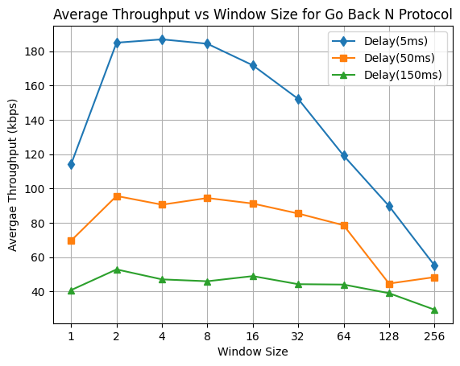

**Question 2** – Discuss your results from Question 1.

We find that for any delay, the average throughput increases as the window size increases from 1, indicating that window size 1 was not using the complete resources available. It then remains fairly constant / starts decreasing as the window size increases, because if even one packet gets lost in a large window, the entire window needs to be retransmitted. Because of this the throughput tends to decrease. As the delay increases, we spend much more time waiting for a lost acknowledgement or a lost packet’s acknowledgement, which increases the running time, and hence, decreases the average throughput.

We set time out value to be RTT ~ 2*delay to be the optimal value, as found from the Stop-and-Wait Protocol.