BY

Mr. TANMAY GURAV

T.Y.B.Sc COMPUTER SCIENCE

ACADEMIC YEAR 2020 -2021

SUBMITTED TO

UNIVERSITY OF MUMBAI

**Dodge This**

**(GAME)**

**A PROJECT REPORT ON**

D.G. RUPAREL COLLEGE

MATUNGA (W) MUMBAI - 400012

DECLARTION

I,Mr Tanmay Gurav Vinod, Student of D.G. RUPAREL COLLEGE OF ARTS, SCIENCE AND COMMERCE of TYCS SEMESTER- VI hereby, deceive that I have completed the project on Dodge this in academic year 2020-2021, the information submitted is true and original to the best of my knowledge.

ACKNOWLEDGEMENT

I am completely satisfied at this moment to present my project on Game Dodge This!. This project has been a learning challenge process for me. The completion of this project would have been unattainable without the supervision given to me by all the Professors of my college and my friends.

I would like to express thanks to all the professors, for their extensive uphold and cooperation all the way in the development and achievement of the project by providing me the truthful and precise information

Index

|  |  |  |
| --- | --- | --- |
| SR. NO. | INDEX TOPIC | PAGE |
| Preliminary Investigation | | |
| 1 | Gaming in the field of Software Engineering | 5 |
| 2 | Background of this Project | 6 |
| 3 | About the Project | 7 |
| 4 | Scope of the Project | 9 |
| System Analysis | | |
| 1 | Event Table | 11 |
| 2 | Sequence Diagram | 12 |
| 3 | Use Case Diagram | 13 |
| 4 | Activity Diagram |  |
| 5 | State Chart |  |
| System Design | | |
| 1 | Component Diagram | 17 |
| 2 | Deployment Diagram | 18 |
| System Coding | | |
| 1 | Menu Tree | 20 |
| 2 | Structure of Database | 23 |
| 3 | Program Description | 22 |
| 4 | Validations | 24 |
| 5 | Future Enhancements | 25 |
| 6 | Reference & Bibliography | 26 |

Preliminary Investigation

Gaming in the field of Software Engineering

EVENT TABLE

|  |  |  |  |  |
| --- | --- | --- | --- | --- |
| EVENT | TRIGGER | SOURCE | ACTIVITY | RESPONSE |
| Start Game | Player launching game | Player | Game Menu | Choosing game mode |
| Select Colors | Selecting Colors | Player | Colors Menu | Colors Scene |
| Select Shapes | Selecting Shapes | Player | Shapes Menu | Shapes Scene |
| Collecting Shape | Correct Shape | Script | Points | + 1 point |
| Collecting Color | Correct Color | Script | Points | + 1 point |
| Collecting Shape | Wrong Shape | Script | Hints | pop-up hint |
| Collecting Color | Wrong Color | Script | Hints | pop-up hint |

Activity Diagram

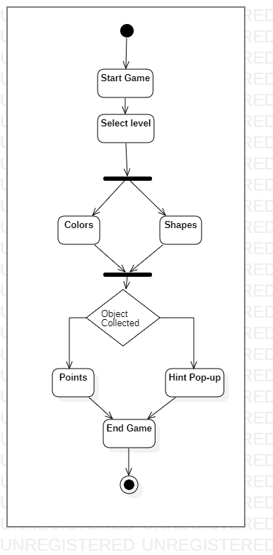

Use Case Diagram

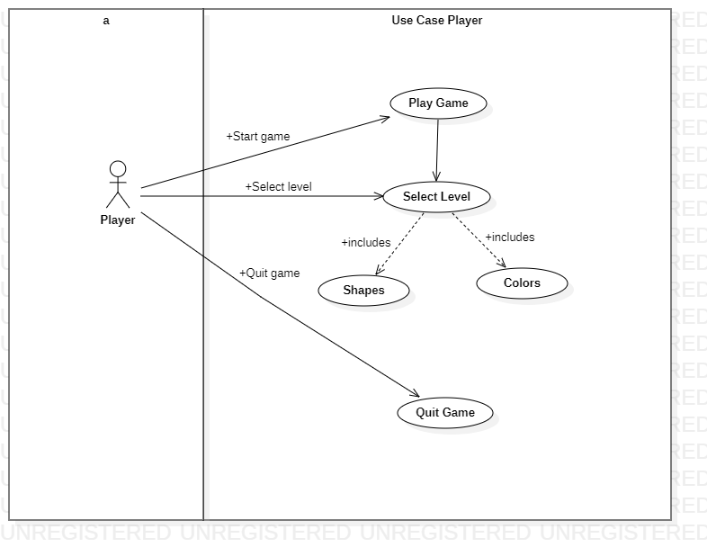

Sequence Diagram

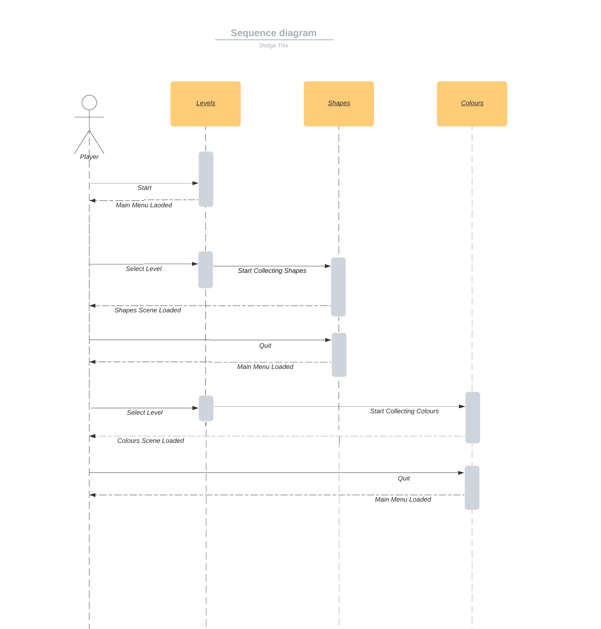

State Diagram

