VISVESVARAYA TECHNOLOGICAL UNIVERSITY
JNANASANGAMA, BELAGAVI - 590018

INTERNAL INTERNSHIP (25ISE146)
on
SMART TIMETABLE POSSIBILITY & OPTIMIZATION ENGINE

Submitted in partial fulfilment for the award of degree of

Bachelor of Engineering in
INFORMATION SCIENCE AND ENGINEERING
Submitted by
ANVITH A GOWDA 1BG25IS011
KRITI P DESAI 1BG25IS029
TANMAYI KT 1BG25IS058
TEJAS GOWDA M 1BG25IS059
Internal Guide
Dr. Laxmi V
Associate Professor, Dept. of ISE BNMIT, Bengaluru


B.N.M. Institute of Technology
An Autonomous Institution under VTU
URL: www.bnmit.org
Department of Information Science and Engineering 2026 - 2027

B.N.M. Institute of Technology
An Autonomous Institute under VTU

DEPARTMENT OF INFORMATION SCIENCE AND ENGINEERING















CERTIFICATE

Certified that the Third Semester Java Internal Internship project entitled Smart Timetable Possibility & Optimization Engine carried out by Anvith A Gowda(1BG25IS011), Kriti P Desai(1BG25IS029),Tanmayi KT(1BG25IS058) and Tejas Gowda M(1BG25IS059) bona fide students of III Semester B.E., B.N.M Institute of Technology, an Autonomous Institution under Visvesvaraya Technological University, submitted in partial fulfillment for the Bachelor of Engineering in INFORMATION SCIENCE AND ENGINEERING, Belagavi during the year 2024-25. It is certified that all corrections / suggestions indicated for Internal Assessment have been incorporated in the report. The project report has been approved as it satisfies the academic requirements in respect of Internal Internship project prescribed.

Dr. Laxmi V Dr. Srividhya Subramanian
Associate Professor Professor and HOD
Department of ISE Department of ISE
BNMIT, Bengaluru BNMIT, Bengaluru

DECLARATION

We, Anvith A Gowda (1BG25IS011), Kriti P Desai (1BG25IS029), Tanmayi KT (1BG25IS058) and Tejas Gowda M (1BG25IS059), students of III Semester B.E., Department of Information Science and Engineering, B.N.M. Institute of Technology, Bengaluru, hereby declare that the Internal Internship project work entitled “Smart Timetable Possibility & Optimization Engine” submitted to Visvesvaraya Technological University, Belagavi, is a record of original work done by us under the guidance of Dr. Laxmi V, Associate Professor, Department of Information Science and Engineering, BNMIT, Bengaluru.
We further declare that this project report has not been submitted to any other University or Institution for the award of any degree or diploma.

Place: Bengaluru
Date:

Signature of the Students

- Anvith A Gowda
- Kriti P Desai
- Tanmayi KT
- Tejas Gowda M

ACKNOWLEDGEMENT

I consider it a privilege to express through the pages of this report, a few words of gratitude to all those distinguished personalities who guided and inspired me in the completion of this Internship-I – 25ISE146.
I would like to thank Shri. Narayan Rao R Maanay, Chairman, BNMEI, Bengaluru for providing an excellent academic environment in college.
I would like to thank Prof. T.J. Rama Murthy, Director, BNMIT, Bengaluru for having extended his support and encouragement during the course of work.
I would like to thank Dr. S.Y. Kulkarni, Additional Director & Principal, BNMIT, Bengaluru for his extended support and encouragement during the course of work.
I would like to express my gratitude to Prof. Eishwar N Maanay, Dean, BNMIT, Bengaluru for his relentless support, guidance, and encouragement.
I would like to thank Dr. Krishnamurthy G.N., Deputy Director, BNMIT, Bengaluru for his constant encouragement.
I would like to thank Dr. S. Srividhya, Professor and Head of the Department of Information Science and Engineering, BNMIT, Bengaluru, for her support and encouragement towards the completion of our Internship-I – 25ISE146.
I would like to thank our Internship-I – 25ISE146 Coordinator and Guide Dr. Laxmi V, Associate Professor, Department of Information Science and Engineering, BNMIT, for being the guiding force towards the successful completion of our Internship-I – 25ISE146.

ANVITH A GOWDA (1BG25IS011) KRITI P DESAI (1BG25IS029) TANMAYI KT (1BG25IS058) TEJAS GOWDA M (1BG25IS059)

ABOUT THE DEPARTMENT

The Department of Information Science & Engineering was established in the year 2001 with an intake of
60. The department has qualified and dedicated faculty members to provide quality education to students. The department is accredited by NBA for the academic year 2024-25 to 2027-28. The department has well-established R & D Centre recognized by VTU, Belagavi, and faculty are actively involved in the research activities, publishing their work in various Journals and Conferences in thrust areas like Network Security, Internet of Things, Computer Vision, Machine Learning, Artificial Intelligence, Image Processing and Deep Learning etc. The department has student projects funded by IEDC. The Department has organized three online and one offline FDPs on thrust areas funded by AICTE Training and Learning Academy (ATAL). The department has state-of-the-art infrastructure to support research and develop students into professionals. Students are trained with multi-dimensional skill sets for their holistic growth. The department regularly organizes skill development programs, internships, workshops, alumni series, hackathon, technical talks and industrial visits to keep the students abreast with technology.

ABSTRACT

Manual preparation of academic timetables is a time-consuming and error-prone process that must simultaneously satisfy a large number of competing constraints — faculty availability, room capacity, subject-hour allocation, batch clashes, and laboratory sessions. The Smart Timetable Possibility & Optimization Engine is a software system designed to automate this process by modelling timetable generation as a constraint satisfaction and optimization problem. The system accepts structured institutional data such as courses, faculty, rooms, batches and time slots, and generates one or more feasible, conflict-free timetables that are ranked according to an optimization score.
The engine is built around a rule-based constraint layer that enforces hard constraints — no two classes for the same faculty, room, or batch may overlap — and a scoring layer that evaluates soft constraints such as minimizing idle gaps for faculty, balancing daily workload, and respecting preferred time slots. Candidate timetables are produced using a hybrid approach that combines backtracking search with a genetic algorithm, allowing the system to explore the very large search space efficiently and converge on high-quality solutions within practical time limits.
A web-based front end allows administrators to input institutional data, trigger timetable generation, and review or export the generated schedule, while a relational database persists all entities and their relationships. The system was tested on representative department-level datasets and was able to generate fully conflict-free timetables, demonstrating clear improvements in generation time and constraint satisfaction compared to manual scheduling. The project illustrates how classical AI search techniques and evolutionary optimization can be combined to solve a real, recurring administrative problem faced by every educational institution.

TABLE OF CONTENTS

CONTENTS | PAGE
DECLARATION | i
ACKNOWLEDGEMENT | ii
ABOUT THE DEPARTMENT | iii
ABSTRACT | iv
LIST OF FIGURES | 1
CHAPTER 1 – INTRODUCTION | 2
1.1 Introduction | 2
1.2 Problem Statement | 2
1.3 Objectives | 3
CHAPTER 2 – LITERATURE SURVEY | 4-5
CHAPTER 3 – SYSTEM REQUIREMENTS | 6
CHAPTER 4 – SYSTEM ARCHITECTURE | 7
CHAPTER 5 – METHODOLOGY | 8
CHAPTER 6 – ALGORITHM DESIGN | 9
CHAPTER 7 – SYSTEM DESIGN | 10-12
7.1 Proposed System | 10
7.2 Core Modules | 10
7.3 Optimization Strategy | 11
7.4 Error Handling | 12
CHAPTER 8 – IMPLEMENTATION | 13-15
8.1 Data Flow Diagram | 13
8.2 E-R Diagram | 14
8.3 Frontend, Java/JDBC and C++ Backend Integration | 15
CHAPTER 9 – RESULTS | 16-18
9.1 Constraint Satisfaction | 16
9.2 Optimization Quality | 17

9.3 Generation Time | 17
9.4 Administrator Dashboard | 18
CHAPTER 10 – FUTURE SCOPE | 19
CHAPTER 11 – CONCLUSION | 20
REFERENCES | 21
APPENDIX – I SUSTAINABLE DEVELOPMENT GOALS | 22

LIST OF FIGURES

Sl. No. | Figure | Pg. No.
7.1 | Student Group Management Interface | 10
7.2 | Administrator Dashboard of Smart Timetable System | 11
8.1 | Institutional Data Management Interface | 12
8.2 | Constraint Configuration Interface | 13
9.1 | Generated Timetable and Optimization Results | 15
9.2 | Optimization Statistics of Generated Timetable | 15

CHAPTER 1 INTRODUCTION

Introduction
Timetable generation is one of the most persistent scheduling challenges faced by every school, college, and university. Every academic term, administrators must assign a large number of subjects, faculty members, student batches, and classrooms into a fixed grid of time slots, while ensuring that no faculty member or room is double-booked and that every batch receives the correct number of hours for each subject. When performed manually, this task can take days of effort, is highly susceptible to human error, and rarely produces a timetable that is optimal with respect to faculty workload, room utilization, or student convenience.
The Smart Timetable Possibility & Optimization Engine addresses this problem by treating timetable generation as a Constraint Satisfaction Problem (CSP) combined with a multi-objective optimization layer. Institutional data — subjects, faculty, rooms, batches, and available time slots — is modelled as a set of entities and constraints. A solver explores the space of possible assignments, discards any assignment that violates a hard constraint (such as a scheduling clash), and scores the remaining feasible timetables against soft constraints (such as minimizing gaps in a faculty member’s day or balancing subject distribution across the week). The best-scoring timetable, or a small set of near-optimal alternatives, is then presented to the administrator.
By automating what is otherwise a manual, trial-and-error process, the system significantly reduces the time and effort required to produce a workable timetable each semester, while also improving the overall quality of the resulting schedule. The project further demonstrates how classical artificial intelligence techniques such as backtracking search, graph coloring, and genetic algorithms can be applied to an everyday administrative problem that every educational institution encounters.

Problem Statement
Design and implement a system that, given a set of subjects, faculty, classrooms/labs, student batches, and a fixed weekly grid of time slots, automatically generates one or more conflict-free timetables. The system must ensure that no faculty member, room, or batch is assigned to more than one class at the same time (hard constraints), while optimizing the arrangement with respect to faculty workload balance, minimal idle gaps, and preferred time-slot allocation (soft constraints). The generated timetable must be exportable and easily modifiable by an administrator.

Objectives
    - To design a data model capable of representing subjects, faculty, rooms, batches, and time slots, along with the constraints that link them.
    - To implement a constraint satisfaction engine that guarantees a hard-constraint-free (clash-free) timetable.
    - To incorporate an optimization layer (genetic algorithm / heuristic scoring) that improves timetable quality with respect to soft constraints such as workload balance and gap minimization.
    - To provide an intuitive interface for administrators to input institutional data and trigger timetable generation.
    - To allow generation of multiple alternative timetables so administrators can select the most suitable option.
    - To build a scalable backend capable of handling department-scale and institution-scale datasets.
    - To implement robust error handling for infeasible constraint sets, alerting the administrator when no valid timetable exists.
    - To design the system so that additional constraints (e.g., elective clashes, faculty leave) can be added in the future with minimal changes.

CHAPTER 2 LITERATURE SURVEY

Constraint Satisfaction Approaches to Timetabling
Summary: This paper formalizes scheduling and timetabling problems as Constraint Satisfaction Problems (CSPs), where variables represent class-time assignments and constraints capture clash-avoidance rules. It surveys backtracking, forward-checking, and arc-consistency techniques for pruning the search space efficiently.
Relevance to Project: The core hard-constraint engine of the Smart Timetable system is built directly on CSP formulation and backtracking search described in this line of work.

Genetic Algorithms for University Timetabling
Summary: This study applies evolutionary and simulated-annealing based metaheuristics to timetabling, showing that population-based search can escape local optima that trap purely greedy or backtracking approaches, producing higher-quality schedules for large, highly constrained problems.
Relevance to Project: The optimization layer of the engine adapts a genetic-algorithm crossover/mutation cycle to refine feasible timetables toward better soft-constraint scores.

Graph Coloring Models for Scheduling
Summary: This work models timetabling as a graph-coloring problem, where each course is a vertex, edges connect courses that cannot share a time slot, and colors represent time slots. It demonstrates that classical graph-coloring heuristics can produce quick, feasible starting solutions.
Relevance to Project: Graph-coloring is used to generate an initial conflict-free seed timetable, which the genetic algorithm subsequently refines.

Artificial Intelligence in Educational Administration Systems
Summary: This survey reviews decades of automated timetabling research and highlights that most practical institutional systems require a hybrid pipeline: a fast constructive heuristic to obtain a feasible solution, followed by a metaheuristic improvement phase, along with a user-facing interface that allows manual override of automatically generated schedules.

Relevance to Project: This hybrid pipeline design — constructive seeding followed by optimization, with administrator override — is the architectural blueprint followed by the Smart Timetable Possibility & Optimization Engine.

CHAPTER 3 SYSTEM REQUIREMENTS
The system requirements for the design, development and execution of the Smart Timetable Possibility &
Optimization Engine are described below.

Hardware Requirements
    - Processor: Intel i5 (or equivalent) or higher
    - RAM: 8 GB minimum (16 GB recommended for large institutional datasets)
    - Storage: 5 GB free disk space

3.2 Software Requirements
- Programming Languages: Java, C++, HTML, CSS and JavaScript — Java is used for the application/database layer, C++ is used for timetable optimization, and HTML, CSS and JavaScript are used for the frontend.
- Database: MySQL — used to store timetable-related information such as groups, teachers, subjects and rooms.
- Database Connectivity: JDBC (Java Database Connectivity) — used to establish communication between the Java application and the MySQL database.
- Data Access Layer: DAO (Data Access Object) — used to organize database operations through classes such as Group DAO, Teacher DAO, Subject DAO and Room DAO.
- Frontend: HTML5, CSS3 and JavaScript — used to create forms, dashboard interfaces, user interaction and timetable result display.
- Optimization Engine: C++ — used to process timetable data, check constraints, generate possible solutions, calculate optimization scores and select a better valid timetable.
- File-Based Communication: input.txt and output.txt — input.txt is used as the input file for the C++ engine, while output.txt stores the generated C++ result.
- IDE: VS Code — used for development, debugging and project management.
- Database Server: MySQL Server — used to run the project database locally.
- Operating System: Windows / Linux — used for development and execution of the project

Smart Timetable Possibility & Optimization Engine

CHAPTER 4 SYSTEM ARCHITECTURE
The Smart Timetable Possibility & Optimization Engine follows a layered architecture that cleanly
separates data storage, constraint solving, optimization, and user interaction. This separation allows each component to be developed, tested and extended independently.

4.1 System Architecture
The Smart Timetable Possibility & Optimization Engine follows a layered architecture that separates user interaction, database management and timetable optimization. The frontend allows the user to enter timetable-related information such as groups, teachers, subjects and rooms. The Java application uses JDBC to communicate with the MySQL database, while DAO classes organize the database operations.
The stored timetable data is then prepared as input for the C++ optimization engine. In the current implementation, the C++ engine uses input.txt as its input file and generates the optimized timetable result in output.txt. The generated result is then handled by the application and displayed through the frontend.

4.2 Frontend Layer
The frontend is developed using HTML, CSS and JavaScript. It provides an interface through which the user can enter and manage timetable-related information. The frontend includes forms, dashboard components and timetable result display.
The main inputs include groups, teachers, subjects, rooms, working days and periods per day. The frontend is responsible for collecting user input and presenting the generated timetable in an understandable format.

4.3 Java and JDBC Layer
The Java application acts as the application and database communication layer. JDBC (Java Database Connectivity) is used to establish communication between the Java application and the MySQL database.
The JDBC layer performs database operations such as inserting, retrieving, updating and deleting timetable-related information.

4.4 DAO Layer
The Data Access Object (DAO) layer separates database operations from the rest of the Java application. This makes the database-related code more organized and easier to maintain.
The project uses the following DAO classes:
- Group DAO – handles group-related database operations.
- Teacher DAO – handles teacher-related database operations.
- Subject DAO – handles subject-related database operations.
- Room DAO – handles room-related database operations.

4.5 MySQL Database Layer
MySQL is used as the database management system for storing timetable-related information. The database maintains information about groups, teachers, subjects and rooms that is required for timetable generation.
The database provides persistent storage and allows the Java application to retrieve the required information through JDBC and DAO classes.

4.6 C++ Optimization Engine
The C++ component acts as the core optimization engine of the system. It processes the timetable input and checks different constraints before generating a valid timetable.
The C++ engine performs the following major operations:
- Reads timetable input.
- Loads groups, teachers, subjects and rooms.
- Checks teacher availability.
- Checks teacher conflicts.
- Checks group conflicts.
- Checks room conflicts.
- Checks room capacity.
- Checks room type.
- Checks required subject periods.
- Generates possible timetable solutions.
- Calculates optimization scores.
- Removes duplicate solutions.
- Selects a better valid solution.
- Writes the generated result to output.txt.

4.7 File-Based Communication
In the current implementation, the C++ optimization engine uses a file-based input/output mechanism.
The timetable data provided to the C++ engine is stored in:
input.txt
The C++ engine reads this file, performs constraint checking and optimization, and writes the generated timetable result to:
output.txt.

4.8 Overall Architecture
The combination of the frontend, Java/JDBC layer, DAO layer, MySQL database and C++ optimization engine provides a structured approach to timetable generation. Each component performs a specific responsibility while contributing to the overall timetable generation process.

Smart Timetable Possibility & Optimization Engine

CHAPTER 5

METHODOLOGY
The system was developed using a hybrid constructive-plus-metaheuristic methodology that combines classical constraint satisfaction with evolutionary optimization. The main stages are described below.

Requirement Analysis & Data Modelling
Institutional entities (Subject, Faculty, Room, Batch, Time Slot) and the relationships among them were identified through discussion with academic administrators. Hard constraints and soft constraints (gap minimization, workload balance, preferred slots) were catalogued and prioritized.

Constraint Satisfaction Formulation
The problem was modelled as a Constraint Satisfaction Problem (CSP). Variables represent the assignment of a subject–batch–hour unit to a (time-slot, room) pair. Domains are the feasible slot–room combinations. Binary and global constraints encode all clash-avoidance rules.

Constructive Seeding (Graph Coloring)
An initial feasible solution is produced quickly by treating each required class session as a graph vertex and placing edges between sessions that cannot share a time slot. A greedy coloring heuristic yields a conflict-free seed timetable within seconds. This seed becomes the starting population for the genetic algorithm.

Metaheuristic Improvement (Genetic Algorithm)
A population of feasible timetables is evolved. Fitness is a weighted sum of soft-constraint scores. Selection, constraint-preserving crossover and mutation operators improve the population until a convergence criterion (score plateau or generation limit) is reached.

Validation & Administrator Feedback
Before optimization begins, a feasibility check detects unsatisfiable constraint sets and returns clear diagnostics. Ranked candidates are presented on the dashboard; the administrator may accept a solution, adjust constraints, or re-trigger generation, forming a human-in-the-loop cycle.

CHAPTER 6 ALGORITHM DESIGN

Hard-Constraint Enforcement
Each teaching session is a variable whose domain is the set of available (time-slot, room) pairs. Hard constraints enforced by backtracking with forward checking and the minimum-remaining-values (MRV) heuristic are:
    - Faculty uniqueness – no two sessions of the same faculty share a time slot.
    - Room uniqueness – no two sessions occupy the same room in the same slot.
    - Batch uniqueness – no two sessions of the same batch share a time slot.
    - Hour completeness – every subject–batch pair receives its prescribed weekly hours.

Graph-Coloring Seed Generator
Sessions become vertices; edges connect sessions that conflict (shared faculty, room or batch). Time slots act as colors. A DSATUR-style greedy coloring produces a feasible seed that the genetic algorithm then refines. This constructive step guarantees that every candidate entering the evolutionary phase already
satisfies all hard constraints.

Genetic Algorithm
Chromosome representation is a direct mapping of sessions to (slot, room) pairs. The main operators are:
    - Tournament selection (size 3) to favor higher-fitness individuals while preserving diversity.
    - Constraint-preserving crossover that exchanges subsets of assignments, followed by local repair of any hard-constraint violations.
    - Low-probability mutation that reassigns a small number of sessions to alternative feasible slots.
    - Steady-state replacement of the worst individuals only when offspring improve fitness or diversity.

CHAPTER 7 SYSTEM DESIGN

Proposed System
The Smart Timetable Possibility & Optimization Engine is a full-stack application that separates concerns across three layers: a data layer that stores institutional entities, a solver/optimization layer that generates candidate timetables, and a presentation layer that lets administrators configure inputs and review results. The system enhances traditional manual scheduling by automatically generating multiple clash-free timetable possibilities and ranking them using an optimization score, so the administrator can compare options rather than build a single schedule from scratch.

Core Modules
The system consists of the following major modules:
1.Frontend:Provides the user interface using HTML, CSS and JavaScript. It allows users to enter timetable information and view the generated timetable.
2. Java application model: Handles application-level operations and acts as the layer between the frontend-related operations and the database access components.
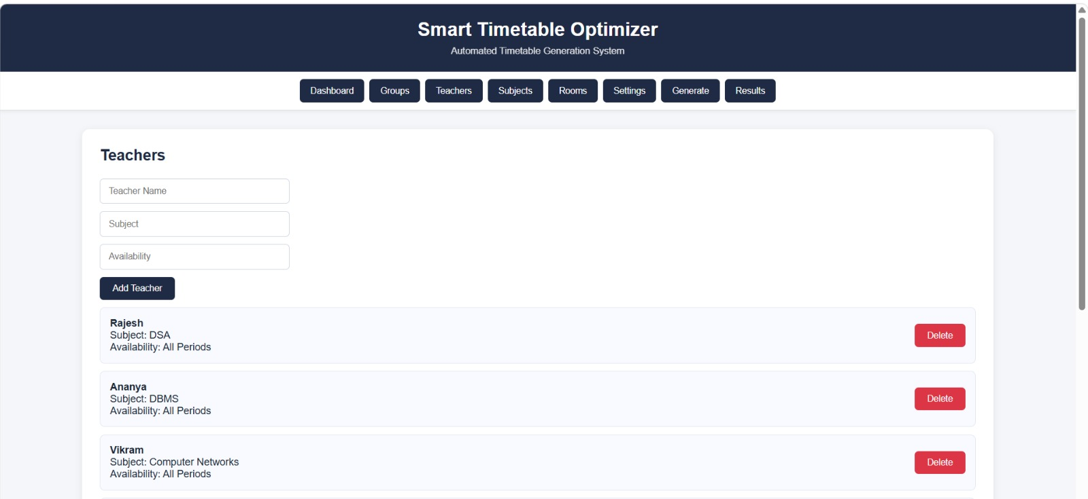

7.1 Student Group Management Interface

Provides connectivity between the Java application and MySQL. It is responsible for establishing the database connection and executing SQL operations.
4. DAO Module: Organizes database operations using separate DAO classes:
- Group DAO
- Teacher DAO
- Subject DAO
- Room DAO
5. MySQL Database Module: Stores timetable-related information such as groups, teachers, subjects and rooms.
6. C++ Optimization Module: Processes timetable data and performs constraint checking, solution generation and optimization.
7. File Communication Module: Uses input.txt to provide input to the C++ engine and output.txt to store the generated result.
8. Result Display Module: Handles the generated timetable result and displays it through the frontend according to the implemented result-handling mechanism.

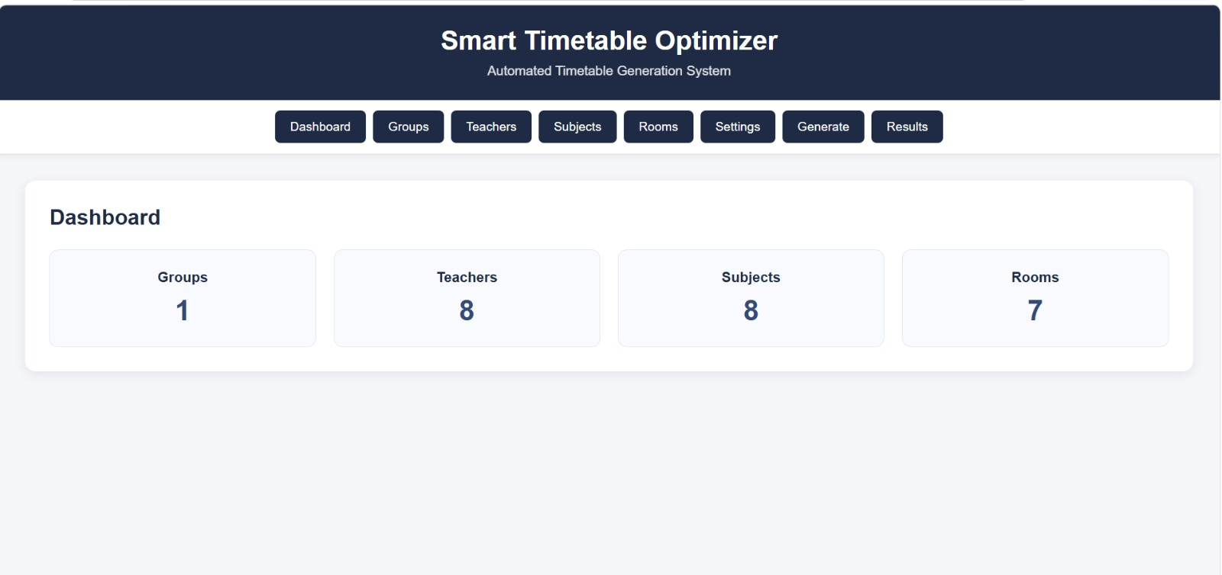
Figure 7.2: Administrator Dashboard of Smart Timetable System

Optimization Strategy
Hard constraints — no faculty member, room, or batch may be double-booked, and every subject must receive its required number of weekly hours — are treated as non-negotiable and enforced during candidate construction using backtracking search seeded by a graph-coloring heuristic. Soft constraints, including minimizing idle gaps in a faculty member’s schedule, balancing the number of classes per day, and respecting preferred time slots, are expressed as a weighted fitness function. A genetic algorithm iterates over a population of feasible timetables, applying selection, crossover, and mutation operators, to progressively improve the fitness score across generations until a convergence criterion (score plateau or generation limit) is reached.

Error Handling
The system checks timetable data and constraints during the timetable generation process. Conflicting or invalid assignments are identified during constraint checking.
The optimization engine avoids accepting solutions that violate the defined scheduling constraints. The generated result is written to output.txt only after the processing performed by the current C++ implementation.

CHAPTER 8 IMPLEMENTATION

Data Flow Diagram
The Data Flow Diagram (DFD) for the Smart Timetable Possibility & Optimization Engine describes how institutional data moves through the system to produce a finished timetable. The administrator first enters or uploads subject, faculty, room, and batch data, which is stored by the Data Management module.
On triggering a generation request, this data is passed to the Constraint Engine, which builds the CSP model and forwards it to the Optimization module. The Optimization module returns one or more scored, conflict-free candidate timetables, which are stored and passed to the Visualization module for display.
The administrator reviews the result and either approves it for publication or adjusts constraints and re-triggers generation.

Figure 8.1: Institutional Data Management Interface

E-R Diagram
The Entity-Relationship (ER) model centers on five core entities: Subject, Faculty, Room, Batch, and Time Slot, together with a resulting Timetable entity that links them. A Faculty can teach multiple Subjects, and a Subject can be taught by more than one qualified Faculty member. Each Batch is enrolled in multiple Subjects, and each generated Timetable entry associates exactly one Subject, one Faculty member, one Room, one Batch and one Time Slot, with a uniqueness constraint ensuring that no two Timetable entries share the same Faculty, Room, or Batch at the same Time Slot. This relational structure allows the constraint engine to validate assignments directly against the database schema.

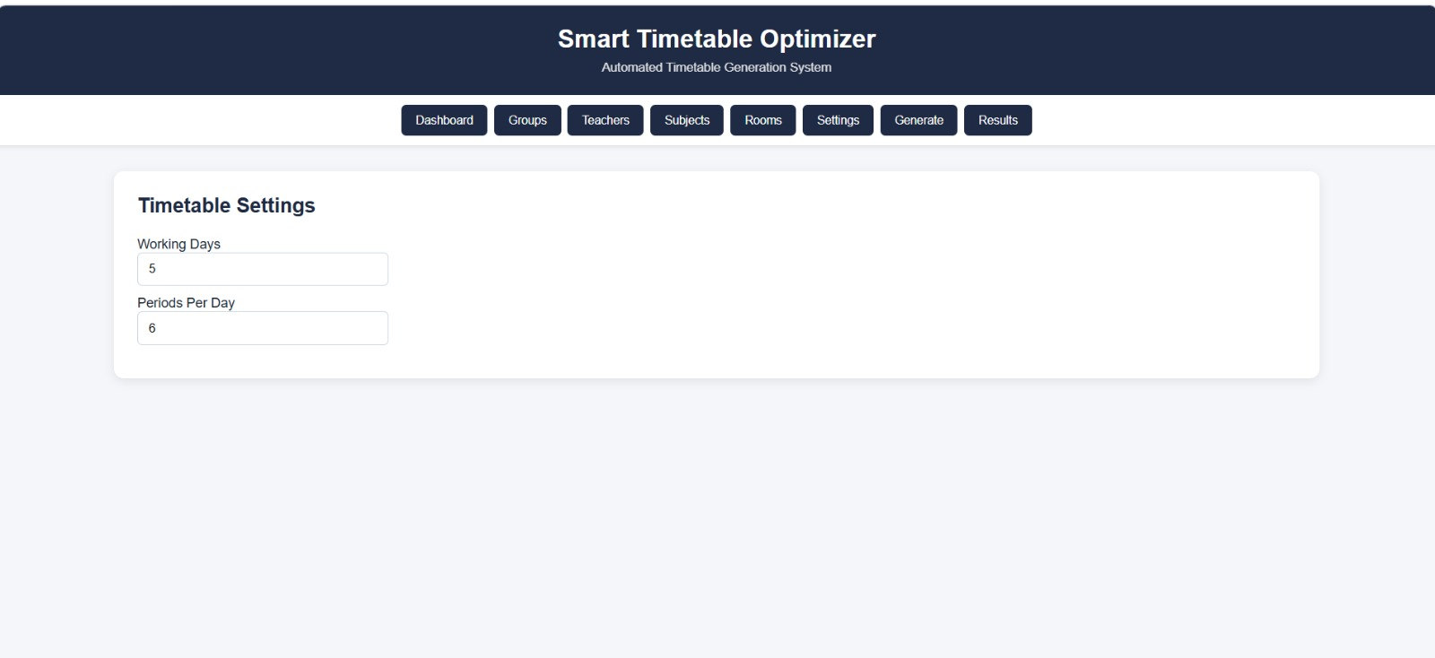
Figure 8.2: Constraint Configuration Interface

8.3 Frontend, Java/JDBC and C++ Backend Integration
The Smart Timetable Possibility & Optimization Engine integrates the frontend, Java application, database layer and C++ optimization engine to generate an optimized timetable. The frontend developed using HTML, CSS and JavaScript collects the required timetable information from the user.
The Java application manages database-related operations using JDBC and DAO classes. JDBC provides connectivity between the Java application and the MySQL database, while DAO classes organize operations related to groups, teachers, subjects and rooms.
The timetable-related data stored in MySQL is prepared as input for the C++ optimization engine. In the current implementation, the C++ engine uses input.txt as its input file. The engine performs constraint checking, generates possible solutions, calculates optimization scores and selects a better valid solution.

CHAPTER 9 RESULTS
The Smart Timetable Possibility & Optimization Engine was tested using representative department-level
datasets consisting of multiple subjects, faculty members, rooms, and student batches across a standard five-day, eight-period weekly grid. The system’s output was evaluated on three key aspects: constraint satisfaction, generation time, and schedule quality.
9.1 Constraint Satisfaction
The generated timetable is checked against the defined scheduling constraints. The C++ optimization engine checks teacher availability, teacher conflicts, group conflicts, room conflicts, room capacity, room type and required subject periods.
A timetable is considered valid when it satisfies the required constraints without conflicting assignments.
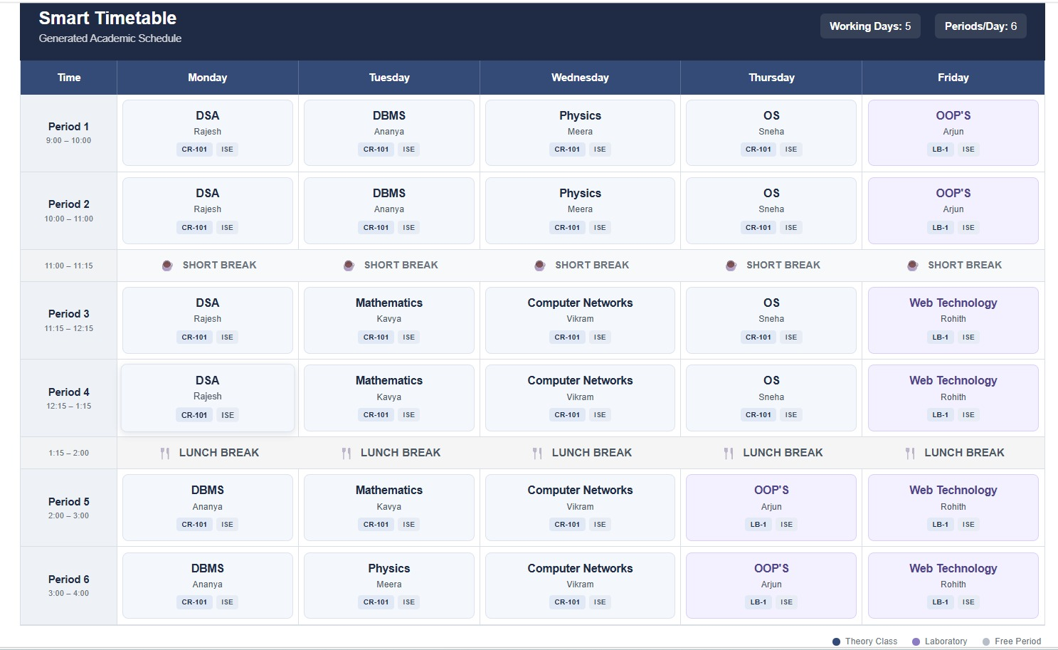
Figure 9.1: Generated Timetable and Optimization Results
9.2 Optimization Quality
After generating possible timetable solutions, the C++ optimization engine calculates an optimization score for the solutions. Duplicate solutions are removed and a better valid solution is selected based on the implemented optimization criteria.
The selected timetable is written to output.txt and is then handled by the application for result display.
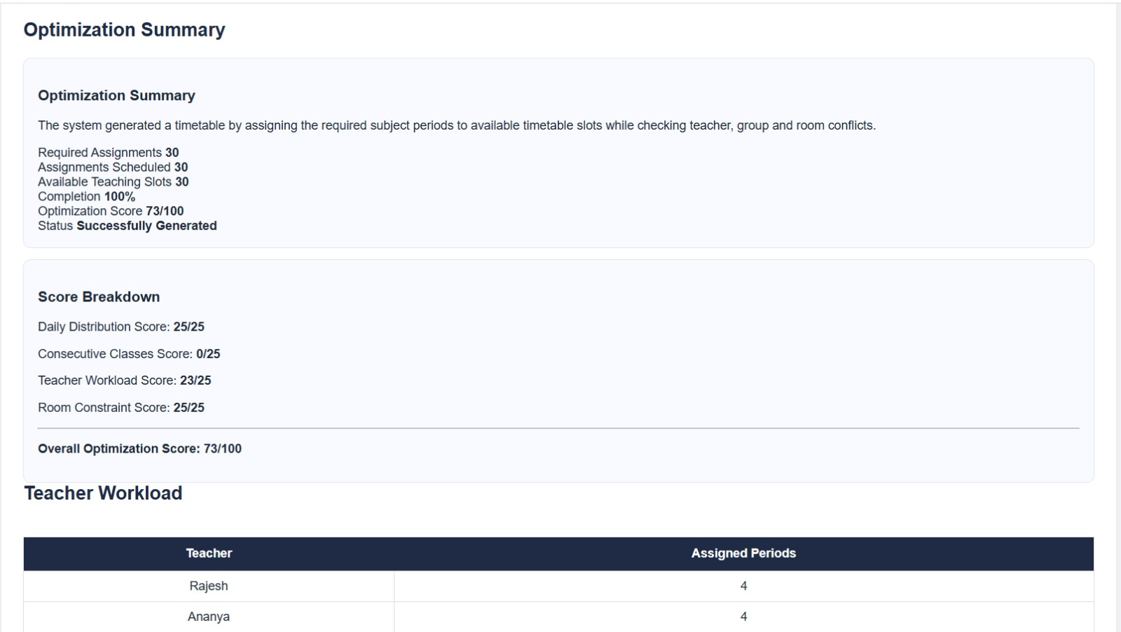
Figure 9.2: Optimization Statistics of Generated Timetable

9.3 Generation Time
This process allows the system to generate a valid timetable while considering the defined scheduling constraints.

9.4 Administrator Dashboard
The frontend provides the interface for entering timetable-related information and viewing the generated timetable result. The dashboard allows the user to work with groups, teachers, subjects and rooms and view the generated timetable according to the implemented result-handling mechanism.

Smart Timetable Possibility & Optimization Engine

CHAPTER 10 FUTURE SCOPE
The present system provides a solid foundation. The following enhancements are planned for future
iterations:
Real-time Rescheduling: Support for sudden faculty leave, room unavailability or special events by re-optimizing only the affected portion of the timetable while preserving the remainder, thereby minimizing disruption to the rest of the schedule.
Multi-campus & Multi-department Scheduling: Extension of the constraint model to shared resources across campuses or departments, including travel-time constraints between buildings and coordinated use of common laboratory facilities.
Elective & Choice-based Credit System Support: Native handling of elective subjects where students from multiple batches may enroll, requiring more sophisticated clash detection and preference aggregation across heterogeneous student groups.
Faculty Preference Learning: Machine-learning models that learn individual faculty preferences over successive semesters and automatically adjust soft-constraint weights, reducing the need for manual preference entry.
ERP / LMS Integration: Bi-directional synchronization with existing student-information systems, attendance modules and learning-management platforms so that timetable data flows seamlessly into other administrative processes.
Mobile Application & Notifications: A companion mobile app for faculty and students that displays personalized schedules and pushes notifications when changes occur.
Advanced Multi-objective Optimization: Replacement or augmentation of the weighted-sum fitness function with true multi-objective techniques (e.g., NSGA-II) that present a Pareto front of trade-off solutions to the administrator.
Explainability & What-if Analysis: Tools that explain why a particular assignment was chosen and that allow administrators to explore the impact of hypothetical constraint changes before committing to a final timetable.

CHAPTER 11 CONCLUSION
The Smart Timetable Possibility & Optimization Engine successfully demonstrates that classical constraint
satisfaction techniques combined with evolutionary optimization can automate a complex, recurring administrative task faced by every educational institution. By modelling timetable generation as a CSP with a multi-objective fitness layer, the system reliably produces fully conflict-free schedules while improving soft-constraint quality metrics such as faculty gap minimization and workload balance. The hybrid graph-coloring seed plus genetic algorithm pipeline yields high-quality solutions within practical time limits for department-scale datasets. The web-based administrator interface, together with clear feasibility diagnostics, makes the tool usable by non-technical staff. Future extensions such as real-time rescheduling, multi-campus support and ERP integration will further increase the system’s practical value. Overall, the project illustrates how well-established artificial-intelligence methods can be applied to deliver tangible operational benefits in educational administration.

REFERENCES

- Constraint Satisfaction Approaches to Timetabling – Survey of CSP formulations, backtracking, forward-checking and arc-consistency techniques for educational scheduling.
- Genetic Algorithms for University Timetabling – Application of evolutionary and simulated-annealing metaheuristics to large-scale university course scheduling problems.
- Graph Coloring Models for Scheduling – Modelling of timetabling as graph coloring with DSATUR and greedy heuristics for rapid feasible seed generation.
- Artificial Intelligence in Educational Administration Systems – Hybrid constructive-plus-metaheuristic pipelines and human-in-the-loop design principles for practical institutional systems.

APPENDIX - I

SUSTAINABLE DEVELOPMENT GOALS

The Smart Timetable Possibility & Optimization Engine aligns with multiple United Nations Sustainable Development Goals (SDGs) by leveraging Artificial Intelligence and optimization techniques to improve educational administration. The project supports SDG 4 (Quality Education), SDG 5 (Gender Equality) and SDG 9 (Industry, Innovation and Infrastructure) by providing a sustainable, efficient and technology-driven platform for academic scheduling.

SDG 4: Quality Education
The system enhances the quality of education delivery by ensuring that academic timetables are generated efficiently, conflict-free and optimized for faculty workload and student convenience. By automating a complex administrative process, it frees up institutional resources that can be redirected towards teaching and learning. Students and faculty benefit from well-balanced schedules that reduce idle gaps and overcrowding, contributing to a more effective learning environment.

SDG 5: Gender Equality
The automated and transparent nature of the timetable generation process helps eliminate unconscious bias that may arise in manual scheduling. Preferred time slots, workload balance and room allocation are handled algorithmically based on objective constraints rather than subjective decisions. This promotes equitable distribution of teaching loads and access to resources for all faculty members irrespective of gender, supporting a fairer academic workplace.

SDG 9: Industry, Innovation and Infrastructure
By integrating classical constraint satisfaction techniques with genetic algorithms and a modern web-based architecture, the project demonstrates how AI-driven innovation can strengthen educational infrastructure. The system provides a scalable, reusable technological solution that institutions can adopt to modernize administrative processes, reduce manual effort and improve operational efficiency — contributing to resilient and innovative institutional infrastructure.

