VISVESVARAYA TECHNOLOGICAL UNIVERSITY
Jnana Sangama, Machhe, Belagavi, Karnataka 590018

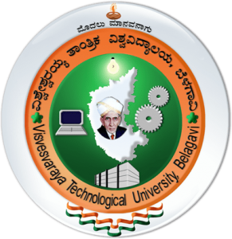

INTERNSHIP-I REPORT
On
“C++ PROGRAMMING AND WEB TECHNOLOGY”

Submitted in partial fulfillment of the requirement
for the award of the degree of

Bachelor of Engineering

In

Information Science and Engineering

By
KRITI P DESAI 1BG25IS029
TANMAYI KT 1BG25IS058
TEJAS GOWDA M 1BG25IS059

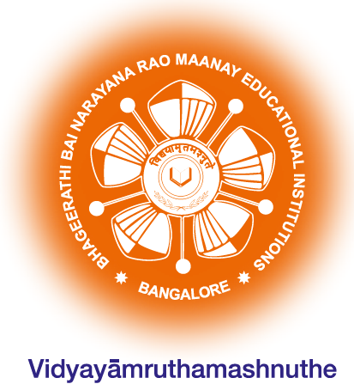

B.N.M. Institute of Technology

An Autonomous Institution under VTU, Approved by AICTE

Department of Information Science and Engineering
2026 – 2027
B.N.M. Institute of Technology
An Autonomous Institution under VTU, Approved by AICTE

DEPARTMENT OF INFORMATION SCIENCE & ENGINEERING

CERTIFICATE

Certified that KRITI P DESAI (1BG25IS029) TANMAYI KT (1BG25IS058) TEJAS GOWDA M (1BG25IS059) has carried out the Internship I – 25ISE146 on C++ Programming and Web Technology conducted internally from 03rd August 2026 to 20th August 2026. Candidate has fulfilled all the requirements prescribed in the curriculum. Candidate has incorporated all the corrections/suggestions indicated during the Internal Assessment. The Internship I – 25ISE146 work has been approved as it satisfies the curriculum requirements.

Dr. Laxmi V Dr. S Srividhya Dr. S Y Kulkarni

Associate Professor Professor & Head, Additional Director &Principal

Dept. of ISE, BNMIT Dept. of ISE, BNMIT BNMIT

B.N.M. Institute of Technology
An Autonomous Institution under VTU, Approved by AICTE

DEPARTMENT OF INFORMATION SCIENCE & ENGINEERING

DECLARATION

I,KRITI P DESAI (1BG25IS029),TANMAYI KT (1BG25IS058) and TEJAS GOWDA M (1BG25IS059) a students of B.E. in Information Science and Engineering, Bengaluru, hereby declare that, I have carried out 15 days of Internship I – 25ISE146 at BNM Institute of Technology, Post Box No.7087, 27th Cross, 12th Main, Banashankari 2nd Stage, Bengaluru-560070 From 03rd August 2026 to 20th August 2026. under the guidance of Dr. Laxmi V, Associate Professor, Department of ISE, BNMIT. This Internship I – 25ISE146 report is submitted to Visvesvaraya Technological University, Belagavi in partial fulfillment of the requirement for the award of degree of Bachelor of Engineering in Information Science & Engineering during the academic year 2026-27.

Place: Bengaluru Signature of Student

ACKNOWLEDGEMENT

I consider it a privilege to express through the pages of this report, a few words of gratitude to all those distinguished personalities who guided and inspired me in the completion of this Internship-I – 25ISE146 .

I would like to thank Shri. Narayan Rao R Maanay, Chairman, BNMEI, Bengaluru for providing an excellent academic environment in college.

I would like to thank Prof. T.J. Rama Murthy, Director, BNMIT, Bengaluru for having extended his support and encouragement during the course of work.

I would like to thank Dr. S.Y. Kulkarni, Additional Director & Principal, BNMIT, Bengaluru for his extended support and encouragement during the course of work.

I would like to express my gratitude to Prof. Eishwar N Maanay, Dean, BNMIT, Bengaluru for his relentless support, guidance, and encouragement.

I would like to thank Dr. Krishnamurthy G.N., Deputy Director, BNMIT, Bengaluru for his constant encouragement.

I would like to thank Dr. S. Srividhya , Professor and Head of the Department of Information Science and Engineering, BNMIT, Bengaluru, for her support and encouragement towards the completion of our Internship-I – 25ISE146 .

I would like to thank our Internship-I – 25ISE146 Coordinator Dr. Laxmi V, Associate Professor Department of Information Science and Engineering, BNMIT, for being the guiding force towards the successful completion of our Internship-I – 25ISE146.

KRITI P DESAI (1BG25IS029)
TANMAYI KT (1BG25IS058)
TEJAS GOWDA M (1BG25IS059)

ABOUT THE DEPARTMENT

The Department of Information Science & Engineering was established in the year 2001 with an intake of 60. The department has qualified and dedicated faculty members to provide quality education to students. The department is accredited by NBA for the academic year 2024-25 to 2027-28. The department has well-established R & D Centre recognized by VTU, Belagavi, and faculty are actively involved in the research activities, publishing their work in various Journals and Conferences in thrust areas like, Network Security, Internet of Things, Computer Vision, Machine Learning, Artificial Intelligence, Image Processing and Deep Learning etc. The department has student projects funded by IEDC. The Department has organized three online and one offline FDPs on thrust areas funded by AICTE Training and Learning Academy (ATAL). The department has state-of-the-art infrastructure to support research and develop students into professionals. Students are trained with multi-dimensional skill sets for their holistic growth. The department regularly organizes skill development programs, internships, workshops, alumni series, hackathon, technical talks and industrial visits to keep the students abreast with technology.

