Module-1
CSS Exercises
Exercise-1
Index.html

<html>
<head>
<title>CSS Methods Demo</title>
<link rel="stylesheet" href="styles.css">
<style>
body {
background-color: lightgray;
}
</style>
</head>
<body>

<h1 style="color:red;">Local Community Event Portal</h1>

<h2>Welcome Section</h2>

<p>This page demonstrates Inline, Internal, and External CSS.</p>

</body>
</html>

Styles.css

h2 {
color: blue;
text-align: center;
}

p {
font-size: 18px;
color: black;
}
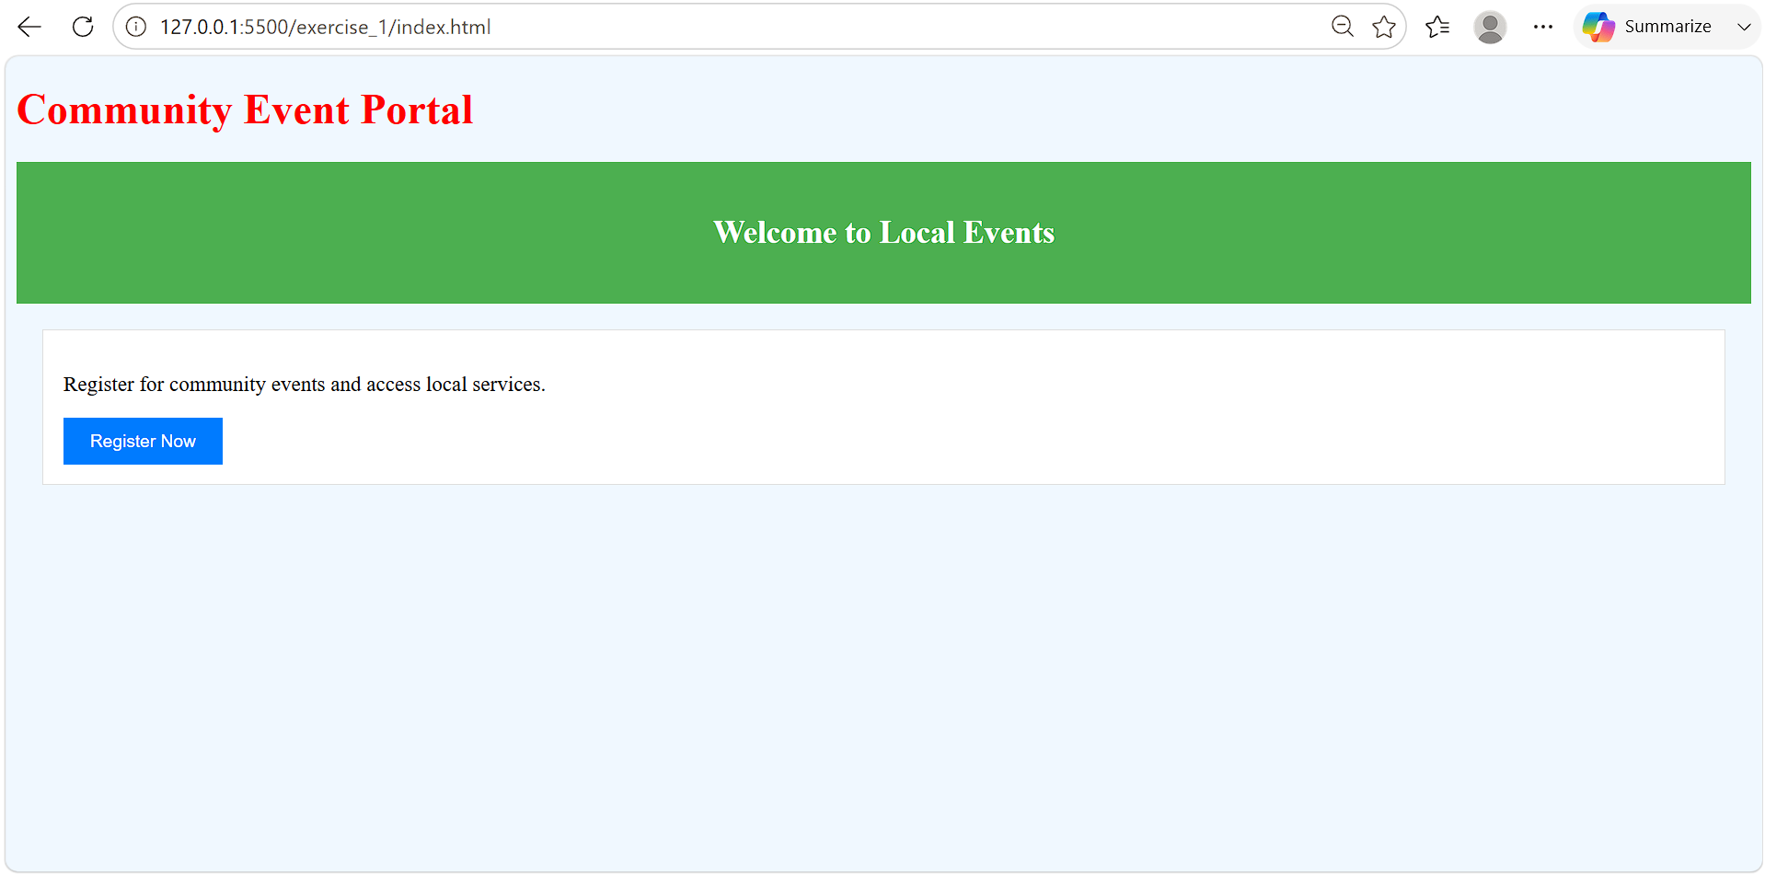

Exercise-2
<html>
<head>
<title>CSS Syntax Demo</title>
<style>
/* Reset default browser spacing */
body {
margin: 0;
padding: 0;
font-family: Arial, sans-serif;
}

/* Style for page heading */
h1 {
text-align: center;
color: #333;
}

/* Style for sub heading */
h2 {
text-align: center;
color: #007BFF;
}

/* Style for paragraph text */
p {
font-size: 16px;
line-height: 1.5;
color: #444;
text-align: center;
}

/* Style for main CTA button */
.cta-button {
background-color: #007BFF;
color: white;
padding: 10px 20px;
border: none;
cursor: pointer;
display: block;
margin: 20px auto;
}

/* Hover effect for CTA button */
.cta-button:hover {
background-color: #0056b3;
}
</style>
</head>

<body>

<h1>Local Community Event Portal</h1>

<h2>Welcome to Events</h2>

<p>This page demonstrates internal CSS with proper structure and comments.</p>

<button class="cta-button">Register Now</button>

</body>
</html>
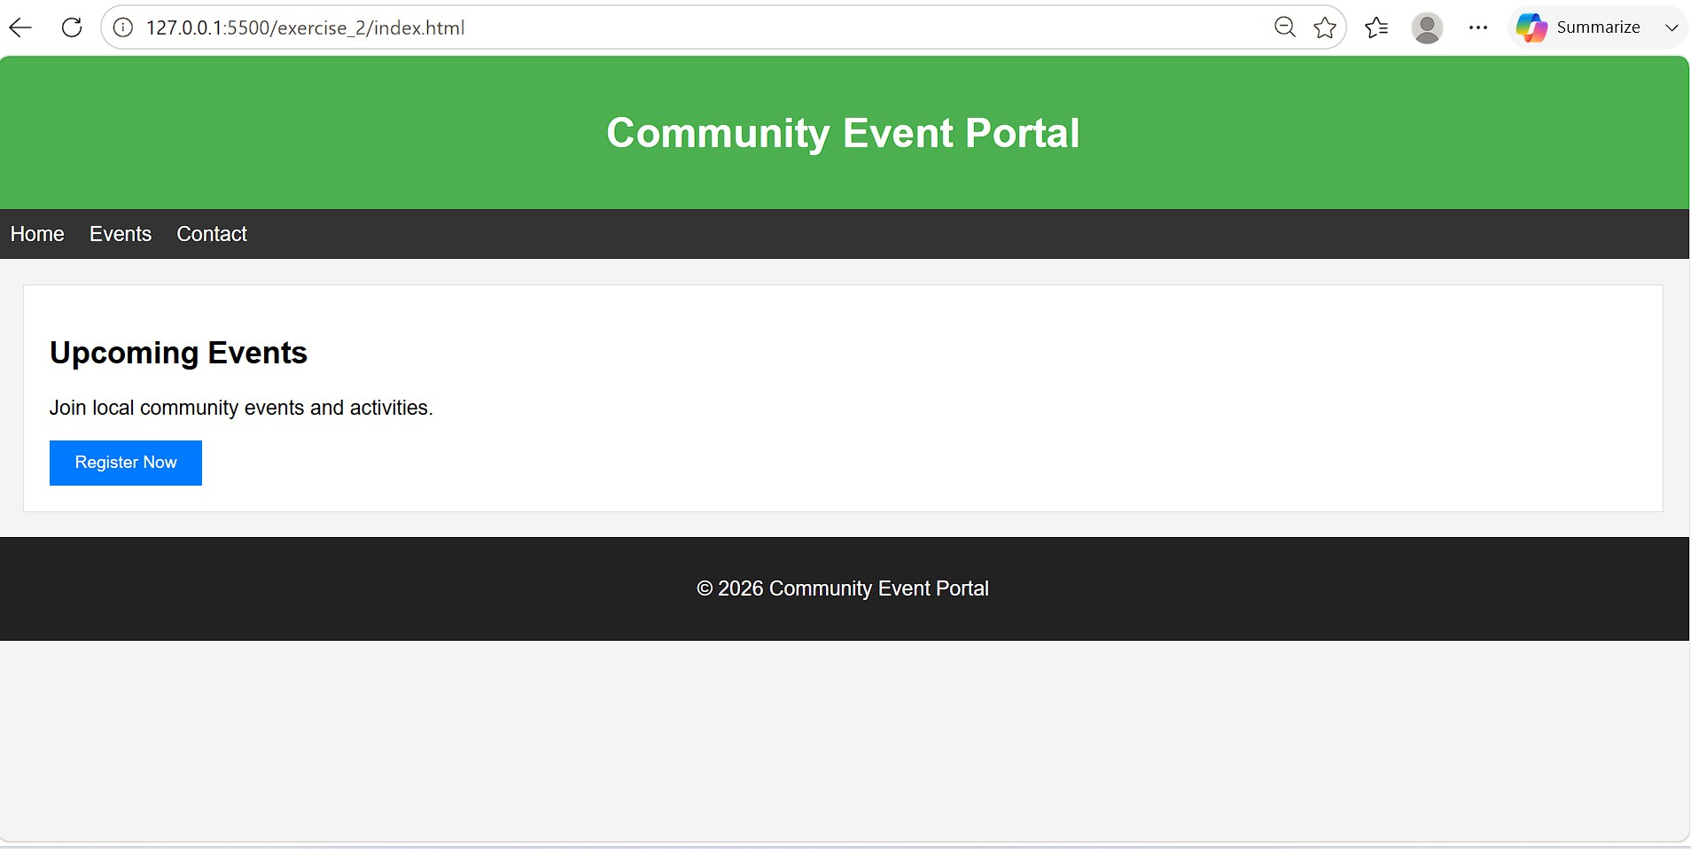
Exercise-3

<!DOCTYPE html>
<html lang="en">
<head>
<meta charset="UTF-8">
<meta name="viewport" content="width=device-width, initial-scale=1.0">
<title>Selectors Playground</title>
<link rel="stylesheet" href="styles.css">
</head>
<body>

<header id="mainHeader">
<h1>Community Event Portal</h1>
</header>

<h2>Upcoming Events</h2>

<div class="eventCard">
<h3>Music Festival</h3>
<p>Enjoy live music and entertainment.</p>
</div>

<div class="eventCard">
<h3>Food Fair</h3>
<p>Explore delicious local cuisines.</p>
</div>

</body>
</html>

Styles.css

/* Universal Selector */
* {
margin: 0;
padding: 0;
box-sizing: border-box;
}

/* Element Selector */
h2 {
color: navy;
text-align: center;
margin: 20px;
}

/* ID Selector */
#mainHeader {
background-color: #4CAF50;
color: white;
text-align: center;
padding: 20px;
}

/* Class Selector */
.eventCard {
border: 1px solid #ccc;
padding: 15px;
margin: 15px;
background-color: #f9f9f9;
}

/* Grouping Selector */
h3,
p {
font-family: Arial, sans-serif;
color: #333;
}
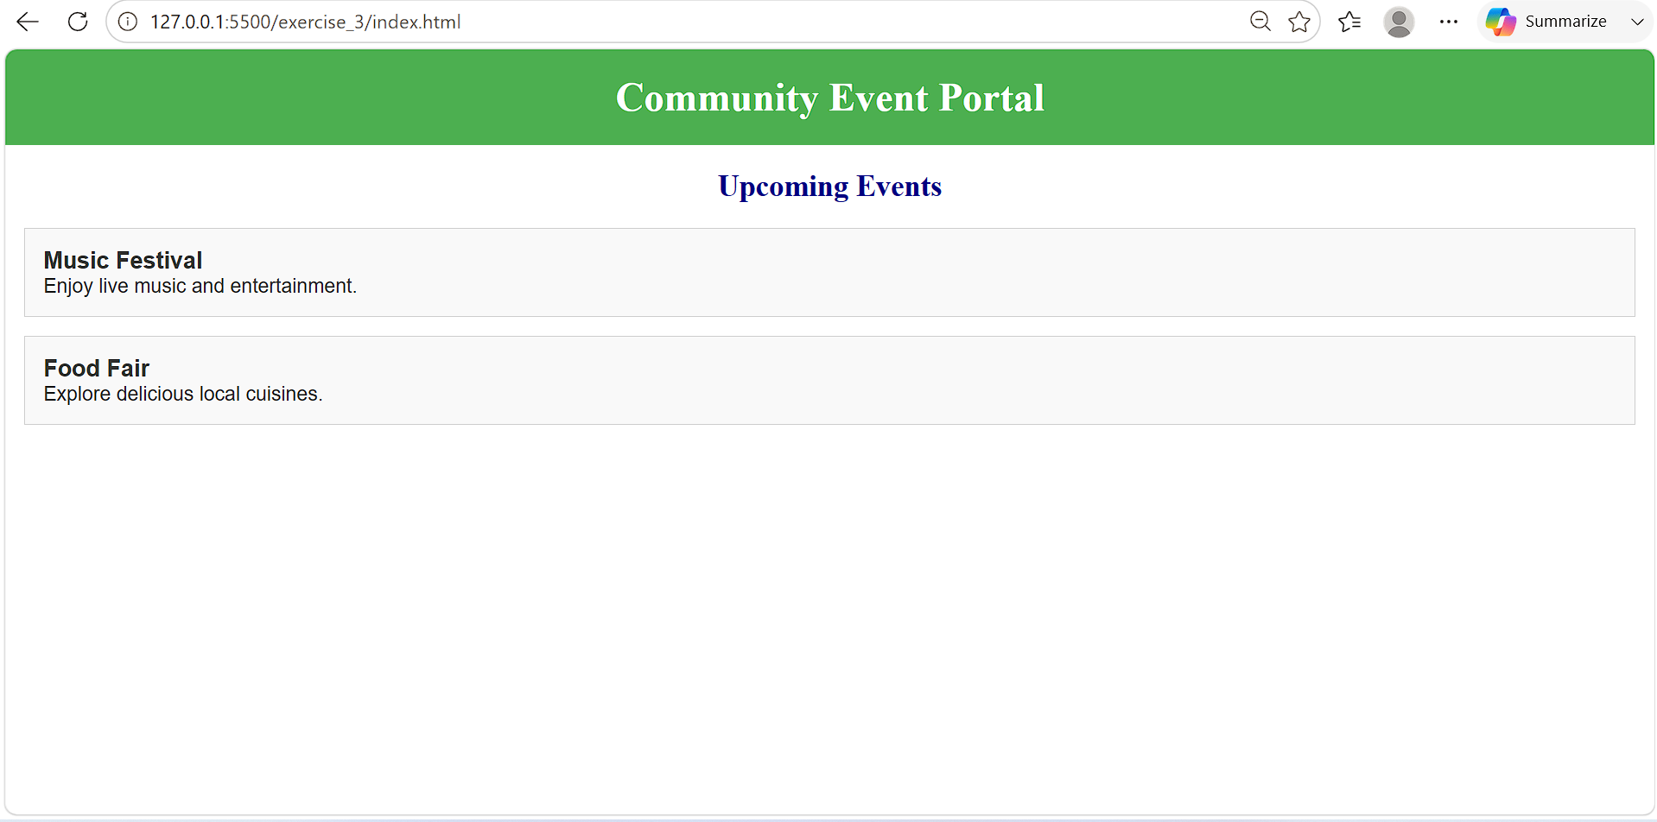

Exercise-4

Index.html

<!DOCTYPE html>
<html lang="en">
<head>
<meta charset="UTF-8">
<meta name="viewport" content="width=device-width, initial-scale=1.0">
<title>Community Event Portal</title>
<link rel="stylesheet" href="styles.css">
</head>
<body>

<header class="section-header">
<h1>Community Event Portal</h1>
</header>

<section class="content">
<h2 class="section-title">Upcoming Events</h2>
<p>Stay informed about local events and community activities.</p>
</section>

<section class="content">
<h2 class="section-title">Public Services</h2>
<p>Access city services and important announcements.</p>
</section>

</body>
</html>

Styles.css

/* ===================================
Body Background Styling
=================================== */
body {
/* Fallback color */
background-color: #e6f2ff;

/* Background image */
background-image: url("city-background.jpg");
background-size: cover;
background-position: center;
background-repeat: no-repeat;

font-family: Arial, sans-serif;
margin: 0;
padding: 0;
}

/* ===================================
Main Header with Gradient
=================================== */
.section-header {
background: linear-gradient(to right, #0066cc, #00cc99);
color: #ffffff;
text-align: center;
padding: 25px;
}

/* ===================================
Section Title with Gradient
=================================== */
.section-title {
background: linear-gradient(to right, #ff7e5f, #feb47b);
color: #ffffff;
padding: 10px;
border-radius: 5px;
}

/* ===================================
Content Area

.content {
margin: 20px;
padding: 20px;

/* RGBA background color */
background-color: rgba(255, 255, 255, 0.85);

border-radius: 8px;
}

p {
/* HEX color */
color: #333333;
line-height: 1.6;
}
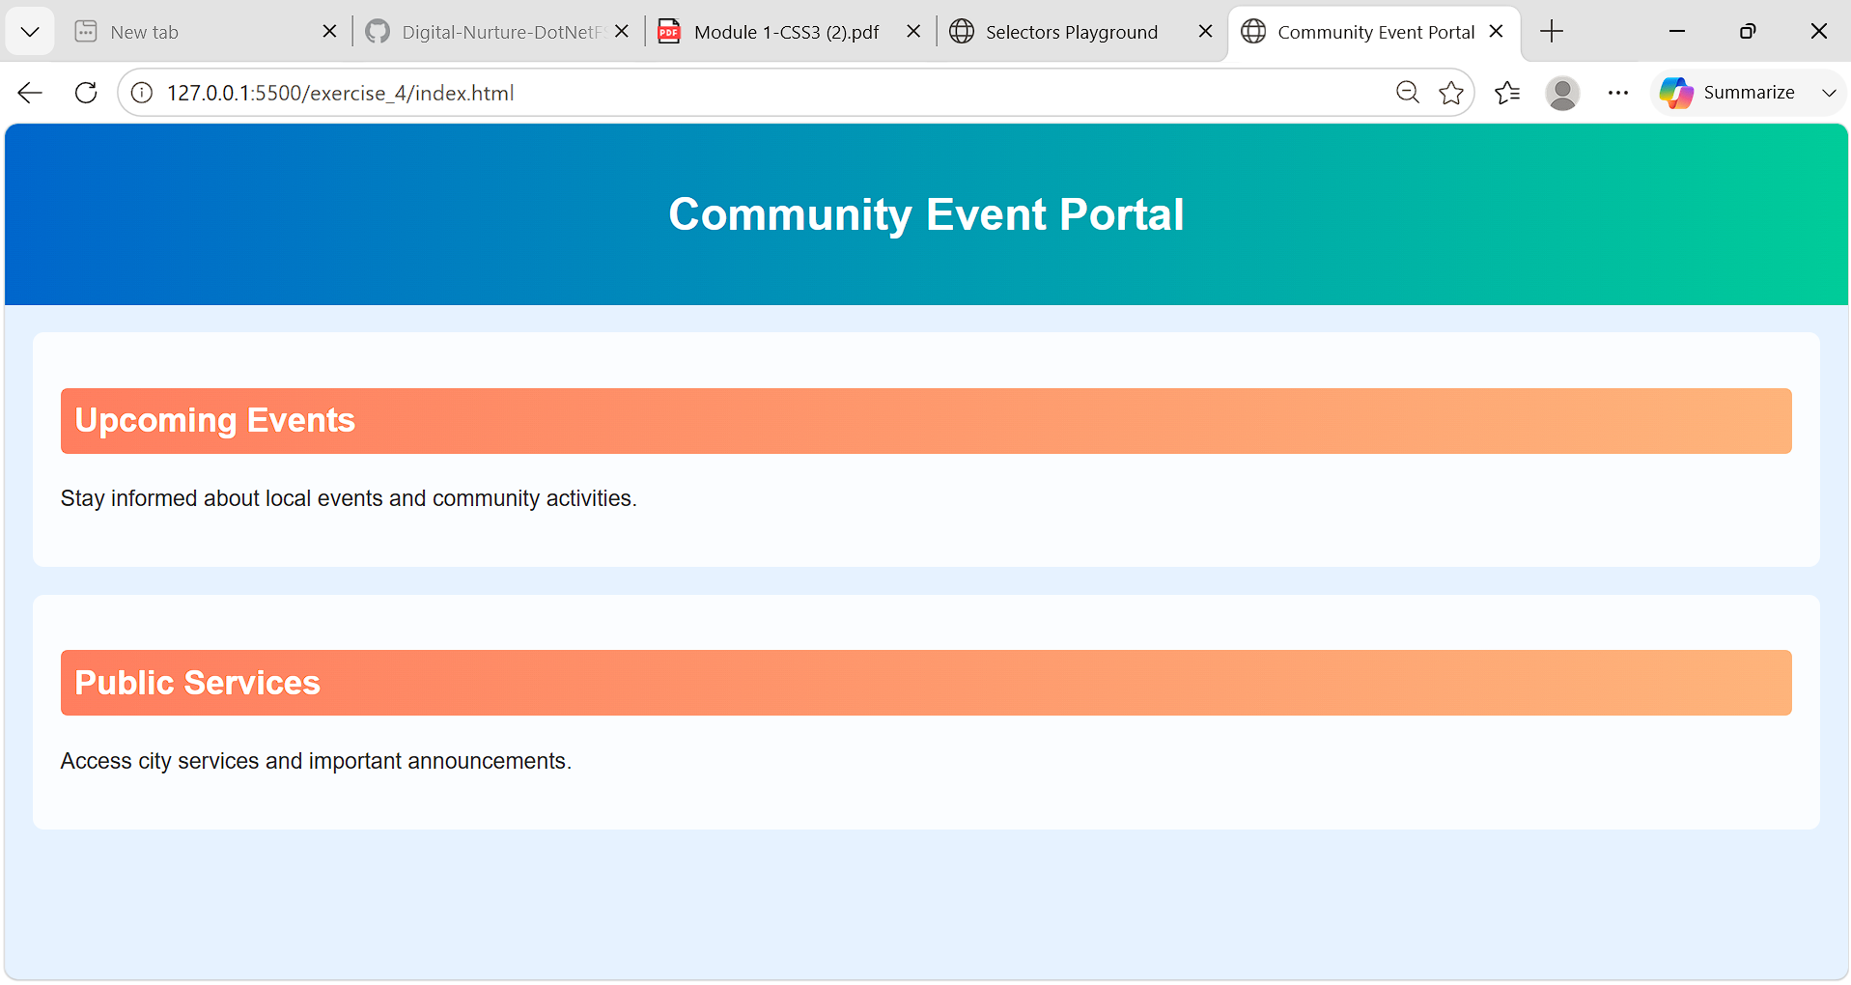

Exercise-5

Index.html

<!DOCTYPE html>
<html lang="en">
<head>
<meta charset="UTF-8">
<meta name="viewport" content="width=device-width, initial-scale=1.0">
<title>Typography Example</title>

<!-- Google Font -->
<link href="https://fonts.googleapis.com/css2?family=Poppins:wght@300;400;600;700&display=swap" rel="stylesheet">

<link rel="stylesheet" href="styles.css">
</head>
<body>

<header class="main-header">
<h1>Community Event Portal</h1>
</header>

<section class="content">
<h2>Upcoming Events</h2>

<p class="description">
Join exciting local events, connect with community members,
and stay updated on city activities throughout the year.
</p>
</section>

</body>
</html>

Styles.css

/* ===================================
General Typography
=================================== */
body {
font-family: 'Poppins', sans-serif;
font-size: 16px;
margin: 20px;
}

/* ===================================
Main Header Styling
=================================== */
.main-header h1 {
font-size: 36px;
font-weight: 700;
text-align: center;
text-transform: uppercase;
}

/* ===================================
Section Heading Styling
=================================== */
h2 {
font-size: 28px;
font-weight: 600;
font-style: italic;
color: #0066cc;
}

/* ===================================
Description Text Styling
=================================== */
.description {
font-size: 18px;
font-weight: 400;
font-style: normal;

text-align: justify;
text-transform: capitalize;
letter-spacing: 1px;
line-height: 1.8;

color: #333333;
}

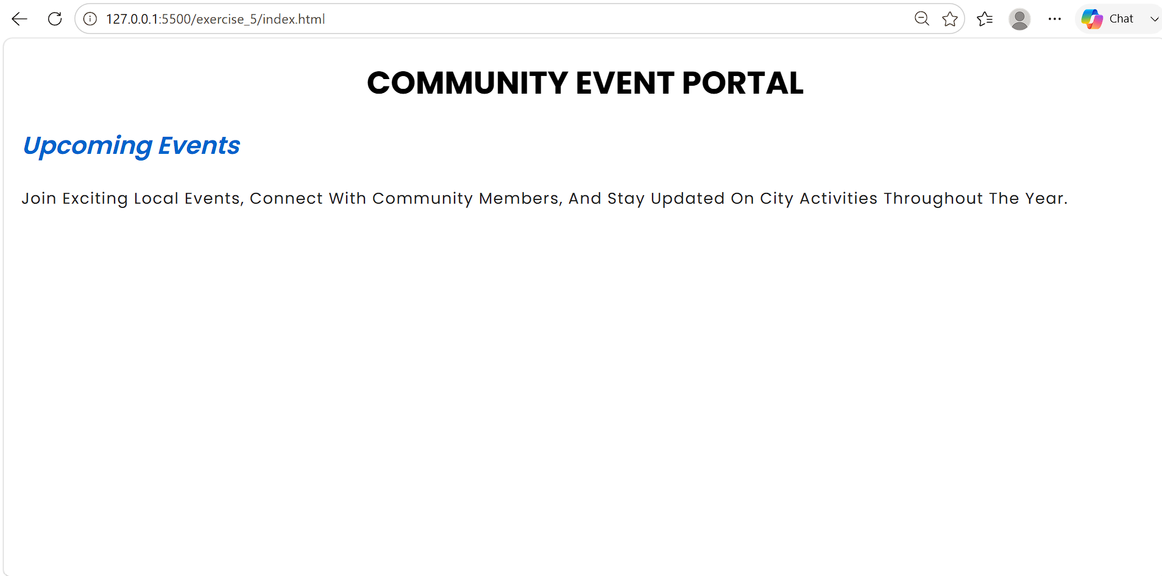

Exercise-6

Index.html

<!DOCTYPE html>
<html lang="en">
<head>
<meta charset="UTF-8">
<meta name="viewport" content="width=device-width, initial-scale=1.0">
<title>Event Admin Table</title>
<link rel="stylesheet" href="styles.css">
</head>
<body>

<h1>Community Event Administration</h1>

<table>
<tr>
<th>Event ID</th>
<th>Event Name</th>
<th>Date</th>
<th>Location</th>
</tr>

<tr>
<td>101</td>
<td>Music Festival</td>
<td>15 July 2026</td>
<td>City Park</td>
</tr>

<tr>
<td>102</td>
<td>Food Fair</td>
<td>22 July 2026</td>
<td>Town Hall</td>
</tr>

<tr>
<td>103</td>
<td>Book Exhibition</td>
<td>30 July 2026</td>
<td>Community Center</td>
</tr>

<tr>
<td>104</td>
<td>Health Camp</td>
<td>05 August 2026</td>
<td>Public Grounds</td>
</tr>
</table>

</body>
</html>

Styles.css

/* ===================================
Table Styling
=================================== */
table {
width: 80%;
margin: 20px auto;
border-collapse: collapse;
text-align: center;
}

/* ===================================
Table Header Styling
=================================== */
th {
border: 1px solid #333;
padding: 12px;
background-color: #4CAF50;
color: white;
}

/* ===================================
Table Data Styling
=================================== */
td {
border: 1px solid #333;
padding: 10px;
background-color: #f9f9f9;
}

/* ===================================
Zebra Striping
=================================== */
tr:nth-child(even) {
background-color: #e6f2ff;
}

