Case Study of drop in User Engagement

Using data set provided by YAMMER, we can analyse that there is a drop in user engagement in recent weeks. We will be using data gathered from the codes to visualize every case.
Analysis 1: Drop in User Engagement

SELECT DATE_TRUNC('week', events.occurred_at),

COUNT(DISTINCT events.user_id) AS weekly_active_users
FROM tutorial.yammer_events events
WHERE events.event_type = 'engagement'

AND events.event_name = 'login'
GROUP BY 1
ORDER BY 1
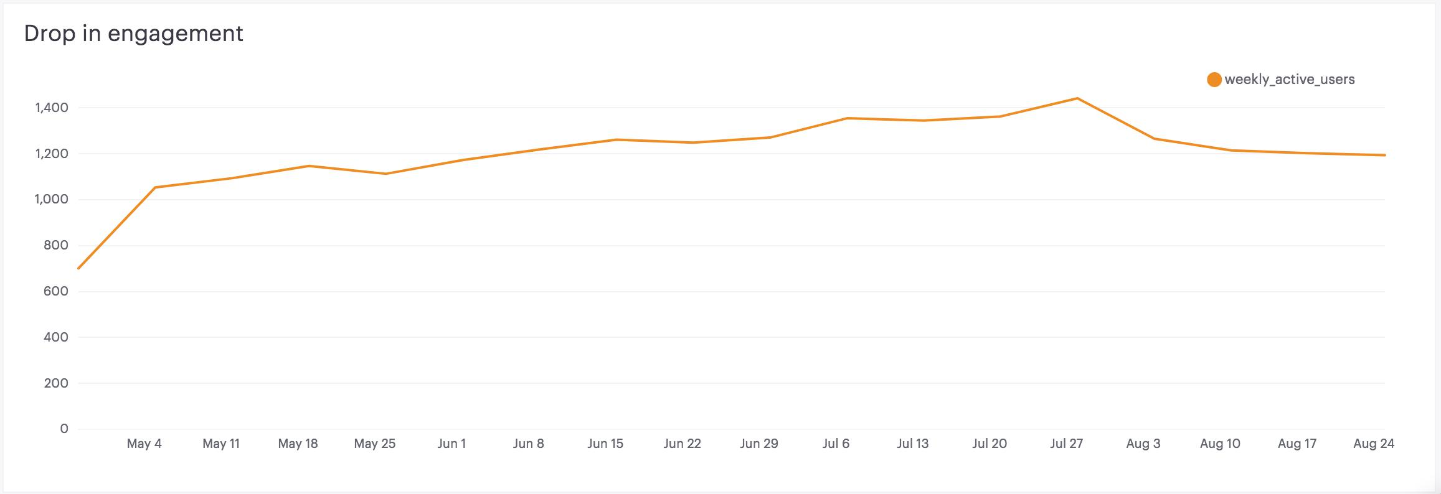

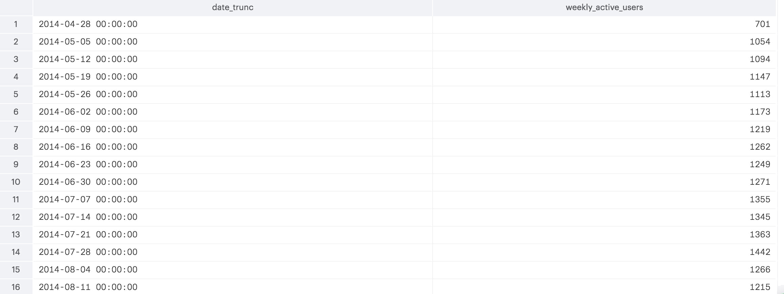

Analysis 2: User engagement by weeks

We can see that user engagement throughout the weeks is still normal. Engagement continues to be high during weeks and low on weekends. Nothing unusual in this trend

--We'll write a query to check the user growth rate SELECT date_ trunc('day',created_at) as day, COUNT (*) as all_users,

COUNT(case when activated_at IS NOT NULL THEN users.user_id ELSE NULL END) AS activated_users
FROM tutorial.yammer_users users

WHERE created_at >= '2014-06-01'

AND created_at < '2014-09-01'
GROUP BY 1
ORDER BY 1
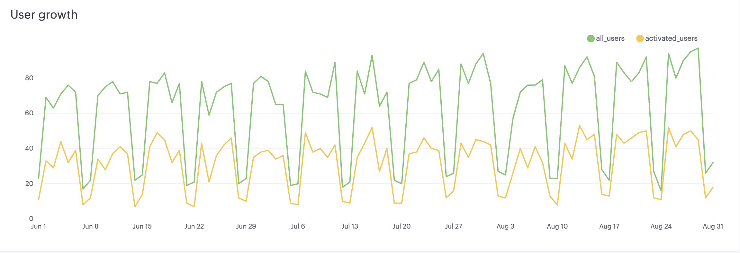
Analysis 3: Engagement by User Age Cohort

SELECT DATE_TRUNC('week',x.occurred_at) AS "week", avg(x.age_at_event) AS "Average age during week",

COUNT(DISTINCT CASE WHEN x.user_age > 70 THEN x.user_id ELSE NULL END) AS "10+ weeks", COUNT(DISTINCT CASE WHEN x.user_age < 70 AND x.user_age >= 63 THEN x.user_id ELSE NULL END) AS "9 weeks",

COUNT(DISTINCT CASE WHEN x.user_age < 63 AND x.user_age >= 56 THEN x.user_id ELSE NULL END) AS "8 weeks",
COUNT(DISTINCT CASE WHEN x.user_age < 56 AND x.user_age >= 49 THEN x.user_id ELSE NULL END) AS "7 weeks",

COUNT(DISTINCT CASE WHEN x.user_age < 49 AND x.user_age >= 42 THEN x.user_id ELSE NULL END) AS "6 weeks",
COUNT(DISTINCT CASE WHEN x.user_age < 42 AND x.user_age >= 35 THEN x.user_id ELSE NULL END) AS "5 weeks",

COUNT(DISTINCT CASE WHEN x.user_age < 35 AND x.user_age >= 28 THEN x.user_id ELSE NULL END) AS "4 weeks",
COUNT(DISTINCT CASE WHEN x.user_age < 28 AND x.user_age >= 21 THEN x.user_id ELSE NULL END) AS "3 weeks",
COUNT(DISTINCT CASE WHEN x.user_age < 21 AND x.user_age >= 14 THEN x.user_id ELSE NULL END) AS "2 weeks",

COUNT(DISTINCT CASE WHEN x.user_age < 14 AND x.user_age >= 7 THEN x.user_id ELSE NULL END) AS "1 week",
COUNT(DISTINCT CASE WHEN x.user_age < 7 THEN x.user_id ELSE NULL END) AS "Less than a week"

FROM ( SELECT events.occurred_at, users.user_id, DATE_TRUNC('week',users.activated_at) AS activation_week,
EXTRACT('day' FROM events.occurred_at - users.activated_at) AS age_at_event,
EXTRACT('day' FROM '2014-09-01'::TIMESTAMP - users.activated_at) AS user_age
FROM tutorial.yammer_users users

JOIN tutorial.yammer_events events
ON events.user_id = users.user_id
AND events.event_type = 'engagement'

AND events.event_name = 'login'

AND events.occurred_at >= '2014-05-01'
AND events.occurred_at < '2014-09-01'
WHERE users.activated_at IS NOT NULL

) x
GROUP BY 1
ORDER BY 1

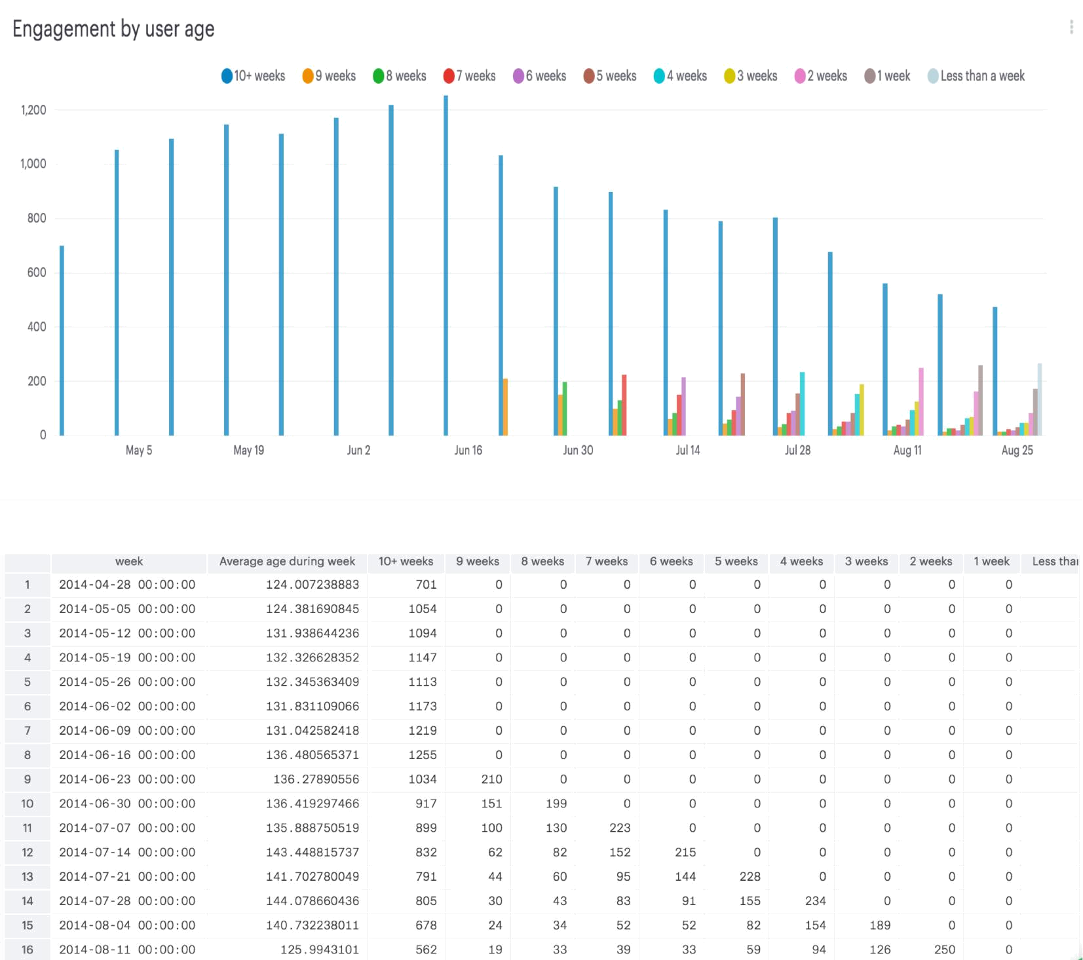

From the graph we can see that there is dip in engagement from old users and the problem is particular to old users only therefore we can say that it is not a one time hike. Looking into the type of device to see if there's any particular product that gives an anomaly.

Analysis 4: Engagement by device

SELECT DATE_TRUNC('week', occurred_at) AS week, COUNT(DISTINCT events.user_id) AS weekly_active_users,

COUNT(DISTINCT CASE WHEN events.device IN ('macbook pro','lenovo thinkpad','macbook air','dell inspiron notebook',

'asus chromebook','dell inspiron desktop','acer aspire notebook','hp pavilion desktop','acer aspire desktop','mac mini')
THEN events.user_id ELSE NULL END) AS computer,

COUNT(DISTINCT CASE WHEN events.device IN ('iphone 5','samsung galaxy s4','nexus 5','iphone 5s','iphone 4s','nokia lumia 635',
'htc one','samsung galaxy note','amazon fire phone') THEN events.user_id ELSE NULL END) AS phone,

COUNT(DISTINCT CASE WHEN events.device IN ('ipad air','nexus 7','ipad mini','nexus 10','kindle fire','windows surface',
'samsumg galaxy tablet') THEN events.user_id ELSE NULL END) AS tablet

FROM tutorial.yammer_events events

WHERE events.event_type = 'engagement'

AND events.event_name = 'login'

GROUP BY 1

ORDER BY 1
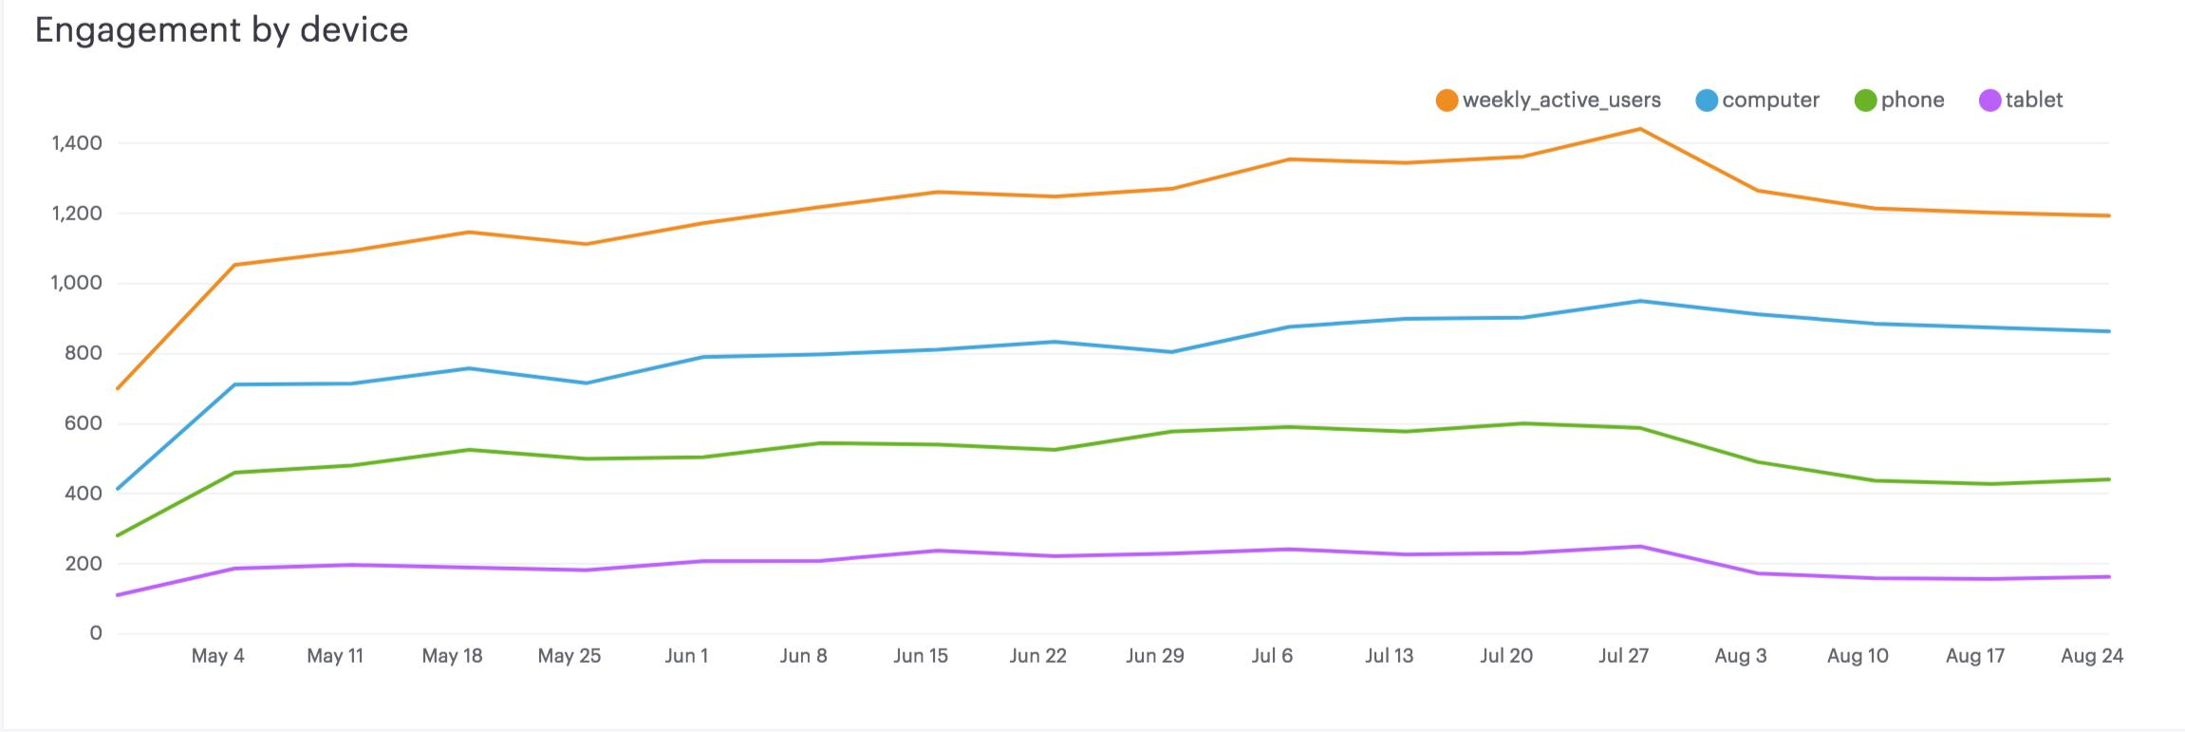
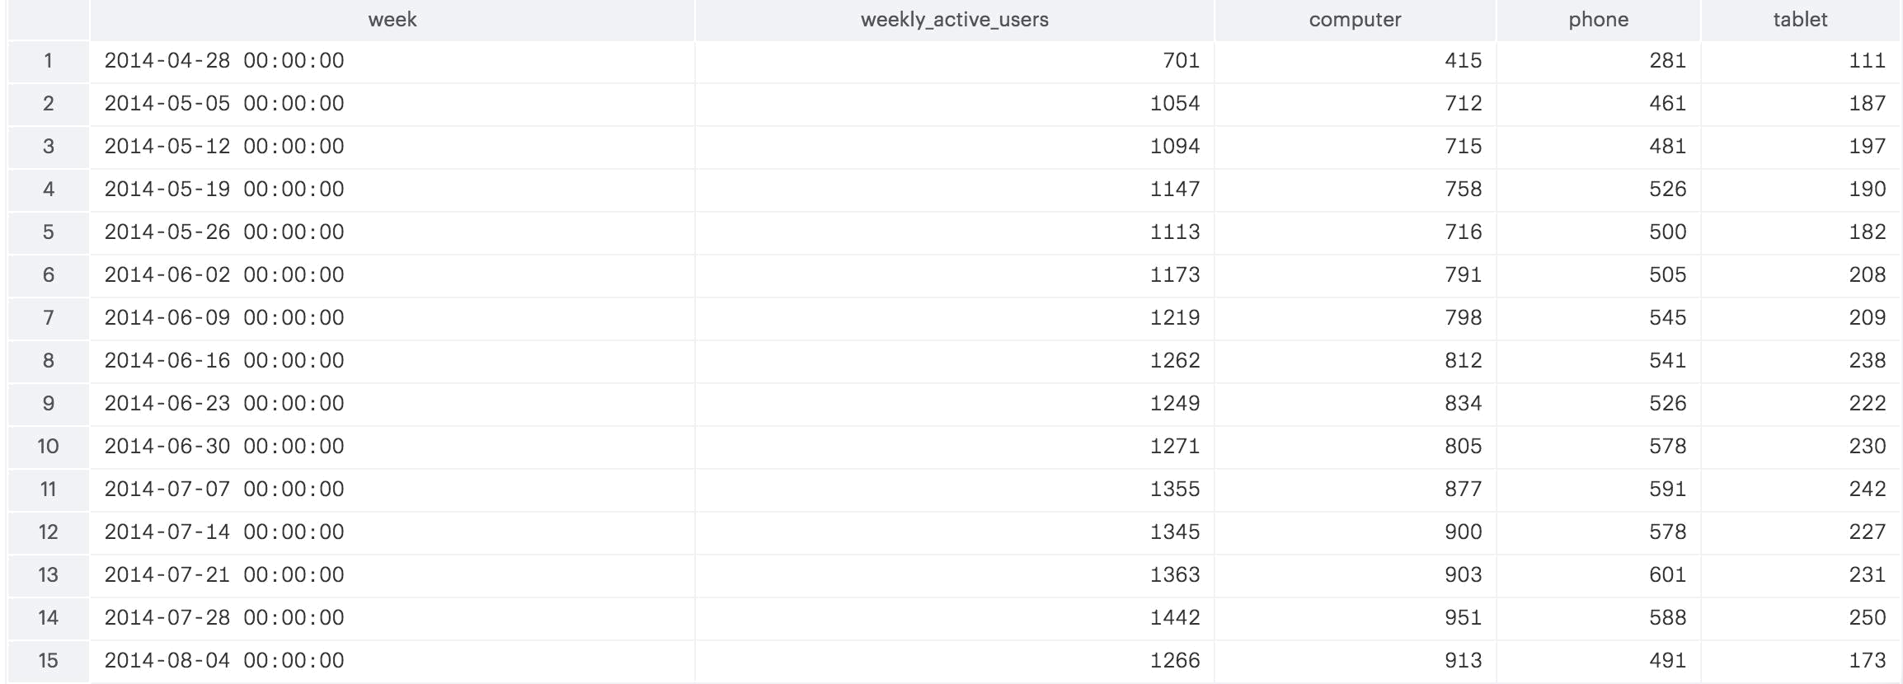

Now by looking at the graph for the devices, we can see that phone devices are where the drop is. Which may mean that maybe there's some issue with the mobile app.

You might also think about what causes people to engage with the product. The purpose of the digest email mentioned is to bring users back into the product. Since we know this problem relates to the retention of long-time users, it’s worth checking out whether the email has something to do with it:

Analysis5: Email Actions

SELECT DATE_TRUNC('week', occurred_at) AS week,

COUNT(CASE WHEN emails.action = 'sent_weekly_digest' THEN emails.user_id ELSE NULL END) AS weekly_emails,
COUNT(CASE WHEN emails.action = 'sent_reengagement_email' THEN emails.user_id ELSE NULL END) AS reengagement_emails,

COUNT(CASE WHEN emails.action = 'email_open' THEN emails.user_id ELSE NULL END) AS email_opens,
COUNT(CASE WHEN emails.action = 'email_clickthrough' THEN emails.user_id ELSE NULL END) AS email_clickthroughs
FROM tutorial.yammer_emails emails

GROUP BY 1

ORDER BY 1

From the graph that shows weekly email actions, even when the weekly emails have increased significantly by YAMMER we can see that the clickthroughs are much lesser than the

Others and there is also a dip in clickthroughs recently. So we can identify that the problem of drop in user engagement is related to email actions on clickthroughs particularly on mobile phone.

The exact reason as to why there's a dip can't be known from the data itself but now we have an understanding as of where the root of the problem lies. This can be reported to the head of the department to further drill down the cause and how it can be resolved to tackle the dip the user engagement.

