ANNASAHEB DANGE COLLEGE OF ENGINEERING AND TECHNOLOGY, ASHTA
(An Empowered Autonomous Institute)

Department of Artificial Intelligence & Data Science
REPORT
ON
NLP-WISPER – REAL-TIME SPEECH-TO-TEXT TRANSCRIPTION SYSTEM
A Python-Based NLP Micro-Project using OpenAI Whisper on Apple MLX
Subject: NLP
Academic Year: 2026 – 2027
Submitted By :-
ROLL No | Name | URN
[Roll No] | [Student Name 1] | [URN]
[Roll No] | [Student Name 2] | [URN]

ABSTRACT
Typing is still the main way people put text into a computer, but speaking is three to four times faster than typing for most users. Speech-to-text systems close this gap, yet the most accurate ones run in the cloud: every word spoken is uploaded to a remote server, which raises privacy concerns, needs a constant internet connection and adds network delay. Accurate open models such as Whisper, on the other hand, are normally used in batch mode on complete audio files and give no live feedback while the user is talking.
NLP-wisper is a Python-based Natural Language Processing (NLP) micro-project that converts live speech into text entirely on the user’s own computer. The browser captures the microphone, resamples the audio to 16 kHz and streams it over a WebSocket to a FastAPI server. An energy-based Voice Activity Detector (VAD) splits the stream into utterances, and OpenAI’s Whisper model, running on the Apple Silicon GPU through the MLX framework, transcribes the current utterance again every 0.45 seconds. Provisional partial results are sent while the user is still speaking, and a final result is committed after 0.7 seconds of silence.
The text is shown in a Monkeytype-style web interface that types each character on screen, backspaces when Whisper revises a partial, and reports words per minute, speaking time, number of utterances and average transcription latency. In tests on an Apple M3 laptop with the Whisper small.en model, the first words appeared about 0.85 seconds after speech started, final results arrived about 0.48 seconds after each utterance ended, and the word error rate on the test sentences was 1.1%. The project shows that modern transformer-based speech recognition can run in real time, privately and offline, on an ordinary laptop.
Keywords: NLP, Automatic Speech Recognition, Whisper, Transformer, MLX, Apple Silicon, Voice Activity Detection, WebSocket, FastAPI, Real-Time Transcription, Streaming.

TABLE OF CONTENTS
Sr. No. | Contents | Page No.
1 | Chapter 1: Introduction | 4
1.1 | Introduction | 4
1.2 | Problem Statement | 4
1.3 | Objectives | 5
1.4 | Scope | 5
2 | Chapter 2: Literature Review and Existing System | 5
2.1 | Literature Review | 5
2.2 | Existing System | 6
2.3 | Proposed System | 6
2.4 | Comparison of Approaches | 6
3 | Chapter 3: Proposed System and Methodology | 7
3.1 | System Overview | 7
3.2 | System Workflow | 7
3.3 | Audio Capture and Resampling | 7
3.4 | Voice Activity Detection | 8
3.5 | Log-Mel Spectrogram Features | 8
3.6 | Whisper Encoder–Decoder Transformer | 8
3.7 | Streaming Strategy: Partials and Finals | 9
3.8 | Context Prompting and Hallucination Filtering | 9
3.9 | Live Typing Animation | 9
3.10 | Speaking-Speed Metrics | 10
4 | Chapter 4: System Design and Architecture | 10
4.1 | System Architecture | 10
4.2 | Use Case Diagram | 11
4.3 | Data Flow Diagram | 11
4.4 | Message Protocol Design | 12
4.5 | Module Design | 13
4.6 | User Interface Design | 13
5 | Chapter 5: System Implementation | 14
5.1 | Technologies Used | 14
5.2 | Model Selection | 14
5.3 | Audio Capture Module | 15
5.4 | Streaming Session Module | 15
5.5 | Transcriber Worker Module | 15
5.6 | WebSocket API Module | 15
5.7 | Typer and Results Modules | 15
5.8 | Configuration | 16
5.9 | Monorepo Build System | 16
5.10 | Installation and Execution | 16
6 | Chapter 6: Testing and Results | 16
6.1 | Testing | 16
6.2 | Test Cases | 17
6.3 | Performance Evaluation | 17
6.4 | Results and Discussion | 18
7 | Chapter 7: Conclusion and Future Scope | 19
7.1 | Conclusion | 19
7.2 | Limitations | 19
7.3 | Future Scope | 20
8 | References | 20

CHAPTER 1: INTRODUCTION

1.1 Introduction
Speech is the most natural way for people to communicate. Converting spoken words into written text, a task known as Automatic Speech Recognition (ASR) or speech-to-text, allows people to write documents, take notes, control applications and caption videos simply by talking. ASR is one of the oldest problems in Natural Language Processing (NLP) and Artificial Intelligence, and for decades it needed carefully engineered acoustic models, pronunciation dictionaries and language models.
In recent years, large neural networks trained on huge amounts of audio have changed this field. OpenAI’s Whisper is a transformer-based encoder–decoder model trained on 680,000 hours of labelled speech collected from the web. It recognizes speech robustly across accents, background noise and technical vocabulary, and it also restores punctuation and capitalization. Because the model weights are public, Whisper can run on a personal computer instead of a cloud server. Apple’s MLX framework makes this practical on Apple Silicon laptops by running the model on the built-in GPU, which shares memory with the CPU.
NLP-wisper is a Python-based NLP micro-project that uses Whisper and MLX to build a real-time, fully local speech-to-text system. The user presses the space bar and starts talking; the words appear on the screen while they are being spoken, typed out one character at a time in a clean interface inspired by the typing-test website Monkeytype. When the user stops, the system shows the complete transcript together with speaking-speed statistics. No audio or text ever leaves the machine.

1.2 Problem Statement
Existing speech-to-text tools force a choice between privacy, accuracy and responsiveness. Cloud services are accurate and fast but send every recording to a third party. Built-in operating-system dictation offers little control and no insight into how it works. Open models such as Whisper are accurate and private, but their standard tools process complete audio files after recording has finished, so the user sees nothing while speaking.
The main difficulties that this project addresses are:
- Privacy: cloud dictation uploads the user’s voice, which may contain personal or confidential information.
- Latency: batch transcription gives no feedback until the whole recording has been processed.
- Segmentation: a live audio stream has no natural boundaries, so the system must decide when one sentence ends and the next begins.
- Responsiveness: Whisper inference is heavy and, if run carelessly, blocks the server that receives the audio.
- Hallucination: Whisper sometimes produces phrases such as “Thank you.” from silence or noise.
Therefore, a system is required that captures speech live, detects when the user is speaking, transcribes it accurately on the local machine, shows provisional text within about a second and commits final text quickly after each pause.

1.3 Objectives
- To develop a real-time speech-to-text web application that runs entirely on the user’s computer.
- To capture microphone audio in the browser and convert it to 16 kHz mono PCM suitable for Whisper.
- To stream audio to a Python backend over a WebSocket with low overhead.
- To detect speech and pauses with an energy-based Voice Activity Detector.
- To transcribe speech with the Whisper transformer model accelerated on the Apple Silicon GPU through MLX.
- To provide fast provisional (partial) results and accurate committed (final) results.
- To filter common Whisper hallucinations produced from silence or noise.
- To present the transcript with a live typing animation and report words per minute, time, utterances and latency.

1.4 Scope
The system focuses on English speech by default, using the English-only Whisper small.en model, and can be switched to multilingual models through configuration. It covers microphone capture, resampling, streaming transport, voice activity detection, transcription, hallucination filtering, live display, speaking-speed statistics and copying of the final transcript.
It is useful for students taking notes, writers drafting text, users who prefer not to type, and anyone who needs dictation without sending their voice to the cloud. The system requires an Apple Silicon Mac because MLX targets Apple’s GPU. It does not identify different speakers, does not store recordings, and its accuracy depends on the chosen Whisper model, the microphone and the background noise.

CHAPTER 2: LITERATURE REVIEW AND EXISTING SYSTEM

2.1 Literature Review
Early speech recognizers modelled speech as a sequence of hidden states. Rabiner’s tutorial on Hidden Markov Models (HMMs) describes the approach that dominated ASR for about thirty years: Gaussian Mixture Models score short frames of audio, HMMs model how sounds follow one another, and a separate language model chooses the most likely word sequence [3]. The audio frames were usually described by Mel-frequency features, which imitate the frequency resolution of the human ear [7].
Deep learning replaced these hand-built components with neural networks trained end to end. Graves et al. introduced Connectionist Temporal Classification (CTC), which lets a network learn from unsegmented audio–text pairs [4], and Baidu’s Deep Speech showed that a recurrent network trained with CTC on large data could outperform traditional pipelines [5]. wav2vec 2.0 then learned speech representations from unlabelled audio and needed only a small amount of labelled data for fine-tuning [6].
The transformer architecture, built entirely on self-attention, became the foundation of modern language and speech models [2]. Whisper applies an encoder–decoder transformer to ASR and is trained with weak supervision on 680,000 hours of web audio. Its authors showed that a single model generalizes well to many datasets without fine-tuning and approaches human robustness [1]. For live use, streaming ASR research has studied how to emit words before an utterance ends while keeping latency low [10], and Voice Activity Detection research has studied how to separate speech from silence and noise reliably [14]. MLX, released by Apple’s machine-learning research team, is an array framework designed for the unified memory of Apple Silicon and is used here to run Whisper on the GPU [9].

2.2 Existing System
Most people today use either a cloud dictation service or the dictation feature built into their operating system. Both upload or process speech in ways the user cannot inspect, and cloud services need an internet connection. Developers who want privacy run open-source Whisper, but the usual command-line tools transcribe a finished recording: the user must record first, wait, and only then read the result. There is no live feedback, no handling of pauses and no measure of speaking speed.

2.3 Proposed System
The proposed system, NLP-wisper, combines the accuracy of Whisper with live streaming. The browser sends 100 ms audio chunks to a local FastAPI server. A lightweight energy-based VAD tracks when the user is speaking. While speech continues, the server re-transcribes the current utterance roughly every 0.45 s and sends a partial result; after 0.7 s of silence it transcribes the utterance one last time and sends a final result. Whisper runs in a separate worker process on the GPU so that the server stays responsive, and the browser animates the changing text like a typing test.

2.4 Comparison of Approaches
Table 2.1: Comparison of Approaches
Approach | Advantage | Limitation
Cloud dictation APIs | High accuracy; built-in streaming | Needs internet; voice leaves the device; usage cost
OS built-in dictation | Integrated and easy to use | Little control; no metrics or configuration
HMM–GMM toolkits | Lightweight; works offline | Lower accuracy; complex training and setup
CTC models (Deep Speech, wav2vec 2.0) | Naturally streamable; offline | Need a language model or fine-tuning for good accuracy
Batch Whisper (command-line tools) | Very accurate and robust; offline | Works on finished files; no live feedback
NLP-wisper (Whisper + MLX + VAD streaming) | Live partials, fully local, GPU-accelerated, typing metrics | Apple Silicon only; re-decodes each utterance as it grows

CHAPTER 3: PROPOSED SYSTEM AND METHODOLOGY

3.1 System Overview
The application captures speech from the microphone, streams it to a local server, segments it into utterances, transcribes each utterance with Whisper and shows the result live in the browser. When the user stops, the remaining audio is finalized and a results screen summarizes the session. The complete workflow is shown in Figure 3.1.

3.2 System Workflow
Figure 3.1 shows the complete workflow of NLP-wisper from the moment the user presses the space bar until the transcript is copied.
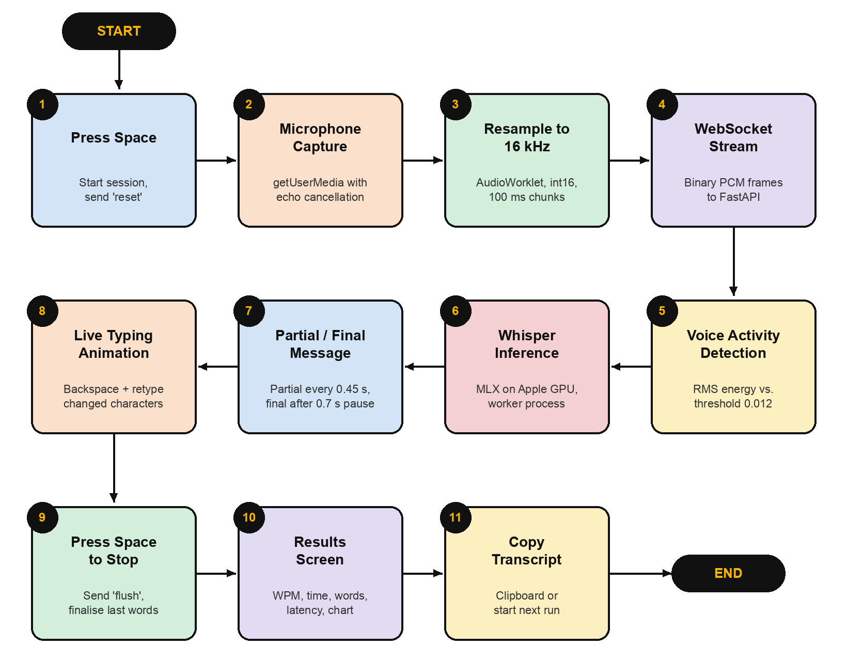
Figure 3.1: System Workflow of NLP-wisper

3.3 Audio Capture and Resampling
Whisper expects mono audio sampled at 16 kHz, but browsers usually record at 44.1 kHz or 48 kHz. The browser requests the microphone with echo cancellation, noise suppression and automatic gain control enabled. An AudioWorklet, which runs on the browser’s real-time audio thread, then performs the following steps:
- Downsampling: the ratio r = input rate / 16 000 is computed (r = 3 for 48 kHz). Each output sample is taken at position t = n·r of the input using linear interpolation between the two neighbouring input samples.
- Quantization: each sample is clipped to [−1, 1] and converted to a 16-bit signed integer.
- Chunking: samples are collected into chunks of 1 600 samples (100 ms), and each chunk is posted to the main thread together with its RMS level for the on-screen level meter.
y[n] = x[i] + (x[i+1] − x[i]) · (t − i), where t = n · r and i = ⌊t⌋

3.4 Voice Activity Detection
A Voice Activity Detector decides which parts of the stream contain speech. NLP-wisper uses a simple and fast energy-based VAD. For every incoming 100 ms chunk of N samples, the Root Mean Square (RMS) energy is computed:
RMS = √( (1/N) · Σ x[k]² )
If the RMS is at least the threshold of 0.012 (about −38 dBFS), the chunk counts as speech; otherwise it counts as silence. Before speech starts, only the last 0.3 s of audio is kept as a pre-roll so that the first syllable is not cut off. Once speech has started, all audio is appended to the utterance buffer, and the length of the trailing silence is tracked. Table 3.1 lists the streaming parameters.
Table 3.1: Streaming and VAD Parameters
Parameter | Value | Purpose
vad_threshold | 0.012 | RMS level above which a chunk counts as speech
end_silence_s | 0.7 s | Silence after speech that ends an utterance
partial_every_s | 0.45 s | Minimum interval between partial transcriptions
min_partial_s | 0.6 s | Shortest audio sent for a partial (shorter clips make Whisper guess)
max_utterance_s | 20 s | Forces a final on very long utterances
preroll_s | 0.3 s | Audio kept from just before speech starts
prompt_chars | 200 | Committed text fed back to Whisper as context

3.5 Log-Mel Spectrogram Features
Whisper does not read raw samples directly. The audio is first converted into a log-Mel spectrogram, a time–frequency picture of the sound. The signal is divided into 25 ms windows with a 10 ms step, a Fourier transform gives the energy at each frequency, and the frequencies are grouped into 80 bands on the Mel scale, which is roughly linear below 1 kHz and logarithmic above it, like human hearing [7]. The logarithm of the band energies is taken, and the input is padded to Whisper’s 30-second window.
mel(f) = 2595 · log₁₀(1 + f / 700)

3.6 Whisper Encoder–Decoder Transformer
Whisper is a sequence-to-sequence transformer [1][2]. The encoder processes the spectrogram with two convolution layers followed by transformer blocks and produces a sequence of audio embeddings. The decoder generates text tokens one at a time; each step attends to the previous tokens and, through cross-attention, to the audio embeddings. The central operation of both parts is scaled dot-product attention:
Attention(Q, K, V) = softmax( Q·Kᵀ / √dₖ ) · V
Here Q, K and V are the query, key and value matrices and dₖ is the key dimension. Special tokens tell the decoder the language and the task. NLP-wisper decodes with temperature 0, which means the most probable token is chosen at every step (greedy decoding). This makes the output deterministic and fast, which matters because the same utterance is transcribed several times as it grows.

3.7 Streaming Strategy: Partials and Finals
Whisper is not a streaming model: it transcribes a complete clip. NLP-wisper makes it feel live by repeatedly transcribing the growing utterance. A timer runs every 100 ms. While the user is speaking, if at least 0.6 s of audio has been collected, new audio has arrived and 0.45 s have passed since the last partial, the whole utterance buffer is transcribed and sent as a partial. When 0.7 s of silence follows speech, or the utterance reaches 20 s, the buffer is transcribed one last time, sent as a final, and removed from the buffer (Figure 3.2).
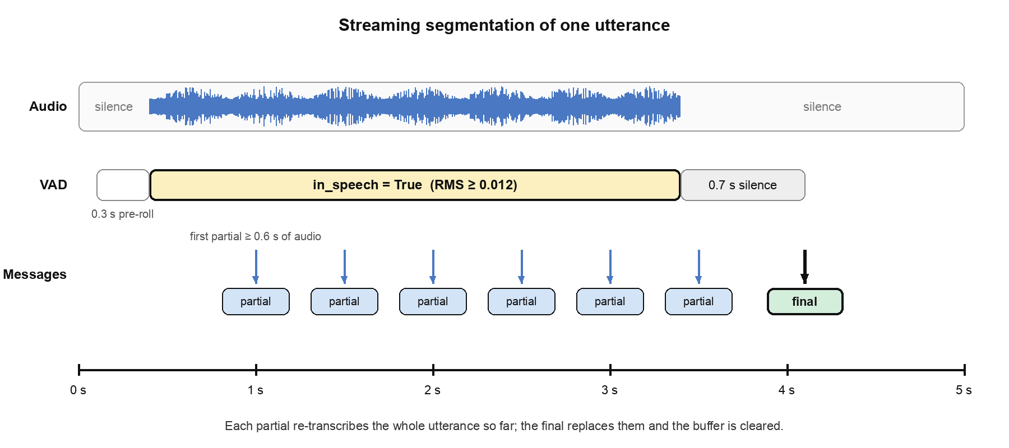
Figure 3.2: Partial and Final Results Within One Utterance
Inference can take longer than a short pause. To avoid losing sentence boundaries, the server records the buffer position of every pause as audio arrives (a list of cuts) instead of checking only on the next timer tick. Each cut is then finalized in order, and any audio that arrived during inference is kept for the next utterance.

3.8 Context Prompting and Hallucination Filtering
Each utterance is transcribed independently, so Whisper could lose track of names or spelling used earlier. To keep the transcript consistent, the last 200 characters of committed text are passed to Whisper as an initial prompt. Whisper’s own conditioning on previous output is disabled so that a mistake is not repeated.
Whisper sometimes “hears” words in near-silence. Two filters remove these hallucinations. First, a segment is dropped if its no-speech probability is above 0.6 and its average log-probability is below −1.0. Second, the whole result is discarded if it matches a list of phrases that Whisper is known to invent, such as “you”, “Thank you.” and “Thanks for watching!”.

3.9 Live Typing Animation
Partials change as Whisper hears more audio; for example, “the lives” may become “the live speech”. Instead of replacing the whole line, the interface compares the text on screen with the newest text and finds their longest common prefix. On every animation frame it first deletes the characters after the prefix (backspacing) and then types the missing characters. The number of characters changed per frame is:
k = max(1, ⌈backlog / 8⌉)
so the view types one character at a time when it is up to date and catches up within about eight frames when it falls behind. Committed (final) characters are drawn in a bright colour and provisional (partial) characters in a dim colour, and the caret follows the last character.

3.10 Speaking-Speed Metrics
Following the convention of typing tests, a “word” is counted as five characters including spaces. Words per minute (WPM) is therefore:
WPM = (characters / 5) / (seconds / 60)
The live display updates time, WPM and word count four times per second. The results screen shows the final WPM and time, the numbers of words, characters and utterances, the average final latency reported by the server, and a chart of cumulative WPM together with a three-second “raw” WPM that reveals bursts and pauses.

CHAPTER 4: SYSTEM DESIGN AND ARCHITECTURE

4.1 System Architecture
NLP-wisper follows a three-layer architecture (Figure 4.1). The presentation layer is the browser application written in TypeScript and built with Vite; it captures audio, manages the session state and renders text and results. The application layer is a FastAPI server that accepts WebSocket connections, runs voice activity detection and decides when to request partial and final transcriptions. The model layer is a separate worker process that holds the Whisper weights and runs inference on the GPU through MLX.
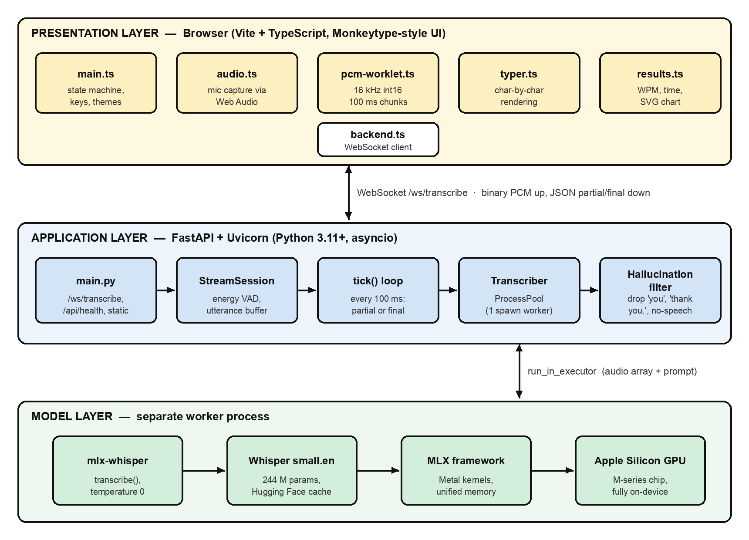
Figure 4.1: System Architecture of NLP-wisper
Whisper’s decoding loop is Python-heavy and holds Python’s Global Interpreter Lock (GIL). If it ran in a thread of the server, it would starve the event loop that receives audio, and chunks would pile up. Running it in its own process keeps the server responsive at all times.

4.2 Use Case Diagram
The main actor is the user, who speaks into the microphone and controls the application with the keyboard. The Whisper engine acts as a supporting actor. The use cases are: start a session (space), view live text, stop and finalize (space), view results, copy the transcript, start the next run, reset the session (Esc) and change the colour theme. Start a session includes microphone capture, streaming and transcription; stop includes flushing the last utterance.

4.3 Data Flow Diagram
Level 0. At Level 0 the system is a single process. The user supplies voice and keyboard commands and receives live text and session statistics. The system reads the Whisper model weights from the local model cache.
Level 1. The Level 1 diagram (Figure 4.2) divides the system into six processes: audio capture (1.0), resampling and chunking (2.0), WebSocket transport (3.0), VAD and segmentation (4.0), Whisper transcription (5.0) and rendering and metrics (6.0). Two data stores are used: D1, the in-memory utterance buffer, and D2, the Whisper model weights.
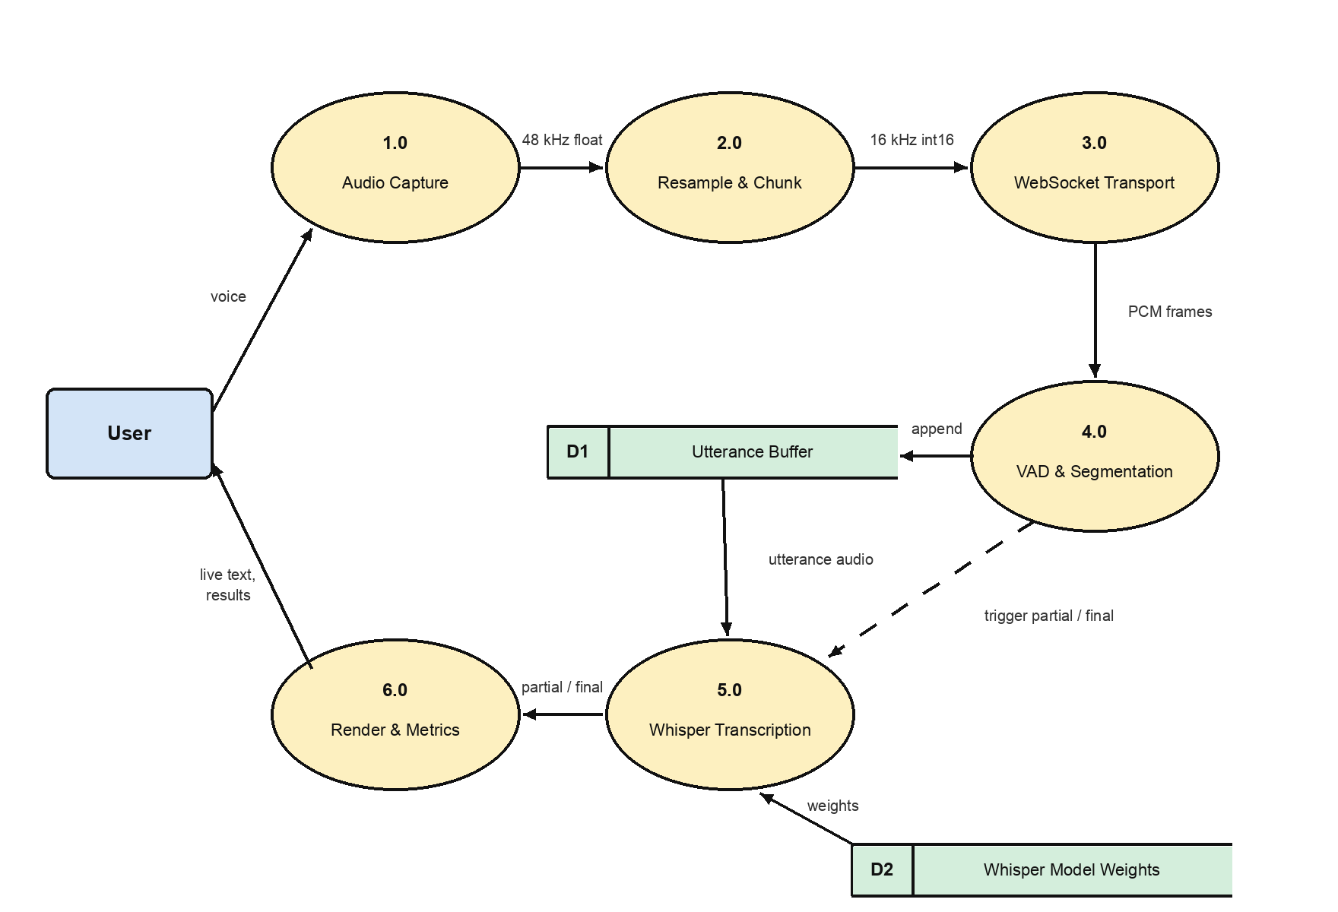
Figure 4.2: Data Flow Diagram – Level 1

4.4 Message Protocol Design
The browser and server communicate over one WebSocket at /ws/transcribe. Audio travels as binary frames of raw 16-bit little-endian PCM, which avoids encoding overhead. Control messages and results travel as small JSON objects (Table 4.1), and their order is shown in Figure 4.3.
Table 4.1: WebSocket Message Protocol
Message | Direction | Contents / Meaning
ready | Server → Client | Sent on connect with the model name and language
(binary) | Client → Server | 100 ms of 16 kHz mono int16 PCM
reset | Client → Server | New run: clear the session and page the model into memory
partial | Server → Client | Provisional text of the current utterance
final | Server → Client | Committed text, audio length (audio_s) and latency (latency_ms)
flush | Client → Server | User stopped: finalize all pending speech
flushed | Server → Client | All pending speech has been finalized

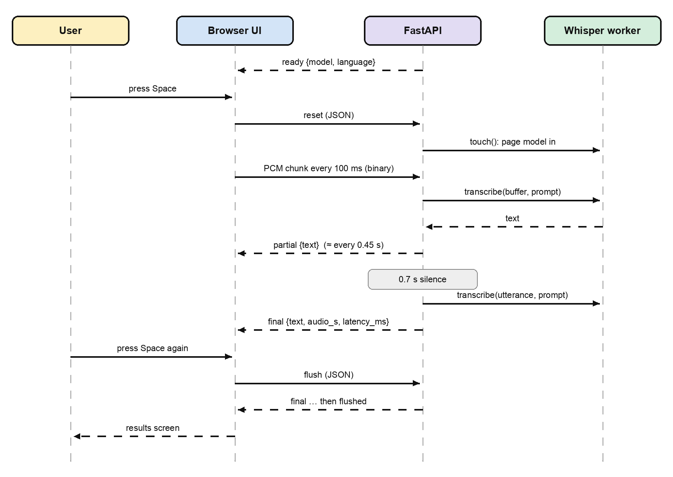
Figure 4.3: Sequence of Messages During One Session

4.5 Module Design
The source code is divided into small modules, each with a single responsibility. The backend lives in apps/api and the frontend in apps/web.
Table 4.2: Responsibilities of the Modules
Module | Responsibility | Main Functions / Classes
main.py | FastAPI app, WebSocket endpoint, health check, static files | transcribe_ws(), health(), run()
stream.py | Per-connection VAD, buffering, partials and finals | StreamConfig, StreamSession.feed(), tick(), flush()
transcriber.py | Whisper worker process and hallucination filter | Transcriber.warmup(), touch(), transcribe()
pcm-worklet.ts | Downsampling to 16 kHz int16 in 100 ms chunks | Pcm16kProcessor.process()
audio.ts | Microphone access and audio graph | Mic.start(), Mic.stop()
backend.ts | WebSocket client with reconnect and backoff | Backend.sendAudio(), sendControl()
typer.ts | Character-by-character rendering and caret | Typer.set(), clear()
results.ts | WPM, time formatting and SVG chart | wpm(), countWords(), renderChart()
main.ts | Session state machine, keyboard and themes | start(), stop(), showResult(), reset()

4.6 User Interface Design
The interface follows the minimal design of Monkeytype. The default serika dark theme uses a dark charcoal background with yellow accents; nord, dracula and carbon themes are also available and the choice is remembered. A header shows the connection status and the active model and language. The centre of the screen holds three lines of large monospaced text with a blinking caret, a small audio level bar and live time, WPM and word counters (Figure 4.4). The application is driven by two keys: space starts and stops, and Esc resets.
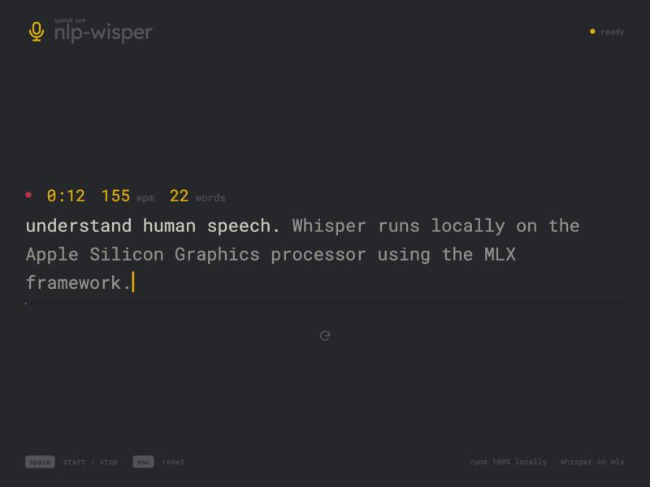
Figure 4.4: Live Transcription Screen (final text bright, partial text dim)

CHAPTER 5: SYSTEM IMPLEMENTATION

5.1 Technologies Used
Table 5.1: Technologies Used
Technology | Role in the Project
Python 3.11+ | Backend language
FastAPI + Uvicorn | Asynchronous web server, WebSocket endpoint and static file hosting
mlx-whisper | Whisper inference implemented on Apple’s MLX framework
NumPy | Audio buffers, RMS energy and sample conversion
TypeScript + Vite | Frontend language, development server and production build
Web Audio API (AudioWorklet) | Real-time microphone capture and resampling in the browser [12]
WebSocket | Full-duplex, low-latency transport for audio and results [11]
uv, pnpm, Turborepo | Python and JavaScript package management and monorepo task running
Ruff, tsc | Python linting and TypeScript type checking

5.2 Model Selection
Whisper is available in several sizes. Larger models are more accurate but slower, and in a streaming system the model must finish each transcription well within the 0.45 s partial interval. The default is mlx-community/whisper-small.en-mlx, an English-only model of about 244 million parameters (around 480 MB to download). It can be changed with the WHISPER_MODEL environment variable.
Table 5.2: Whisper Model Variants
Model | Parameters | Typical Use in NLP-wisper
whisper-tiny.en | 39 M | Fastest; lowest accuracy
whisper-base.en | 74 M | Recommended when speed matters most
whisper-small.en (default) | 244 M | Balance of accuracy and real-time speed
whisper-medium.en | 769 M | Higher accuracy; slower partials
whisper-large-v3-turbo | 809 M | Multilingual and most accurate; needs more memory

5.3 Audio Capture Module
audio.ts opens the microphone with getUserMedia and loads the pcm-worklet module into an AudioContext. The microphone source is connected to the worklet, and the worklet is connected through a muted gain node to the speakers; this keeps the audio graph running without playing the voice back. Every 100 ms the worklet transfers a 3 200-byte buffer to the main thread, which forwards it directly to the WebSocket.

5.4 Streaming Session Module
stream.py keeps one StreamSession per connection. feed() converts incoming bytes to 32-bit floats, computes the RMS, updates the speech and silence state and appends the chunk to the buffer. tick(), called every 100 ms, decides whether to send a partial, finalize a pending cut, or do nothing. An asyncio lock makes sure that only one transcription per session runs at a time. flush() finalizes every pending cut and the current utterance when the user stops.

5.5 Transcriber Worker Module
transcriber.py runs Whisper in a ProcessPoolExecutor with a single worker started with the spawn method. At startup, warmup() transcribes one second of silence, which downloads the model on the first run and loads it into GPU memory. When a new session starts, touch() runs a tiny inference so that the model is paged back in before speech arrives, which matters on machines with little RAM. A watchdog thread in the worker exits if the parent server dies, so the gigabyte of model weights is never left behind.

5.6 WebSocket API Module
main.py creates the FastAPI application. On startup its lifespan handler warms up the model. The endpoint /ws/transcribe accepts a connection, sends the ready message, starts the 100 ms ticker task and then loops over incoming messages: binary frames go to feed(), and JSON messages trigger flush() or reset(). The endpoint /api/health returns the server status, model and language. After a production build, the same server also serves the compiled frontend.

5.7 Typer and Results Modules
typer.ts holds one HTML span per character so that individual characters can be added, removed and coloured cheaply. It schedules its work with requestAnimationFrame and moves the caret with CSS transforms, scrolling the text so that the caret always stays on the third line. results.ts computes WPM and word counts and draws the results chart as an SVG with cumulative and raw WPM lines. backend.ts reconnects automatically if the server restarts, waiting min(5 s, 0.4 s × 2ⁿ) before attempt n.

5.8 Configuration
Table 5.3: Environment Variables
Variable | Default | Description
WHISPER_MODEL | whisper-small.en-mlx | Hugging Face repository of the MLX Whisper model
WHISPER_LANGUAGE | en | Language code; empty for automatic detection (multilingual models)
VAD_THRESHOLD | 0.012 | Microphone RMS that counts as speech; raise it in noisy rooms
API_PORT | 8000 | Port of the FastAPI server
LOG_LEVEL | INFO | DEBUG logs every partial with its latency

5.9 Monorepo Build System
The project is a Turborepo monorepo with two applications. The frontend is a pnpm workspace package, and the backend is a uv workspace member that Turborepo discovers through its experimental Python workspace support, so it needs no package.json. A single pnpm dev command starts the Vite development server on port 5173, which proxies /api and /ws to the FastAPI server on port 8000. pnpm build produces the frontend bundle and a Python wheel, and pnpm lint runs tsc and Ruff.

5.10 Installation and Execution
- Use an Apple Silicon Mac with uv 0.12 or later, Node.js 20 or later and pnpm.
- Install JavaScript dependencies: pnpm install
- Install Python dependencies: uv sync --all-packages
- Start both servers: pnpm dev (the first start downloads the Whisper model).
- Open http://localhost:5173, allow microphone access, press space and start talking.
- Optionally stream a WAV file without a microphone: uv run --package nlp-wisper-api python apps/api/scripts/stream_file.py speech.wav

CHAPTER 6: TESTING AND RESULTS

6.1 Testing
Testing verifies that the application behaves as expected. The following types of testing were applied to NLP-wisper:
- API testing: the health endpoint and the WebSocket handshake were checked directly.
- Streaming testing: speech files were streamed to the server in real time with the project’s stream_file.py script, which sends 100 ms chunks at the same rate as a live microphone.
- Accuracy testing: the final transcripts were compared with the known reference sentences.
- Functional testing: the full browser application was run end to end, from pressing space to the results screen.
- Static checks: pnpm lint runs the TypeScript compiler and the Ruff linter.
Test speech was generated with the macOS say command as 16 kHz mono 16-bit WAV files. All measurements were taken on an Apple M3 MacBook with 8 GB of memory using the whisper-small.en model.

6.2 Test Cases
Table 6.1: Test Cases
ID | Input / Action | Expected Behaviour | Result
TC01 | GET /api/health | Status “ok” with model and language | Pass
TC02 | Open WebSocket /ws/transcribe | “ready” message with model name | Pass
TC03 | Stream one spoken sentence | Several partials, then one final with latency | Pass
TC04 | Stream 3 s of low-level noise | No partial or final text produced | Pass
TC05 | Two sentences separated by a 1.5 s pause | Two separate finals | Pass
TC06 | Send “flush” after speech | Pending speech finalized, then “flushed” | Pass
TC07 | Open UI before the API is ready | Shows offline, then reconnects to “ready” | Pass
TC08 | Press space, speak, press space | Live typing, then results screen with WPM, time, words and latency | Pass
TC09 | Deny microphone permission | Error message “microphone unavailable” | To be recorded
TC10 | Press Esc while listening | Microphone stops; screen resets | To be recorded

TC08 was run in the browser by feeding a recorded speech file in place of the microphone input, so that the complete pipeline, including the worklet, WebSocket, server and typing animation, was exercised. TC09 and TC10 should be recorded after running them manually.

6.3 Performance Evaluation
Accuracy is measured with the Word Error Rate (WER), the standard ASR metric. The recognized text and the reference are lower-cased and stripped of punctuation, and the minimum number of word substitutions (S), deletions (D) and insertions (I) needed to turn one into the other is counted:
WER = (S + D + I) / N
where N is the number of words in the reference. Responsiveness is measured with three further metrics, summarized in Table 6.2.
Table 6.2: Evaluation Metrics
Metric | Definition | Meaning
Word Error Rate | (S + D + I) / N | Share of words recognized incorrectly
First-partial delay | Time from start of audio to first partial | How soon the user sees text
Final latency | Inference time of the final transcription | Delay after a pause before text is committed
Real-Time Factor (RTF) | Final latency / utterance duration | Below 1 means faster than real time

Table 6.3: Measured Results (Apple M3, whisper-small.en)
Test | Audio (s) | Partials | First Partial (s) | Final Latency (ms) | RTF | WER
S1 | 3.68 | 6 | 1.13 | 472 | 0.13 | 0.0%
S2 | 4.46 | 8 | 0.83 | 464 | 0.10 | 0.0%
S3 | 3.07 | 5 | 0.84 | 475 | 0.15 | 0.0%
S4 | 4.90 | 9 | 0.82 | 509 | 0.10 | 5.6%
S5 | 5.25 | 10 | 0.85 | 513 | 0.10 | 0.0%
S6 (2 utterances) | 4.20 + 3.44 | 11 | 0.84 | 476 / 479 | 0.11 / 0.14 | 0.0%
Overall | 29.0 | 49 | 0.85 (median) | 484 (mean) | 0.12 (mean) | 1.1%

6.4 Results and Discussion
Across 90 reference words the system made a single error, giving a WER of 1.1%. The only mistake was in S4, where “then close the file” was recognized as “and close the file”, a small change that keeps the meaning. Text appeared about 0.85 s after speech began, which is the 0.6 s minimum clip length plus one inference. Final results arrived on average 484 ms after each 0.7 s pause, and the real-time factor of about 0.12 means the model transcribes an utterance roughly eight times faster than it is spoken. The 3-second noise test produced no text, confirming that the VAD and the hallucination filters work together.
The partials show why the typing animation is useful. In S1 the partial “the lives” was corrected to “the live speech” one step later, and in S3 one partial briefly contained an invented ending that the next partial removed. The interface backspaces over such revisions smoothly, while finals, which see the whole utterance, were correct in every case. Figure 6.1 shows the results screen after a three-utterance session run through the browser.
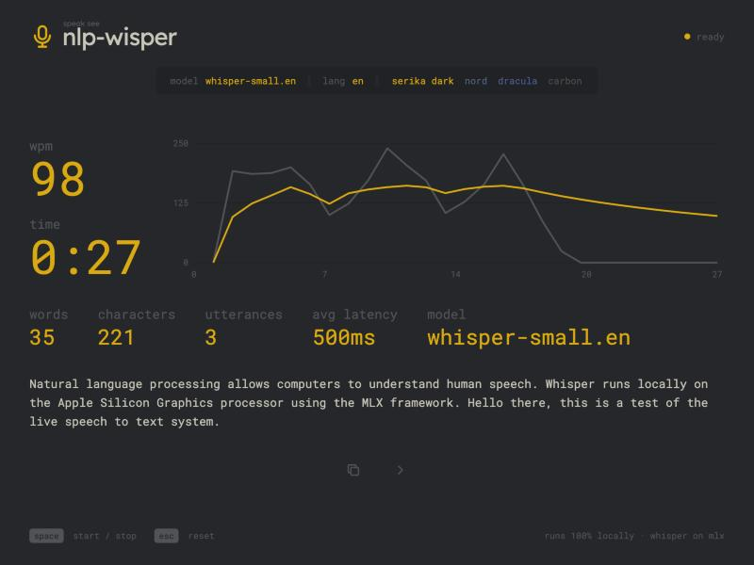
Figure 6.1: Results Screen After a Three-Utterance Session
These results were obtained with clean synthetic speech. Real microphone speech, accents and background noise will raise the error rate, and longer utterances increase the cost of each partial because the whole utterance is transcribed again. Even so, the measurements show that a transformer-based recognizer can deliver live, private speech-to-text on an ordinary laptop.

CHAPTER 7: CONCLUSION AND FUTURE SCOPE

7.1 Conclusion
NLP-wisper demonstrates how a modern NLP model can be turned into a responsive, private, real-time application. The browser captures and resamples the voice, a WebSocket streams it to a local FastAPI server, an energy-based VAD segments it into utterances, and Whisper running on the Apple Silicon GPU through MLX transcribes it. Repeated transcription of the growing utterance gives live partial results, and finals after each pause give accurate committed text.
Careful engineering choices make the system practical: inference runs in its own process so audio is never delayed, pauses are recorded as they happen so sentence boundaries are not lost, recent text is used as a prompt for consistency, and hallucinations are filtered. In testing, text appeared within about a second, finals arrived in under half a second and the word error rate was 1.1%, all without sending any data off the machine.

7.2 Limitations
- The system runs only on Apple Silicon Macs because it depends on MLX.
- Each partial re-transcribes the entire utterance, so very long utterances cost more computation.
- The energy-based VAD can mistake loud background noise for speech and may need its threshold tuned.
- Partials can briefly show incorrect words until a later partial or the final corrects them.
- The resampler uses linear interpolation without an anti-aliasing filter.
- The system does not separate speakers, store transcripts or support editing.

7.3 Future Scope
- A neural VAD such as Silero for more reliable speech detection in noisy rooms.
- Incremental decoding that reuses agreed-upon words instead of re-transcribing the whole utterance.
- Cross-platform inference with whisper.cpp or ONNX Runtime for Windows and Linux.
- Multilingual transcription and live translation with Whisper’s translate task.
- Speaker diarization to label who said what in meetings.
- Saving, searching and exporting transcripts, and voice commands for punctuation and editing.

REFERENCES
- A. Radford, J. W. Kim, T. Xu, G. Brockman, C. McLeavey, and I. Sutskever, “Robust speech recognition via large-scale weak supervision,” in Proc. 40th Int. Conf. Machine Learning (ICML), 2023, pp. 28492–28518.
- A. Vaswani et al., “Attention is all you need,” in Advances in Neural Information Processing Systems (NeurIPS), 2017, pp. 5998–6008.
- L. R. Rabiner, “A tutorial on hidden Markov models and selected applications in speech recognition,” Proceedings of the IEEE, vol. 77, no. 2, pp. 257–286, 1989.
- A. Graves, S. Fernández, F. Gomez, and J. Schmidhuber, “Connectionist temporal classification: Labelling unsegmented sequence data with recurrent neural networks,” in Proc. ICML, 2006, pp. 369–376.
- A. Hannun et al., “Deep Speech: Scaling up end-to-end speech recognition,” arXiv:1412.5567, 2014.
- A. Baevski, H. Zhou, A. Mohamed, and M. Auli, “wav2vec 2.0: A framework for self-supervised learning of speech representations,” in Advances in Neural Information Processing Systems (NeurIPS), 2020.
- S. Davis and P. Mermelstein, “Comparison of parametric representations for monosyllabic word recognition in continuously spoken sentences,” IEEE Trans. Acoustics, Speech, and Signal Processing, vol. 28, no. 4, pp. 357–366, 1980.
- D. Jurafsky and J. H. Martin, Speech and Language Processing, 3rd ed. (draft). Available: https://web.stanford.edu/~jurafsky/slp3/
- A. Hannun, J. Digani, A. Katharopoulos, and R. Collobert, “MLX: Efficient and flexible machine learning on Apple silicon,” 2023. Available: https://github.com/ml-explore/mlx
- Y. He et al., “Streaming end-to-end speech recognition for mobile devices,” in Proc. IEEE ICASSP, 2019, pp. 6381–6385.
- I. Fette and A. Melnikov, “The WebSocket Protocol,” RFC 6455, IETF, 2011.
- W3C, “Web Audio API,” W3C Recommendation. Available: https://www.w3.org/TR/webaudio/
- FastAPI Documentation. Available: https://fastapi.tiangolo.com/
- J. Ramírez, J. C. Segura, C. Benítez, Á. de la Torre, and A. Rubio, “Efficient voice activity detection algorithms using long-term speech information,” Speech Communication, vol. 42, no. 3–4, pp. 271–287, 2004.
- MLX Whisper examples. Available: https://github.com/ml-explore/mlx-examples/tree/main/whisper

