STEPS FOR RUNNING SUPPORT VECTOR MACHINE:

1. First run the file name svm_preprocessing, in this file please enter the **path** of the csv files that are individual files, which already contains the important set of features.
2. Note: please don’t lease any tabbed space in path variable

E.g: The below one is wrong input can give error.



This below is the correct input:



1. The files are: svm_if = important features by information gain

svm_re = important features by recursive feature elimination

svm_et = important features by extra tree classifier

1. Now obtaining the C values from each of the above files **input the C** and **the path of this corresponding C** in the other file svm_auc.

Eg.:This is where we find value of C in first programs: svm_if, svm_r, svm_et for the second programs svm_auc

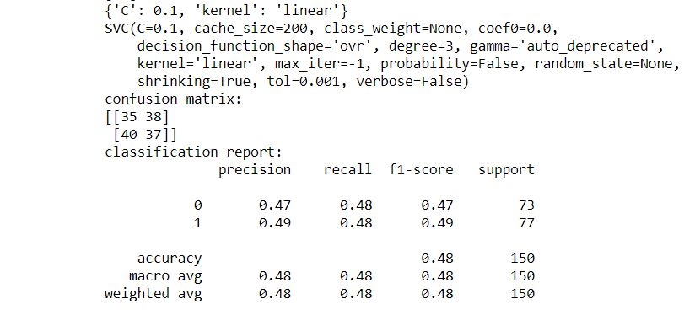

1. If graph didn’t generated in the first attempt of execution then run the program svm_auc, **another time**. There will be a graph as output
2. This file generates the Auc curve.
3. The outputs are in the folder.