**Tanmay Kulkarni**

**TCOB03**

**T1902404335**

**FIFO**

**package** fifoprog;

**import** java.util.Scanner;

// import java.util.Arrays;

**public** **class** fifo {

**public** **static** **void** main(String args[]) {

Scanner scanner = **new** Scanner(System.***in***);

System.***out***.print("Enter the number of frames: ");

**int** frames = scanner.nextInt();

System.***out***.print("Enter the number of pages in the stream: ");

**int** numPages = scanner.nextInt();

**int**[] incomingStream = **new** **int**[numPages];

System.***out***.println("Enter the pages:");

**for** (**int** i = 0; i < numPages; i++) {

incomingStream[i] = scanner.nextInt();

}

**int** pageFaults = 0;

**int** pages = incomingStream.length;

**int**[] temp = **new** **int**[frames];

**for** (**int** i = 0; i < frames; i++) {

temp[i] = -1;

}

System.***out***.println("Incoming \t Frame 1 \t Frame 2 \t Frame 3");

**for** (**int** m = 0; m < pages; m++) {

**int** s = 0;

**for** (**int** n = 0; n < frames; n++) {

**if** (incomingStream[m] == temp[n]) {

s++;

pageFaults--;

}

}

pageFaults++;

**if** ((pageFaults <= frames) && (s == 0)) {

temp[m % frames] = incomingStream[m];

} **else** **if** (s == 0) {

temp[(pageFaults - 1) % frames] = incomingStream[m];

}

System.***out***.println();

System.***out***.print(incomingStream[m] + "\t\t\t");

**for** (**int** n = 0; n < frames; n++) {

**if** (temp[n] != -1)

System.***out***.print(temp[n] + "\t\t\t");

**else**

System.***out***.print(" - \t\t\t");

}

}

System.***out***.println("\nTotal Page Faults:\t" + (pageFaults -1));

System.***out***.println("Total Number of Page FAULTS : " + (incomingStream.length - pageFaults +1 ));

scanner.close();

}

}

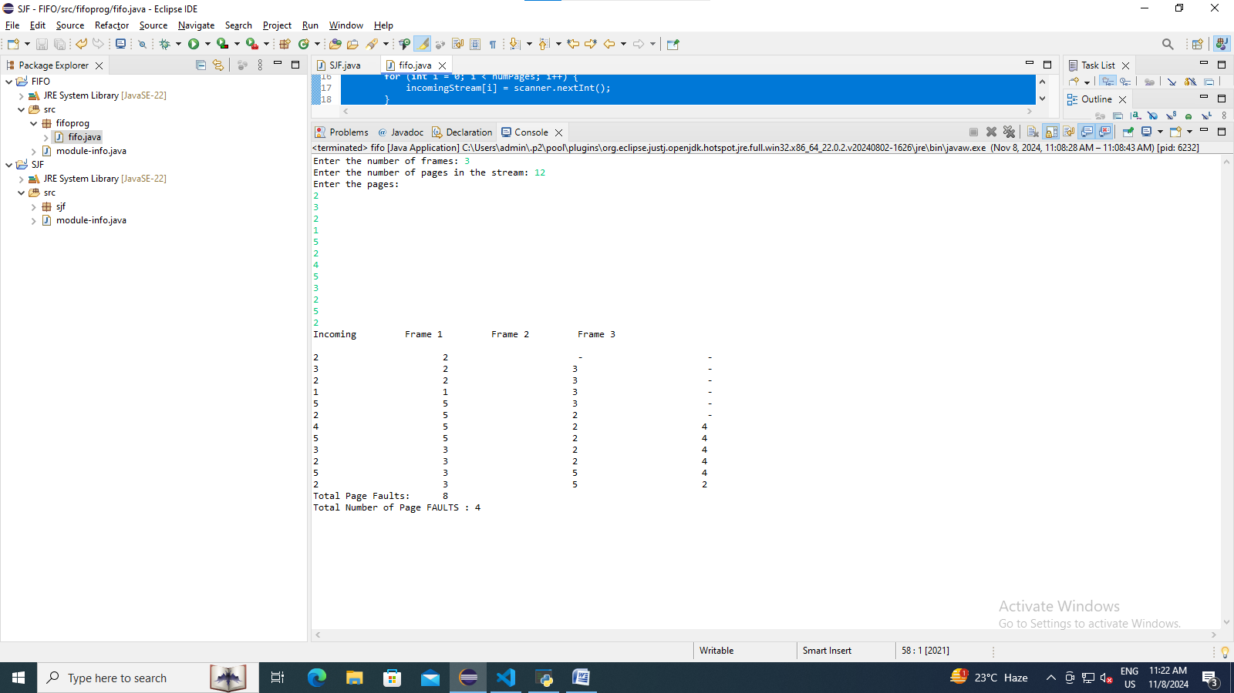

PYTHON GUI FOR WELCOME PAGE

import tkinter as tk;

from tkinter import messagebox

root = tk.Tk()

root.geometry("700x500")

root.resizable(False, False)

root.title("WELCOME")

def fun():

    tk.messagebox.showinfo()

l1 = tk.Label(root, text="WELCOME", font = 44, foreground="red")

l1.place(x= 230,y = 30)

l2 = tk.Label(root, text="Thank you for visiting the website! We hope you enjoy your time here. ", font= 32)

l2.place(x= 20, y= 200)

l3 = tk.Label(root, text="Enter the username")

l3.place(x= 20, y= 70)

e1 = tk.Entry(root)

e1.place(x= 140, y= 70)

l4 = tk.Label(root, text="Enter contact info")

l4.place(x= 20, y= 90)

e2 = tk.Entry(root) #type= "*")

e2.place(x= 140, y= 90)

b1 = tk.Button(root, text="Do not have a account? Click here", activebackground= "blue", command = fun, activeforeground= "white")

b1.place(x= 40, y = 130)

b2 = tk.Button(root, text= "LOGIN", activebackground = "red", command = fun)

b2.place(x= 320, y = 74)

root.mainloop()

