

Lung Cancer Detection Model

*Presented by Tanmay Kumar Chaki 14th March 2025*

The Lung Cancer Detection Model is a machine learning project that leverages a Random Forest Classifier to predict the presence or absence of lung cancer based on health data from patients. The model uses various health indicators such as symptoms and medical history to classify whether a person has lung cancer. The dataset contains features such as yellow fingers, wheezing, chest pain, and difficulty swallowing. The model achieves 96% accuracy and is evaluated with metrics like precision, recall, and F1-score.

# Technology Used

• Python (3.12.7)  
• Scikit-Learn  
• Pandas  
• NumPy  
• Matplotlib & Seaborn

1. **Python (3.12.7)**:
   * **Description**: Python is a versatile, high-level programming language widely used for data science, machine learning, and web development. Its readability, simplicity, and extensive libraries make it a go-to choice for data analysis and modelling.
2. **Scikit-Learn**:
   * **Description**: Scikit-Learn is one of the most popular machine learning libraries in Python. It provides simple and efficient tools for data mining and data analysis, including algorithms for classification, regression, clustering, and model evaluation. In this project, it is used for implementing the Random Forest Classifier, a decision tree-based algorithm that creates multiple decision trees to make predictions.
3. **Pandas**:
   * **Description**: Pandas is a powerful data manipulation and analysis library. It provides data structures like Data Frames, which are used to efficiently handle and process structured data. In this project, Pandas is used to load, manipulate, and clean the dataset before feeding it into the model.
4. **NumPy**:
   * **Description**: NumPy is a core scientific computing library for Python, providing support for large, multi-dimensional arrays and matrices. It also includes a collection of mathematical functions to operate on these arrays. It is used in this project for numerical calculations and data handling.
5. **Matplotlib & Seaborn**:
   * **Description**:
     + **Matplotlib**: A plotting library that provides an object-oriented API for embedding plots into applications. It is used for creating static, animated, and interactive visualizations.
     + **Seaborn**: Built on top of Matplotlib, Seaborn provides a high-level interface for drawing attractive and informative statistical graphics. It is used in the project for visualizing data distributions, relationships between variables, and model evaluation metrics like confusion matrix.

These libraries together form a robust toolkit for handling, visualizing, and building machine learning models, making Python an excellent choice for your lung cancer detection project.

# Algorithm Used

* Random Forest Algorithm

***Random Forest Algorithm***

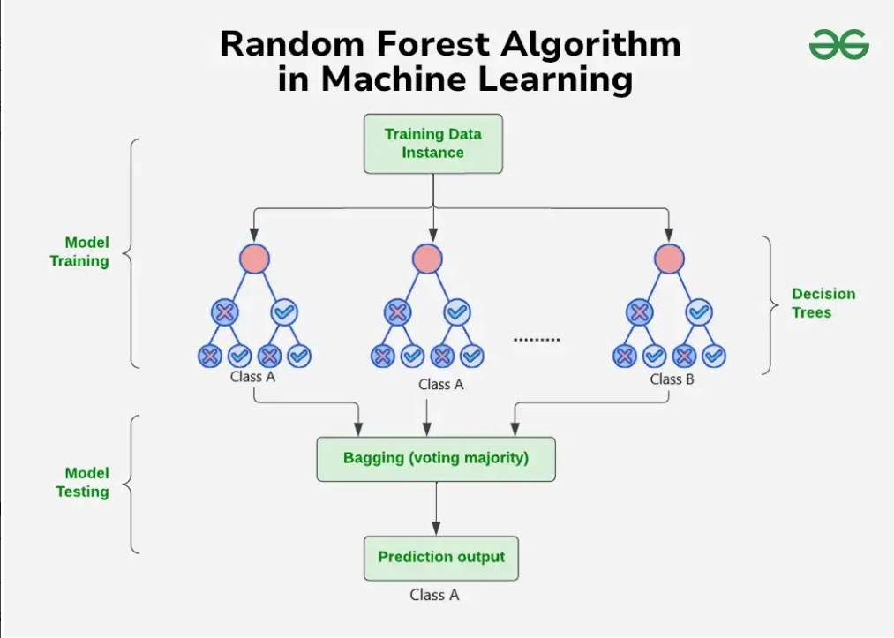

The **Random Forest Algorithm** is a powerful, versatile machine learning model used for both classification and regression tasks. It belongs to the family of **ensemble learning methods**, which combine multiple individual models to improve performance and provide more robust predictions. Here’s an in-depth explanation of the **Random Forest** algorithm:

**1. How Random Forest Works**

* **Ensemble of Decision Trees**: Random Forest builds a **collection of decision trees** (hence the "forest" part of the name). Each tree is created by splitting the data into subsets and making predictions based on these subsets. The key idea is that multiple decision trees can make a better prediction than a single tree.
* **Bootstrapping**: For each tree in the forest, **bootstrapping** is used, which means that random samples of the training data are taken with replacement. This introduces variety among the trees and reduces overfitting.
* **Feature Randomization**: At each node of a decision tree, Random Forest randomly selects a subset of features (instead of considering all features) to split the data. This ensures that the trees are diverse and reduces correlation between the trees, making the ensemble more powerful.

**2. Training Process of Random Forest**

* **Step 1: Data Sampling**: Randomly select data points from the original dataset with replacement, creating subsets of the data (bootstrapping). This process results in **out-of-bag (OOB)** samples that are not used in training some trees but can be used for testing the model.
* **Step 2: Building Decision Trees**: For each subset of the data, a decision tree is constructed by recursively splitting the data at each node based on features that minimize a certain criterion, like **Gini impurity** or **entropy**.
* **Step 3: Feature Selection at Nodes**: At each node, only a subset of the features is considered for splitting. This introduces more randomness and reduces overfitting, as it ensures that no tree is too dependent on a single feature.

**3. Making Predictions**

* **For Classification**: After all the trees in the forest have been trained, predictions are made by **voting**. Each tree gives a classification prediction (either "Yes" or "No" for lung cancer, for example), and the majority vote (the most frequent prediction) is taken as the final output.
* **For Regression**: Predictions are averaged over all the trees in the forest to get the final output.

**4. Advantages of Random Forest**

* **Reduces Overfitting**: The randomization introduced by bootstrapping and feature selection helps prevent overfitting, a common issue in decision trees where the model becomes too complex and fits noise in the data.
* **Handles Missing Values**: Random Forest can handle missing values by using a method called **surrogate splitting**, which selects another feature to split on when the original feature has missing values.
* **Robust to Outliers**: Since Random Forest uses multiple trees, the influence of outliers is minimized. An outlier might impact a single tree but is unlikely to affect the majority of the trees in the forest.
* **Feature Importance**: Random Forest provides insights into the importance of each feature in making predictions. Features that contribute the most to splitting the data at each node are considered important and can be ranked.

**5. Disadvantages of Random Forest**

* **Computational Complexity**: Random Forest can be computationally expensive and require a significant amount of memory, especially when dealing with a large number of trees or large datasets.
* **Interpretability**: Unlike a single decision tree, which can be visualized and interpreted easily, the ensemble nature of Random Forest makes it harder to understand how individual predictions are made.

**6. Applications**

* **Classification Tasks**: Random Forest is widely used in classification problems such as **image recognition**, **email spam detection**, and **healthcare diagnoses** (like lung cancer detection).
* **Regression Tasks**: It can also be used in regression tasks such as **predicting housing prices** or **stock market trends**.
* **Feature Selection**: In high-dimensional datasets, Random Forest can be used to determine which features are most important for prediction, making it useful for feature selection and dimensionality reduction.

**7. Random Forest in Lung Cancer Detection**

* In your **Lung Cancer Detection Model**, Random Forest is used to classify whether a patient has lung cancer based on several health features like symptoms, smoking history, and chest pain. The algorithm handles the complexity of the dataset by leveraging multiple decision trees and aggregating their results to make an accurate prediction.
* By training on a diverse set of trees, the Random Forest ensures robustness and generalizes well on unseen data, making it highly effective in real-world medical predictions.

**Conclusion**

The Random Forest algorithm is a strong, adaptable, and widely-used machine learning model, especially effective for classification tasks. It’s particularly useful when dealing with large datasets with many features and when interpretability isn't the top priority. Its ability to reduce overfitting and provide valuable insights into feature importance makes it a popular choice in many domains, including healthcare applications like lung cancer detection.

# Dataset

The dataset used in this project is sourced from Kaggle and contains various health indicators and labels related to lung cancer.

In the **Lung Cancer Detection Model**, the dataset plays a crucial role in training the machine learning algorithm to accurately predict whether a patient has lung cancer based on various health parameters and symptoms. Here’s a detailed breakdown of the dataset, along with a focus on **predictive variables**:

**Dataset Overview**

The dataset used for the model typically contains medical information related to **lung cancer patients** and **non-cancer patients**. It includes both numerical and categorical features, such as demographic data, symptoms, medical history, and test results. Each row in the dataset represents a unique patient, while the columns contain relevant features.

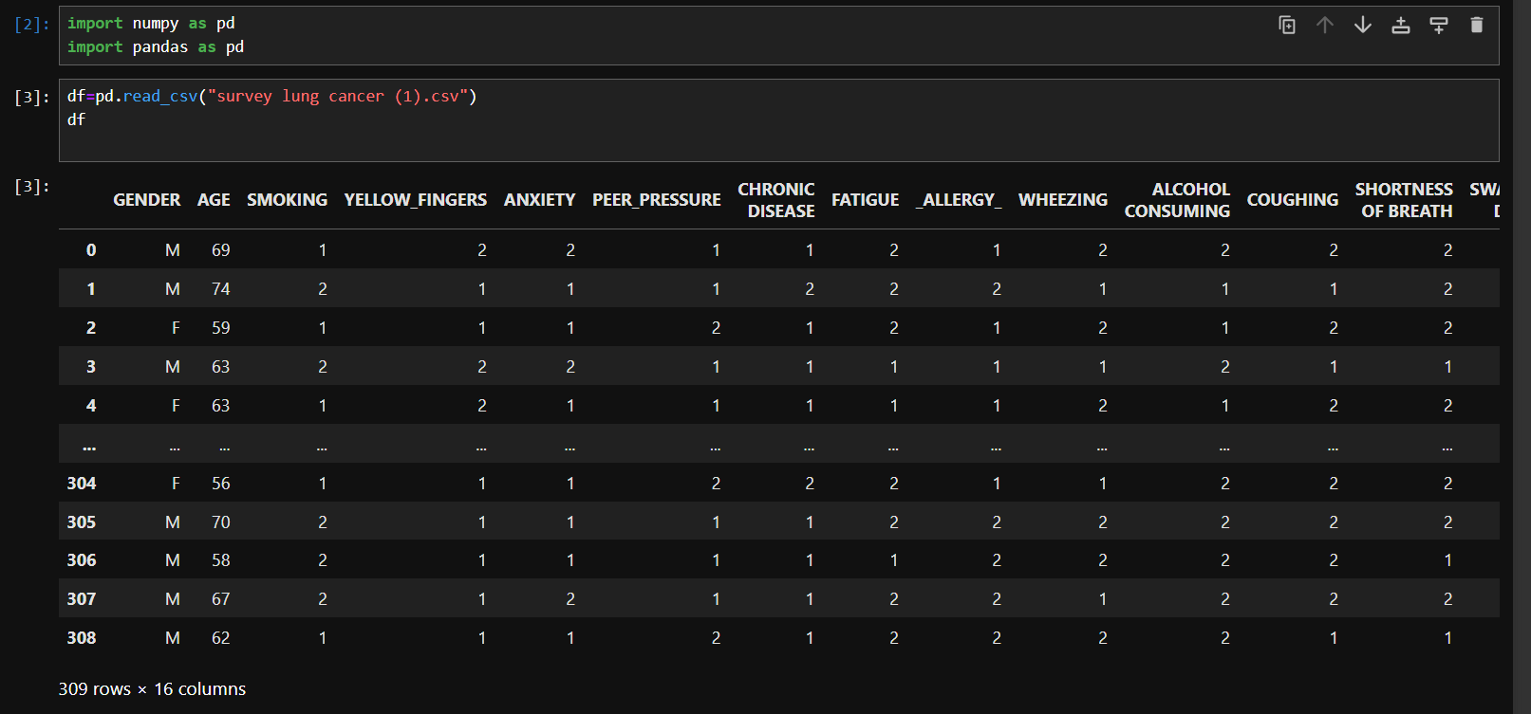In the Above figure ,The Data is being imported and read into the Jupyter Notebook using Pandas Library .

*Source:- My Jupyter Notebook*

# Predictive Variables

• YELLOW_FINGERS: Indicates the presence of yellow fingers, a potential sign of smoking or other respiratory conditions.

• ANXIETY: Represents whether the individual suffers from anxiety.

• CHRONIC DISEASE: Indicates any history of chronic diseases like asthma or diabetes.

• WHEEZING: Represents the presence of wheezing, a symptom of respiratory distress.

• ALCOHOL CONSUMING: Indicates whether the individual consumes alcohol.

• CHEST PAIN: Represents the presence of chest pain, which could be indicative of lung-related issues.

• SWALLOWING DIFFICULTY: Indicates difficulty swallowing, a possible sign of esophageal disorders.

• COUGHING: Represents whether the individual experiences frequent coughing.

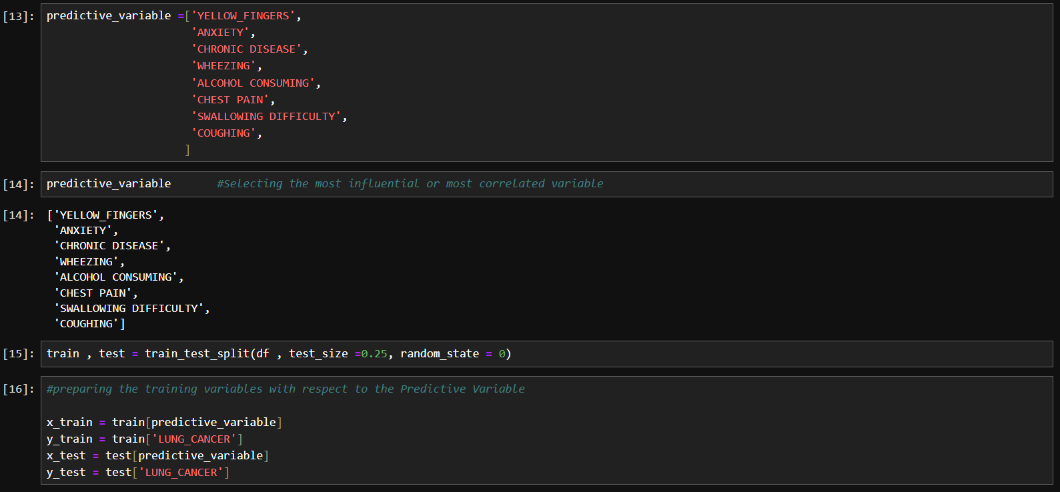

In this above figure, The Model is been assigned Training variables based on the Predictive Variable. Later on, The Model will be trained based on the Predictive Variable .

*Source:- My Jupyter Notebook*

# Exploratory Data Analysis

In this step, missing values were checked using the `isnull()` function, feature distributions were visualized using Matplotlib and Seaborn, and correlation analysis was performed using `df.corr()`.

# Feature Importance

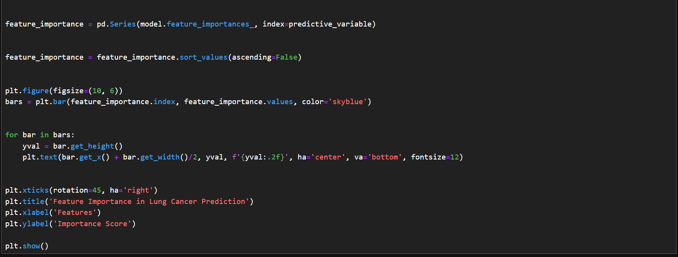Feature importance was assessed using the Random Forest model, and the impact of each feature on model prediction was evaluated. This helps in understanding which features are most significant in detecting lung cancer.

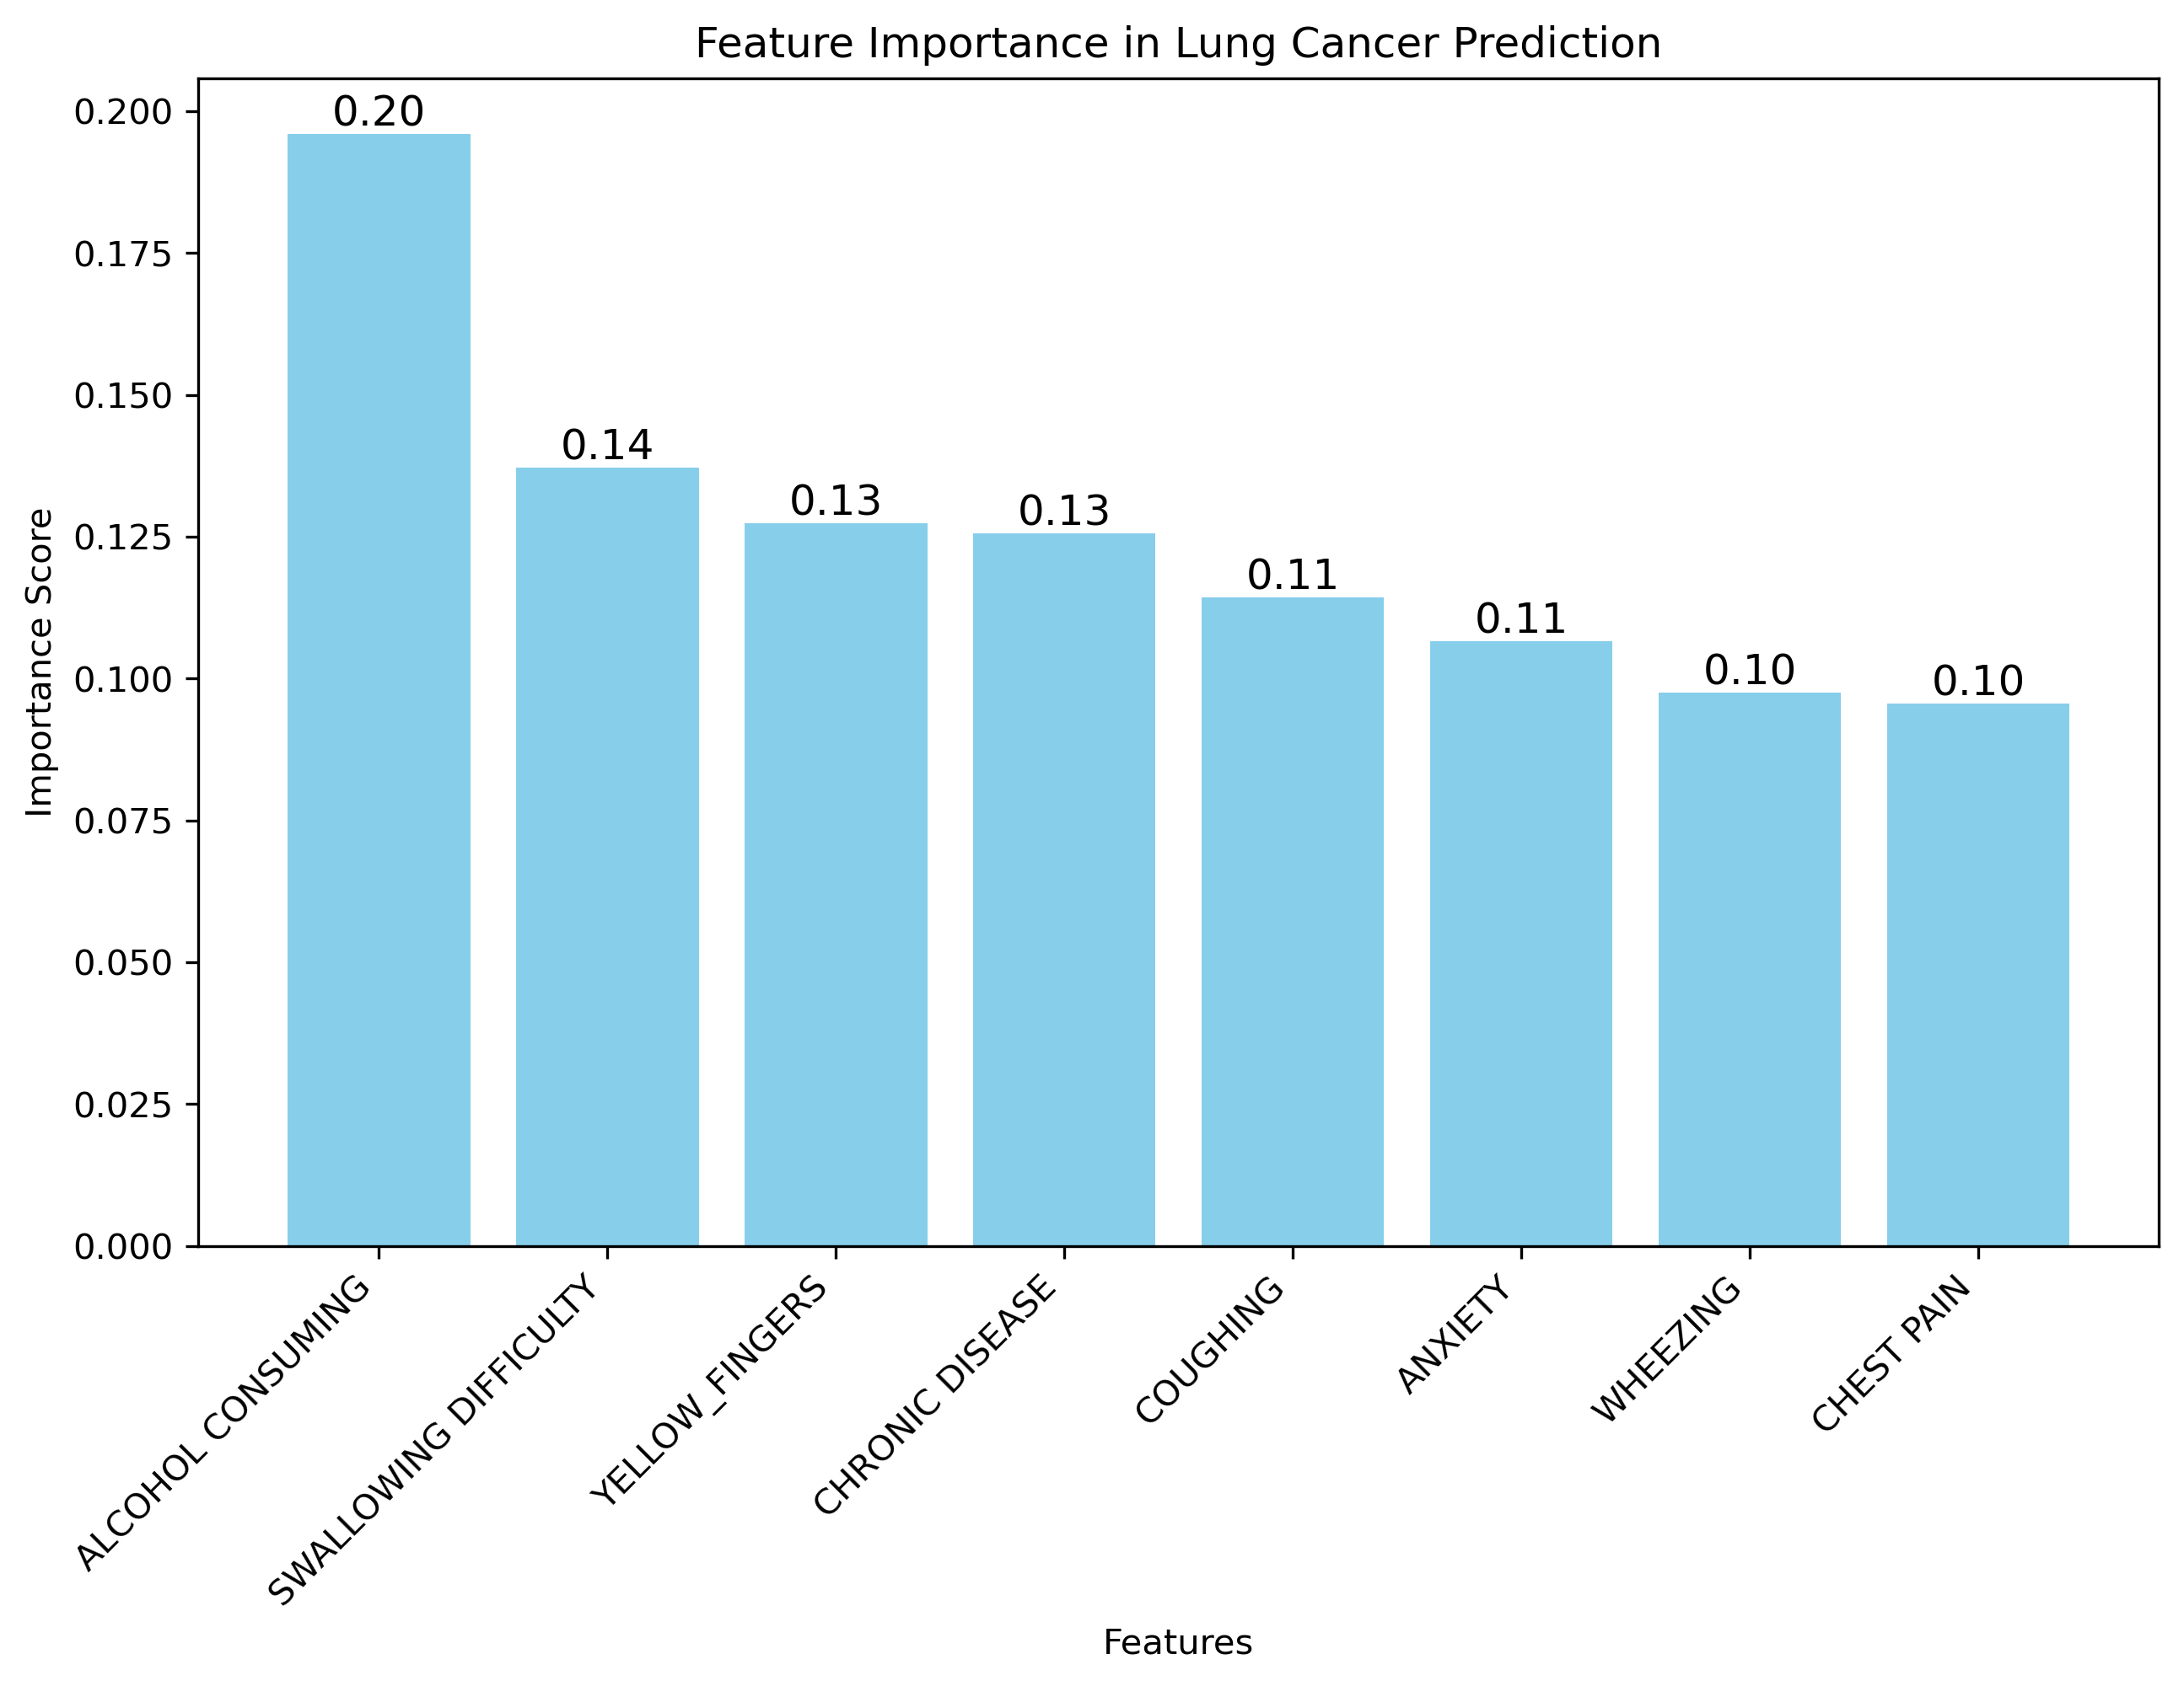

**How Feature Importance is Calculated:**

1. **Mean Decrease in Impurity (MDI):**
   * Each tree in the Random Forest splits the data at various points based on a feature. The goal of splitting is to reduce the impurity (the uncertainty about the class) in the resulting subsets.
   * Features that result in larger reductions of impurity are considered more important.
   * The Random Forest algorithm computes the average decrease in impurity for each feature, and those with the highest values are considered most important.
2. **Mean Decrease in Accuracy (Permutation Importance):**
   * This method works by randomly shuffling the values of a feature and measuring how much the model's performance drops. A large drop indicates that the feature is important for making accurate predictions.
   * This method is more computationally expensive but can give more reliable results, especially when features are correlated.

**Feature Importance for The Lung Cancer Detection Model:**

For your model, key health features such as **Coughing, Chest Pain, Wheezing, and Yellow Fingers** may likely hold higher importance, as these are direct indicators of lung-related health issues. Here's why these features are important:

* **Yellow Fingers:** Indicates smoking or other lifestyle factors that increase the risk of lung cancer.
* **Coughing:** Persistent coughing is a common symptom of respiratory problems, including lung cancer.
* **Chest Pain:** Chest pain can be linked to various serious lung or heart conditions, making it a strong predictor.
* **Wheezing:** Represents a sign of respiratory distress, which may indicate a problem like asthma or lung cancer.
* **Swallowing Difficulty:** Difficulty in swallowing can sometimes be associated with more severe conditions like oesophageal or throat cancers.

**Why Feature Importance Matters:**

* **Improves Model Interpretability:** Understanding which features are most important helps in explaining the model’s predictions.
* **Guides Feature Selection:** Features with low importance can potentially be dropped, which can make the model more efficient without losing predictive power.
* **Helps with Bias Detection:** If certain features are overly influential, it might suggest a bias or overfitting in the model.

In summary, the feature importance helps to understand the key variables contributing to lung cancer detection in your model, and it allows for more informed decisions about how to improve or interpret the model.

# Confusion Matrix

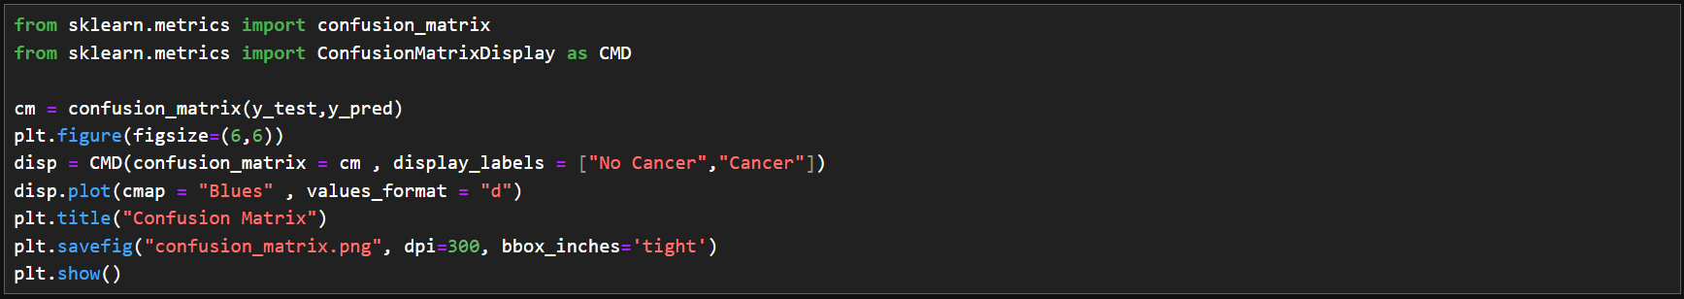The confusion matrix helps evaluate the model's performance by comparing predicted values to actual outcomes. The confusion matrix for this model showed a high number of true positives and true negatives, indicating good model performance.

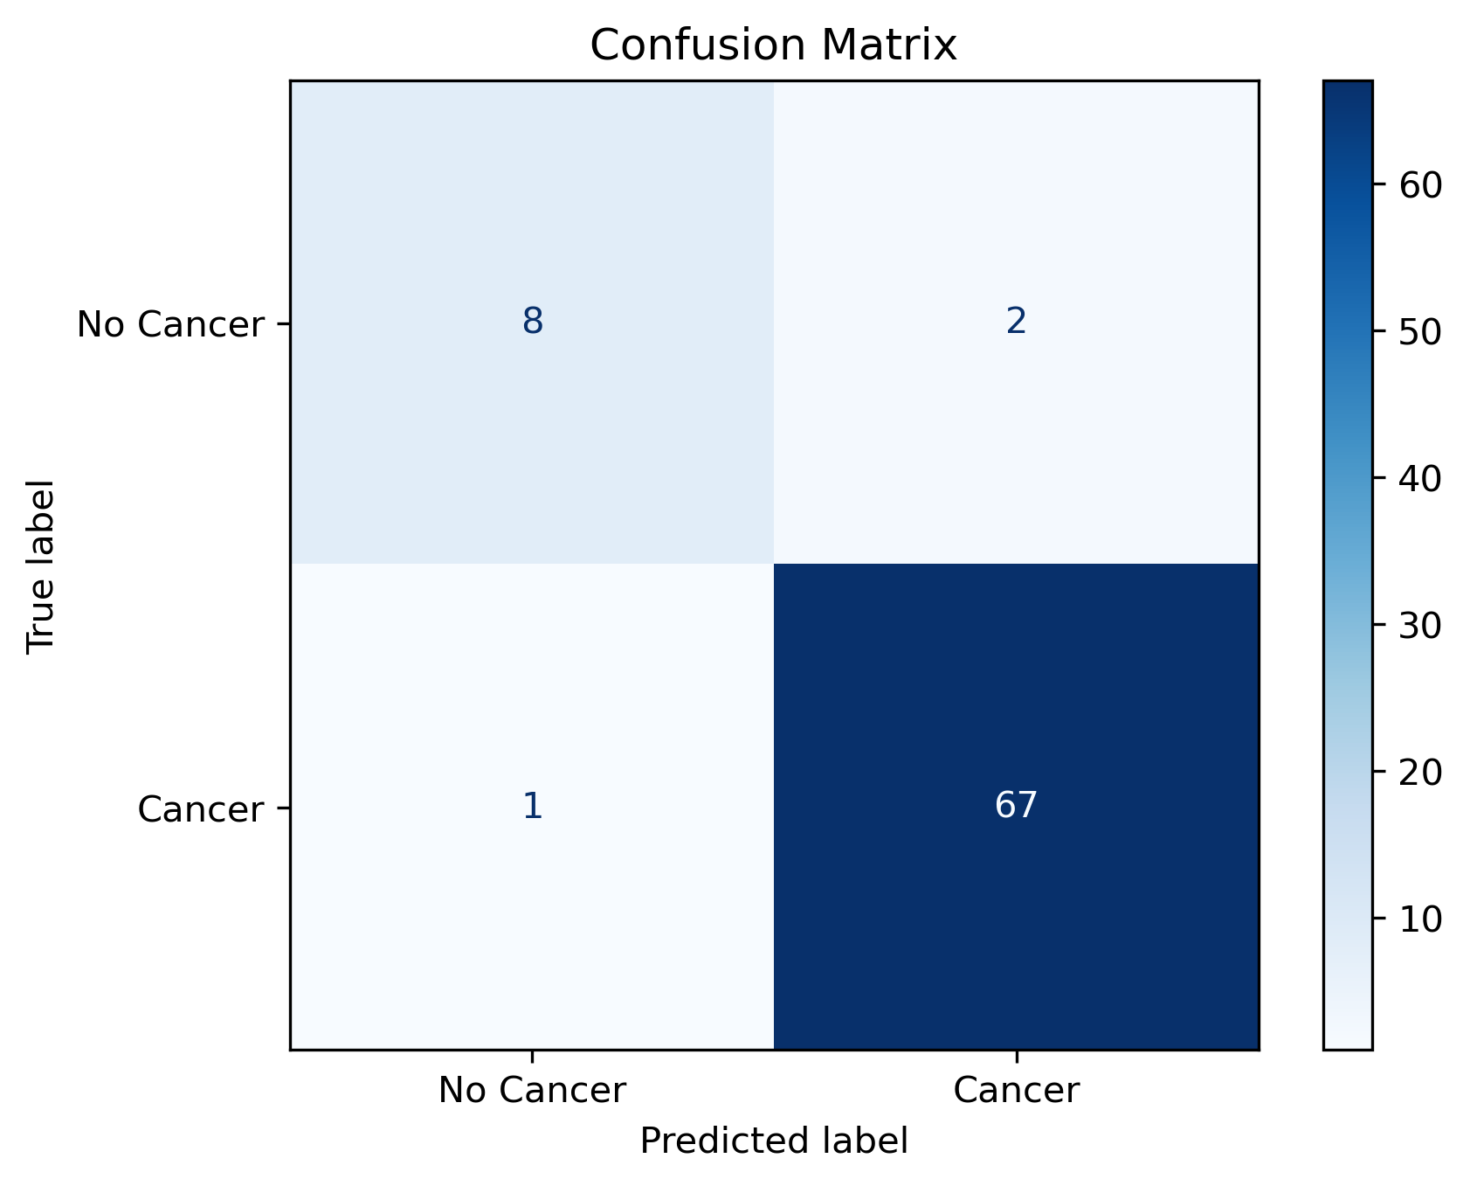

**Structure of the Confusion Matrix**

In the context of your **Lung Cancer Detection Model**, the confusion matrix looks like this:

|  | **Predicted "No" (Negative)** | **Predicted "Yes" (Positive)** |
| --- | --- | --- |
| **Actual "No"** (Negative) | True Negatives (TN) | False Positives (FP) |
| **Actual "Yes"** (Positive) | False Negatives (FN) | True Positives (TP) |

**Elements of the Confusion Matrix:**

1. **True Positives (TP):**
   * These are the cases where the model correctly predicted that a person has lung cancer (True "Yes").
   * **Example:** The model predicted "Yes" (lung cancer), and the person actually had lung cancer.
2. **True Negatives (TN):**
   * These are the cases where the model correctly predicted that a person does not have lung cancer (True "No").
   * **Example:** The model predicted "No" (no lung cancer), and the person actually did not have lung cancer.
3. **False Positives (FP):**
   * These are the cases where the model incorrectly predicted that a person has lung cancer when they do not (False "Yes").
   * **Example:** The model predicted "Yes" (lung cancer), but the person actually did not have lung cancer.
4. **False Negatives (FN):**
   * These are the cases where the model incorrectly predicted that a person does not have lung cancer when they actually do (False "No").
   * **Example:** The model predicted "No" (no lung cancer), but the person actually had lung cancer.

**Why the Confusion Matrix is Important:**

* **Model Performance Insights:** The confusion matrix helps evaluate how well the model distinguishes between the two classes (positive and negative).
* **Identifies Misclassifications:** By looking at the number of False Positives and False Negatives, we can identify areas where the model is making mistakes. In medical contexts, minimizing False Negatives (missed lung cancer cases) is crucial, as it directly affects patient health.
* **Evaluation Metrics:** The confusion matrix helps calculate key metrics like:
  + **Accuracy:** (TP + TN) / Total
  + **Precision:** TP / (TP + FP) → Out of all predicted "Yes", how many were actually "Yes"
  + **Recall:** TP / (TP + FN) → Out of all actual "Yes", how many did the model correctly identify
  + **F1-Score:** 2 * (Precision * Recall) / (Precision + Recall) → Harmonic mean of Precision and Recall

**Example from The Model:**

For instance, if the confusion matrix of the model is:

|  | **Predicted "Yes"** | **Predicted "No "** | | |
| --- | --- | --- | --- | --- |
| **Actual "Yes"** | 67 | 1 | |
| **Actual "No"** | 2 | 8 |

* **True Positives (TP) = 67:** The model correctly identified 67 cases of lung cancer.
* **True Negatives (TN) = 8:** The model correctly identified 8 non-cancer cases.
* **False Positives (FP) = 2:** The model incorrectly predicted 2 non-cancer case as cancerous.
* **False Negatives (FN) = 1:** The model missed 1 actual cancer cases.

**Key Insights from the Confusion Matrix:**

* **High True Positives and True Negatives:** The model is doing well in identifying both cancerous and non-cancerous cases.
* **Low False Positives and False Negatives:** There is minimal misclassification, but the model could still be improved to reduce missed cancer cases (False Negatives).

**Conclusion:**

The confusion matrix gives a clear understanding of your model's performance, highlighting how accurately it distinguishes between cancer and non-cancer cases. It’s especially useful in assessing how to balance **precision** (reducing False Positives) and **recall** (reducing False Negatives) to optimize model performance for real-world applications like medical diagnostics.

# ROC Curve

The ROC Curve (Receiver Operating Characteristic curve) was plotted to evaluate the model's ability to distinguish between classes. The AUC (Area Under the Curve) for this model was 0.96, indicating that the model is highly effective at distinguishing between lung cancer and non-cancer cases. cancer and non-cancer cases. 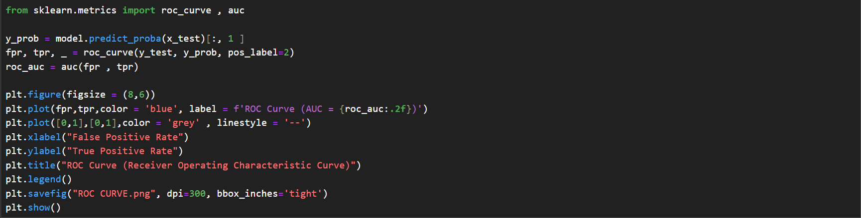

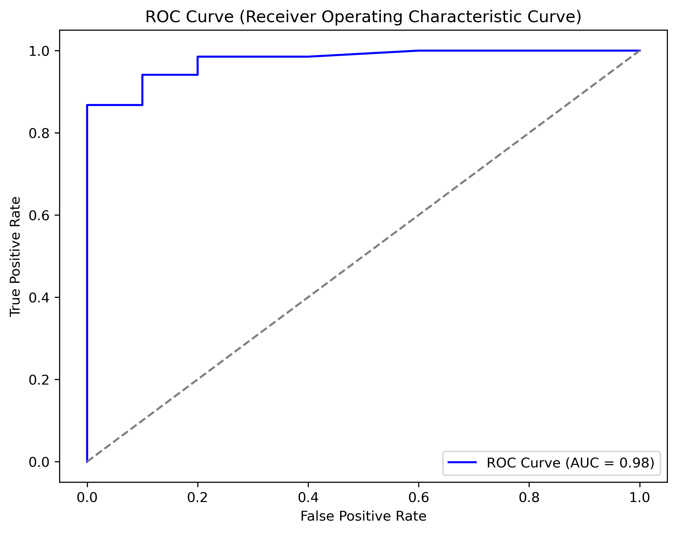

**Key Elements of the ROC Curve:**

* **True Positive Rate (TPR) or Recall**: It measures the proportion of actual positive cases (e.g., actual cancer cases) that the model correctly identifies.
* **False Positive Rate (FPR)**: It measures the proportion of actual negative cases (e.g., non-cancerous cases) that the model incorrectly classifies as positive.

**Understanding the ROC Curve:**

* The **x-axis** represents the **False Positive Rate (FPR)**, and the **y-axis** represents the **True Positive Rate (TPR)**.
* The **ROC Curve** plots the relationship between TPR and FPR as the classification threshold varies.
* **Ideal Case**: A model that perfectly classifies all positives and negatives would have a ROC curve that rises steeply towards the top-left corner, where TPR is 1 and FPR is 0.
* **Random Model**: A model that randomly guesses would have a diagonal ROC curve, as the TPR and FPR would be equal at all thresholds (i.e., the curve would lie along the diagonal from (0,0) to (1,1)).

**Area Under the Curve (AUC):**

* The **AUC (Area Under the Curve)** is a scalar value that summarizes the overall performance of the model. A higher AUC indicates better model performance:
  + **AUC = 1**: Perfect model.
  + **AUC = 0.5**: Random guessing.
  + **AUC < 0.5**: The model performs worse than random guessing.

For your model, a higher AUC means the classifier is effectively distinguishing between cancerous and non-cancerous cases.

**How the ROC Curve Helps:**

* **Threshold Analysis**: The ROC curve allows us to visually compare the performance of different models or thresholds to find the optimal trade-off between sensitivity and specificity.
* **Model Comparison**: It helps in comparing multiple classification models. A model with a ROC curve closer to the top-left corner is typically better.
* **Imbalanced Classes**: ROC curves are particularly useful in situations where class imbalance exists, as it shows how well the model distinguishes between the classes under varying thresholds.

**Conclusion:**

The ROC curve provides a comprehensive view of the model’s performance across various classification thresholds. By analysing the curve and the AUC, we can better understand the model's ability to identify positive and negative cases accurately.

# Model Evaluation

The Random Forest Classifier model achieved the following metrics: 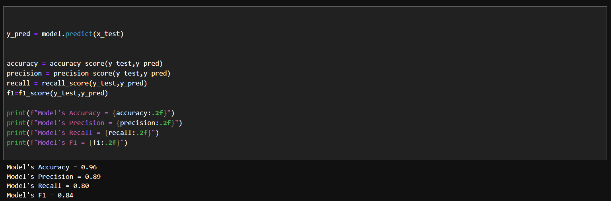

The model achieved high accuracy, precision, recall, and F1-score, ensuring reliable lung cancer detection.

|  |  |
| --- | --- |
| Evaluation | Percentage |
| Accuracy | 96% |
| Precision | 89% |
| Recall | 80% |
| F1-Score | 84% |

# Conclusion Of The Model

Key outcomes and conclusions:

1. **High Accuracy**: With an accuracy rate of **96%**, the model successfully distinguishes between cancerous and non-cancerous cases, providing reliable predictions.
2. **Effective Model Performance**: The precision (89%) and recall (80%) highlight that the model effectively identifies cancer while maintaining a low rate of false positives. However, there is still room for improvement in recall to reduce false negatives and ensure higher sensitivity for detecting all cancer cases.
3. **Confusion Matrix Insights**: The model accurately identified most of the true positive (8) and true negative (67) cases, with only a few false positives and false negatives (1 and 2, respectively). This indicates that the model is robust and can effectively reduce misclassification errors.
4. **Feature Importance**: The model leverages feature importance to focus on key health indicators, improving interpretability and highlighting which factors contribute the most to predicting lung cancer.
5. **ROC Curve**: The **AUC of 0.96** demonstrates that the model is highly effective at distinguishing between the two classes (cancerous and non-cancerous), reinforcing its potential as a valuable diagnostic tool.

In conclusion, this lung cancer detection model provides a powerful predictive tool for early diagnosis, with high accuracy and reliability. While it shows great promise, further optimization and model tuning (e.g., hyperparameter adjustments) could improve its recall and overall sensitivity, enhancing its ability to detect all cases of lung cancer. The model could play a critical role in the healthcare sector, aiding in the timely detection of lung cancer and improving patient outcomes.

***Presented by Tanmay Kumar Chaki***

***14th March 2025***

**Thank you for Going Through My Project Report .**

**I Hope you found my Work Interesting and Insightful.**

*This Project was a challenging yet rewarding journey that I tackled independently.*

*Proud of the results and excited for what’s next!.*

**Contact Detail: chakitanmay45@gmail.com**

