Practical No. 8
Advance DataTypes
- Write a Python program to create list and apply various functions to it.

Program 1: Creating and Displaying a List
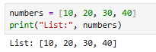

Program 2: Accessing List Elements
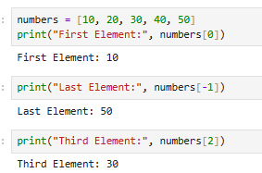

Program 3: List Slicing
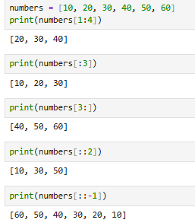

Program 4: Traversing a List
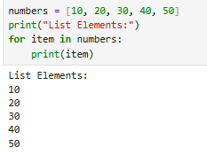

Program 5: Adding Elements to a List
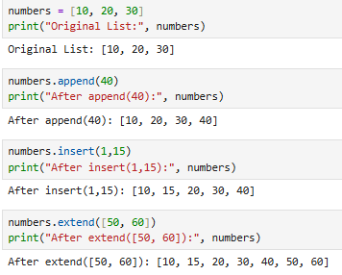

Program 6: Removing Elements from a List
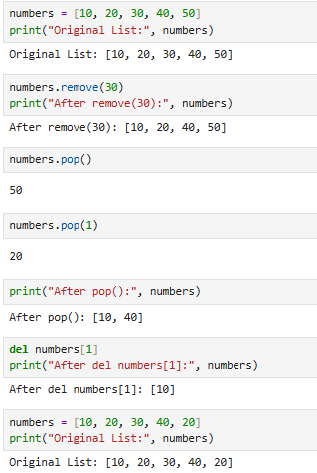

Program 7: Searching in a List
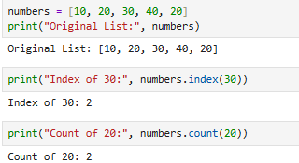

Program 8: Sorting and Reversing a List
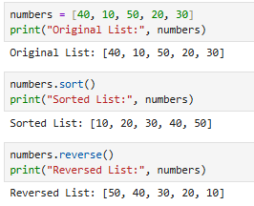

Program 9: Copying and Clearing a List
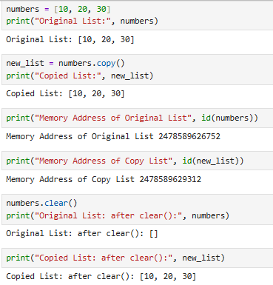

Program 10: Using Built-in Functions on Lists
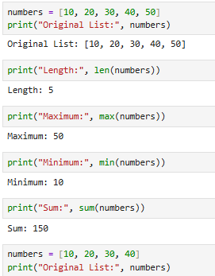

Program 11: Updating List Elements
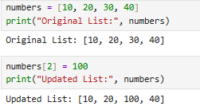

Program 12: List Concatenation and Repetition
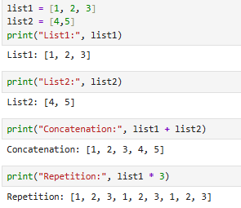

B. Write a Python program to create tuple and apply various
functions to it.
Program 1: Creating and Displaying a Tuple
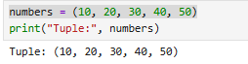

Program 2: Accessing Tuple Elements
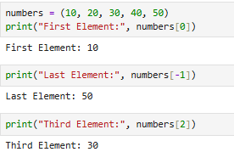

Program 3: Tuple Slicing
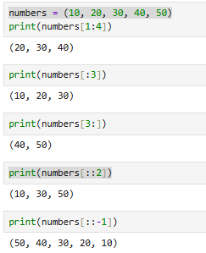

Program 4: Traversing a Tuple
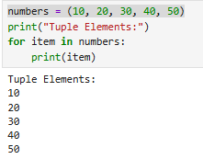

Program 5: Tuple Concatenation and Repetition
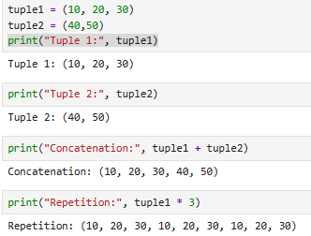

Program 6: Searching in a Tuple
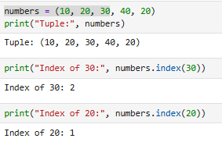

Program 7: Membership Operators
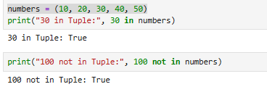

Program 8: Built-in Functions on Tuples
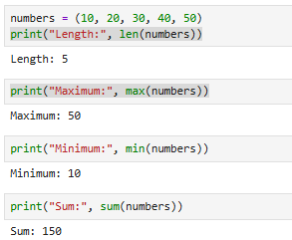

Program 9: Converting Tuple to List and List to Tuple
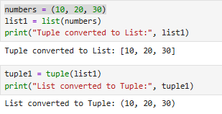

Program 10: Demonstrating Tuple Immutability
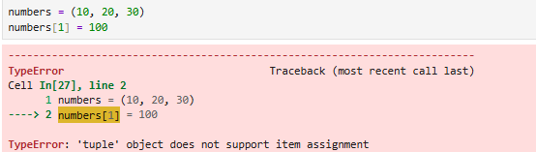

Aim c] Write a Python program to create dictionary and apply various functions to it.
Program 1: Creating and Displaying a Dictionary
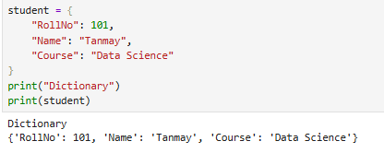

Program 2: Accessing Dictionary Elements
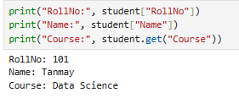

Program 3: Adding and Updating Elements
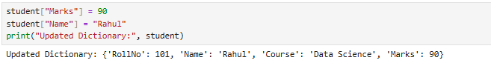

Program 4: Traversing a Dictionary
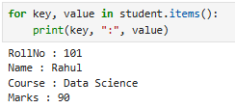

Program 5: Dictionary Functions
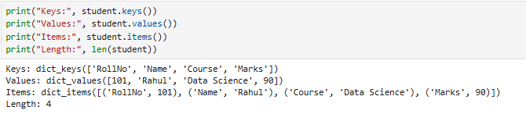

Program 6: Copying a Dictionary
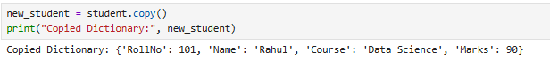

Program 7: Removing Dictionary Elements and Clearing a Dictionary
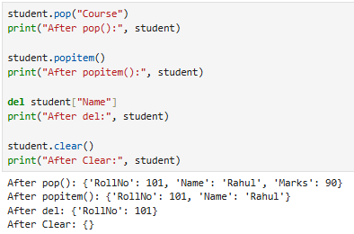

Program 8: Membership Operators
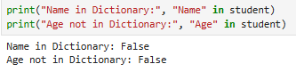

Program 9: Merging Dictionaries
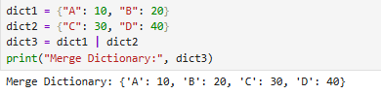

Aim D] Write a Python program to create set and apply various functions to it.
Program 1: Creating and Displaying a Set
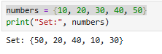

Program 2: Adding Elements to a Set
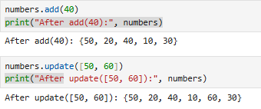

Program 3: Removing Elements from a Set
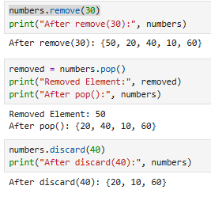

Program 4: Traversing a Set
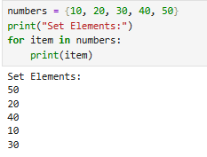

Program 5: Membership Operators
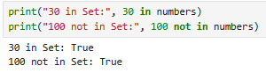

Program 6: Set Operations
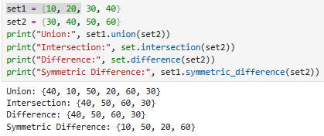

Program 7: Subset and Superset
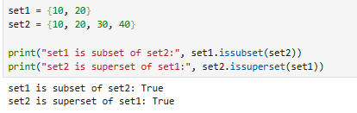

Program 8: Built-in Functions on Sets
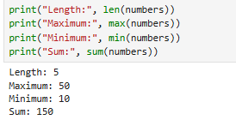

Program 9: Copying and Clearing a Set
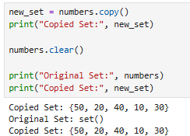

Program 10: Demonstrating Duplicate Elements


