REVOKE
Grant All Privileges:

Revoke Select:
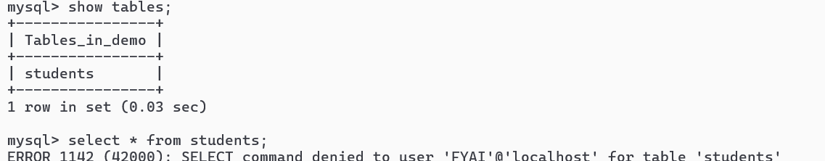

Revoke Insert
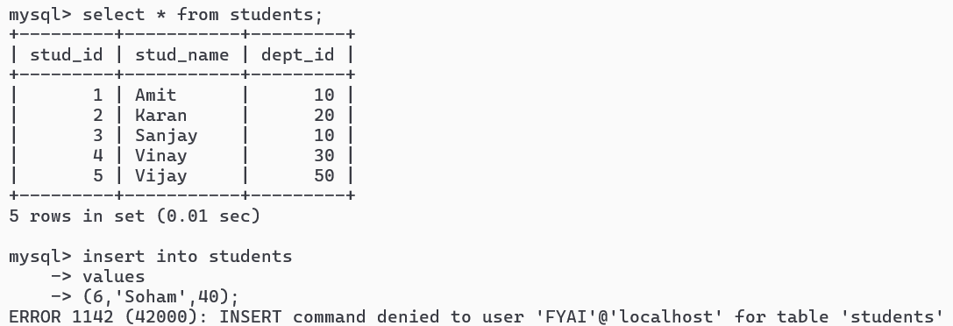

Revoke Update:

Revoke Delete

Revoke Drop:

