Name: Tanmay Parmar

Student No: 300872344

Section: 004

1. Develop a multithreaded console application that adds, subtracts, divides, and multiplies 2 randomly selected numbers concurrently in four separate execution paths (i.e., four threads). Please follow the following guidelines to accomplish this:

* Create 2 classes: Driver class and Calculator class.

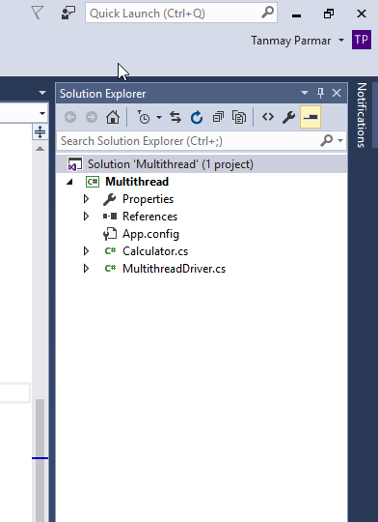

* The driver class named Driver:

~ contains the Main() method.

~creates, names, starts each of the 4 threads, and provides appropriate prompts (like Starting threads, Threads Started) within the Main() method.

**MultithreadDriver.cs**

using System;

using System.Collections.Generic;

using System.Linq;

using System.Text;

using System.Threading;

using System.Threading.Tasks;

namespace Multithread

{

class MultithreadDriver

{

static void Main(string[] args)

{

Calculator calculator1 = new Calculator();

Thread thread1 = new Thread(new ThreadStart(calculator1.Add));

thread1.Name = "threadADD";

Calculator calculator2 = new Calculator();

Thread thread2 = new Thread(new ThreadStart(calculator2.Sub));

thread2.Name = "threadSub";

Calculator calculator3 = new Calculator();

Thread thread3 = new Thread(new ThreadStart(calculator3.Multiply));

thread3.Name = "threadMultiply";

Calculator calculator4 = new Calculator();

Thread thread4 = new Thread(new ThreadStart(calculator4.Div));

thread4.Name = "threadDivide";

Console.WriteLine("Starting Thread");

thread1.Start();

thread2.Start();

thread3.Start();

thread4.Start();

Console.WriteLine("Threads started.");

Console.ReadKey();

}

}

}

**Calculator.cs**

using System;

using System.Collections.Generic;

using System.Linq;

using System.Text;

using System.Threading;

using System.Threading.Tasks;

namespace Multithread

{

public class Calculator

{

Random random = new Random();

int number1;

int number2;

int sleepTime;

public Calculator()

{

//random number generator

number1 = random.Next(0, 100);

number2 = random.Next(0, 100);

//random sleeping time

sleepTime = random.Next(1000);

}

public void Add()

{

Thread current = Thread.CurrentThread;

// for our understanding, we put the thread to sleep for

// sleepTime amount of time

Console.WriteLine("{0} is going to sleep for {1} milliseconds", current.Name, sleepTime);

Thread.Sleep(sleepTime);

int add = number1 + number2;

Console.WriteLine("Addition of " + number1 + " and " + number2 + " is:" + add);

Console.WriteLine("{0} done sleeping.", current.Name);

}

public void Sub()

{

Thread current = Thread.CurrentThread;

// for our understanding, we put the thread to sleep for

// sleepTime amount of time

Console.WriteLine("{0} is going to sleep for {1} milliseconds", current.Name, sleepTime);

Thread.Sleep(sleepTime);

int sub = number1 - number2;

Console.WriteLine("Substraction of " + number1 + " and " + number2 + " is:" + sub);

Console.WriteLine("{0} done sleeping.", current.Name);

}

public void Div()

{

Thread current = Thread.CurrentThread;

// for our understanding, we put the thread to sleep for

// sleepTime amount of time

Console.WriteLine("{0} is going to sleep for {1} milliseconds", current.Name, sleepTime);

Thread.Sleep(sleepTime);

int div = number2 / number1;

Console.WriteLine("Division of " + number2 + " and " + number1 + " is: " + div);

Console.WriteLine("{0} done sleeping.", current.Name);

}

public void Multiply()

{

Thread current = Thread.CurrentThread;

// for our understanding, we put the thread to sleep for

// sleepTime amount of time

Console.WriteLine("{0} is going to sleep for {1} milliseconds", current.Name, sleepTime);

Thread.Sleep(sleepTime);

int multi = number1 * number2;

Console.WriteLine("Multiplication of " + number1 + " and " + number2 + " is: " + multi);

Console.WriteLine("{0} done sleeping.", current.Name);

}

}

}

Final Output

