**Detailed Report on Innovative Monitoring System for TeleICU Patients Using Video Processing and Deep Learning**

**Introduction**

**Problem Statement**

In critical care scenarios, patients require intensive monitoring and care to ensure their safety and recovery. Traditional ICU settings are designed to provide this level of care. However, in remote or underserved locations, providing the same level of intensive care is challenging due to a lack of specialized medical personnel and resources. This gap in healthcare services can lead to delayed treatment, increased complications, and higher mortality rates.

**Solution Overview**

Our innovative monitoring system for TeleICU patients uses video processing and deep learning to provide comprehensive and real-time patient monitoring. The system employs a trained deep learning model to detect and recognize faces quickly, assess patient stability, and identify critical changes in patient conditions. By processing video feeds from ICU units, the system can differentiate between patients, doctors, and nurses, focusing on the patient's condition while providing context-aware monitoring. This ensures that any significant changes in patient stability are detected promptly, allowing for immediate intervention.

The solution integrates several advanced technologies to achieve high accuracy and reliability. The YOLOv8 model is utilized for efficient object detection, while tools like OpenCV and TensorFlow facilitate video processing and deep learning tasks. Roboflow is used for data annotation and model training, ensuring that the system is well-equipped to handle diverse and realistic scenarios. By combining these technologies, the TeleICU monitoring system offers fast detection, high precision, and reliable patient stability assessment, ultimately improving healthcare outcomes and operational efficiency in remote and underserved areas.

**Features Offered**

* **Fast Detection**: The system utilizes a trained deep learning model to quickly detect and recognize faces in the video feed. This rapid detection is crucial for timely intervention in critical situations.
* **Patient Stability Detection**: The system can determine if a patient is stable or unstable within a short time frame. This feature allows for immediate response to changes in the patient's condition.
* **Accuracy and Precision**: The use of advanced models and rigorous training ensures high accuracy and precision in detecting faces and assessing patient stability.
* **Detection of Critical Aspects**: The system can identify critical aspects of patient conditions, such as significant movements or changes in vital signs, that require urgent attention.

**Process Flow**

**Understanding the Problem Statement and Requirements**

The project begins with a thorough understanding of the problem statement and the specific requirements of a TeleICU monitoring system. This involves identifying the key challenges in remote patient monitoring, understanding the needs of healthcare providers, and defining the objectives of the solution.

**Data Collection and Processing**

Data collection is a critical step in developing an effective monitoring system. For this project, we collected video data from YouTube, which provided a diverse range of scenarios for model training. The collected data was then processed to prepare it for training. This involved tasks such as frame extraction, annotation, and augmentation to ensure the model learns from varied and realistic scenarios.

**Selection of Appropriate Models and Libraries**

The choice of model and libraries is crucial for the success of the project. We selected the YOLOv8 model for its efficiency and accuracy in object detection tasks. The following libraries and tools were also utilized:

* **OpenCV**: For video processing, including frame extraction and manipulation.
* **TensorFlow**: For implementing and training deep learning models.
* **Roboflow**: For data annotation, augmentation, and managing the training process.
* **Ultraedit**: For coding, documentation, and managing project files.

**Training, Validation, and Testing**

The collected data was used to train the YOLOv8 model. The training process involved multiple iterations to optimize the model's performance. The model was then validated and tested to ensure its accuracy and reliability in real-world scenarios. This step included:

* **Training**: Using annotated video frames to teach the model to detect faces and assess patient stability.
* **Validation**: Testing the model on unseen data to ensure it generalizes well to new scenarios.
* **Testing**: Evaluating the model's performance on real-world video feeds to confirm its reliability and accuracy.

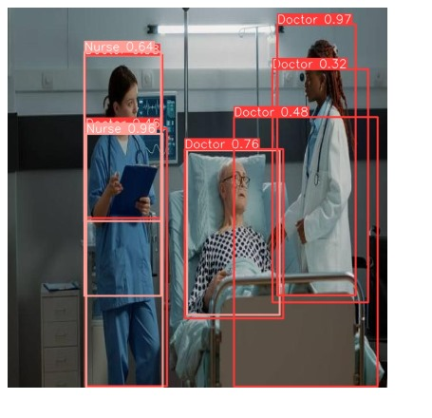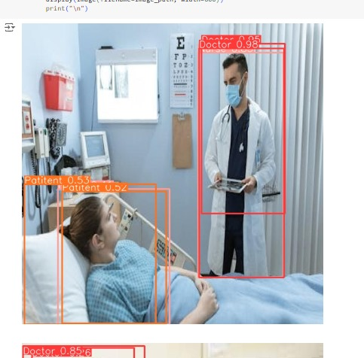

**Detailed System Architecture**

Input video

Processing the frames

Person type detection

Motion detection

Output

Stable or unstable Patient

**Input Video**

The system takes input from video feeds of the ICU. These feeds are continuously monitored to detect any changes in the patient's condition.

**Processing the Frames**

Each frame of the video is processed to detect faces and movements. This involves:

* **Frame Extraction**: Breaking down the video into individual frames for analysis.
* **Face Detection**: Using the YOLOv8 model to identify and locate faces in each frame.
* **Movement Analysis**: Detecting significant movements that might indicate changes in patient stability.

**Person Type Detection**

The system differentiates between different types of persons in the frame, such as patients, doctors, and nurses. This is important for context-aware monitoring, ensuring that the system focuses on the patient's condition.

**Motion Detection**

The system detects any significant motion that might indicate changes in patient stability. For example, sudden movements or lack of movement can be indicators of a critical situation.

**Output**

Based on the detected data, the system determines if the patient is stable or unstable and provides alerts if necessary. The output is designed to be easily interpretable by healthcare providers, ensuring timely and appropriate responses.

**Technologies Used**

The success of this project relies on the integration of several advanced technologies:

* **YOLOv8 Model**: An efficient and accurate object detection model used for face detection and patient stability assessment.
* **Roboflow**: A computer vision tool for data annotation, augmentation, and model training.
* **OpenCV**: An open-source library used for video processing and manipulation.
* **TensorFlow**: A popular deep learning framework used for implementing and training the detection model.
* **Ultraedit**: A powerful text editor used for coding, documentation, and managing project files.

**Team Members and Contributions**

The project was a collaborative effort involving the following team members:

* **Mithilesh Dudhankar**: Responsible for coding and implementing the detection model.
* **Tanmay Pranjale**: Handled data collection and processing, ensuring the model had high-quality and diverse data for training.
* **Shrushti Dixit**: Managed documentation and the GitHub repository, ensuring that all aspects of the project were well-documented and organized.

**Conclusion**

The innovative monitoring system for TeleICU patients using video processing and deep learning represents a significant advancement in remote patient care. By leveraging advanced technologies, this system optimizes patient monitoring, enhances care delivery, and improves healthcare outcomes. It ensures that patients in critical conditions receive timely and appropriate care, regardless of their location.

This project demonstrates the potential of integrating deep learning and video processing in healthcare. The system's ability to quickly and accurately detect faces, assess patient stability, and provide actionable insights can significantly enhance the quality of care in remote and underserved areas. As healthcare continues to evolve, such innovative solutions will play a crucial role in bridging the gap between availability and accessibility of critical care services.

**References**

[1] Ren, S., He, K., Girshick, R., & Sun, J. (2015). Faster r-cnn: Towardsreal-time object detection with region proposal networks. In Advances in neural information processing systems (pp. 91-99).

[2] Redmon, J., & Farhadi, A. (2016). YOLOV8: Better, Faster, Stronger. arXiv preprintarXiv:1612.08242.

[3] Kumar, S., Merchant, S., & Reynolds, R. (2013). Tele-ICU: efficacy and cost-effectiveness approach of remotely managing the critical care. The open medical informatics journal, 7, 24.

[4] Chihaoui, M., Elkefi, A., Bellil, W., & Amar, C. B. (2016). Detection and tracking of the moving objects in a video sequence by geodesic active contour. In Computer Graphics, Imaging and Visualization (CGiV), 2016 13th International Conference on (pp. 212-215).

[5] Rajput, S. J., & Oza, S. D. (2013) A New Algorithm for Tracking of Multiple Moving Objects. international Journal of Scientific Engineering and Technology, Volume, (2), 691-693.

[6] Raheja, J. L., Gopinath, D., & Chaudhary, A. (2014). GUI system for elders/patients in intensive care. In Technology Management Conference (ITMC), 2014 IEEE International (pp. 1-5).