Simple image 🡪 resize the image 🡪

1. Original image
2. Image to gray
3. Gray to blur
4. Blur to canny
5. Canny to contour

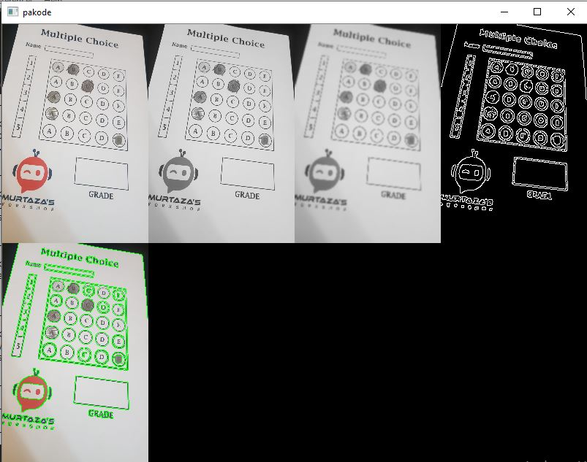

Get contour points of biggest rect and second biggest rect

Fir bad me arrange points to get the bird view perspective of those two big contours

def reorderPoints(myPoints):

myPoints = myPoints.reshape((4,2)) # (4,1,2) --> (4,2)

add = myPoints.sum(1) # axis --> 1

print(add)

myPointsNew = np.zeros((4,1,2), np.int32)

myPointsNew[0] = myPoints[np.argmin(add)]

myPointsNew[3] = myPoints[np.argmax(add)]

diff = np.diff(myPoints, axis = 1)

myPointsNew[1] = myPoints[np.argmin(diff)]

myPointsNew[2] = myPoints[np.argmax(diff)]

return myPointsNew

Return the rows and get individual ans for a row based on pixel count in each box.

Mark ans right and wrong and return inverse perspective of score and bubbles in final image