$mango

Creating Database
>use madhu

Insertion
> db.madhu.insertOne(
... {
... "name": "madhu",
... "dept": "ISE"
... }
... )

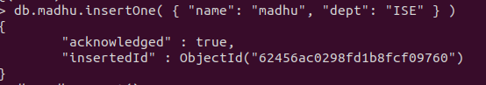
Counting
> db.madhu.count()


> db.madhu.insertMany(
... [
... {"name": "Akash" , "dept":"ISE" },
... {"name" : "Ullaas" , "dept" : "CSE"},
... ]
... )
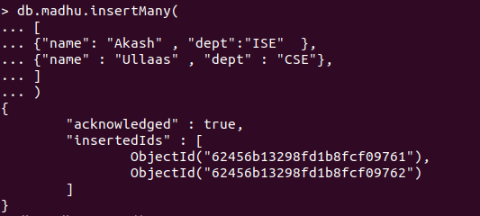
Reading
> db.madhu.find()

> db.madhu.find().pretty()

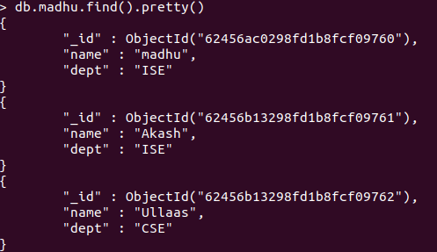
db.madhu.updateMany(
... {},
... {
... $set : {"college" : "NMIT" }
... }
... )
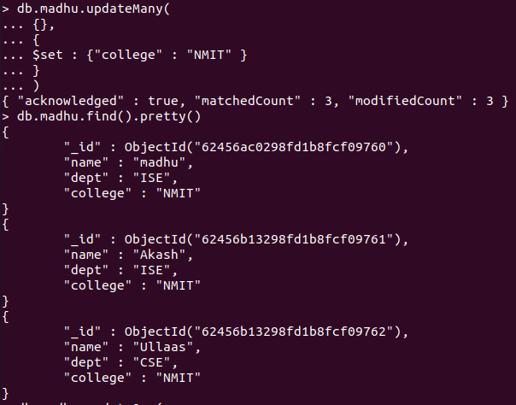
Updating

> db.madhu.updateOne(
... {"name" : "Akash"},
... {
... $set : {"dept":"CSE"}
... }
... )

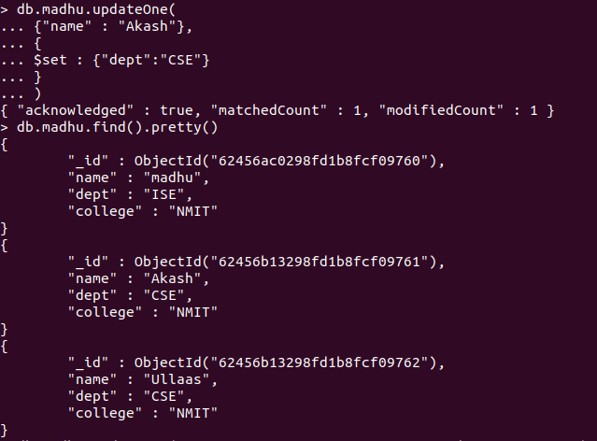
Deleting

> db.madhu.deleteOne( { "name": "Ullaas"} )
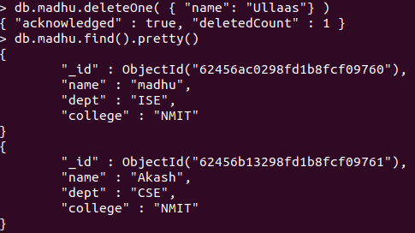

> db.madhu.updateOne(
... {"name" : "madhu"},
... { $unset : { "dept" : ""}})

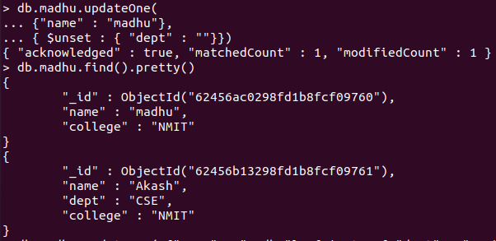
> db.madhu.updateOne( {"name" : "madhu"}, { $set : { "dept" : "ISE"}})

