Tanmay Sharan
1NT19IS177
ISE C2

Tasks To complete
To start with hadoop

hadoop version
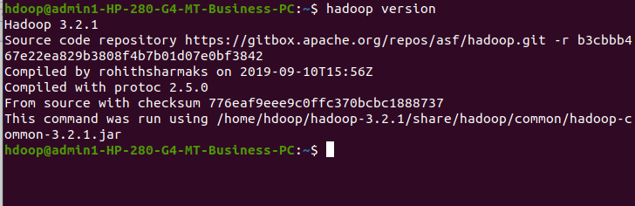
start-dfs.sh
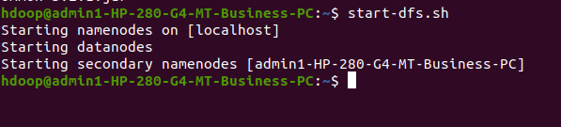

1. Create a directory named by your name
hadoop fs -mkdir /madhu
hadoop fs -ls /
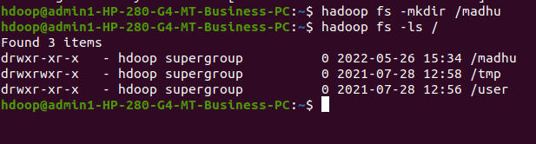

2. Add two empty files into it
hadoop fs -touchz /madhu/one.txt
hadoop fs -touchz /madhu/two.txt

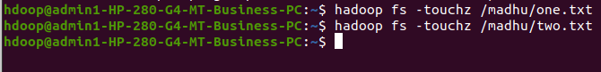

3. List all the files in the directory that you have created
hadoop fs -ls /madhu
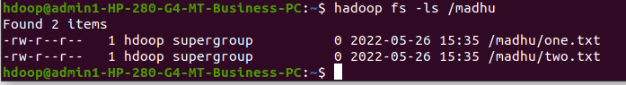
4. Create one more directory by your usn and put that inside the directory of your name
hadoop fs -mkdir /madhu/1NT19IS176
hadoop fs -ls /madhu
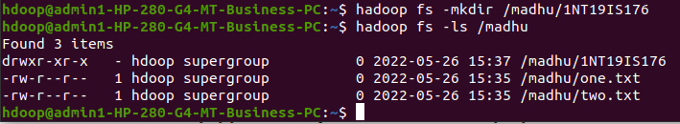
5. Create a file in your local system by the name_usn.txt and add the contents as "Syntax to list Is command is hadoop fs -Is "
cat > madhu_1NT19IS176.txt
"Syntax to list ls command is hadoop fs -ls"
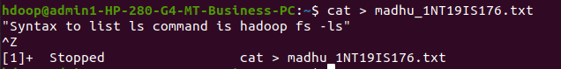
6. Put the file usn_name.txt in your hdfs directory called usn
hadoop fs -touchz /madhu/1NT19IS176/1NT19IS176_madhu.txt
hadoop fs -ls /madhu/1NT19IS176
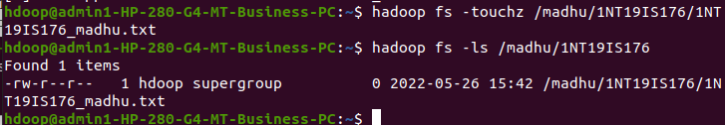

7. Put empty file of hdfs into the local file system
hadoop fs -copyToLocal /madhu/1NT19IS176/1NT19IS176_madhu.txt
ls
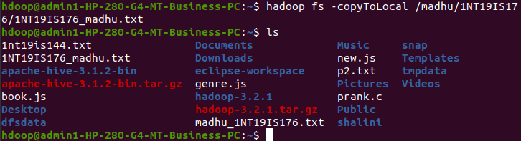
8. Use mv command to move files from local file system and hdfs file system
hadoop fs -mv /madhu/two.txt /madhu/1NT19IS176
hadoop fs -ls /madhu/1NT19IS176
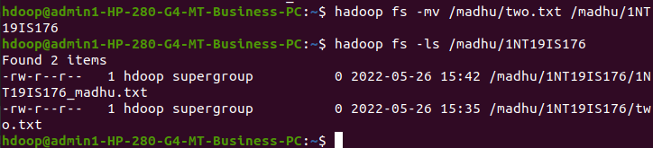
9. Experiment of cp command
hadoop fs -cp /madhu/one.txt /madhu/1NT19IS176
hadoop fs -ls /madhu/1NT19IS176
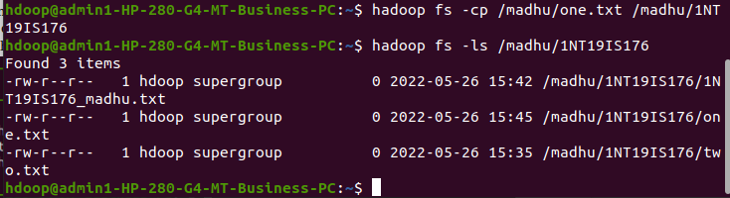
10. Display the total size of all the files in name directory
hadoop fs -moveFromLocal madhu_1NT19IS176.txt /madhu
hadoop fs -du /madhu
hadoop fs -du -s /madhu
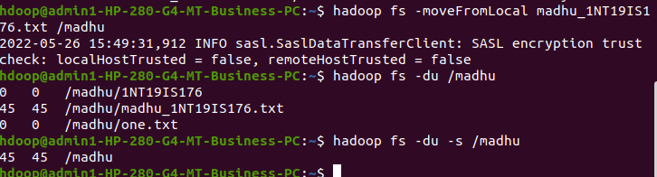

11. Display each file size in usn directory Use stat command on name and usn directories
hadoop fs -du /madhu/1NT19IS176
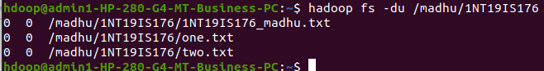
12. Illustrate the use of append command
cat > one.txt
Hello
^Z
[2]+ Stopped cat > one.txt
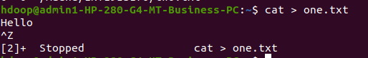

hadoop fs -appendToFile one.txt /madhu/1NT19IS176/two.txt
hadoop fs -cat /madhu/1NT19IS176/two.txt
