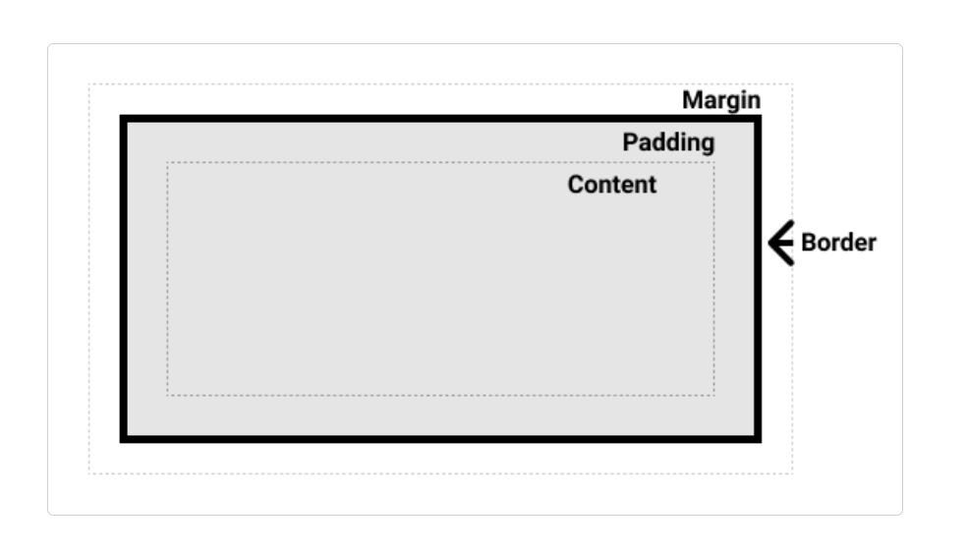
Types of CSS box model
1. Standard CSS box model
2. Alternative CSS box model
.box{
box-sizing: border-box;
}

Types of boxes

1. Block:
The box will break onto a new line.
- The box will extend in the inline direction to fill the space available in its container. In most cases this means that the box will become as wide as its container, filling up 100% of the space available.
- The width and height properties are respected.
- Padding, margin and border will cause other elements to be pushed away from the box
example
<div><footer><form><h1>-<h6><header><hr><li><main><nav><ol><p><table><ul><video>
are examples of block element

<body>
<div class = “box box-blue”>1</div>
<div class = “box box-red”>2</div>
<div class = “box box-purple”>3</div>
<div class = “box box-orange”>4</div>
</body>

// STYLING
.box {
border-bottom: 2px solid black;
height: 50px;
width: 20%;
}
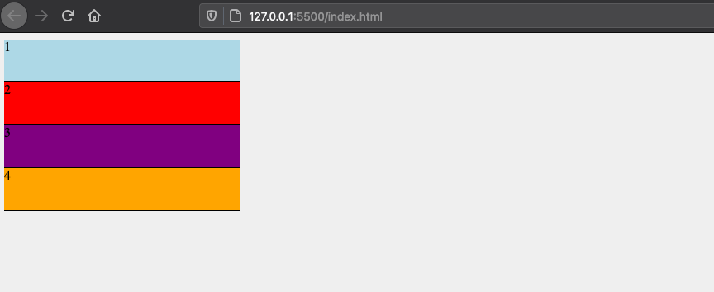

2. Inline

The box will not break onto a new line.
- The width and height properties will not apply.
- Vertical padding, margins, and borders will apply but will not cause other inline boxes to move away from the box.
- Horizontal padding, margins, and borders will apply and will cause other inline boxes to move away from the box.
<a><button><em><i><img><input><span><var> etc are example of inline element.

//STYLING
.box {
border-bottom: 2px solid black;
width: 100px;
height: 50px;
display: inline;
}

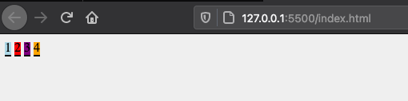
3. flex
If we set display: flex; on an element, the outer display type is block, but the inner display type is changed to flex

<div class="container">
<div> 1 </div>
<div> 2 </div>
<div> 3 </div>
<div> 4 </div>
</div>

.container {
display: flex;
background: gray;
}

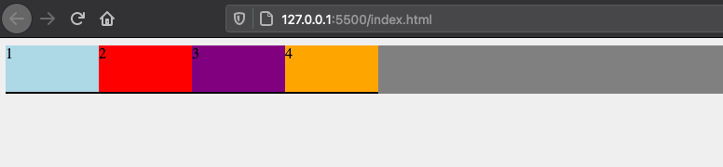

4. inline-flex

display: inline-flex;

container {
display: inline-flex;
padding: 10px;
background-color: gray;
}
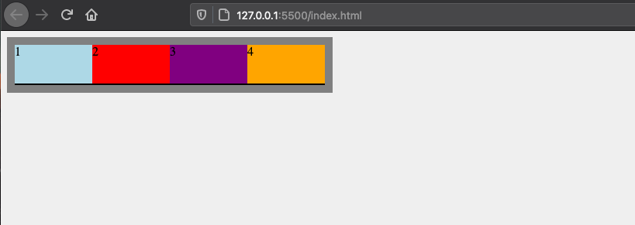

5. inline-block
An element with display: inline-block does a subset of the block things we already know about:
- The width and height properties are respected.
- padding, margin, and border will cause other elements to be pushed away from the box.
It does not, however, break onto a new line, and will only become larger than its content if you explicitly add width and height properties.

.box {
display: inline-block;
}

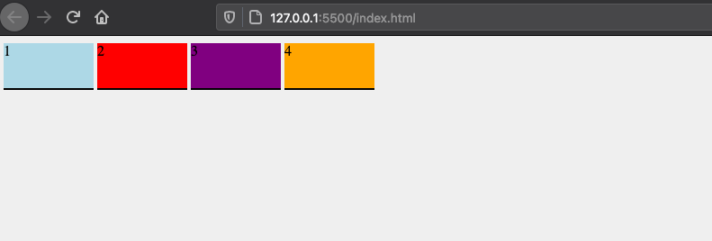
pixels.

Margins
* margin-top
* margin-right
* margin-bottom
* margin-left

Margin collapse rules:

* If you have two elements whose margins touch, and both margins are positive, those margins will combine to become one margin, and its size will be equal to the largest individual margin.
* If one margin is negative, its value will be subtracted from the total.
* Where both are negative, the margins will collapse and the smallest (furthest from zero) value will be used.

.box{
margin: 0 auto;
}

auto is used for horizontal centering

Border

* border-top, border-right, border-bottom, border-left
* border-width, border-style, border-color
* border-top-width, border-top-style, border-top-color, border-right-width, border-right-style, border-right-color, border-bottom-width, border-bottom-style, border-bottom-color, border-left-width, border-left-style, border-left-color.

Padding

Padding-top, padding-bottom, padding-left, padding-right.

