Domains.csv (233,274,101 rows x 7 columns)

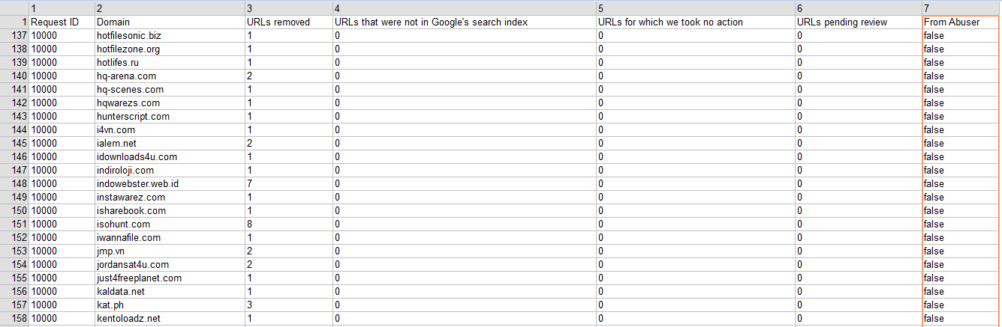

Urls-no-action-taken.csv (128,941,708 rows x 4 columns)

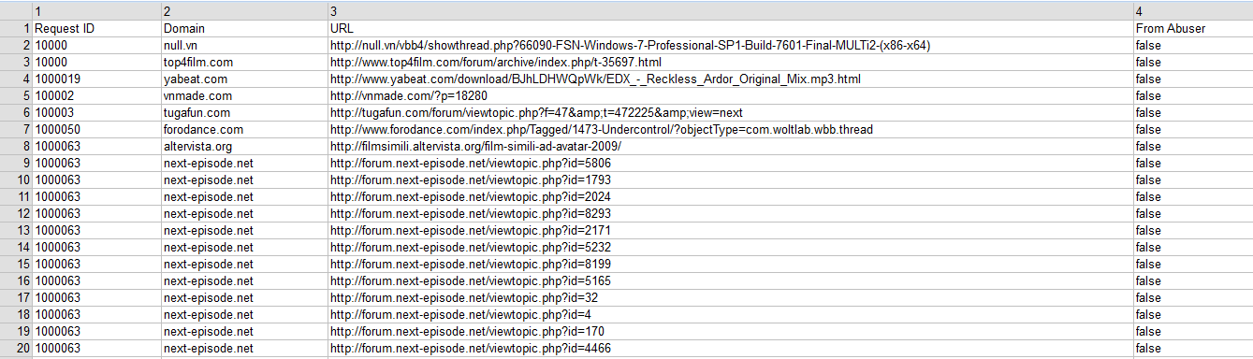

Requests.csv (6,990,660 rows x 12 columns)

