**PRACTICAL NO 3:**

**Aim : - To implement Hamming Code using C and C++.**

**Code : -**

#include<iostream>

using namespace std;

int hamming(int *data,int *redundant,int n,int r)

{

int hammcode[n],count=0,k=0,r1=r;

for(int i=n;i>=1;i--)

{

if(redundant[r1-1]!=i)

{

hammcode[i]=data[k]:

++k;

}

else

{

hammcode[i]=0;

--r1;

}

}

for(int i=0;i<r;i++)

{

for(int j=1;j<=n;j++)

{

if((1<<i)&j

{

if(hammcode[j]==1)

{

++count; ///for even parity.

}

}

}

if(count%2==0)

{

hammcode[redundant[i]]=0;

}

else

{

hammcode[redundant[i]]=1;

}

count=0;

}

cout<<"HAMMING CODE:";

for(int i=n;i>=1;i--)

{

cout<<hammcode[i];

}

}

int main()

{

int size,a=2,r=1;

cout<<"enter size of the data :";

cin>>size;

while(1)

{

if(a>=(size+1+r))

{

break;

}

++r;

a=a*2;

}

int data[size];

int redundant[5]={1,2,4,8,16},j=r;

cout<<"enter data :";

for(int i=0;i<size;i++)

{

cin>>data[i];

}

if(data[0]==0){cout<<"Inappropriate data entered";

exit(0);}

hamming(data,redundant,size+r,r);

return 0;

}

**Output: -**

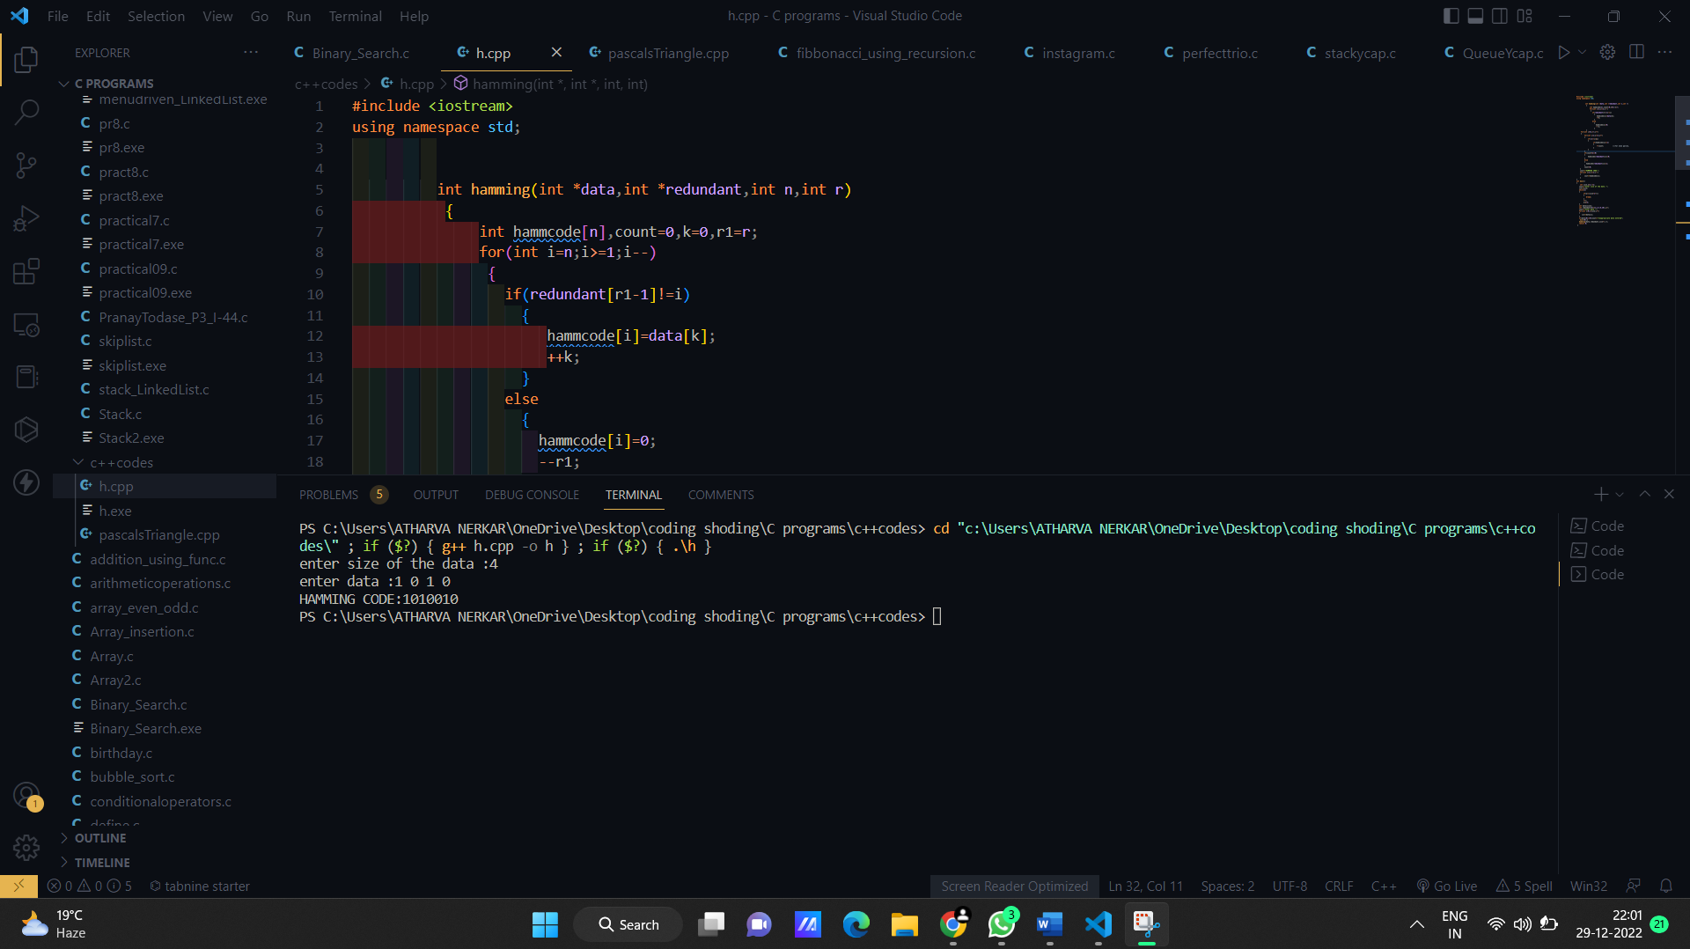

**Conclusion: Hamming code was implemented successfully.**