COMPARATIVE STUDY AND INNOVATION-GAP REPORT
SIH25031 – Crowdsourced Civic Issue Reporting and Resolution System
Smart India Hackathon 2025
Problem Statement ID: SIH25031
Problem Statement: Crowdsourced Civic Issue Reporting and Resolution System
Category: Software
Theme: Clean & Green Technology

1. INTRODUCTION
The problem statement SIH25031 – Crowdsourced Civic Issue Reporting and Resolution System focuses on improving the way citizens report civic problems and how government authorities receive, process, prioritize and resolve them.
Typical civic issues include:
- Potholes and damaged roads
- Garbage accumulation
- Broken streetlights
- Water leakage
- Drainage and waterlogging
- Damaged public infrastructure
- Waste-management problems
- Other public-service issues
The central idea is to use citizens as a continuous source of information about problems occurring in their surroundings.
However, the objective should not be limited to creating another complaint-registration application. A useful solution needs to cover the complete lifecycle of an issue:
Report → Validate → Classify → Prioritize → Assign → Resolve → Verify → Analyze → Prevent
SIH25031 was listed by the Government of Jharkhand as a software problem under the Clean & Green Technology theme.

2. OBJECTIVE OF THIS STUDY
Before designing our own solution, it is necessary to understand what has already been proposed or implemented.
This report therefore studies three representative solutions:
Solution 1 — Pratham
A multi-access civic reporting and resolution platform proposed for SIH2025.
Solution 2 — E-Samadhan
A publicly presented SIH-oriented implementation combining geo-tagging, AI classification, community participation and administrative dashboards.
Solution 3 — CivicFix
A 2026 academic implementation explicitly referencing SIH25031 and combining PWA access, AI classification, SLA escalation and blockchain auditing.
These three represent different stages of development:
Basic integrated civic workflow → AI/crowdsourced civic platform → advanced accountability-oriented platform

3. EXISTING SOLUTION 1: PRATHAM
3.1 Overview
The Pratham solution proposes a single application/web platform with different access levels for:
- Citizens
- Government departments
- Engineers/repair personnel
The central objective is to bring reporting, analysis, grouping, addressing and resolution into one system.
Source:
Pratham – SIH2025 Civic Issue Reporting presentation https://www.scribd.com/document/938213534/SIH2025-Civic-Issue
3.2 Main Features
- Civic issue reporting
Citizens can report civic problems through the platform.
- Location-based grouping
Similar issues are grouped based on:
- Location
- User input
For example, several reports about the same pothole can be treated as a common issue.
- Crowd-based priority
The proposed system increases the priority of an issue as more citizens report it.
This uses the crowd itself as a signal of importance.
- Multi-level access
The same platform is intended for:
Citizen → Department → Engineer/Repair personnel
This allows an issue to move through the complete resolution chain.
- Tracking
The system provides issue/ticket status so that progress can be followed.
- Map-based view
Departments can view issue requests geographically.
- Repair scheduling
Engineers/contractors can use the system to manage scheduled repairs.
3.3 Identified Challenges
Interestingly, the Pratham proposal itself identifies several challenges:
- Digital divide
- Data integrity
- Spam
- Lack of backend integration
- Inter-departmental coordination.
These are valuable because they show that simply creating the software interface does not completely solve the civic problem.

4. EXISTING SOLUTION 2: E-SAMADHAN
4.1 Overview
E-Samadhan is a publicly presented solution specifically associated with SIH2025's civic issue problem.
It expands the basic reporting model by introducing AI and community-driven mechanisms.
Source:
E-Samadhan – SIH25031 project material https://id.scribd.com/document/911466268/Crowdsourced-Civic-Issue-Reporting-and-Resolution-System-SIH25031
4.2 Main Features
A. Geo-tagged reporting
Citizens provide:
- Issue image
- Description• Location
The location allows authorities to understand exactly where the problem occurs.
- Multimedia reporting
Citizens can provide photographic evidence of an issue.
- AI-based issue classification
The system proposes automatically identifying the category of a civic issue from submitted information.
For example:
Image → Pothole → Road Department
- Duplicate detection
The system attempts to identify reports referring to the same problem.
This prevents the database from being unnecessarily filled with separate complaints about one physical issue.
- Crowdsourced validation
Citizens can participate in validating or supporting reported issues.
- Upvoting
Community support can help authorities understand which problems are considered important by residents.
- Authority dashboard
Officials can view and manage civic issues.
- Priority management
AI and citizen information can contribute to determining issue priority.
- Automated routing
The system proposes sending an issue to the appropriate department.
- Real-time tracking
Citizens can monitor progress after submitting a complaint.
- Data-driven planning
Historical complaint data can be used to identify patterns and assist future planning.

5. EXISTING SOLUTION 3: CIVICFIX
5.1 Overview
CivicFix is particularly important because it is described in a 2026 peer-reviewed paper as a system developed under SIH25031 for the Government of Jharkhand.
It represents a significantly more advanced architecture than a basic complaint portal.
Source:
CivicFix – 2026 research paper (PDF) https://www.ijarsct.co.in/Paper35343.pdf
5.2 Main Features
- Progressive Web Application
The system uses a PWA rather than depending exclusively on a conventional installed mobile application.
This can make access easier because users can access the system through a browser.
- Geo-tagged multimedia complaints
Reports can contain:
- Geographic information
- Images/media
- Complaint information
- Voice input
The system supports voice input, including multiple regional languages.
This addresses accessibility and language barriers.
- AI-based categorization
A CNN-based engine is described for automatic categorization of reports.
- Administrative routing
Issues are routed through a four-tier administrative hierarchy.
- SLA escalation
The system uses Service Level Agreements to monitor whether issues are handled within expected timeframes.
If the responsible level does not act, escalation can occur.
- Real-time notifications
Socket.io is used for real-time updates.
- Blockchain audit trail
Administrative actions are recorded through an immutable blockchain-based audit mechanism.
This is intended to improve accountability.
- Reported evaluation
The paper reports:
- 66.7% reduction in average resolution time
- 2.3× increase in complaint submissions
- Mean citizen satisfaction of 4.1/5
These figures are reported by the authors of the paper, so they should be presented in our report as reported evaluation results rather than independently verified municipal outcomes.

6. COMPARATIVE FEATURE ANALYSIS
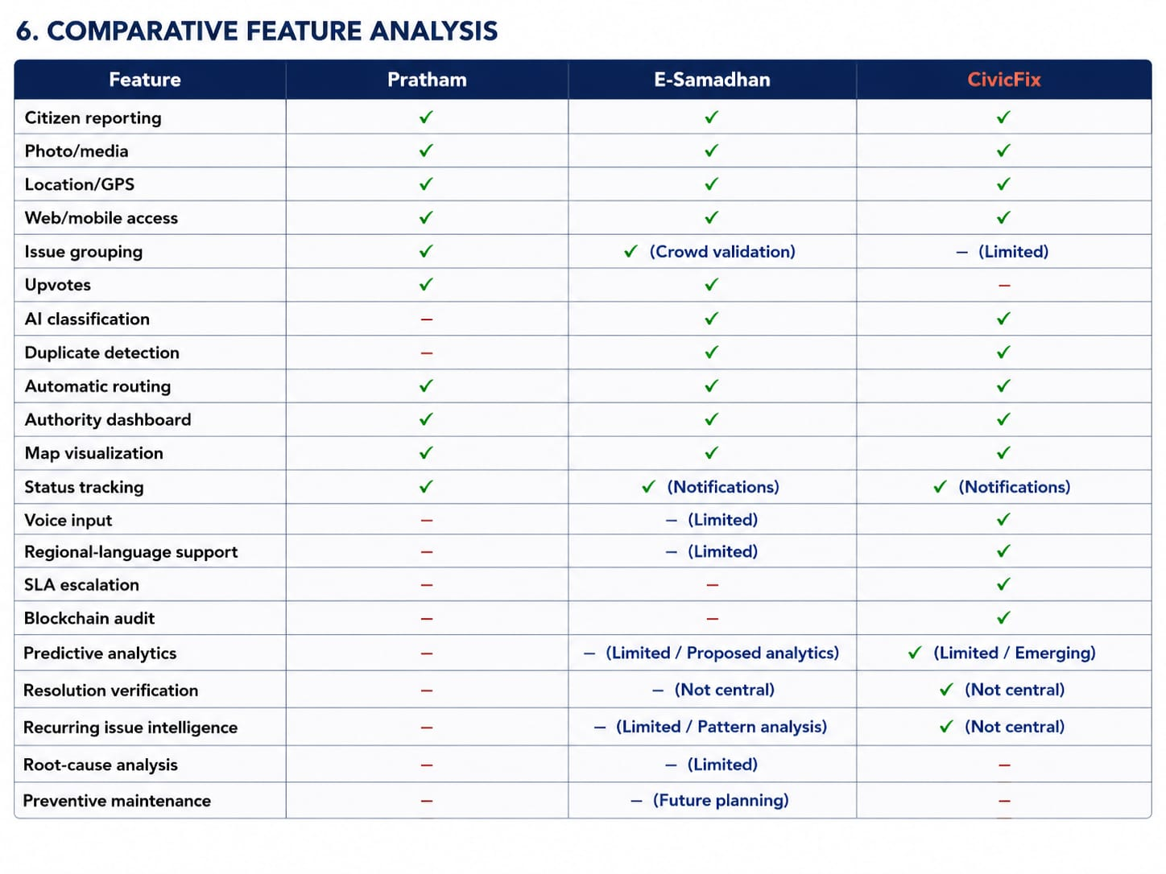
7. WHAT HAS EFFECTIVELY ALREADY BEEN SOLVED?
After comparing these solutions, the following capabilities should now be considered baseline rather than major innovation:
Basic reporting:
- Photo
- Description
- GPS
- Complaint ID
Basic management:
- Admin dashboard
- Department assignment
- Issue status
- Notifications
Basic visualization:
- Maps
- Issue markers
- Heatmaps
Crowdsourcing:
- Multiple citizen reports
- Upvotes
- Community validation
- Duplicate grouping
AI:
- Automatic classification
- Priority assistance
- Duplicate detection
Accessibility:
- Web/PWA
- Voice input
- Regional-language input
Accountability:
- SLA
- Escalation
- Administrative logs
Therefore, a new SIH solution that says:
“Our innovation is that citizens can upload a photo and authorities can see it on a map” would have very little differentiation.

8. ADDITIONAL SIH2025 SOLUTIONS SHOW THE COMPETITION IS ALREADY MOVING BEYOND THE BASICS
Other publicly available SIH25031 submissions reinforce this conclusion.
For example, the JANSETU proposal combines:
- Photo + GPS reporting
- Real-time tracking
- AI categorization
- Duplicate detection
- Priority assignment
- Automatic routing
- Performance analytics.
Source:
JANSETU – SIH2025 presentation https://www.scribd.com/presentation/969942482/SIH2025-IDEA-Presentation-Format-1-1-1
Another SIH proposal uses multiple channels including:
- App
- Website
- Voice calls
- Speech-to-text
- WhatsApp/SMS notifications
- Automatic routing
- Auto-escalation.
Source:
https://www.scribd.com/presentation/922725159/SIH2025-IDEA-Presentation-Format-1-1
A separate 2025 proposal focuses on:
- AI severity detection
- Crowd validation
- Automated routing
- Administrative dashboards
- Privacy-preserving media processing.
Source:
https://in.linkedin.com/in/tanvi-vilaskar-1a905a263
This means the competitive baseline for SIH has already become quite high.

9. THERE ARE ACTUALLY MORE SIH25031 SUBMISSIONS
This is important for your report because it demonstrates the competition.
For example, a publicly available Civic Saviours presentation for SIH25031 describes:
- Real-time reporting
- Auto-assignment to departments
- Heatmaps
- Analytics
- Citizen participation
- Transparency
- Scalability.
Source:
Civic Saviours – SIH25031 presentation https://www.scribd.com/document/968142523/Updated-Pp-t
Another publicly available SIH25031 proposal describes:
- Photo + location reporting
- Text/voice input
- Centralized map
- Automated routing
- Transparency loop
- Recurring-problem analytics.
Source:
https://www.scribd.com/presentation/945919481/SIH25031-Civic-Issue-Reporting
This is useful evidence that recurring-issue analytics itself is already being proposed, so I would not claim that as completely unexplored either.

10. THE MAJOR RESEARCH AND INNOVATION GAP
The existing solutions are very good at answering:
“How do we report and process a civic issue?”
The next generation should answer:
“How do we verify, understand, predict and prevent civic issues?” This is the main opportunity for our project.

11. PROPOSED GAP 1 — NO-DOWNLOAD / OMNICHANNEL REPORTING
A major usability improvement would be to avoid forcing every citizen to install an application.
Proposed channels:
WhatsApp
Lightweight Web/PWA
QR-based reporting
Optional mobile application
All channels should connect to one backend.
Example:
Citizen sends:
“There is a broken streetlight near my location.”
The system asks for:
Location
Photo
Optional voice description
The backend converts this into a structured civic complaint.
Why this matters:
The objective should be:
“Reduce the number of steps between noticing a problem and reporting it.”
Importantly, WhatsApp alone is not a sufficient innovation because some SIH proposals already include WhatsApp/SMS channels.
The innovation should instead be the omnichannel architecture.

12. PROPOSED GAP 2 — IMPACT-BASED PRIORITIZATION
Existing systems often use:
More reports = higher priority
This is useful but insufficient.
Our system can calculate a broader:
Civic Impact Score
Possible factors:
Severity
+
Number of affected people
+
Crowd confirmations
+
Traffic density
+
Proximity to schools/hospitals
+
Recurrence
+
Time unresolved
+
Location importance
The result would be:
Priority = civic impact, not simply popularity.
This prevents highly visible but low-impact complaints from always dominating the queue.

13. PROPOSED GAP 3 — RESOLUTION VERIFICATION
This is one of the strongest directions for our project.
Currently, an authority can update:
Status: Resolved
But the important question is:
Was it actually resolved?
Proposed workflow:
Authority submits:
After-resolution image/video
↓
System compares it with:
Original complaint evidence
↓
Citizen/community can verify
↓
System generates:
Resolution Confidence Score
↓
Issue becomes:
Verified Resolved or
Needs Review or
Reopened
This creates a genuine feedback loop.

14. PROPOSED GAP 4 — RECURRING ISSUE DETECTION
Suppose the same location produces:
- Drainage complaint — January
- Drainage complaint — March
- Drainage complaint — June
- Drainage complaint — September
A conventional system sees four separate complaints.
Our system should recognize:
Recurring Civic Issue and alert the authority.
Example:
Location: Zone A
Issue: Drainage
Occurrences: 4
Period: 9 months
Recommendation:
“Repeated temporary repairs detected. Permanent infrastructure inspection recommended.” This changes the system from complaint resolution to infrastructure intelligence.

15. PROPOSED GAP 5 — ROOT-CAUSE ANALYSIS
Instead of only identifying:
“There are 80 waterlogging complaints.”
the system should investigate patterns such as:
- Drainage blockage
- Low-lying terrain
- Waste accumulation
- Insufficient drainage capacity
- Repeated infrastructure failure
- Seasonal rainfall patterns
The system can provide:
Potential contributing factors rather than claiming a definitive engineering diagnosis.
Municipal engineers can then make the final decision.

16. PROPOSED GAP 6 — PREDICTIVE CIVIC HOTSPOTS
This is perhaps the strongest long-term innovation.
Historical data can be used to identify:
“Where is a civic problem likely to appear next?”
For example:
Historical data:
Drainage complaints + rainfall + location + recurrence
↓
AI/ML analysis
↓
Predicted hotspot
↓
Authority receives preventive alert
↓
Inspection/maintenance occurs before the issue becomes severe.
This changes the system from: Reactive to:
Predictive and preventive.

17. PROPOSED GAP 7 — PREDICTIVE SLA ESCALATION
CivicFix already demonstrates SLA-based escalation.
Therefore, simply adding escalation would not be novel enough.
Instead, we can extend it.
Existing approach:
Deadline missed
→ Escalate.
Proposed approach:
Historical resolution data
+
Current workload
+
Issue severity
+
Department performance
↓
Predict probability of delay
↓
Warn responsible authority before the deadline is missed.
This would create:
Predictive accountability rather than reactive escalation.

18. PROPOSED GAP 8 — CITIZEN VERIFICATION AS A CONTINUOUS FEEDBACK LOOP
Crowdsourcing should not stop after reporting.
Citizens could participate throughout the lifecycle:
Report
“Streetlight is broken.”
↓
Confirm
“Someone else confirms the same issue.”
↓
Resolution
Authority marks it resolved.
↓
Verify
Nearby citizens can confirm:
Fixed or
Still exists
This creates a continuous:
Citizen → Government → Citizen feedback loop.

19. PROPOSED GAP 9 — CIVIC TRUST AND SPAM DETECTION
Crowdsourcing introduces risks:
- Fake complaints
- Duplicate reports
- Malicious uploads
- Spam
- Manipulated voting
The system should combine:
- Image evidence
- Location consistency
- Duplicate similarity
- Citizen confirmations
- Submission patterns
- Trust/reliability signals
However, AI should not automatically reject uncertain reports.
A safer workflow is:
High confidence → Automatic processing
Medium confidence → Community validation
Low confidence → Human review

20. PROPOSED OVERALL SOLUTION
Based on the existing landscape, our proposed system should have three major layers.
Layer 1 — REPORT
WhatsApp / Web / QR / PWA
Citizen provides:
- Image
- Location
- Voice/text
- Optional description
↓
Layer 2 — RESOLVE
AI performs:
- Classification
- Duplicate clustering
- Severity estimation
- Impact scoring
System performs:
- Department routing
- SLA tracking
- Escalation
- Resolution verification
↓
Layer 3 — PREVENT
Historical data performs:
- Recurring issue detection
- Hotspot detection
- Root-cause insights
- Predictive analysis
- Preventive-maintenance recommendations

21. PROPOSED END-TO-END WORKFLOW
Step 1
Citizen notices an issue.
Step 2
Citizen reports through WhatsApp/Web/QR.
Step 3
System captures:
- Location
- Image
- Time
- Description
Step 4
AI identifies issue category.
Step 5
System searches for similar nearby reports.
Step 6
Duplicate reports are clustered.
Step 7
Civic Impact Score is calculated.
Step 8
Issue is routed automatically.
Step 9
SLA timer begins.
Step 10
Authority/engineer works on the issue.
Step 11
Resolution evidence is uploaded.
Step 12
System performs resolution verification.
Step 13
Citizen/community can confirm or reject the resolution.
Step 14
Issue is closed or reopened.
Step 15
Historical data is analyzed.
Step 16
Recurring patterns are detected.
Step 17
Future civic hotspots are predicted.
Step 18
Authorities receive preventive recommendations.

22. WHAT WE SHOULD BUILD VS WHAT WE SHOULD NOT OVERCLAIM
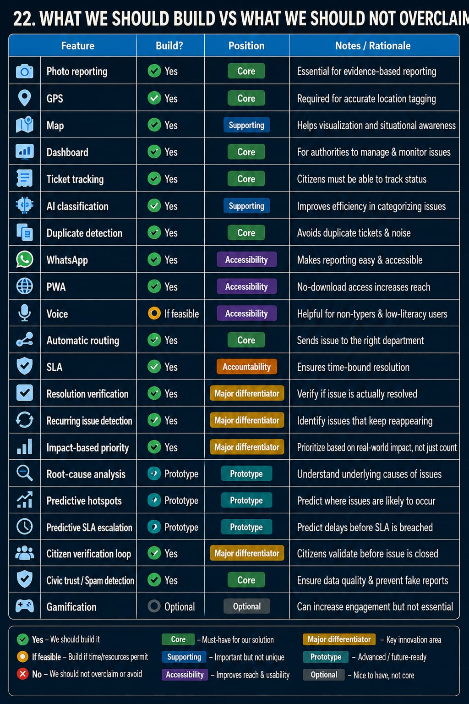

23. RECOMMENDED SIH INNOVATION
Our proposed innovation should therefore be framed as:
“From Civic Complaint Management to Predictive Civic Intelligence”
The system would not merely collect complaints.
It would:
Make civic reporting accessible, understand the problem automatically, combine reports from the community, determine real-world impact, route the issue, monitor resolution, verify the outcome, identify recurring failures and predict future civic hotspots.

24. FINAL PROBLEM-SOLUTION GAP
EXISTING SYSTEMS
Citizen
↓
Report
↓
Map
↓
Department
↓
Resolve
↓
Status
This is already widely explored.
OUR PROPOSED SYSTEM
Citizen
↓
Accessible Reporting
WhatsApp / Web / QR / Voice
↓
AI Understanding
Image + Text + Voice
↓
Crowd Intelligence
Duplicate clustering + validation
↓
Impact Intelligence
Severity + affected population + location + recurrence
↓
Smart Resolution
Department routing + SLA + escalation
↓
Resolution Verification
Evidence + citizen confirmation
↓
Civic Intelligence
Recurring issue + root-cause patterns
↓
Prediction
Future hotspots + preventive maintenance
↓
Better Governance

25. CONCLUSION
The study of existing SIH25031 solutions shows that the basic problem of civic issue reporting has already received substantial attention.
Solutions such as Pratham, E-Samadhan, and CivicFix, along with other SIH submissions, have already explored:
- Geo-tagged reporting
- Multimedia evidence
- Maps
- Dashboards
- Issue grouping
- AI classification
- Duplicate detection
- Crowd validation
- Automatic routing
- Notifications
- Voice input
- Regional-language access
- SLA escalation
- Administrative auditing.
Therefore, our project should not compete by simply adding another reporting application.
The strongest opportunity lies in building the next layer of civic intelligence.
The proposed system should focus particularly on:
- Omnichannel, no-download reporting
- Impact-based rather than purely vote-based prioritization
- AI-assisted verification
- Resolution verification
- Recurring issue detection
- Predictive civic hotspots
- Root-cause insights

8. Predictive SLA/accountability
The final vision is:
Report → Understand → Validate → Prioritize → Resolve → Verify → Learn → Predict → Prevent
This approach gives the SIH project a stronger innovation story because it does not attempt to replace existing complaint portals. Instead, it proposes an intelligent civic-resolution layer capable of converting crowdsourced observations into actionable and eventually preventive governance intelligence.

26. ACTUAL REFERENCE AND EVIDENCE SECTION
The following references should be explicitly included in the report to substantiate the claim that these capabilities have already been proposed or developed.
REFERENCE 1 — PRATHAM
Pratham – “Civic Issue Reporting & Resolution,” Smart India Hackathon 2025, SIH25031.
What it proves:
- Reporting
- Location-based grouping
- Crowd-based priority
- Department/engineer workflow
- Ticket/status tracking
- Maps
- Repair scheduling
Source:
https://www.scribd.com/document/938213534/SIH2025-Civic-Issue
The Pratham presentation also identifies digital divide, data integrity, spam, backend integration and inter-departmental coordination as challenges.
REFERENCE 2 — E-SAMADHAN
E-Samadhan – “Crowdsourced Civic Issue Reporting and Resolution System,” SIH25031.
What it proves:
- Geo-tagged reporting
- Multimedia submissions
- AI-powered classification
- Community participation
- Upvoting
- Duplicate detection
- Automated routing
- Authority dashboards
- Real-time tracking
Source:
https://id.scribd.com/document/911466268/Crowdsourced-Civic-Issue-Reporting-and-Resolution-System-SIH25031
REFERENCE 3 — CIVICFIX
Dnyaneshwar Gumalwad, “Crowdsourced Civic Issue Reporting and Resolution System,” International Journal of Advanced Research in Science, Communication and Technology, Volume 6, Issue 6, May 2026.
The paper explicitly identifies the project reference as:
Smart India Hackathon 2025 — SIH25031 | Government of Jharkhand
What it proves:
- Progressive Web Application
- Geo-tagged multimedia complaints
- Voice input
- Regional-language support
- CNN-based automatic categorization
- Four-tier administrative routing
- SLA escalation
- Real-time notifications
- Blockchain audit trail
Reported evaluation:
- 66.7% reduction in average resolution time
- 2.3× increase in complaint submissions
- Mean citizen satisfaction of 4.1/5
These are reported by the authors and should not be represented as independently verified municipal outcomes. Source:
https://www.ijarsct.co.in/Paper35343.pdf
REFERENCE 4 — JANSETU
JANSETU – “Crowdsourced Civic Issue Reporting and Resolution System,” SIH2025, SIH25031.
What it proves:
- Photo + GPS reporting
- Real-time tracking
- AI categorization
- Duplicate detection
- Priority assignment
- Automatic routing
- Performance analytics
Source:
https://www.scribd.com/presentation/969942482/SIH2025-IDEA-Presentation-Format-1-1-1
REFERENCE 5 — CIVIC SAVIOURS
Civic Saviours – “Civic Saviours Redressal System,” SIH2025, SIH25031.
What it proves:
- Real-time reporting
- Auto-assignment to departments
- Heatmaps
- Analytics
- Citizen participation
- Transparency
- Scalability
Source:
https://www.scribd.com/document/968142523/Updated-Pp-t
REFERENCE 6 — ADDITIONAL SIH25031 PROPOSAL
A publicly available SIH25031 proposal describes:
- Photo + location reporting
- Text/voice input
- Centralized map
- Automated routing
- Transparency loop
- Recurring-problem analytics
Source:
https://www.scribd.com/presentation/945919481/SIH25031-Civic-Issue-Reporting
REFERENCE 7 — MULTI-CHANNEL SIH PROPOSAL
Another SIH proposal uses multiple channels including:
- App
- Website
- Voice calls
- Speech-to-text
- WhatsApp/SMS notifications
- Automatic routing
- Auto-escalation
Source:
https://www.scribd.com/presentation/922725159/SIH2025-IDEA-Presentation-Format-1-1
REFERENCE 8 — AI SEVERITY / VALIDATION PROPOSAL
A 2025 proposal focuses on:
- AI severity detection
- Crowd validation
- Automated routing
- Administrative dashboards
- Privacy-preserving media processing
Source:
https://in.linkedin.com/in/tanvi-vilaskar-1a905a263
REFERENCE 9 — CIVIC ISSUE REPORTING RESEARCH
A 2026 research implementation describes a civic issue platform in which citizens report issues using images, descriptions and live location, with centralized complaint management and department-level processing.
Source:
https://irjaeh.com/index.php/journal/article/view/1862
REFERENCE 10 — ZENODO IMPLEMENTATION
A 2026 implementation describes a web-based civic issue system with user, department and admin modules, user registration, email verification, complaint submission, images, descriptions and department interaction.
Source:
https://zenodo.org/records/19402303

27. IMPORTANT RESEARCH POSITIONING
The report should not state:
“No one has ever implemented these features.”
Instead, it should state:
“Existing solutions have demonstrated individual capabilities, but there remains an opportunity to integrate them into a stronger end-to-end civic intelligence and prevention framework.”
The existence of multiple SIH25031 submissions demonstrates that the problem already has significant competition and that basic reporting, geolocation, AI classification, routing, dashboards and tracking are becoming common.
Therefore, our innovation should be based on:
How effectively we combine these technologies, how accessible the system is, how accurately it verifies real-world resolution, how intelligently it prioritizes civic impact, and how effectively it learns from historical problems to support prevention.

28. KEY TAKEAWAY FOR OUR TEAM
We should NOT pitch:
“A platform where citizens report potholes and authorities resolve them.”
We SHOULD pitch:
“An omnichannel, AI-assisted civic intelligence platform that converts crowdsourced reports into verified, impact-prioritized, accountable resolutions while learning from recurring issues to predict and prevent future civic problems.”
The strongest differentiating direction is:
Verified + Predictive Civic Resolution
Citizen → Report → AI Understands → Crowd Validates → Impact Prioritization → Department Assignment →
SLA Monitoring → Resolution Evidence → Citizen Verification → Recurrence Analysis → Prediction → Prevention

29. REFERENCES FOR BIBLIOGRAPHY
- Pratham, “Civic Issue Reporting & Resolution,” Smart IndiaHackathon 2025, SIH25031.
https://www.scribd.com/document/938213534/SIH2025-Civic-Issue
- E-Samadhan, “Crowdsourced Civic Issue Reporting andResolution System,” SIH25031.
https://id.scribd.com/document/911466268/Crowdsourced-Civic-Issue-Reporting-and-Resolution-System-SIH25031

3. Gumalwad, D., “Crowdsourced Civic Issue Reporting and
Resolution System,” International Journal of Advanced Research in Science, Communication and Technology, Vol. 6, Issue 6, May 2026.
https://www.ijarsct.co.in/Paper35343.pdf
- JANSETU, “Crowdsourced Civic Issue Reporting andResolution System,” SIH2025, SIH25031.
https://www.scribd.com/presentation/969942482/SIH2025-IDEA-Presentation-Format-1-1-1
- Civic Saviours, “Civic Saviours Redressal System,” SIH2025,SIH25031.
https://www.scribd.com/document/968142523/Updated-Pp-t
- Additional SIH25031 proposal.
https://www.scribd.com/presentation/945919481/SIH25031-Civic-Issue-Reporting
- Multi-channel SIH proposal.
https://www.scribd.com/presentation/922725159/SIH2025-IDEA-Presentation-Format-1-1
- AI severity / validation proposal.
https://in.linkedin.com/in/tanvi-vilaskar-1a905a263
- Crowdsourced civic issue reporting and resolution researchimplementation.
https://irjaeh.com/index.php/journal/article/view/1862
- Zenodo civic issue reporting implementation.
https://zenodo.org/records/19402303

