**Application Load Balancer with Auto Scaling Group**

1. Sign in to the AWS Console.

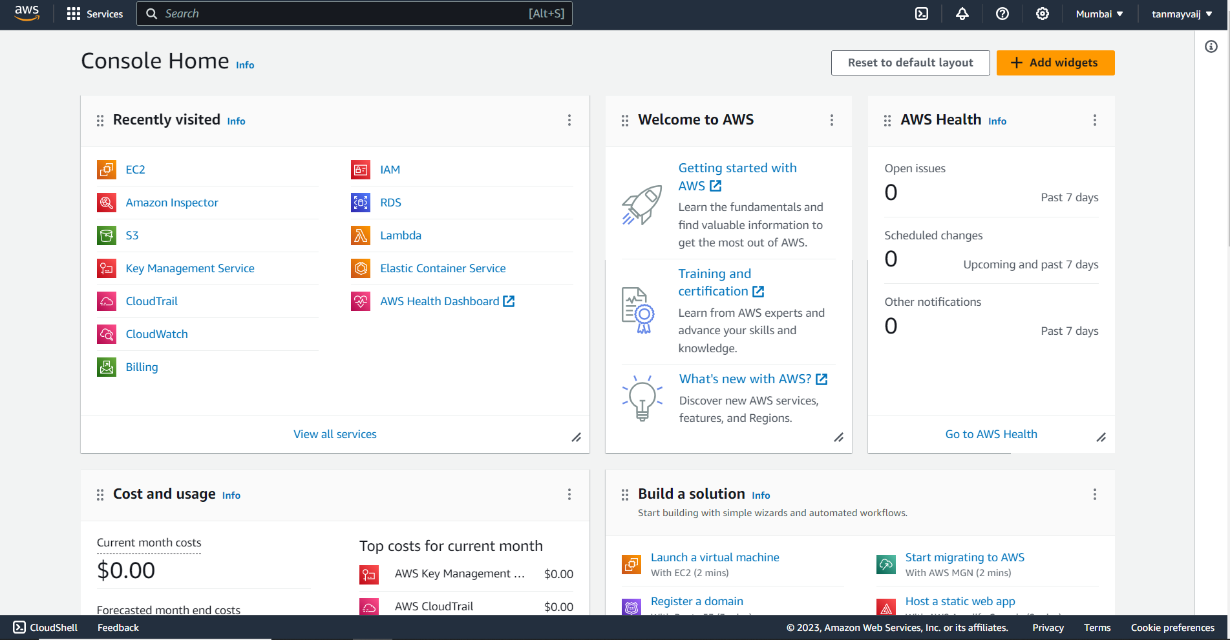

2. Search and select EC2.

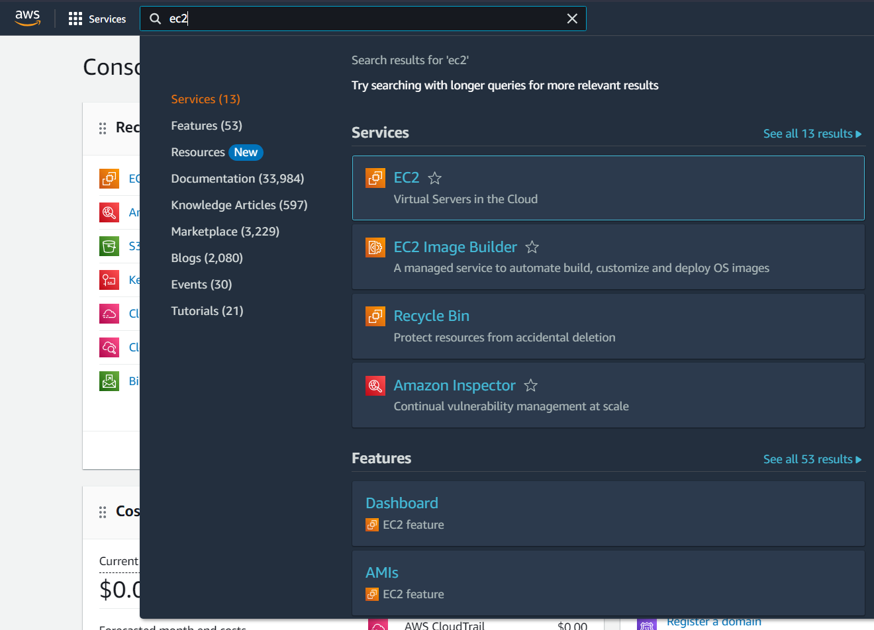

3. In the side menu select “Security Groups”.

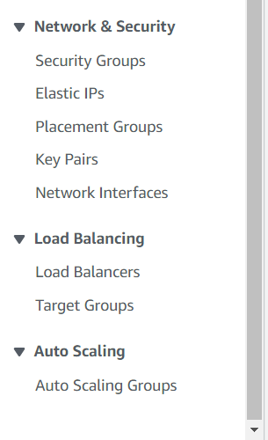

4. Click on “Create security group”.

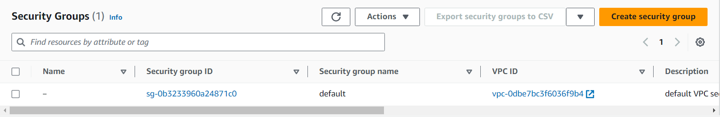

5. Give a name and description for the load balancer security group.

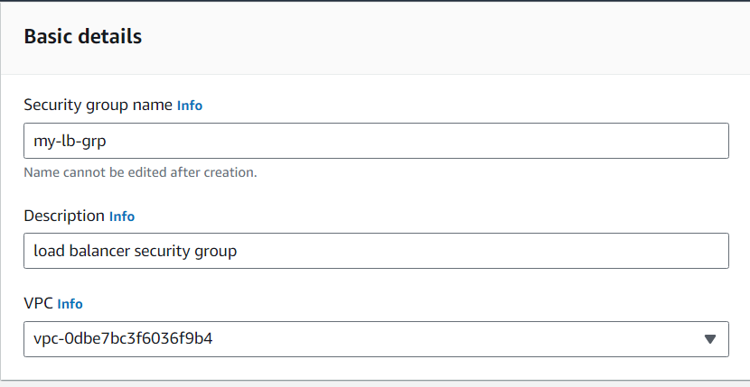

6. In the “Inbound rules” add two rules, “HTTP” and “HTTPS” and give their sources as “Anywhere”.

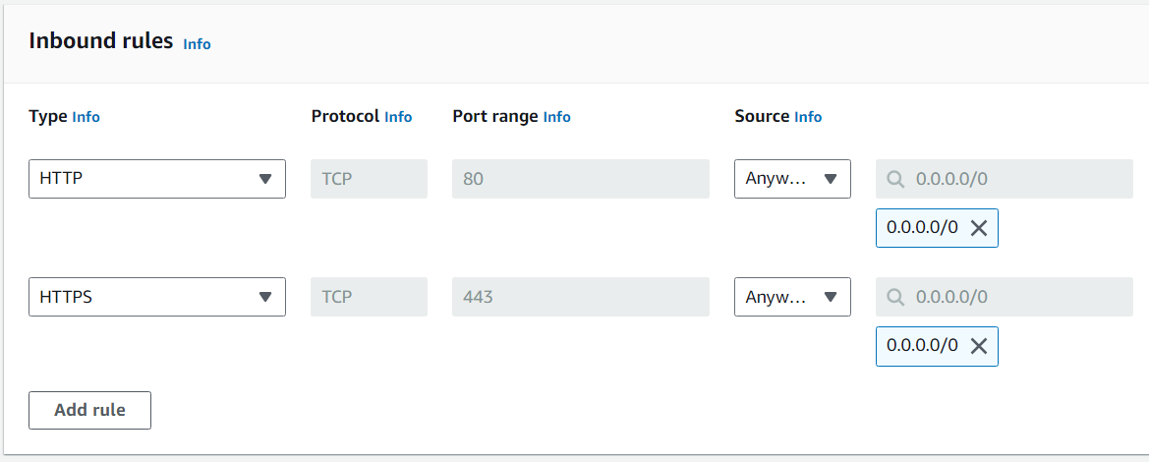

7. Now create a security group for the launch template.

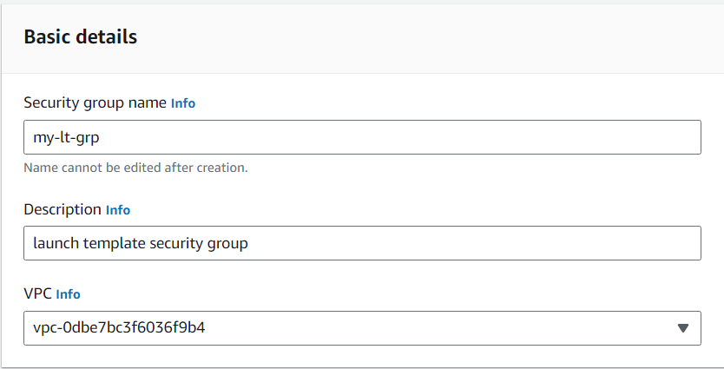

8. Add SSH and set its source as “Anywhere”, then add HTTP and HTTPS and set their source as the security group of the load balancer.

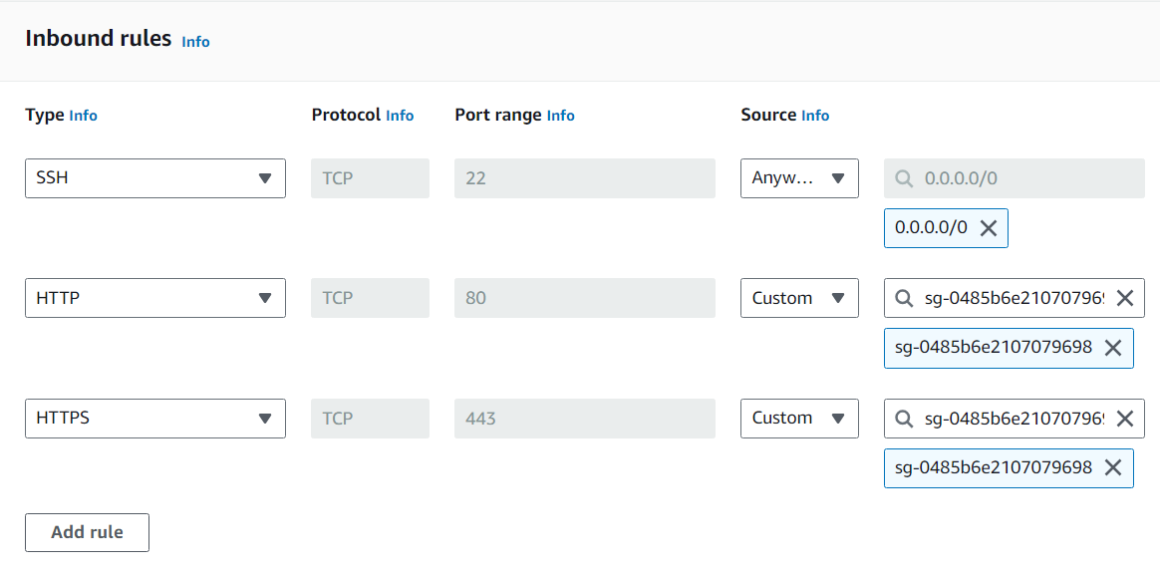

9. Now, from the side menu click on “Launch Templates”

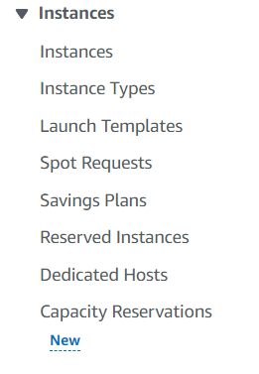

10. Give a name and description to the launch template.

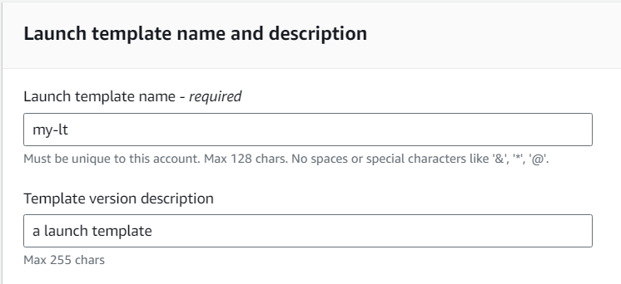

11. Select “Ubuntu” as the OS Image.

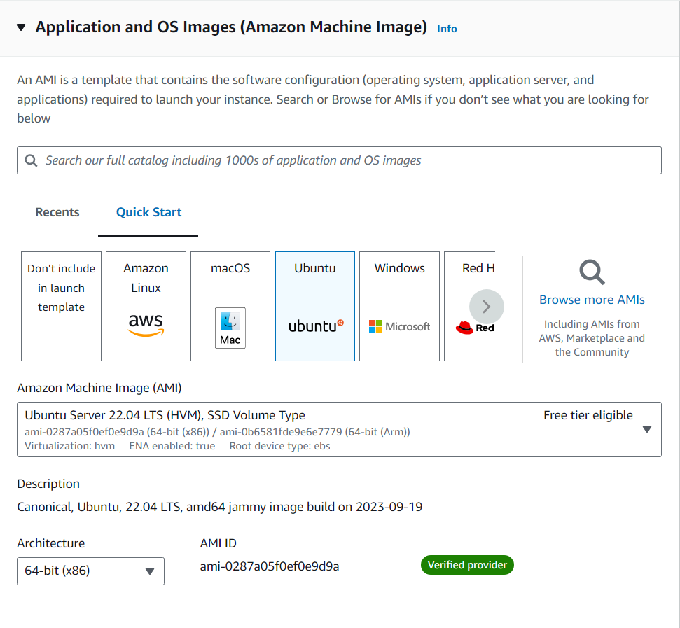

12. Select “t2.micro” as the instance type.

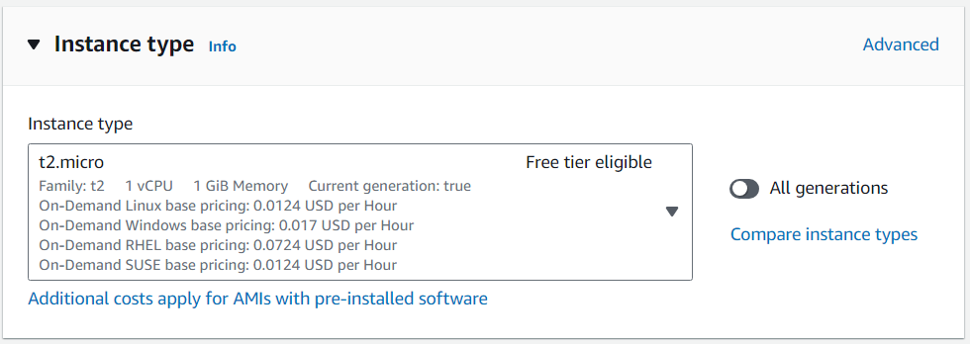

13. Select a key pair name or create if it doesn’t exist.

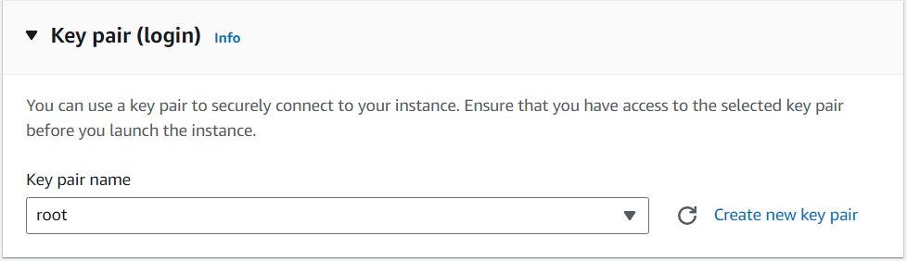

14. Select the security group created for the launch template.

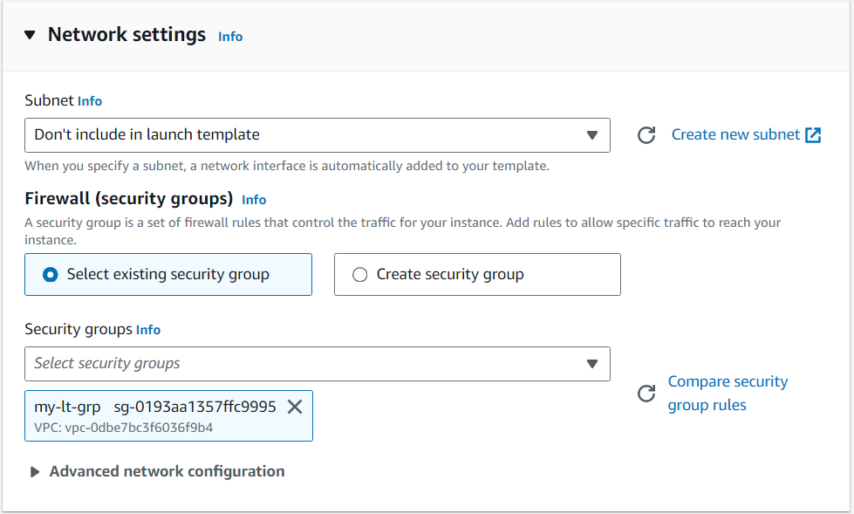

15. Now click on advance settings, and scroll down till end, and add the following code. Then click on “Create launch template”.

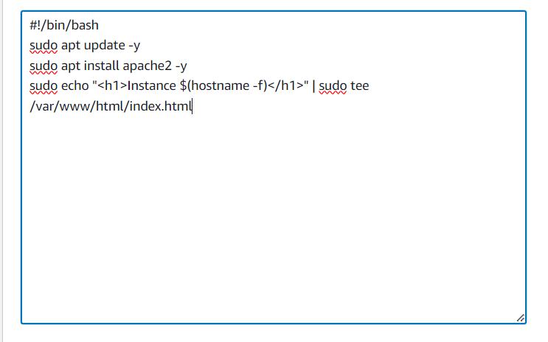

16. Inside the menu, click on the target group and then click on “Create target group”.

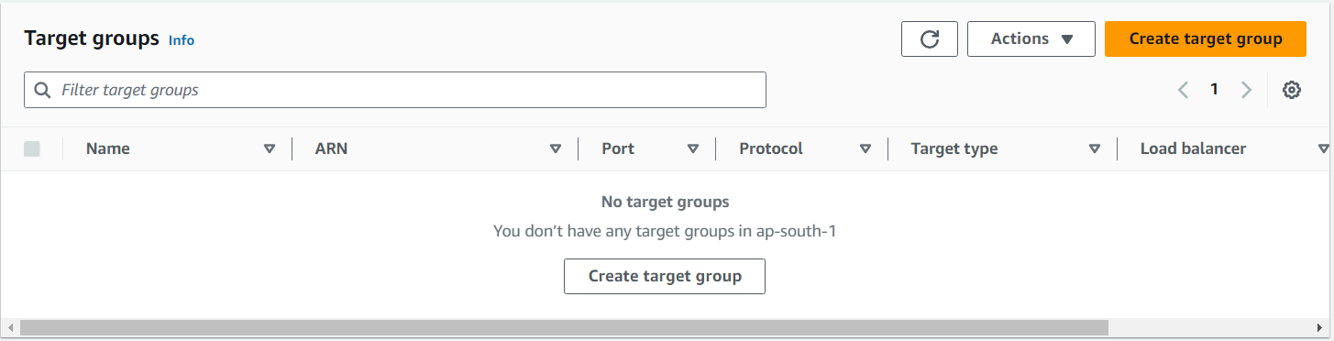

17. Choose “Instances” as the target type and give a name to the target group. Then click next and click on “Create target group”.

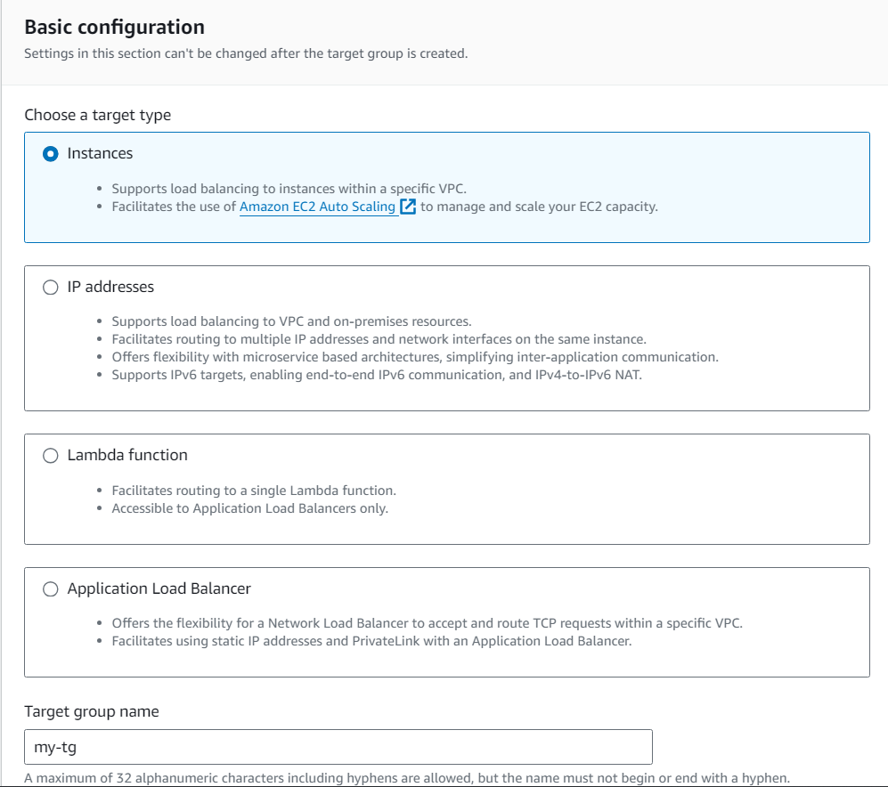

18. Now in the side menu click on load balancers, and then click on “Create load balancer”.

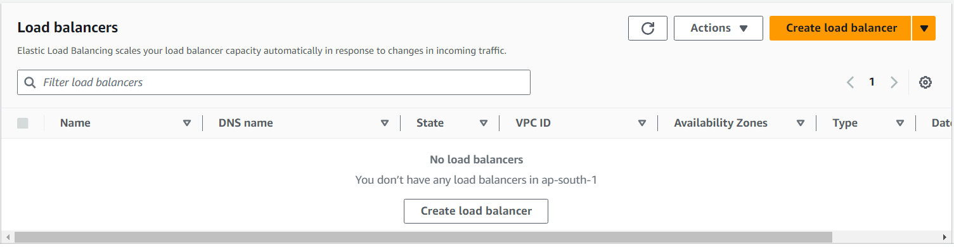

19. Give a name to the load balancer.

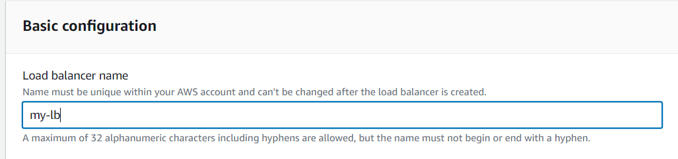

20. Select at least 2 zones.

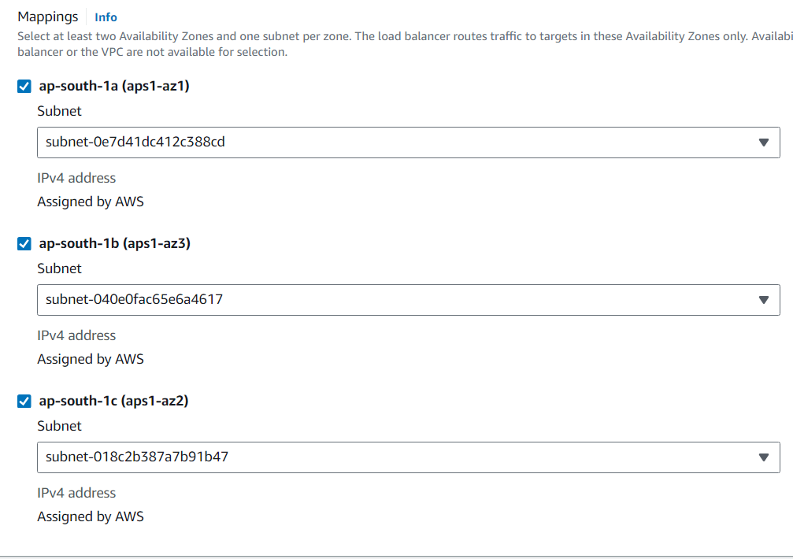

21. Select the security group created for load balancer.

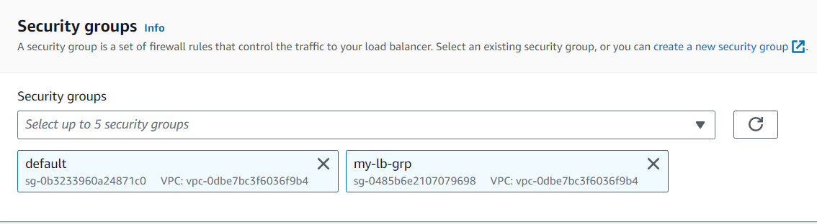

22. Here select the target group which we created already and at the end click on “Create load balancer”.

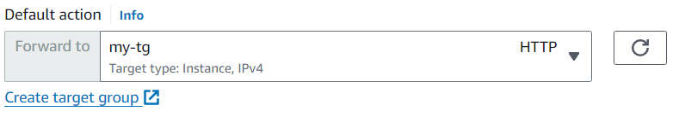

23. Then in the side menu click on Auto Scaling Group, give a name and select the launch template which we created previously.

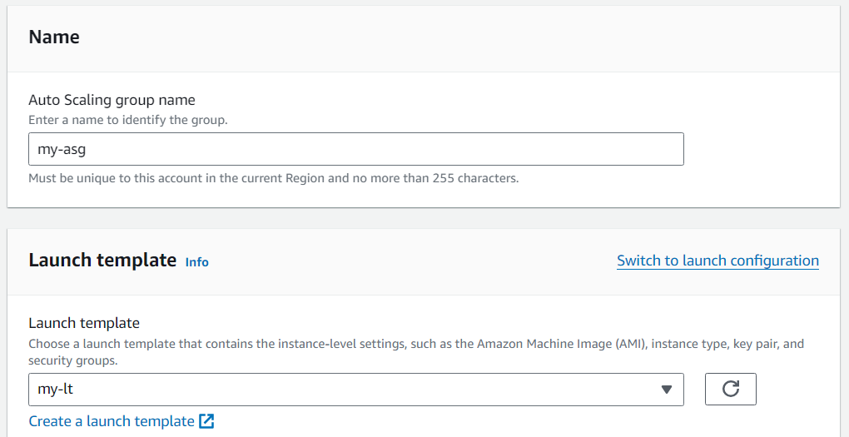

24. Select all the 3 zones and then click on “Next”.

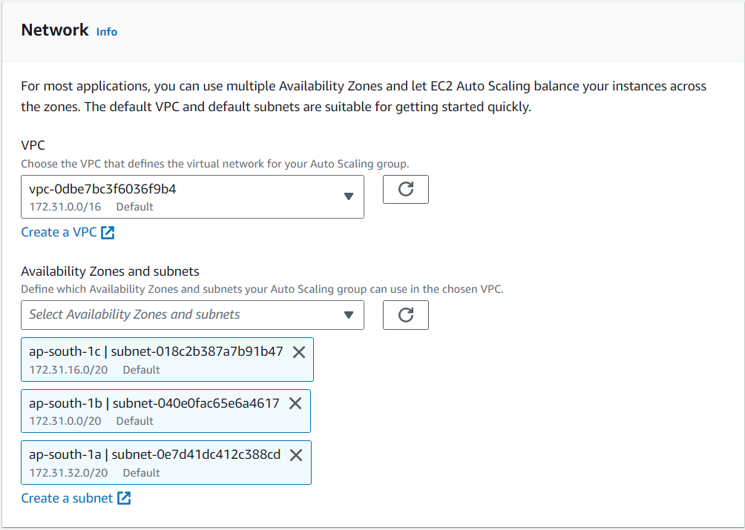

25. Select “Attach to an existing load balancer” and select the load balancer.

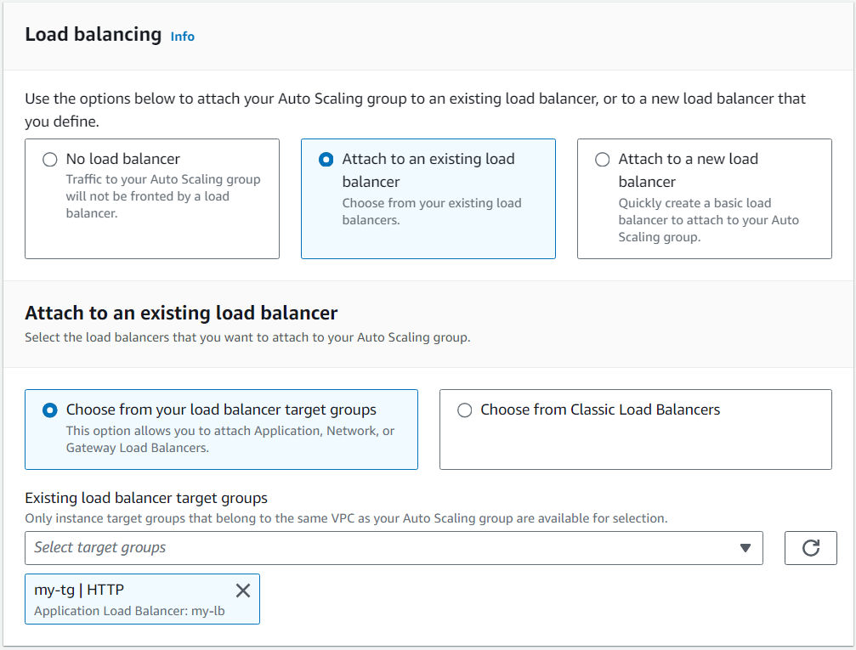

26.Turn on Elastic Load Balancing health checks, and set the Health check grace period to 60 seconds.

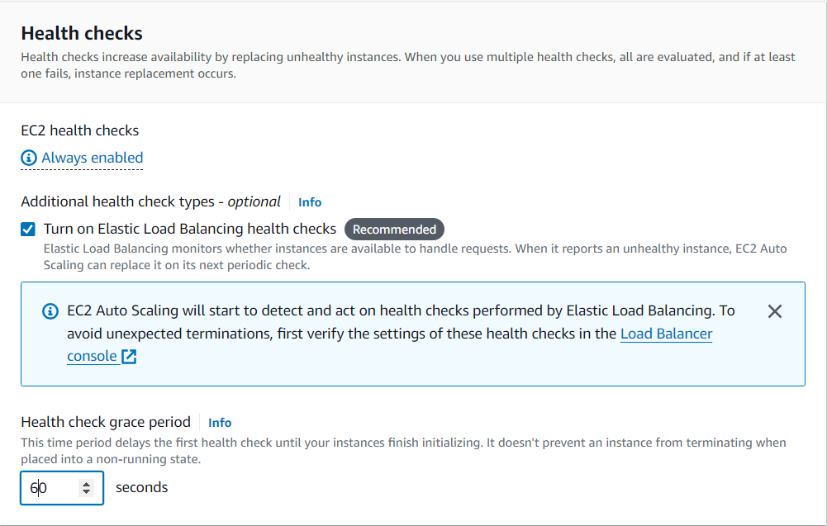

27. Set the “Max desired capacity” to 4. Select a target tracking scaling policy with the metric type: Average CPU utilisation. Set target value to 30 and instance warmup to 60 seconds. Then click on “Create auto scaling group”.

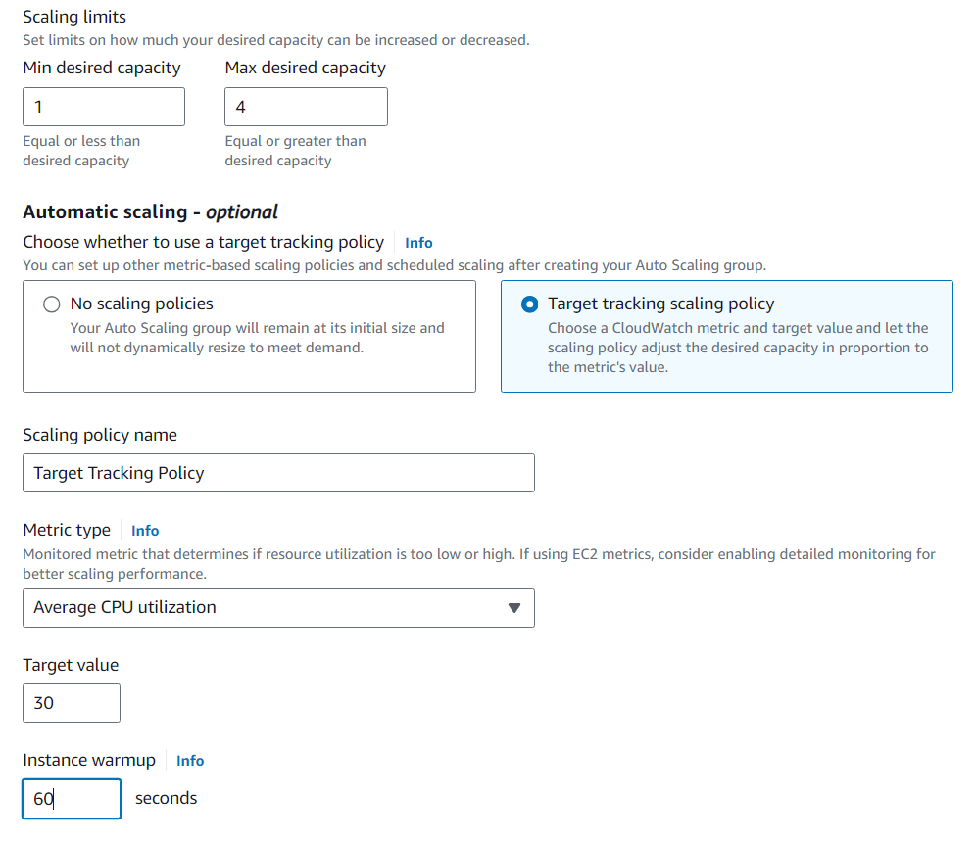

28. An instance will start running after creating auto scaling group, connect to the instance and fire the command “sudo apt update -y && sudo apt install stress -y && sudo stress –cpu 8 –timeout 200”.

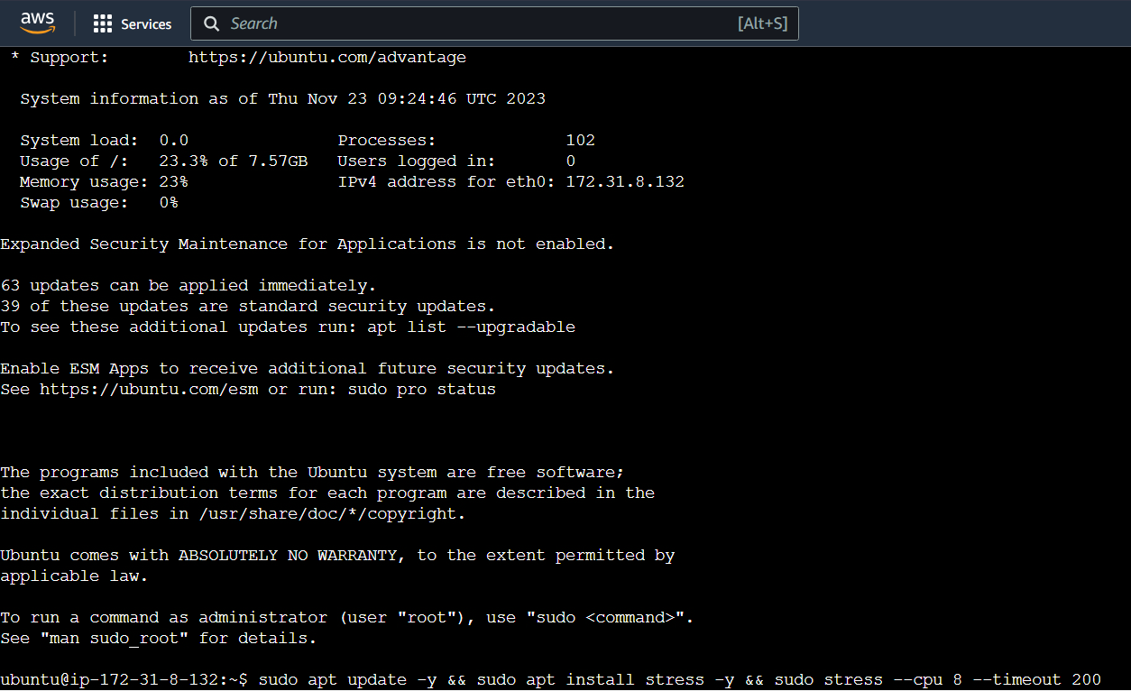

29. After a few minutes all the 4 instances will start running due to stress.

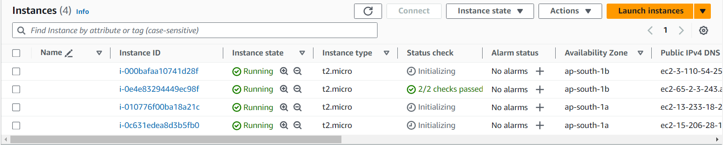

30. Then put the load balancer dns name in the browser and it will start showing different ip addresses on every reload.

