**Demonstration of IAM Users, Group, AWS Managed Policy Granular Access**

1. Sign into AWS Console.

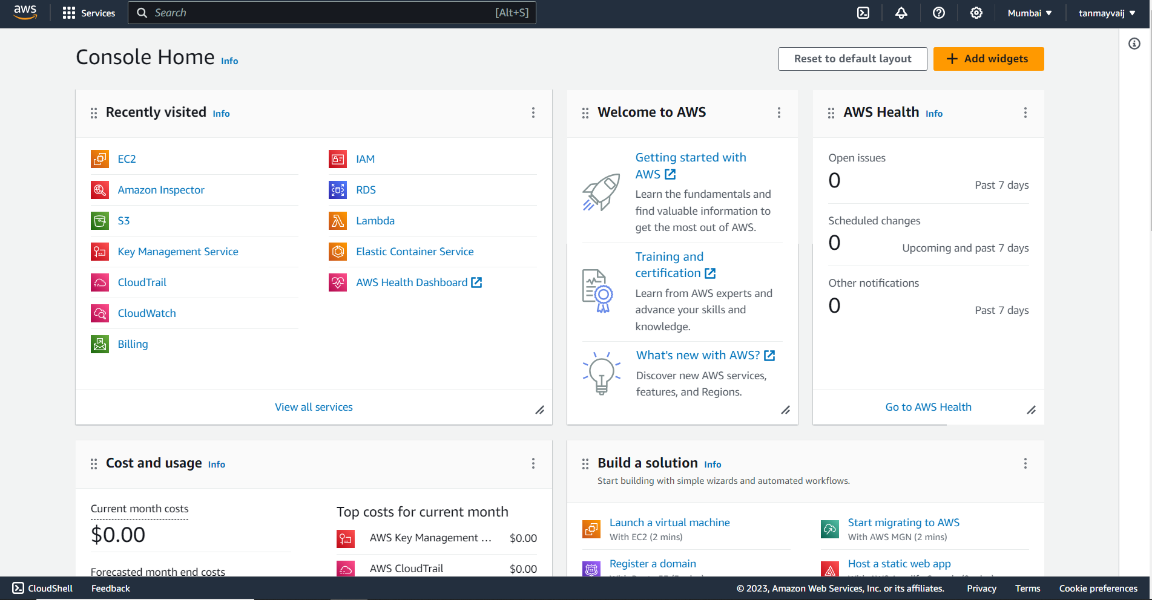

2.Search and open IAM dashboard.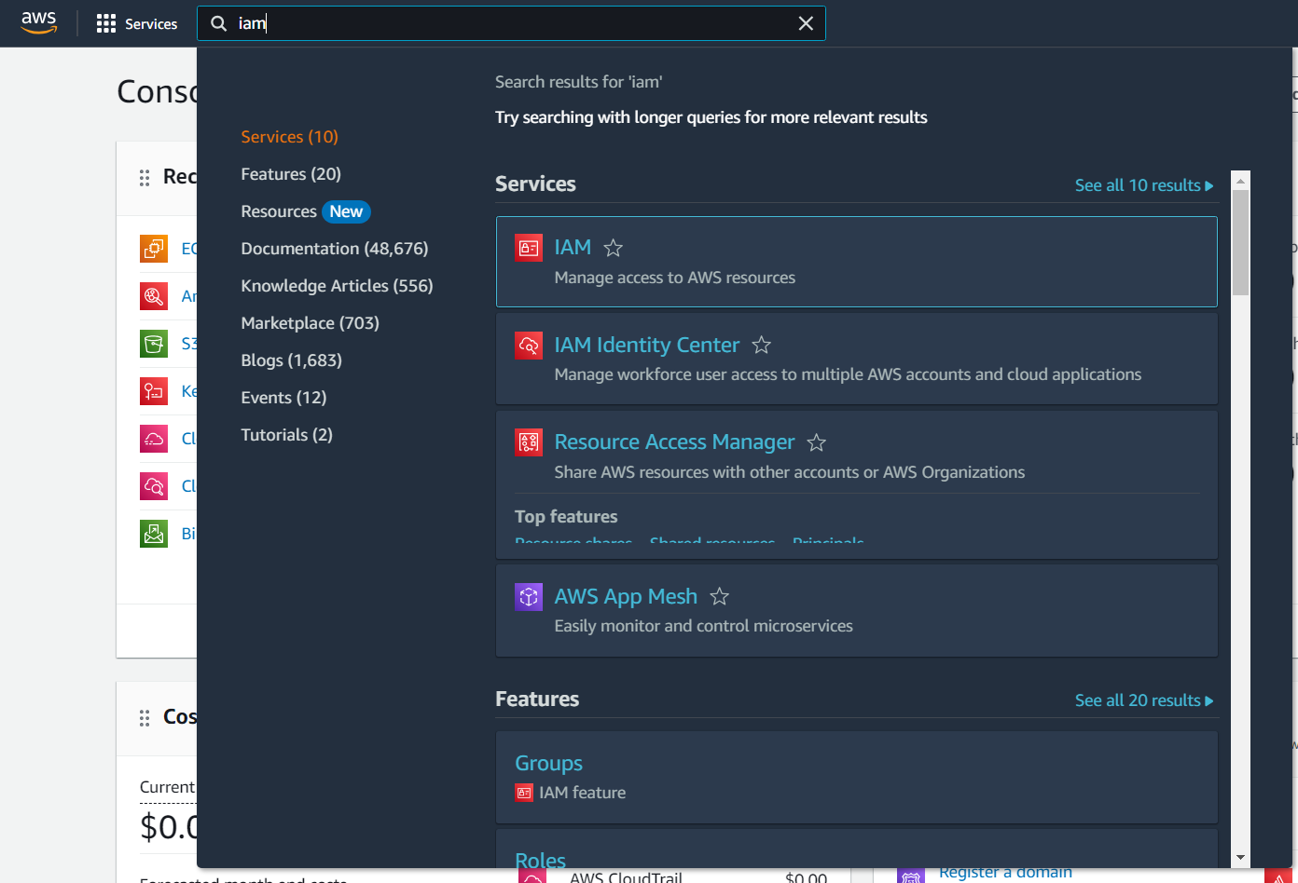

3. Click on the “Users” in the side menu.

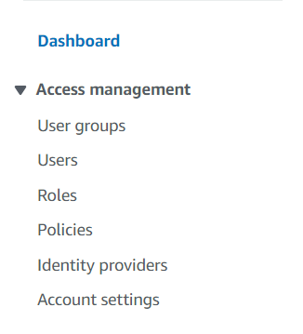

4. Click on “Create user”.

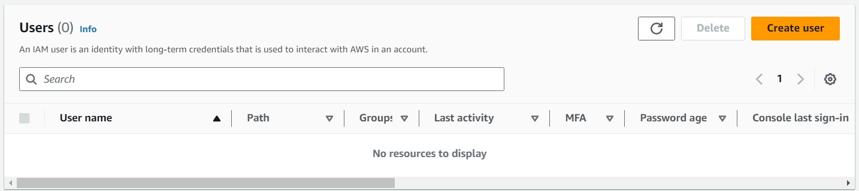

5. Enter the username, check the “Provide user access to the AWS Management Console”, and set a custom password.

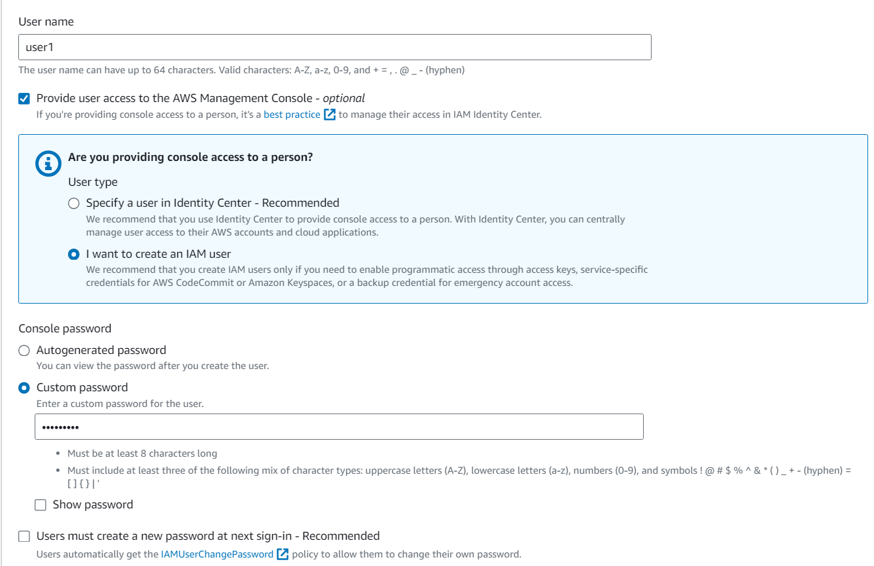

6. Select the “Add user to group” and then click on “Create group”.

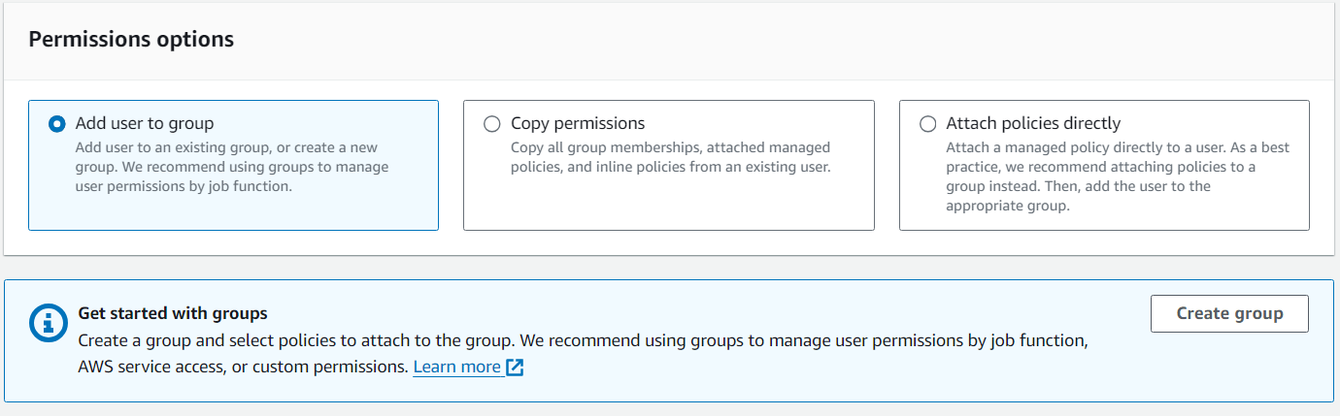

7. Give a group name, search and select the AmazonEC2FullAccess. Then select the group in which you want to add the user.

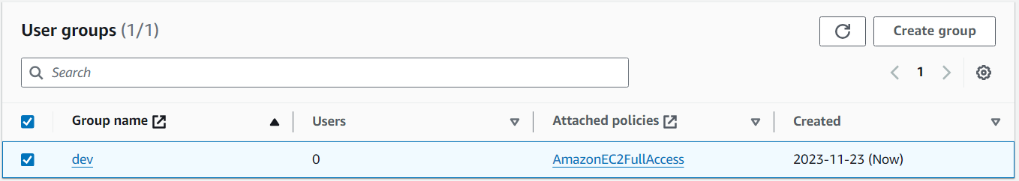

8. Then in the users section, the created user appears.

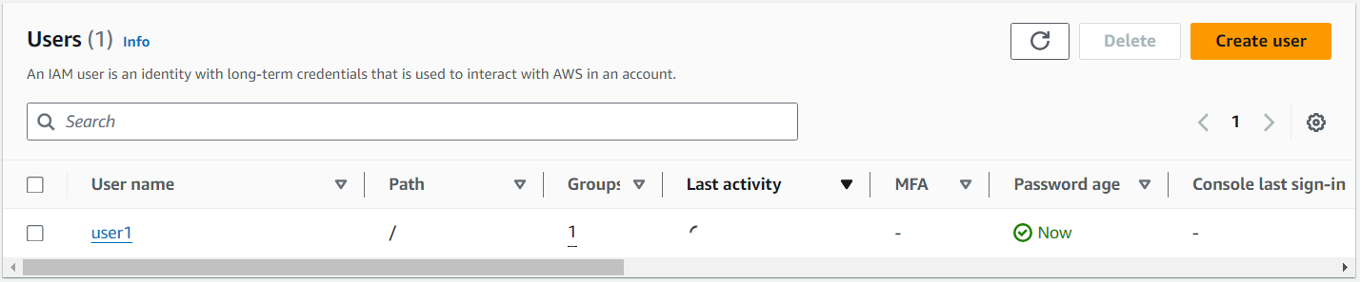

9. Repeat the same process and create another two user with permission for AmazonS3FullAccess and AdministratorAccess respectively.

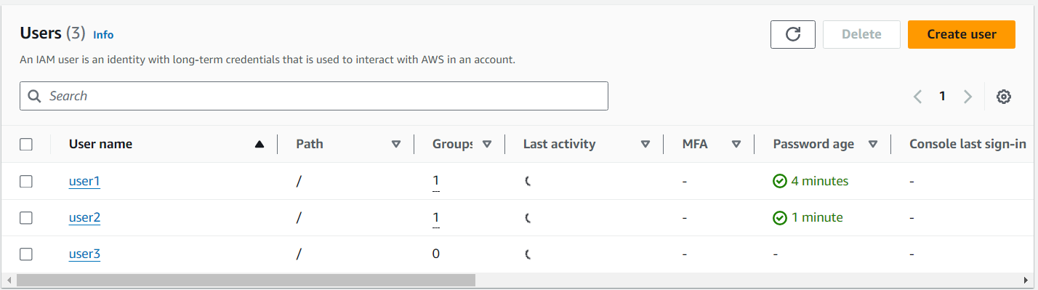

10. Copy the Sign-in URL for IAM users and paste it into browser url and sign in into user1 account.

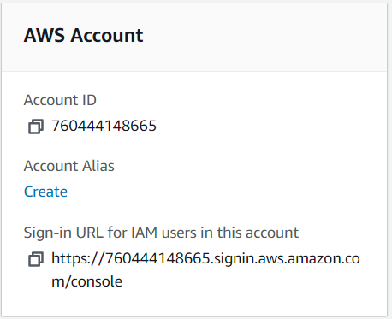

11. Try to create a bucket and AWS will not allow to do so, as there is no permission provided for S3.

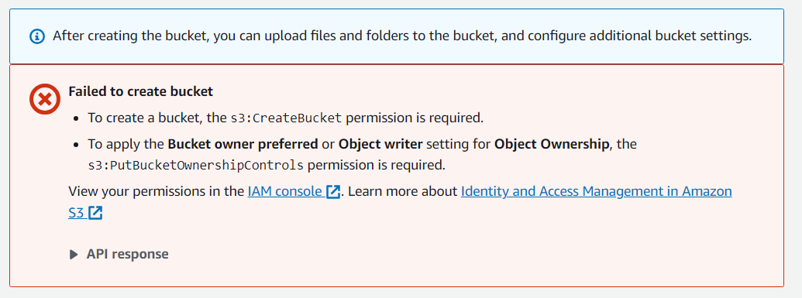

12. Then sign in to user2, and try to create an instance, AWS shows the error message.



13. Now sign in to user3, and try to create both, AWS will allow as user3 is having AdminstratorAcess.

