**Demonstration of AWS Load Balancer**

1. Sign in to the AWS console.

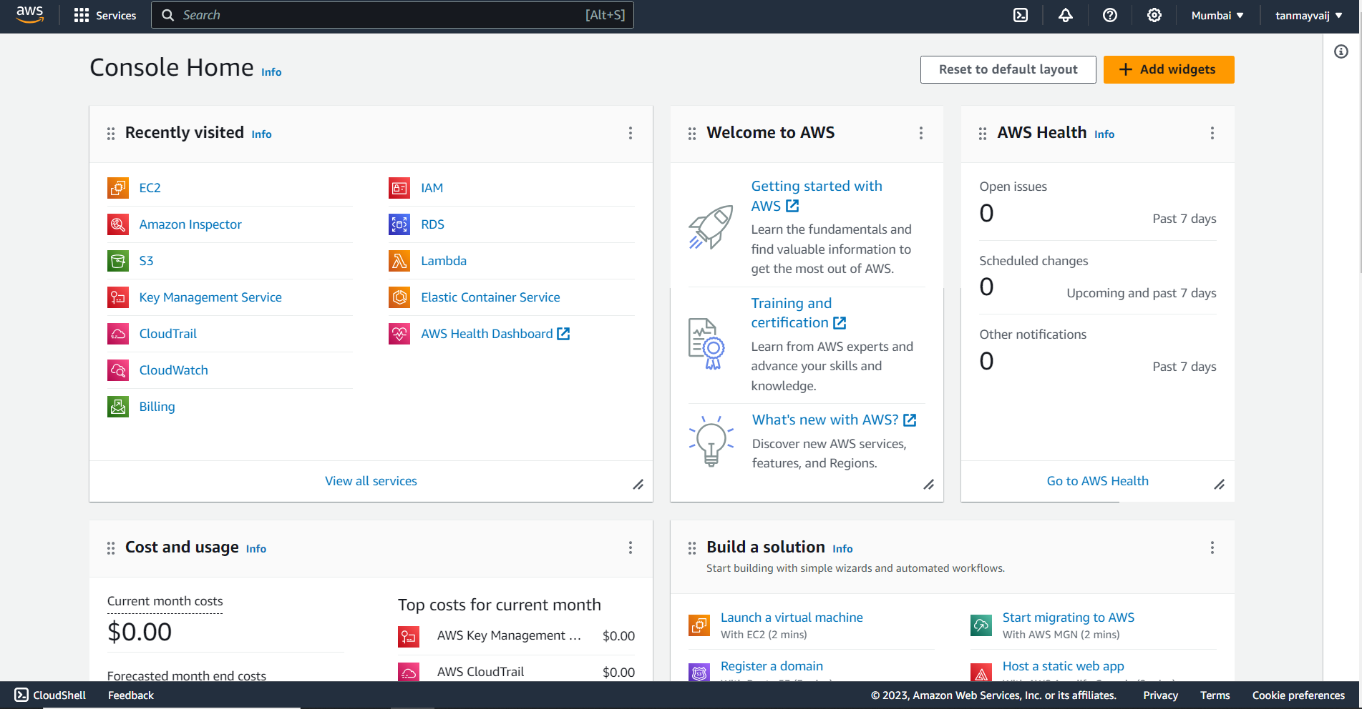

2. Search for EC2 and click on the EC2 tab.

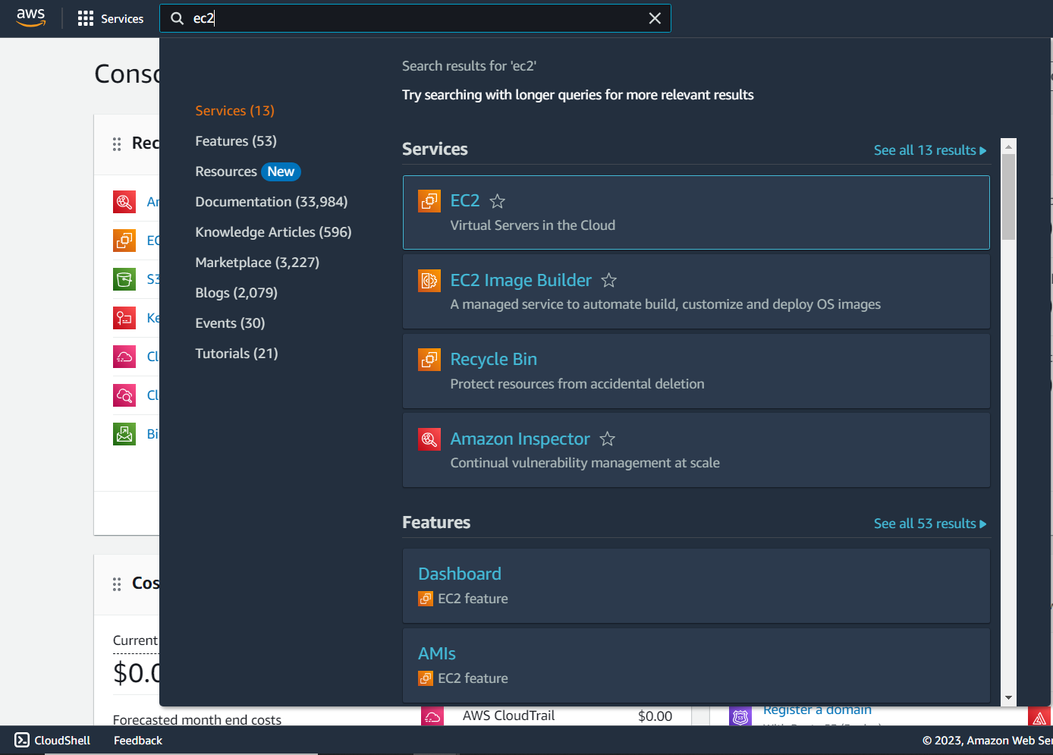

3. Click and open the instance dashboard by clicking on “Instances” in the “Resources” card.

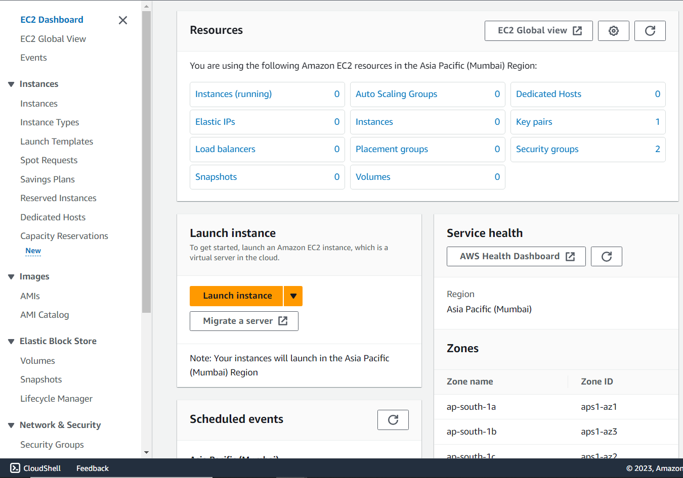

4. Click on “Launch instances”.

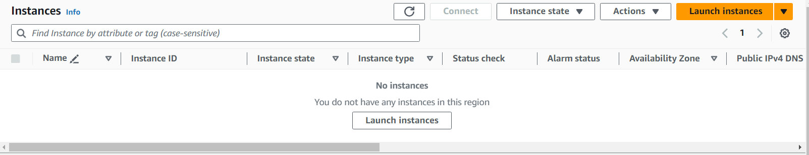

5. Give a name to the instance

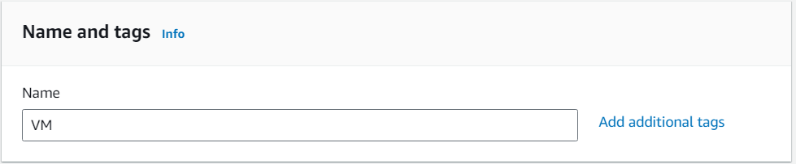

6. Select the OS Image

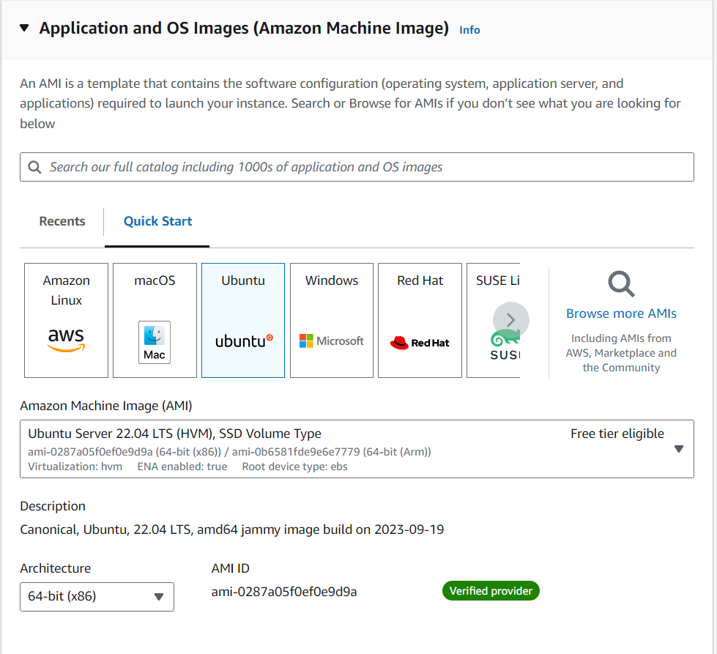

7. Create a key pair or select one if it is already created.

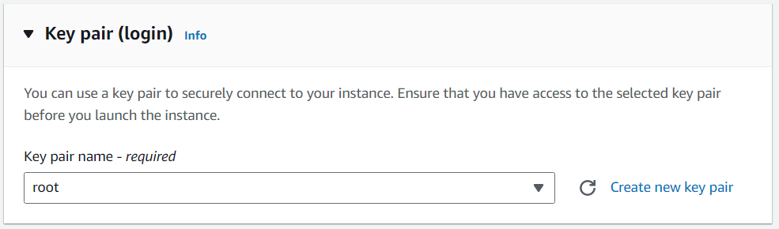

8. Create a security group or select an existing one. ( https, http, ssh should be given anywhere access ).

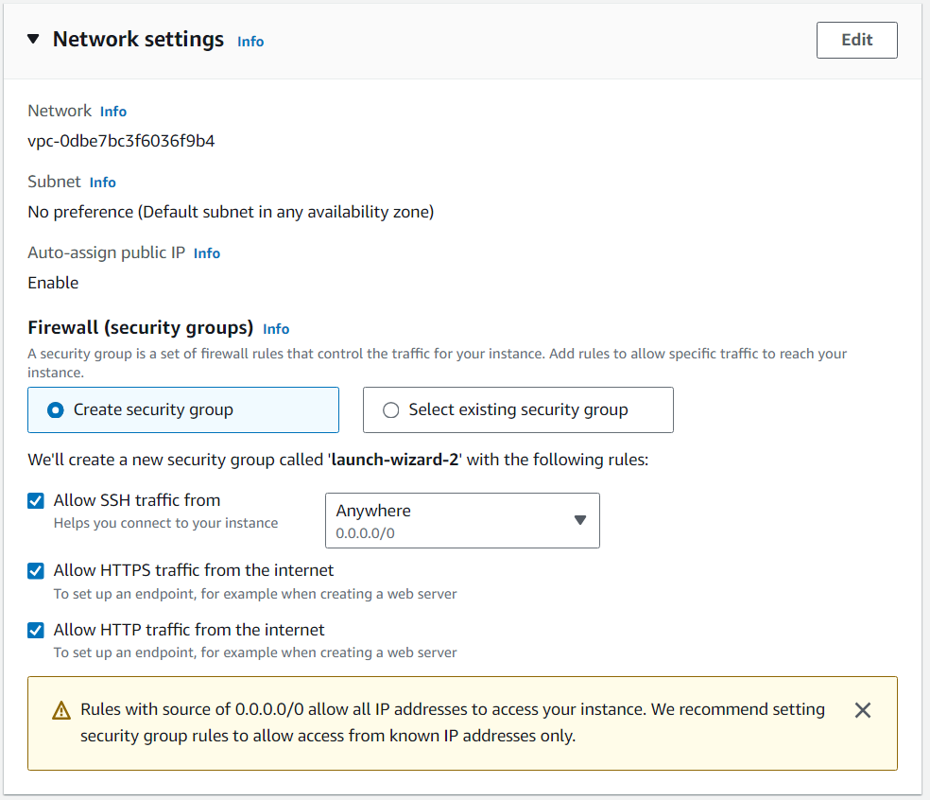

9. Enter the number of instances to create.

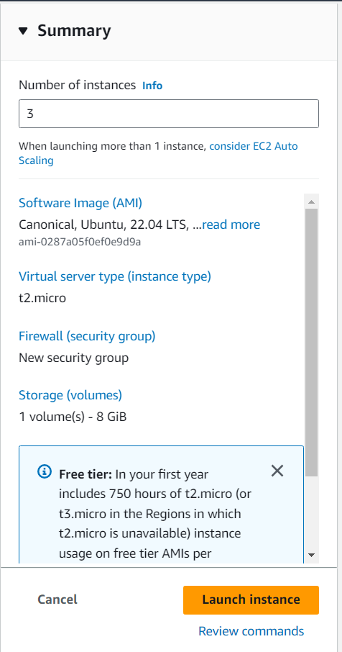

10. Rename these instances to identify them uniquely and wait till each instance passes the status check. Then select one instance and click connect.

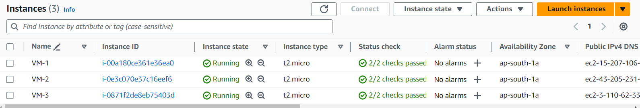

11. Simply click “Connect” and a terminal will open.

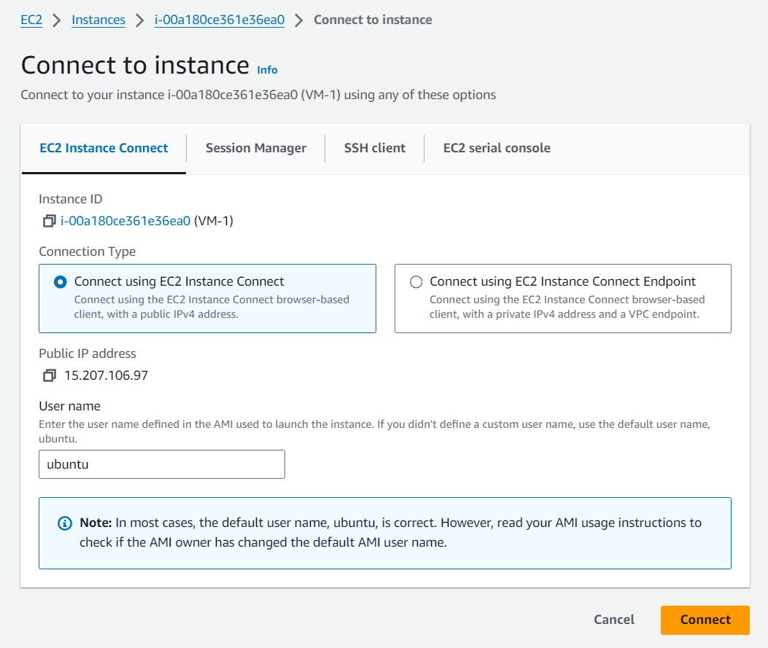

12. Enter the command “sudo apt update -y && sudo apt install apache2 -y && sudo echo ‘<h1>Instance VM-1</h1>’ | sudo tee /var/www/html/index.html ”. Repeat the same steps with the other two instances.

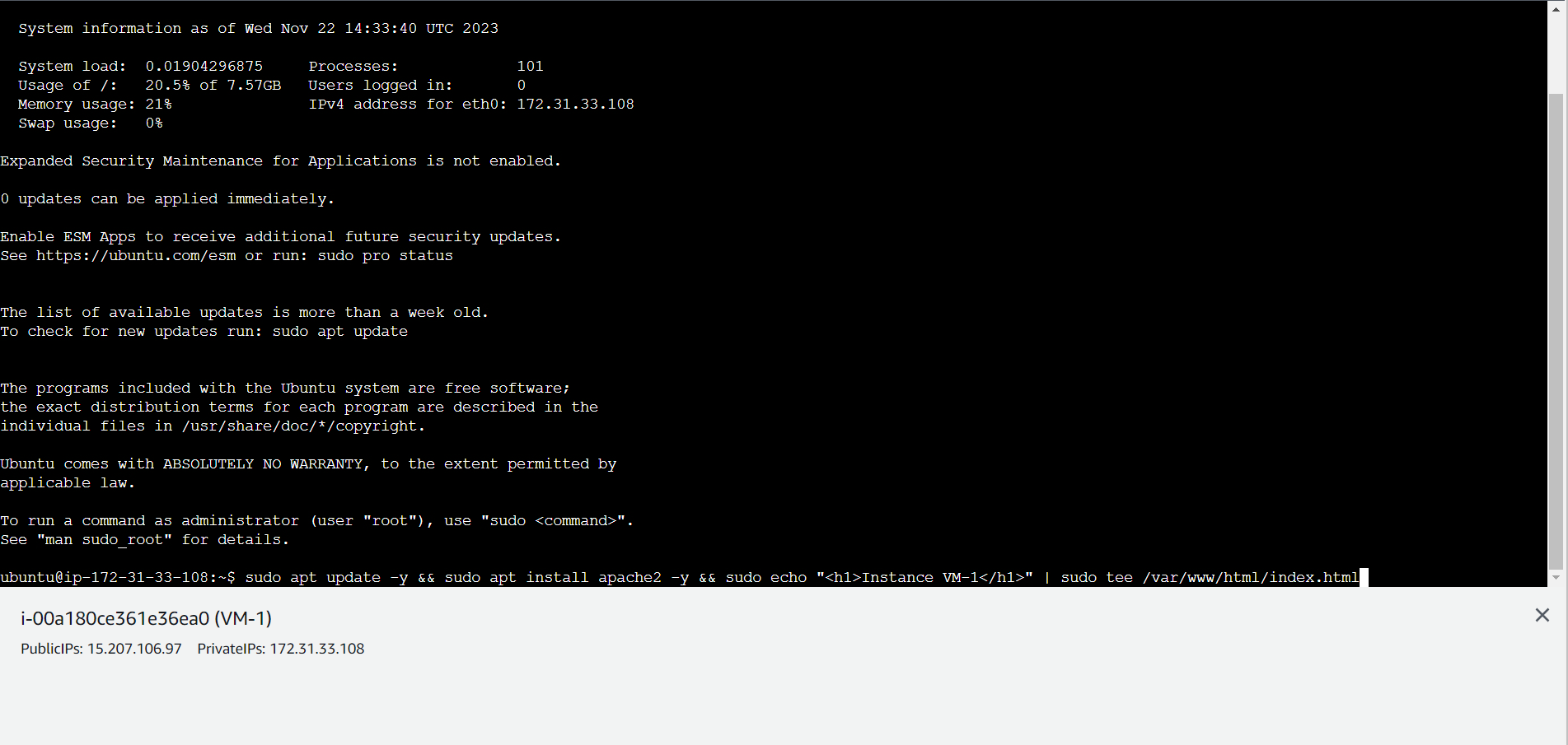

13. Now select ‘Load Balancers’ from the side menu.

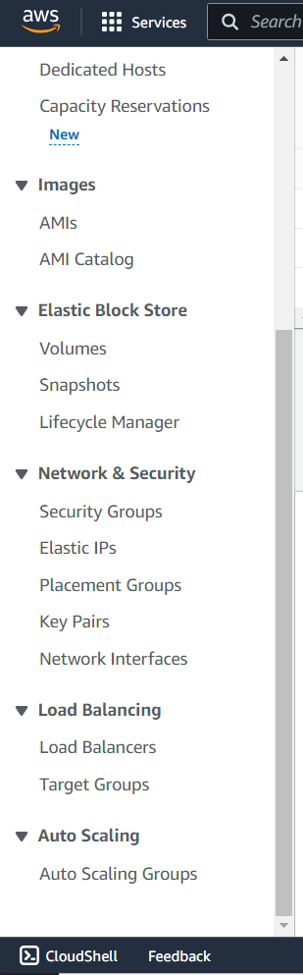

14. Click on “Create load balancer”.

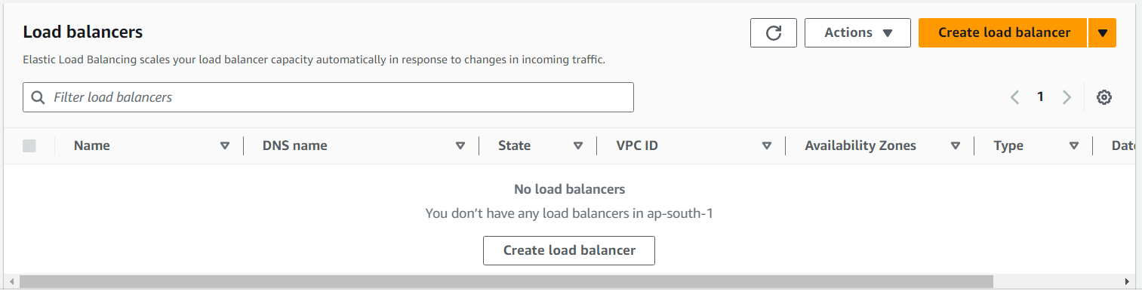

15. Select the “Application Load Balancer”.

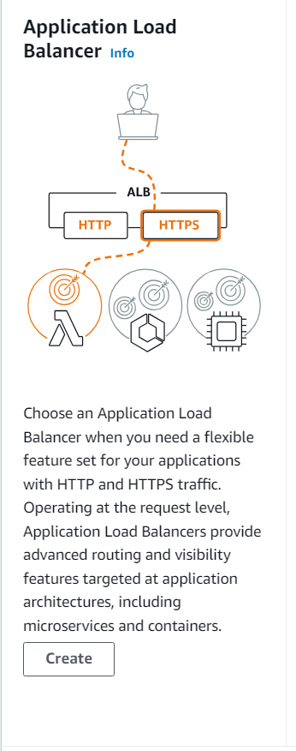

16. Enter a name for load balancer.

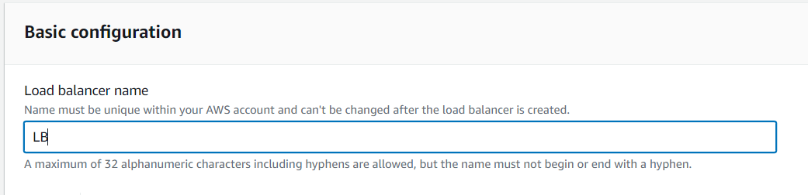

17. In the network mapping card select at least two zones.

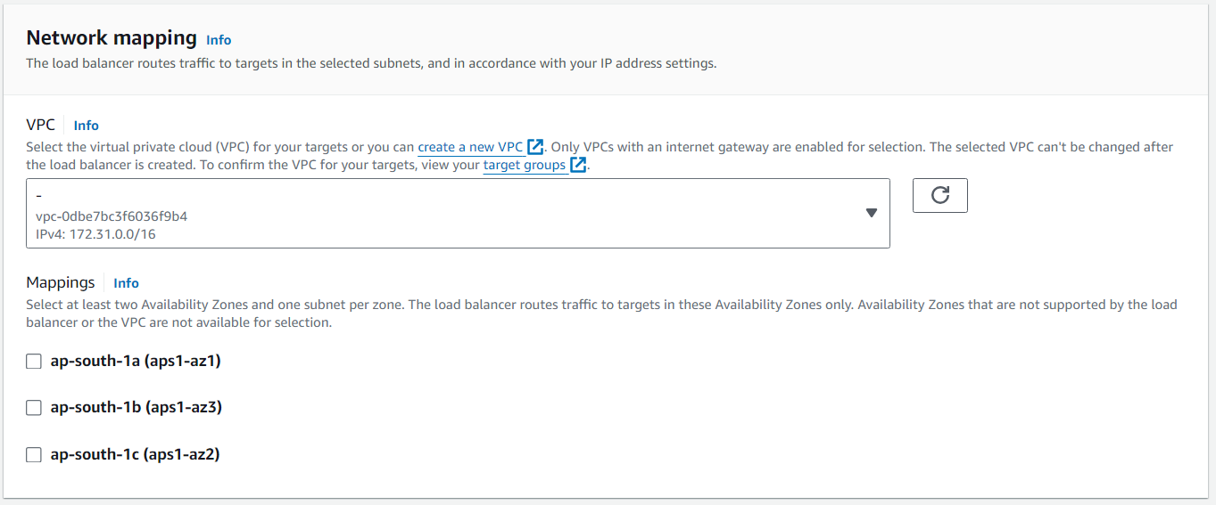

18. Select the security group used for instances.

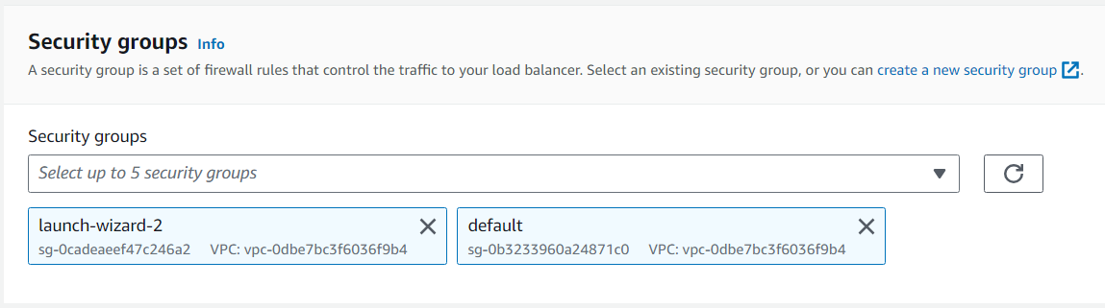

19. Now create a target group by clicking on “Create target group”.

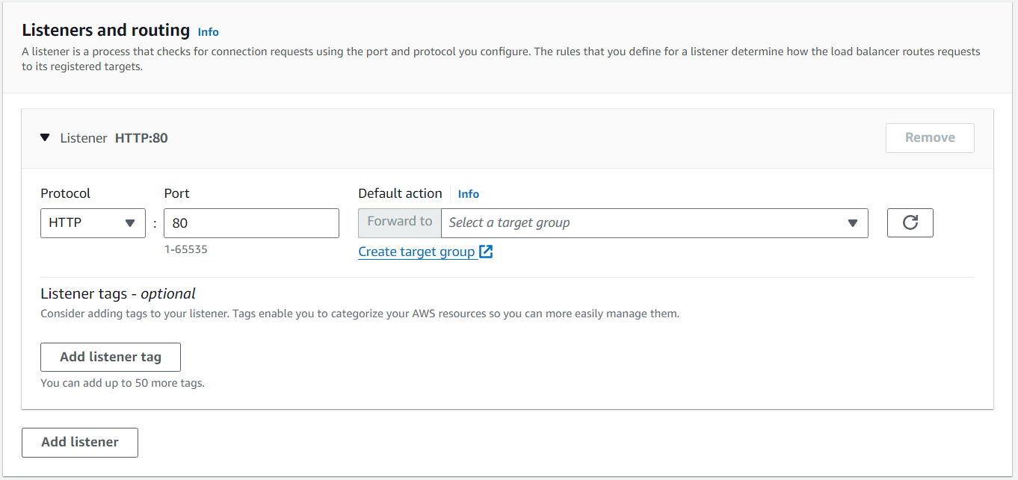

20.Select “Instances” as the target type.

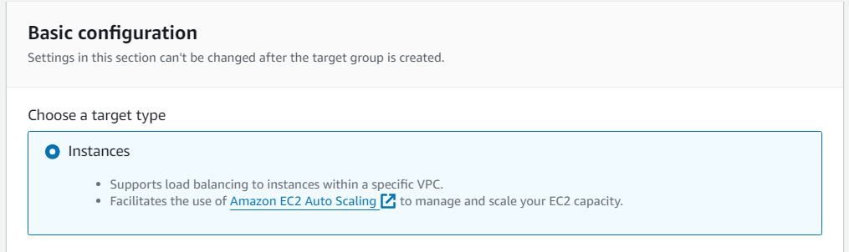

21. Give a name to the target group.



22. Select all the instances and click on “Include as pending below” and click on create target group.

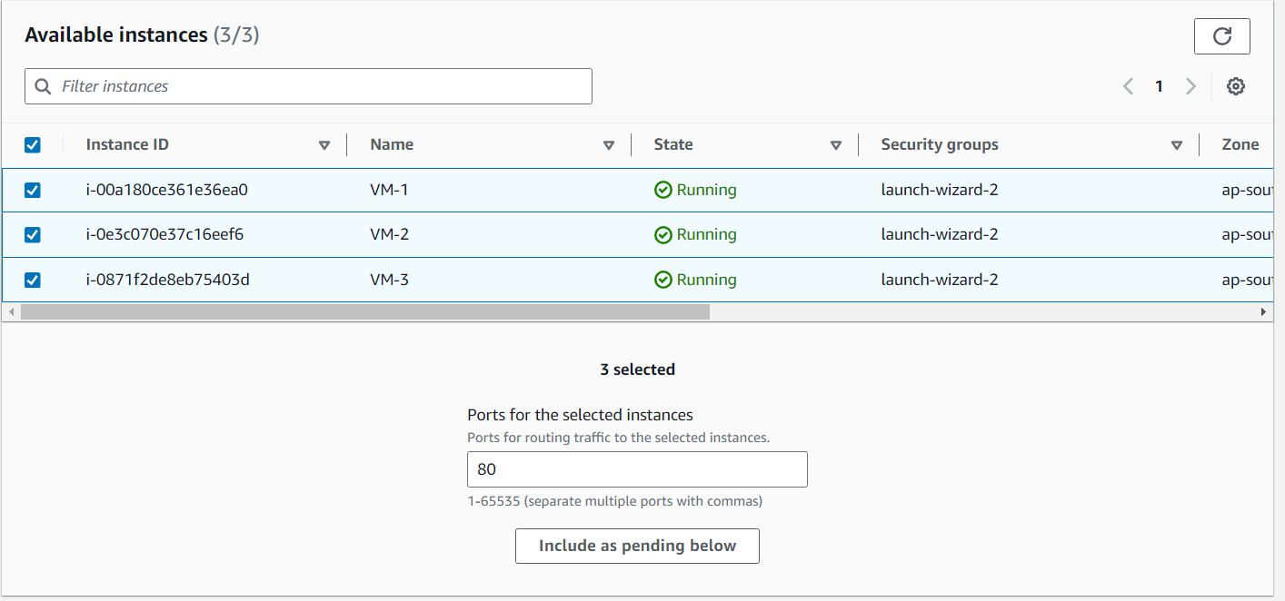

23. Now select the target group in load balancer creation and click on create load balancer

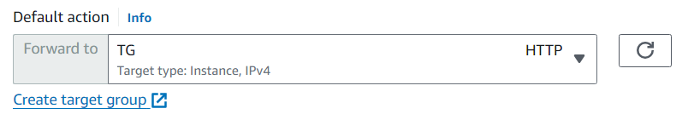

24. Now wait till the “State” becomes “Active”.

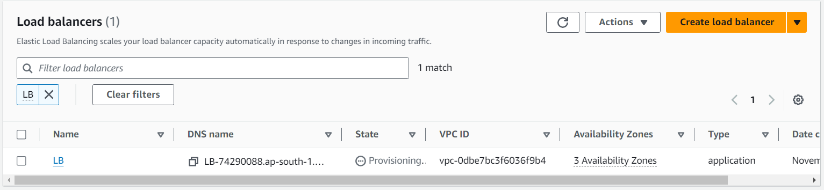

25. Now copy paste the dns name, and keep reloading the page, it should keep changing the page.

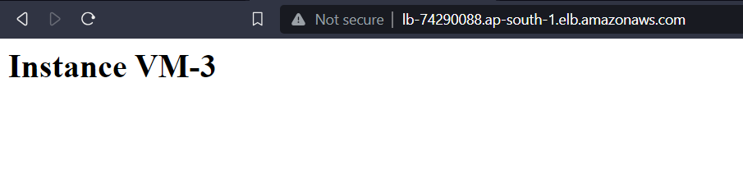

26. Now if one instance is stopped or terminated the load balancer will not be able to send traffic to that instance. The traffic will be diverted to other instances