浙江大学城市学院实验报告
课程名称 iOS移动应用开发
实验项目名称 实验十三 iOS数据持久性存储
学生姓名 王晨旭 专业班级 软工1702 学号 31701257
实验成绩 指导老师（签名 ） 日期
注意：
- 务请保存好各自的源代码及实验报告文档，已备后用。
- 请把实验报告和实验项目放在一个文件夹（如实验01）后打包为rar压缩文件，并上传到BB平台。
- 压缩文件名为：学号_姓名_日期_实验X.rar，如30801001_姓名_20180229_实验01.rar
一、实验目的：
熟悉掌握iOS应用中的数据存储。练习属性列表、偏好设置、归档、SQLite和CoreData的数据持久性存储。
二、实验内容
- 请按照以下要求完成应用程序沙盒的文件系统 ，要求如下：
- 创建Mac xOS终端下，显示根路径、Documents、Library和tmp等文件路径。
- 在iOS单视图下，通过文本标签，显示应用程序的文件系统。
- 在模拟器中运行程序。

- 请按照以下要求编写代码，使用plist属性列表保存数据，要求如下：
- 新建工程，搭建程序界面。新建姓名、学号、、性别、出生年月、电话号码、QQ号和保存按键。
- 各文本输入框，按照实际内容，调用不同的输入键盘类型。
- 日期输入调用UIDatePicker。
- 单击保存后，保存输入数据。关闭程序，重新打开时，读取上次数据。
- 在模拟器上运行程序

- 采用偏好设置，编写代码，实现以下界面设计。要求如下：
- 新建工程，搭建程序界面。
- 在模拟器上运行程序测试。

- 请按照以下要求完成SQLite数据库设计，要求如下：
- 创建工程，通过iOS的SQLite创建数据库，建立两张表：teacher和student；
- teacher表包含字段：id, name, age, address, phoneno;
- student表包含字段：id, name, number, course, core;
- 完成建表，添加记录，插入记录，删除记录，修改记录的操作
- 在模拟器运行程序，通过软件，查看数据库内容，验证结果。
- 查看数据库内容，可安装使用sqlitebrowser查看。

- 请使用CoreData保存数据，实现iOS中持久化存储。要求如下：
- 创建工程，通过iOS的CoreData完成持久化存储；
- 创建成绩管理数据库course_core，建立物理课数据表physics，包含id， name，number，core。
- 建立数据输入UI界面，通过界面按键，完成数据记录的添加、读取、修改、插入的操作。
- 在模拟器运行程序，通过sqlitebrowser查看验证结果。

三、实验步骤、结果及分析：
- 部分代码及程序运行结果截图。

#import <Foundation/Foundation.h>

int main(int argc, const char * argv[]) {
@autoreleasepool {
NSString *appPath = NSHomeDirectory();
NSLog(@"沙盒路径：%@", appPath);

NSArray *array = NSSearchPathForDirectoriesInDomains(NSDocumentDirectory, NSUserDomainMask, YES);
NSString *docPath = [array objectAtIndex:0];
NSLog(@"Document 路径：%@", docPath);

NSString *tmpPath = NSTemporaryDirectory();
NSLog(@"tmp路径：%@", tmpPath);

NSArray *libArray = NSSearchPathForDirectoriesInDomains(NSLibraryDirectory, NSUserDomainMask, YES);
NSString *libPath = [libArray objectAtIndex:0];
NSLog(@"Library 路径：%@", libPath);
}
return 0;
} 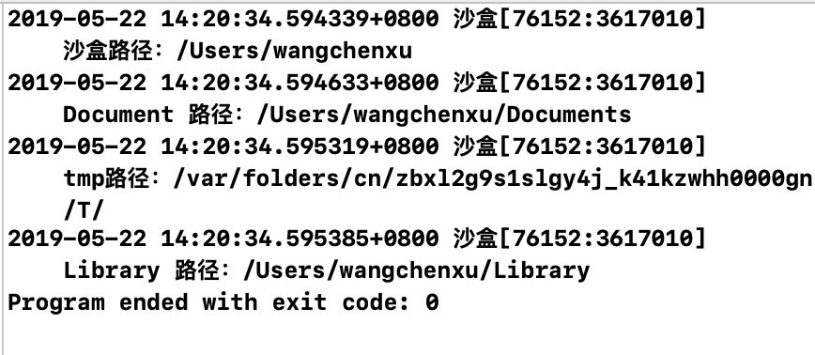
- 部分代码及程序运行结果截图。

@implementation ViewController

- (void)viewDidLoad {
[super viewDidLoad];
// Do any additional setup after loading the view.
[[NSNotificationCenter defaultCenter]addObserver:self selector:@selector(keyboardWillShow:) name:UIKeyboardWillShowNotification object:nil];
// 注册通知监听器，监听键盘收起事件
[[NSNotificationCenter defaultCenter]addObserver:self selector:@selector(keyboardWillHide:) name:UIKeyboardWillHideNotification object:nil];

}
-(void)keyboardWillShow:(NSNotification *)notification{
// 开启视图升起的动画效果
[UIView beginAnimations:@"keyboardWillShow" context:nil];
[UIView setAnimationCurve:UIViewAnimationCurveEaseInOut];
// 获取视图View的位置
CGRect rect=self.view.frame;
rect.origin.y=-60;
self.view.frame=rect;
// 结束动画
[UIView commitAnimations];
}

// 键盘关闭时调用的方法
-(void)keyboardWillHide:(NSNotification *)notification
{
// 开始视图下降动画效果
[UIView beginAnimations:@"keyboardWillHide" context:nil];
[UIView setAnimationCurve:UIViewAnimationCurveEaseInOut];
// 获取主视图View的位置
CGRect rect = self.view.frame;
rect.origin.y = 0;
// 恢复主视图View的位置
self.view.frame = rect;
// 结束动画
[UIView commitAnimations];
}
-(void)dealloc{
// 移除通知监听器
[[NSNotificationCenter defaultCenter]removeObserver:self];
}

/*读取plist文件的信息*/
- (void)read
{
// 从文件初始化NSDictionary对象
NSDictionary *dict = [NSDictionary
dictionaryWithContentsOfFile:[self filePath]];
NSDictionary *Lily = [dict objectForKey:@"Student"];
// 将plist文件的信息显示到对应的文本框和分段控件
if (Lily) {
self.nameField.text = [Lily objectForKey:@"Name"];
self.birthdayField.text = [Lily objectForKey:@"Birthday"];
self.sexSegment.selectedSegmentIndex =
[[Lily objectForKey:@"Sex"] intValue];
self.numberField.text = [Lily objectForKey:@"Number"];
}
}
- (void)touchesBegan:(NSSet *)touches withEvent:(UIEvent *)event
{
[self.view endEditing:YES]; // 退出键盘
}
- (NSString *) filePath
{
// 获取应用程序的沙盒目录
NSArray *array=NSSearchPathForDirectoriesInDomains(NSDocumentDirectory,NSUserDomainMask,YES);
NSString *path=[array objectAtIndex:0];
return [path stringByAppendingPathComponent:FileName];
}

-(BOOL)textFieldShouldReturn:(UITextField *)textField
{
if (textField == self.nameField) {
[self.birthdayField becomeFirstResponder]; // 切换到birthField
}else if (textField == self.birthdayField){
[self.numberField becomeFirstResponder]; // 切换到numberField
}
return YES;
}

-(void)alertViewWithTitle:(NSString *)title message:(NSString *)message CertainButtonTitle:(NSString *)buttonTitle{
UIAlertController *alert = [UIAlertController alertControllerWithTitle:title message:message preferredStyle:UIAlertControllerStyleAlert];
UIAlertAction *defult = [UIAlertAction actionWithTitle:buttonTitle style:UIAlertActionStyleDefault handler:nil];

[alert addAction:defult];
[self presentViewController:alert animated:YES completion:nil];

}
- (IBAction)saveBtn:(id)sender {
NSString *name=self.nameField.text;
NSString *birthday=self.birthdayField.text;
NSInteger sex=self.sexSegment.selectedSegmentIndex;
NSString *number=self.numberField.text;

// 判断表格填写是否完整
if(!name.length||!birthday.length||!number.length){
[self alertViewWithTitle:@"提示" message:@"信息不完整，请重新填写" CertainButtonTitle:@"确定"];
return;
}
[self.view endEditing:YES];

// 创建字典对象封装学生信息
NSMutableDictionary *Student=[[NSMutableDictionary alloc]init];
NSMutableDictionary *dic=[[NSMutableDictionary alloc]init];
[Student setObject:name forKey:@"Name"];
[Student setObject:birthday forKey:@"Birthday"];
[Student setObject:[NSNumber numberWithInteger:sex] forKey:@"Sex"];
[Student setObject:number forKey:@"Number"];
[dic setObject:Student forKey:@"Student"];
// 将字典对象转为属性列表持久保存在plist文件中
if ([dic writeToFile:[self filePath] atomically:YES]) {
[self alertViewWithTitle:@"提示" message:@"保存成功" CertainButtonTitle:@"确定"];
NSLog(@"%@",[self filePath]);
}
return;
}
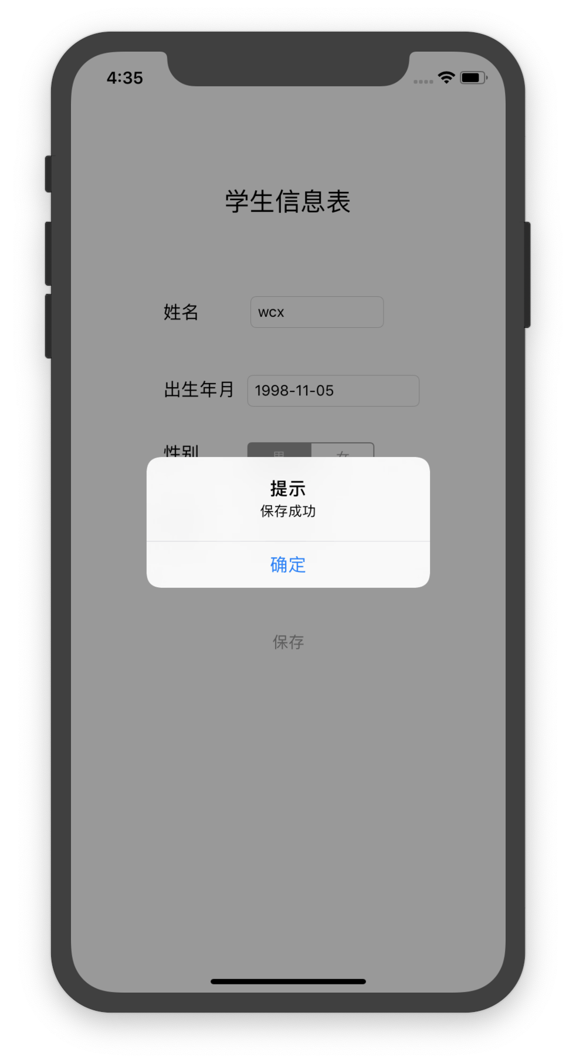
- 部分代码及程序运行结果截图。
#import "ViewController.h"
#define FileName @"itcast.UserLogin.plist"
@interface ViewController ()

@end

@implementation ViewController

- (void)viewDidLoad {
[super viewDidLoad];
// Do any additional setup after loading the view.
NSFileManager *manager=[NSFileManager defaultManager];
if ([manager fileExistsAtPath:[self filePath]]) {
// 创建NSUserDefaults实例对象
NSUserDefaults *user=[NSUserDefaults standardUserDefaults];
NSString *name=[user objectForKey:@"Name"];
NSString *password=[user objectForKey:@"Password"];
BOOL remember=[[user objectForKey:@"isRemember"]boolValue];

// 显示到界面中
self.nameField.text=name;
if (remember) {
self.passwordField.text=password;
}
[self.UISwitch setOn:remember];

}
}
-(NSString *)filePath
{
NSArray *array = NSSearchPathForDirectoriesInDomains(NSLibraryDirectory, NSUserDomainMask, YES);
NSString *path = [array objectAtIndex:0];
NSString *finalPath = [path stringByAppendingPathComponent:@"Preferences"];
return [finalPath stringByAppendingPathComponent:FileName];
}
- (void)touchesBegan:(NSSet *)touches withEvent:(UIEvent *)event
{
[self.view endEditing:YES]; // 退出键盘
}
- (IBAction)login:(id)sender {
NSString *name=self.nameField.text;
NSString *password=self.passwordField.text;
NSNumber *remember=[NSNumber numberWithBool:self.UISwitch.on];

if (!name.length||!password.length) {
[self alertViewWithTitle:@"提示" message:@"账号和密码不能为空！"CertainButtonTitle:@"确定"];
return;
}
NSUserDefaults *user=[NSUserDefaults standardUserDefaults];
[user setObject:name forKey:@"Name"];
[user setObject:password forKey:@"Password"];
[user setObject:remember forKey:@"isRemember"];

// 立即保存信息
[user synchronize];
[self alertViewWithTitle:@"提示" message:@"登录成功"CertainButtonTitle:@"确定"];
}
-(void)alertViewWithTitle:(NSString *)title message:(NSString *)message CertainButtonTitle:(NSString *)buttonTitle{
UIAlertController *alert = [UIAlertController alertControllerWithTitle:title message:message preferredStyle:UIAlertControllerStyleAlert];
UIAlertAction *defult = [UIAlertAction actionWithTitle:buttonTitle style:UIAlertActionStyleDefault handler:nil];

[alert addAction:defult];
//显示
[self presentViewController:alert animated:YES completion:nil];

}
@end

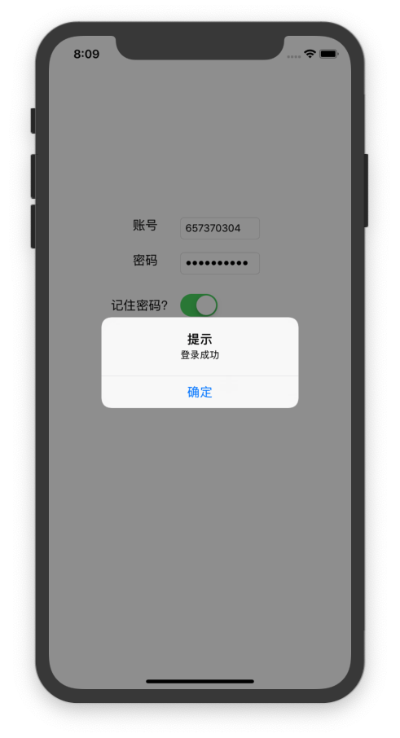

#import "ViewController.h"
#import<sqlite3.h>
@interface ViewController ()

@end

@implementation ViewController
static sqlite3 *db = NULL;
- (void)viewDidLoad {
[super viewDidLoad];
// Do any additional setup after loading the view.
NSString *docDir = [NSSearchPathForDirectoriesInDomains(NSDocumentDirectory, NSUserDomainMask, YES) firstObject];
// 创建数据库路径
NSString *dataBasePath = [docDir stringByAppendingPathComponent:@"database1.sqlite"];
NSLog(@"数据库路径：%@", dataBasePath);

// 是数据库的句柄，表示数据库象征，是操作数据库的实例对象。
// 如果数据库存在就会返回数据库，如果数据库不存在，则会创建一个新的数据库返回
int result = sqlite3_open([dataBasePath UTF8String], &db);
// 判断数据库是否打开成功
if (result == SQLITE_OK) {
NSLog(@"打开数据库成功");
NSLog(@"%@",dataBasePath);
}else {
NSLog(@"打开数据库失败");
}

const char *sql="CREATE TABLE IF NOT EXISTS t_students(id integer PRIMARY KEY AUTOINCREMENT,name text NOT NULL, age INTEGER NOT NULL,number text NOT NULL,course text NOT NULL);";
char *errmsg= NULL;
result = sqlite3_exec(db, sql, NULL, NULL, &errmsg);
if (result==SQLITE_OK) {
NSLog(@"创表成功");
}else {
NSLog(@"创表失败--%s--%s--%d",errmsg,__FILE__,__LINE__);
}
const char *sql1="CREATE TABLE IF NOT EXISTS t_teachers(id integer PRIMARY KEY AUTOINCREMENT,name text NOT NULL, age INTEGER NOT NULL,phonenum text NOT NULL);";
char *ermsg= NULL;
result = sqlite3_exec(db, sql1, NULL, NULL, &errmsg);
if (result==SQLITE_OK) {
NSLog(@"创表成功");
}else {
NSLog(@"创表失败--%s--%s--%d",ermsg,__FILE__,__LINE__);
}
}

-(void)touchesBegan:(NSSet *)touches withEvent:(UIEvent *)event{
[self.view endEditing:YES];
}

- (IBAction)save:(id)sender {

NSString *name=self.name.text;
int age=[self.age.text intValue];
NSString *number=self.number.text;
NSString *course=self.course.text;
if (name && age && number&&course) {
NSString *sql = [NSString stringWithFormat:@"INSERT INTO t_students(name, age,number,course)VALUES ('%@', %d,'%@','%@');", name, age,number,course];
char *error = nil;
// 2.执行插入sql语句
sqlite3_exec(db, sql.UTF8String, NULL, NULL, &error);
if (error) {

[self alertViewWithTitle:@"提示" message:@"添加失败" CertainButtonTitle:@"确定"];
}else
{

[self alertViewWithTitle:@"提示" message:@"保存成功" CertainButtonTitle:@"确定"];
}

}else{
[self alertViewWithTitle:@"提示" message:@"请将信息填写完整" CertainButtonTitle:@"确定"];
}
}

- (IBAction)read:(id)sender {
const char *sql = "SELECT name, age FROM t_students;";
sqlite3_stmt *stmt; // 用于提取数据的
// 1.做查询前的准备, 检查sql语句是否正确
int result = sqlite3_prepare_v2(db, sql, -1, &stmt, NULL);
if (result == SQLITE_OK) {// 准备完成, 没有错误
// 2.提取查询到的数据到stmt, 一次提取一条
// 如果返回值为SQLITE_ROW, 就代表提取到了一条记录
while(sqlite3_step(stmt) == SQLITE_ROW)
{
// 3.取出提取到的记录(数据)中的第0列的数据
const unsigned char *name = sqlite3_column_text(stmt, 0);
int age = sqlite3_column_int(stmt, 1);
NSLog(@"%s %d", name, age);
self.readname=[NSString stringWithFormat:@"%s", name];

self.readage=[NSString stringWithFormat:@"%d", age];
}
}
sqlite3_close(db);
}

- (IBAction)readt:(id)sender {
const char *sql = "SELECT name, age FROM t_teachers;";
sqlite3_stmt *stmt; // 用于提取数据的
// 1.做查询前的准备, 检查sql语句是否正确
int result = sqlite3_prepare_v2(db, sql, -1, &stmt, NULL);
if (result == SQLITE_OK) {// 准备完成, 没有错误
// 2.提取查询到的数据到stmt, 一次提取一条
// 如果返回值为SQLITE_ROW, 就代表提取到了一条记录
while(sqlite3_step(stmt) == SQLITE_ROW)
{
// 3.取出提取到的记录(数据)中的第0列的数据
const unsigned char *name = sqlite3_column_text(stmt, 0);
int age = sqlite3_column_int(stmt, 1);
NSLog(@"%s %d", name, age);
self.readname=[NSString stringWithFormat:@"%@", name];

self.readage=[NSString stringWithFormat:@"%d", age];
}
}
sqlite3_close(db);
}

- (IBAction)savet:(id)sender {
NSString *name=self.tname.text;
int age=[self.tage.text intValue];
NSString *phonenum=self.phonenum.text;
if (name && age && phonenum) {
NSString *sql = [NSString stringWithFormat:@"INSERT INTO t_teachers(name, age,phonenum)VALUES ('%@', %d,'%@');", name, age,phonenum];
char *error = nil;
// 2.执行插入sql语句
sqlite3_exec(db, sql.UTF8String, NULL, NULL, &error);
if (error) {

[self alertViewWithTitle:@"提示" message:@"添加失败" CertainButtonTitle:@"确定"];
}else
{

[self alertViewWithTitle:@"提示" message:@"保存成功" CertainButtonTitle:@"确定"];
}

}else{
[self alertViewWithTitle:@"提示" message:@"请将信息填写完整" CertainButtonTitle:@"确定"];
}
}
-(void)alertViewWithTitle:(NSString *)title message:(NSString *)message CertainButtonTitle:(NSString *)buttonTitle{
UIAlertController *alert = [UIAlertController alertControllerWithTitle:title message:message preferredStyle:UIAlertControllerStyleAlert];
UIAlertAction *defult = [UIAlertAction actionWithTitle:buttonTitle style:UIAlertActionStyleDefault handler:nil];

[alert addAction:defult];
//显示
[self presentViewController:alert animated:YES completion:nil];
}
@end
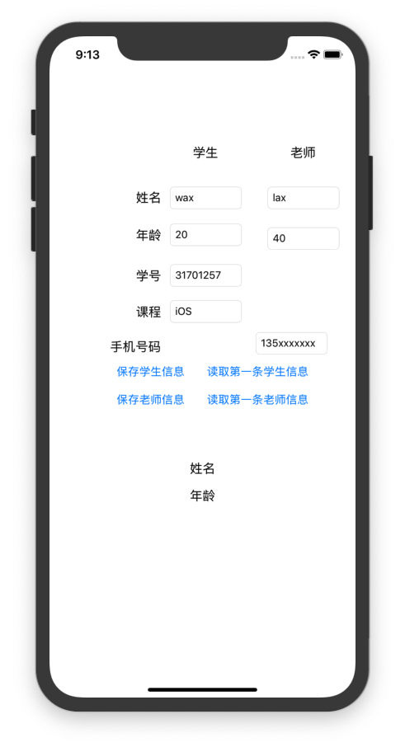
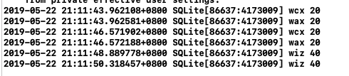
- 部分代码及程序运行结果截图。

//
// ViewController.m
// coreData
//
// Created by 王晨旭 on 2019/5/22.
// Copyright © 2019 王晨旭. All rights reserved.
//

#import "ViewController.h"
#import <CoreData/CoreData.h>
#import "Physics+CoreDataClass.h"
@interface ViewController ()
@property (weak, nonatomic) IBOutlet UITextField *pid;
@property (weak, nonatomic) IBOutlet UITextField *name;
@property (weak, nonatomic) IBOutlet UITextField *number;
@property (weak, nonatomic) IBOutlet UITextField *core;
- (IBAction)insertData:(id)sender;
- (IBAction)selectData:(id)sender;
- (IBAction)deleteData:(id)sender;
- (IBAction)updateData:(id)sender;
@property (weak, nonatomic) IBOutlet UILabel *rname;
@property (weak, nonatomic) IBOutlet UILabel *rnum;
@property(strong,nonatomic)NSManagedObjectContext *context;
@end

@implementation ViewController

- (void)viewDidLoad {
[super viewDidLoad];
[self context];
}

- (IBAction)insertData:(id)sender {
Physics *ph1 = [NSEntityDescription insertNewObjectForEntityForName:@"Physics" inManagedObjectContext:self.context];

NSNumberFormatter *f = [[NSNumberFormatter alloc] init];
ph1.pid=[f numberFromString:self.pid.text];
ph1.name = self.name.text;
ph1.number =self.number.text;
ph1.core = self.core.text;

//保存 - 通过上下文操作
NSError *error = nil;
[self.context save:&error];
if (!error) {
NSLog(@"success");
}else{
NSLog(@"%@",error);
}
}

- (IBAction)selectData:(id)sender {
NSFetchRequest *request = [NSFetchRequest fetchRequestWithEntityName:@"Physics"];
request.fetchLimit = 5;
request.fetchOffset = 10;
NSError *error = nil;
NSArray *phys = [self.context executeFetchRequest:request error:&error];
if (!error) {
NSLog(@"phys: %@",phys);
for (Physics *phy in phys) {
self.rname.text=phy.name;
self.rnum.text=phy.number;
break;
}
}else{
NSLog(@"%@",error);
}

}

- (IBAction)deleteData:(id)sender {
NSFetchRequest *request = [NSFetchRequest fetchRequestWithEntityName:@"Physics"];

NSPredicate *pre = [NSPredicate predicateWithFormat:@"name=%@",self.name.text];
request.predicate = pre;

NSArray *phys = [self.context executeFetchRequest:request error:nil];

for (Physics *phy in phys) {
NSLog(@"删除的人 %@",phy.name);
[self.context deleteObject:phy];
}

// 3.用context同步下数据库
//所有的操作暂时都是在内存里，调用save 同步数据库
[self.context save:nil];
}

- (IBAction)updateData:(id)sender {
NSArray *phys = [self findPhysicsWithName:@"wcx"];

// 2.更新身高
if (phys.count == 1) {
Physics *phy = phys[0];
phy.number = self.number.text;
}

// 3.同步（保存）到数据
[self.context save:nil];
}
-(NSArray *)findPhysicsWithName:(NSString *)name{
// 1.查找员工
NSFetchRequest *request = [NSFetchRequest fetchRequestWithEntityName:@"Physics"];

NSPredicate *pre = [NSPredicate predicateWithFormat:@"name=%@",name];
request.predicate = pre;

return [self.context executeFetchRequest:request error:nil];

}
-(void)setupContext{

// 1.上下文 关联Company.xcdatamodeld 模型文件
// NSManagedObjectContext *context = [[NSManagedObjectContext alloc] init];
//@wujz
NSManagedObjectContext *context = [[NSManagedObjectContext alloc] initWithConcurrencyType:NSPrivateQueueConcurrencyType];

// 关联模型文件

// 创建一个模型对象
// 传一个nil 会把 bundle下的所有模型文件 关联起来
NSManagedObjectModel *model = [NSManagedObjectModel mergedModelFromBundles:nil];

// 持久化存储调度器
NSPersistentStoreCoordinator *store = [[NSPersistentStoreCoordinator alloc] initWithManagedObjectModel:model];

// 存储数据库的名字
NSError *error = nil;

// 获取docment目录
NSString *doc = [NSSearchPathForDirectoriesInDomains(NSDocumentDirectory, NSUserDomainMask, YES) lastObject];

// 数据库保存的路径
NSString *sqlitePath = [doc stringByAppendingPathComponent:@"coreData.db"];
NSLog(@"文件路径：%@", sqlitePath);

[store addPersistentStoreWithType:NSSQLiteStoreType configuration:nil URL:[NSURL fileURLWithPath:sqlitePath] options:nil error:&error];

context.persistentStoreCoordinator = store;

self.context = context;
}

-(void)touchesBegan:(NSSet *)touches withEvent:(UIEvent *)event{
// 创建员工
for (int i = 0; i < 10; i++) {
Physics *emp1 = [NSEntityDescription insertNewObjectForEntityForName:@"Physics" inManagedObjectContext:self.context];

// 设置员工属性
emp1.name = [NSString stringWithFormat:@"wangwu %d",i];
emp1.number= [NSString stringWithFormat:@"12345 %d",i];
emp1.core=[NSString stringWithFormat:@"x %d",i];

//保存 - 通过上下文操作
NSError *error = nil;
[self.context save:&error];
if (!error) {
NSLog(@"success");
}else{
NSLog(@"%@",error);
}

}

}
@end

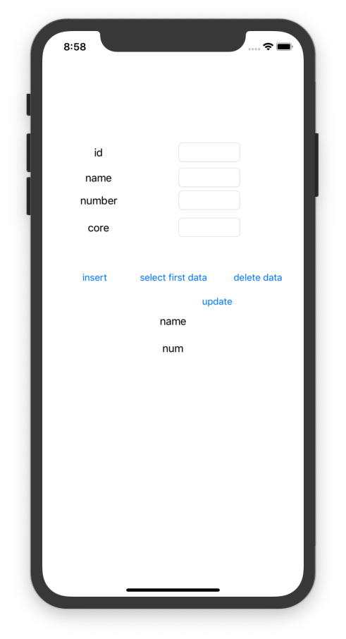
四、思考题

